Grade 8 Life Orientation Exam
Development of Self in Society: Term 1&2
2017
70 Marks
Possible examination questions: Development of Self in Society
REMINDER: Paper should include components of each topic covered so far this year
Note to Teacher: Please ensure that your selection of questions is of such a nature that your question paper satisfies the requirements of Bloom’s taxonomy.

SPREAD OF COGNITIVE LEVELS
 | LOW |  | MEDIUM |  | HIGH
Question | Remembering | Understanding | Applying | Analysing | Evaluating | Creating
1 | 4 | 2 | 4
2 |  |  | 5
3 | 10
4 | 2 |  | 2 |  | 2 | 4
5 |  | 1 |  | 8 | 6
6 |  | 2 |  | 4 | 4
7 | 2 |  | 4 |  |  | 4
8 |  | 2 | 4 |  |  | 4
Total marks | 25 |  | 31 |  | 24
Target | 30% |  | 40% |  | 30%

SECTION A:
Answer ALL the questions in this section.

Question 1:
True or False:
Indicate whether the following statements are TRUE or FALSE. Give a reason if the statement is false.

1.1. | A good way to initiate a friendship is to try to connect over something mutual.
1.2 | You should always keep a friend’s secret, no matter what.
1.3. | A romantic relationship always includes a physically sexual component.
1.4. | Self-esteem is fixed, you either have a good self-esteem or a bad one.
1.5. | Having a high self-esteem will mean you will place more value on yourself and you will therefore be more likely to avoid dangerous and risky behaviour.
1.6. | Figuring out who you are will require you to make choices, problem solve and engage in critical and creative thinking.
1.7. | Your ideal self refers to the person you desire to be.
 |  | [10]
Question 2:
Instruction: Complete the following paragraphs by using the WORDS in the word box.

attraction values intellectually menopause
reproduction physically relationships puberty

2. | Our sexuality is a very important aspect of our personality and our ___2.1.___. It is a vital part of who we are. The way that we express our sexuality depends on our attitudes and __2.2.___, our gender role and the relationships that we choose.  During ___2.3.___ we begin to mature into men and women with the ability to reproduce and with an understanding of sexuality. Previously, your sexuality would probably not have been an issue for you but feelings of ___2.4.___ and romance become significant in a person’s life. Important learning takes place in adolescence: your sexual identity begins to develop - not only physically, but emotionally and ___2.5.___ as well.
 |  | [5x1]
Question 3:

Provide a definition for the following terms.

3.1. | Self-awareness | (1x2)
3.2. | Self-motivation | (1x2)
3.3. | Relationship | (1x2)
3.4. | Acquaintance | (1x2)
3.5. | Individuality | (1x2)
 |  | [10]
 | TOTAL FOR SECTION A: | [25]
SECTION B:
Answer ALL of the questions in this section.

Question 4:

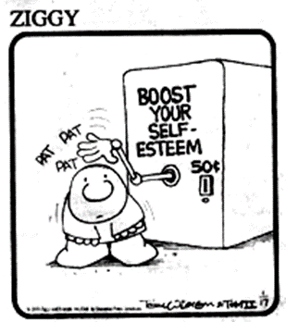
4.1. | What is self-esteem? | (1x2)
4.2. | Why is self-esteem important? | (1x2)
4.3. | How do your friends and your peers influence your self-concept formation and self-motivation? | (1x2)
4.4. | Recommend two ways somebody could try to improve their self-esteem. | (2x2)
 |  | [10]
Question 5:
Study the following image and answer the questions that follow:

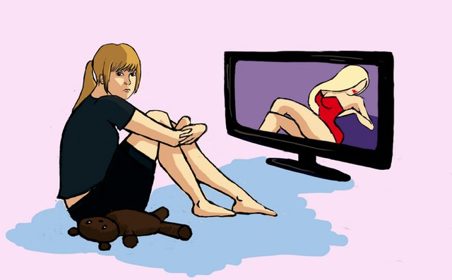
http://theairspace.net/insight/gender-equality-in-the-media-the-new-social-movement/

5.1. | Why is the media so influential over our sexuality? | (1)
5.2. | What message do you think the image on the screen sends to the girl regarding her?  5.2.1. Gender role (2x1) (2)  5.2.2. Sexual orientation (2x1) (2)  5.2.3. Sexual identity (2x1)(2) | (6)
5.3. | Explain, by means of examples, how the following influences your sexuality:  5.3.1. Your friends and peers (2x2)  5.3.2. Your family and community norms (2x2) | (8)
 |  | [15]
 | TOTAL FOR SECTION B: | [25]
SECTION C:
Answer any TWO out of the following three questions.

Question 6: Study the POSTER and complete the question that follows.

 |  | (10)
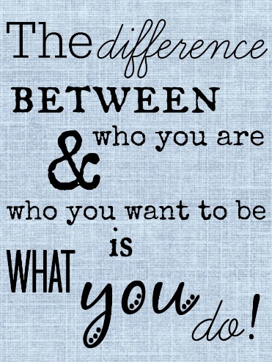
6.1. | Write a short essay in which you provide your friends with advice as to how they should attempt to extend their personal potential. Your answer should include the following:  - Explain what it means to achieve your full potential (2x1)  - Suggest FOUR ways how to achieve their full potential (4x2) | [10]
Question 7: Study the cartoon below and complete the question that follows.

7.
 | 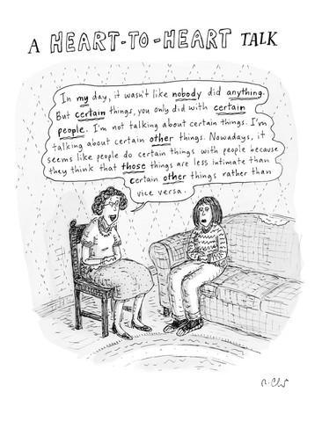
7.1. | Write a essay in which you do a critical evaluation of why so many people struggle with issues around sexuality. Your answer must include the following:  - Define the term sexuality (1x2)  - Discuss TWO reasons why so many people struggle with issues around sexuality (2x2)  - Recommend TWO ways to develop a healthy understanding of sexuality (2x2) | [10]
Question 8: Read the statement below and answer the question that follows.

8.1.
 | 
The end of a relationship (no matter what type of relationship) can be difficult.
Write an essay on relationships and include the following:

- State TWO ingredients of a healthy relationship (2x1)
- What somebody should do in order to recover once a relationship that they cared about is over (2x2)
- Provide TWO pieces of advice regarding how to end a relationship in a healthy way
(2x2)
 |  | [10]
 | TOTAL FOR SECTION C: | [20]
 | GRAND TOTAL: | [70]

MEMORANDUM
SECTION A:
Answer ALL the questions in this section.

Question 1:
True or False:
Indicate whether the following statements are TRUE or FALSE. Give a reason if the statement is false.

1.1. | A good way to initiate a friendship is to try to connect over something mutual.  TRUE
1.2 | You should always keep a friend’s secret, no matter what.  FALSE  If the secret is harmful to the friend or to somebody else, then you should tell an adult who you trust and who is able to do something about it.
1.3. | A romantic relationship always includes a physically sexual component.  FALSE  A romantic relationship is based on love; this does not have to include a physically sexual component.
1.4. | Self-esteem is fixed, you either have a good self-esteem or a bad one.  FALSE  Self-esteem is not fixed; it can go up or down depending on the situation. You could have a high self-esteem in English class but not on the Hockey field.  A negative self-esteem can be developed into positive self-esteem.
1.5. | Having a high self-esteem will mean you will place more value on yourself and you will therefore be more likely to avoid dangerous and risky behaviour.  TRUE
1.6. | Figuring out who you are will require you to make choices, problem solve and engage in critical and creative thinking.  TRUE
1.7. | Your ideal self refers to the person you desire to be.  TRUE
 |  | [10]
Question 2:
Instruction: Complete the following paragraphs by using the WORDS in the word box.

attraction values intellectually menopause
reproduction physically relationships puberty

2. | Our sexuality is a very important aspect of our personality and our ___2.1.___. It is a vital part of who we are. The way that we express our sexuality depends on our attitudes and __2.2.___, our gender role and the relationships that we choose.  During ___2.3.___ we begin to mature into men and women with the ability to reproduce and with an understanding of sexuality. Previously, your sexuality would probably not have been an issue for you but feelings of ___2.4.___ and romance become significant in a person’s life. Important learning takes place in adolescence: your sexual identity begins to develop - not only physically, but emotionally and ___2.5.___ as well.
 | 2.1. relationships  2.2. values  2.3. puberty  2.4. attraction  2.5. intellectually | [5x1]
Question 3:

Provide a definition for the following terms.

3.1. | Self-awareness  This refers to what you know about yourself; whether you are conscious of your character, your strengths and weaknesses and your feelings. | (1x2)
3.2. | Self-motivation  The ability to do what needs to be done without influence from other people or situations. Ability to find the strength within to complete tasks, even when faced with difficulty. | (1x2)
3.3. | Relationship  A type of connection or association between people who are related to or who have dealings with each other. Some relationships are closer to us and are more important to us, some are not as close. | (1x2)
3.4. | Acquaintance  A person who you know slightly but who is not a friend; e.g. a friend of a friend. | (1x2)
3.5. | Individuality  The character of a particular person or thing that distinguishes them from others of the same kind. | (1x2)
 |  | [10]
 | TOTAL FOR SECTION A: | [25]
SECTION B:
Answer ALL of the questions in this section.

Question 4:

4.1. | What is self-esteem?  This refers to how you feel about yourself; confidence in your worth and your abilities. | (1x2)
4.2. | Why is self-esteem important?  Please accept any appropriate/relevant/suitable answers.  The more confident you are in your self and your abilities the more opportunities you will take and the more you are likely to achieve. | (1x2)
4.3. | How do your friends and your peers influence your self-concept formation and self-motivation?  Please accept any appropriate/relevant/suitable answers.  We care what people around us think, particularly our peers and contemporaries. They influence us by example – we see what they do and compare ourselves to them –  They influence us through what they say and do to us. If they compliment us it will influence us differently to if they insult us. | (1x2)
4.4. | Recommend two ways somebody could try to improve their self-esteem.  Please accept any appropriate/relevant/suitable answers.  - Exercise and eat healthily. This will ensure that you have the energy to deal with what life throws your way; the endorphins will make you feel good; and you will look the best and healthiest version of yourself.  - Accept and believe compliments that people give you.  - Become aware of your thoughts and count how many times a day YOU put yourself down. Replace negative self talk with positive self talk. | (2x2)
 |  | [10]
Question 5:
Study the following image and answer the questions that follow:

 | http://theairspace.net/insight/gender-equality-in-the-media-the-new-social-movement/
5.1. | Why is the media so influential over our sexuality?  It is all around us; we cannot get away from it. | (1)
5.2. | What message do you think the image on the screen sends to the girl regarding her?  5.2.1. Gender role (2x1) (2)  5.2.2. Sexual orientation (2x1) (2)  5.2.3. Sexual identity (2x1)(2)  Please accept any appropriate/relevant/suitable answers.  5.2.1. The message about her gender role is that woman are objects. They are there to look good and to be used for sexual pleasure, not much else.  5.2.2. Heterosexuality is important. This sort of image is stereotypically attractive to men.  5.2.3. The message about her sexual identity is an over-sexualisation; sex is expected and is a given; this sort of pose and these clothes and make-up is what is attractive and desirable. | (6)
5.3. | Explain, by means of examples, how the following influences your sexuality:  5.3.1. Your friends and peers (2x2)  Please accept any appropriate/relevant/suitable answers.  Many teenagers and young people choose to have sex or to get involved in a sexual relationship because the people around them are doing it and so they do not want to feel left out, they are experiencing pressure or they start to believe that because everybody else is doing it that it must be normal and accepted.  Peers and friends influence you about your gender roles and sexual orientation. We like to feel validated and accepted by those around us, particularly our friends during our teens, and so we will generally accept the gender roles and sexual orientation expected by these people. E.g. if your friends do not believe that it is right to be gay it will be a lot more difficult for you to live this out in front of them.  5.3.2. Your family and community norms (2x2)  Please accept any appropriate/relevant/suitable answers.  Norms are what communities and families understand to be correct, they are the rules that societies live by and so your family and community will generally follow these. Each community has a set of norms about sex and sexuality. An example could what age is deemed appropriate and alright for you to have a boyfriend or a girlfriend.  As you are brought up in and taught by your family and the community around you so you will be taught that these norms are correct and expected. | (8)
 |  | [15]
 | TOTAL FOR SECTION B: | [25]
SECTION C:
Answer any TWO out of the following three questions.

Question 6: Study the POSTER and complete the question that follows.

 |  | (10)
6.1. | Write a short essay in which you provide your friends with advice as to how they should attempt to extend their personal potential. Your answer should include the following:  - Explain what it means to achieve your full potential (2x1)  - Suggest FOUR ways how to achieve their full potential (4x2)  Please accept any appropriate/relevant/suitable answers.  Explanation:  Achieving your full potential is about being the best person you can be and achieving what you are capable of.  Any FOUR for TWO marks each:  Suggestion and discussion:  In order to achieve your full potential you should:  Work on your self-awareness and then work to your strengths and your interests. It is easier to achieve more if you are interested in what you are doing.  Learn how to deal with failure. Everyone fails in their quest to succeed and it is important that you do not let this get you down and you give up. You need to learn to be resilient.  You must not just talk the talk, you must actually follow through with the actions; many people talk about what they should do, they know it, but they do not actually do it. This may be difficult but you need to learn to prioritise.  Believe in yourself. A big part of any battle is within yourself, you are often your biggest critic and you hold yourself back. Work on improving your self-esteem and believe you are worth the success. | [10]
Question 7: Study the cartoon below and complete the question that follows.

7.
7.1. | Write a essay in which you do a critical evaluation of why so many people struggle with issues around sexuality. Your answer must include the following:  - Define the term sexuality (1x2)  - Discuss TWO reasons why so many people struggle with issues around sexuality (2x2)  - Recommend TWO ways to develop a healthy understanding of sexuality (2x2)  Please accept any appropriate/relevant/suitable answers.  Sexuality:  This is our understandings and feeling about sex and us as a sexual being. It incorporates everything to do with sex including our sexual identity, gender role and sexual orientation.  Any TWO for TWO marks each.  - So many people struggle with issues of sexuality because it is incredibly personal and can therefore be embarrassing to talk about.  - Parents often struggle to talk to their children about sexuality (as in this cartoon) and this sends the message to children that this is something that is taboo and should not be discussed. Sexuality is something that everyone deals with and so not talking about it often leaves children and teens confused and unsure about what is happening to them.  - People are often unsure of who to go to about these feelings or questions they may have and unfortunately will often fill in the gaps with common myths or stereotypes learnt from peers or the media.  Any TWO for TWO marks each.  In order to develop a healthy understanding of sexuality:  - It is important for you to understand that everyone is different; be careful about comparing yourself to others – including those on the media.  - Find somebody you trust who you are able to talk to and able to gather reliable information from. | [10]
Question 8: Read the statement below and answer the question that follows.

8.1.
The end of a relationship (no matter what type of relationship) can be difficult.
Write an essay on relationships and include the following:

- State TWO ingredients of a healthy relationship (2x1)
- What somebody should do in order to recover once a relationship that they cared about is over (2x2)
- Provide TWO pieces of advice regarding how to end a relationship in a healthy way
(2x2)

Please accept any appropriate/relevant/suitable answers.

Healthy relationship:
Respect
Honesty / Trust
Kindness

Any TWO for TWO marks each:
How to end a relationship in a healthy way:
Do so face-to-face (unless the relationship was abusive). Do not do so online or via a text message.
Be nice about it, now is not the time to point out all the flaws of the relationship. You do not have to argue about it or argue about the details of the relationship.
Be respectful to the other person and think about how you would like to be treated if you were in their shoes.
Do not make promises that you do not intend to keep. Do not promise to be their friend if that is not something you are willing to do.

Any TWO for TWO marks each:
How to get over a relationship:
Spend time with friends and family who love you and who you can have some fun with, this may help you to remember all that you have besides the relationship that has just ended.
Exercise and eat healthily. This will allow your body to better deal with what has happened, you will have more energy and will be able to be more positive.

 |  | [10]
 | TOTAL FOR SECTION C: | [20]
 | GRAND TOTAL: | [70]

