CONSTITUTIONAL RIGHTS AND RESPONSBILITLIES BANK OF QUESTIONS
GRADE 9 MARKS: 70
LIFE ORIENTATION EXAM
JUNE 2016
Instructions:
- This paper consists of three sections.
- Section A : 25 marks
- Section B : 25 marks
- Section C: 20 marks
- Answer ALL the questions in SECTIONS A & B.
- Answer TWO of the THREE questions in SECTION C.

SECTION A: 25 MARKS
Answer ALL the questions in this section.
Question 1: Multiple Choice [5 MARKS]
Choose the correct answer and write down the letter only.
  - Reasons people naturally stereotype others include:
A It gives us something to do to help us pass the time
B People are naturally mean and hurtful
C It’s the right thing to do
D It’s quicker and easier than getting to know the person [1]

  - The responsibility of an umpire in a sport’s match is to ensure:
A Fair Play
B Poor Sportsmanship
C Rules are abused
D None of the Above [1]

  - In Chapter 2 of the Constitution of South Africa, you will find the:
A Provinces
B Security Services
C Bill of Rights
D None of the Above [1]

1.4. South Africa’s “Rainbow Nation” is an expression used to describe:
A The colours of the rainbow
B The celebration of our diversity post-apartheid
C Our personal cultural heritage
D A form of discrimination based on highlighting differences [1]

1.5. Which of the following statements is NOT true for people living with HIV?
A People living with HIV can lead long, healthy lives with the use of antiretroviral medication
B People with HIV cannot transmit the virus through hugging
C It is possible for mothers living with HIV to give birth to HIV-negative babies
D People living with HIV are not entitled to basic human rights [1]

Question 2: Choose the Correct Answer [5 MARKS]
Complete the sentences below by using the words in the word-bank. You may use each word only ONCE.
Bureaucracy ANC Visionary National Democracy International Jacob Zuma
Municipal Cosatu ICE DA Thabo Mbeki IEC Dictator Provincial

2.1. On Wednesday, 03 August 2016 South Africans cast their vote in the _____ elections. [1]
2.2. The _____ manages free and fair elections in South Africa at all levels of government. [1]
2.3. South Africa’s current president is _____. [1]
2.4. One who assumes supreme power and authority over a country is known as a _____. [1]
2.5. The ruling party currently in power in South Africa is called the _____. [1]
Question 3: Match the concepts [5 MARKS]
Match the statements in COLUMN A with the correct term in COLUMN B. You may use each option only once.
Write down the number from COLUMN A and only the letter from COLUMN B you think matches it.
Column A | Column B
3.1. An organisation responsible for upholding human rights’ law | A. Genocide
3.2. The illegal trading of human beings | B. Assimilation
3.3. Being forced to shed your own culture | C. United Nations
3.4. Inhuman working conditions | D. Human Trafficking
3.5. Also referred to as Ethnic Cleansing | E. Sweatshop
Question 4: Fill in the missing words [5 MARKS]
Below two possible answers are indicated in each sentence. Choose the word that best completes the sentences. List the question number and your choice of word only.
4.1. The term (Manipulation/Acculturation) is used to describe when two different ethnic groups exchange cultural elements, resulting in a new or blended culture. [1]
4.2. (Victimisation/Harassment) is when an individual is treated less favourably because they have complained about racial discrimination. [1]
4.3. Archbishop Desmond Tutu would be a good role model for (reconciliation/tyranny) [1]
4.4. (21/16) March is the day we celebrate Human Rights Day in South Africa. [1]
4.5. Refusing to shake the hand of an individual who is HIV positive would be an act of (discrimination/acceptance) [1]
Question 5: True or False [5 MARKS]
State whether each of the following statements is ‘True’ or ‘False.’
5.1. Human rights are not universal. [1]
5.2. ‘Freedom of Expression’ means an individual has the right to incite violence and hatred through written and verbal communication [1]
5.3. Heritage day encourages South Africans to celebrate their diversity. [1]
5.4. Nelson Mandela was both a national and international icon of peace and reconciliation. [1]
5.5. The age at which a person is eligible to cast a vote in South Africa is 16. [1]

SECTION B: 25 MARKS
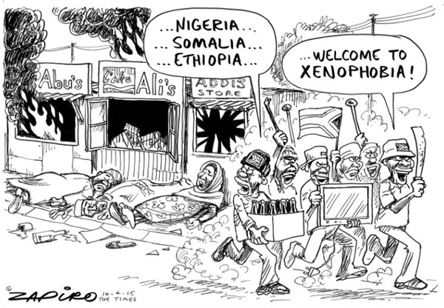
Answer ALL the questions in this section
Question 6: Human Rights [10 MARKS]

Consider the cartoon below:

  - Identify the type of discriminatory behaviour that is taking place in the cartoon. [1]

  - The discriminatory behaviour illustrated in the cartoon demonstrates a violation
of human rights. What impact does such a violation of human rights have on
communities and on South Africa as a whole? [2+2=4]

6.3. Explain how the following rights have been violated; your answer should also reflect an understanding of what the right entails:
a) Right to Equality [2]
b) Right to Freedom and Security [2]

  - Name the court, which protects the supreme law of the land and guarantees the basic rights and freedoms of all persons. [1]

Question 7: Referencing [5 MARKS]
Consider the cartoon below and answer the questions that follow:

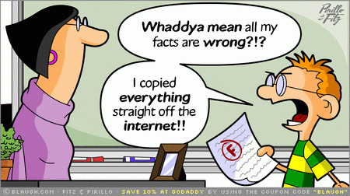

7.1. What was morally wrong with the way the student completed his assignment? [1]

7.2. List TWO consequences of the behaviour identified above. [2]

7.3. Describe TWO ways the student can avoid making the same mistake in future. [2]

Question 8: Gang violence [10 MARKS]
Read the adapted extract and answer the questions that follow:

Does Gang Violence Constitute a Violation of Our Human Rights?
By Newsroom on March 21, 2016news, Voc News
As we celebrate Human Rights Day, South Africans are reminded of the struggles of the past, particularly the 1960 Sharpeville massacre that resulted in the murder of 69 individuals, and pay homage to the heroes who bravely fought for the dismantlement of Apartheid. Human rights are defined as universal values that are integrated in every human being and grants each individual their dignity and enables their development.

How has South Africa fared in terms of international human rights standards?
South Africa, as a country, is party to numerous human rights bodies and conventions that were developed by the African Union (AU) and the UN, which speaks to the notion that human rights are acknowledged to be instrumental to the life of each South African. South Africa is also party to the AU Charter on the Rights and Welfare of a Child (ACRWC) and the UN Convention on the Rights of the Child (UNCRC), both of which were adopted in 1990. These instruments guarantee the right to life, association, movement, and assembly to the South African child.

Professor in international human rights law at the Centre for Human Rights at the University of Pretoria, Michelo Hansungule explained that since the dismantling of the apartheid system, South Africa is considered to be abiding by the basic human rights in comparison to other African countries. However, there remain serious areas of concern, specifically in the area of security.

Closer to home, Cape Town battles it’s most serious challenge – gang violence – which violates the maximum right – the right to life.

Though the right to life is declared protected in the constitution of South Africa and international law that is applicable to South Africa, however in practice, individuals living within gang-infested areas are not guaranteed their right to an adequate quality of life as their rights to free movement and to freely associate are consistently violated.

8.1. How does gang violence violate the rights of children? [2]
8.2. Young children are amongst the most vulnerable when it comes to gang influence and violence. Explain why you think this is the case. [2]
8.3. Consider the following three rights identified in the article:
A Right to Association
A Right to Movement
A Right to Assembly
8.3.1 How does gang violence infringe on these three rights? [3]
8.4. What initiatives would you promote to prevent young children from becoming members of a gang? [3]

SECTION C: ESSAYS 20 MARKS
Remember to only answer TWO out of the three possible essay questions. You must answer each question in an essay format.
Question 9: HIV/AIDS [10 Marks]
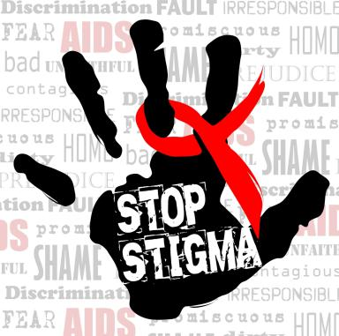

In a well-constructed essay, discuss the impact of stigma on the lives of people living with HIV.
Make sure to cover the following in your essay:
- The impact on an individual’s emotional, psychological, and physical well-being [3]
- Ways to support people living with HIV [4]
- Ways to prevent the stigmatisation of people living with HIV [3]

Question 10: Public Holidays [10 Marks]
Consider the history behind why we celebrate Human Rights Day and Freedom Day in the table below:
21 March: Human Rights Day  During the Apartheid era there were human rights abuses by all sides; Human Rights Day is but one step to ensure that the people of South Africa are aware of their human rights and to ensure that such abuses never again occur. | 27 April: Freedom Day  This was the day in 1994 when the first democratic election was held in South Africa, i.e. an election when all adults could vote irrespective of their race, and the day in 1997 when the new constitution took effect.

Being able to cast a vote in an election is an important human right. In an essay, comment on:
- The importance of voting in a democracy taking into consideration South Africa’s history [3]
- Reasons why citizens of a country may feel apathetic about voting [3]
- How you would encourage people to vote in an election [4]

Question 11: Role Models [10 Marks]
Consider the quotes below:
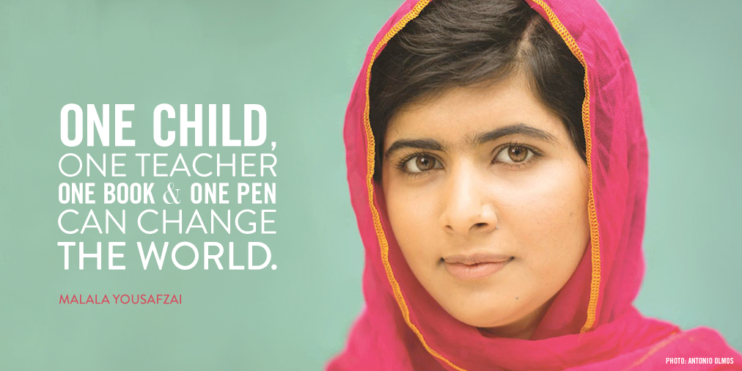
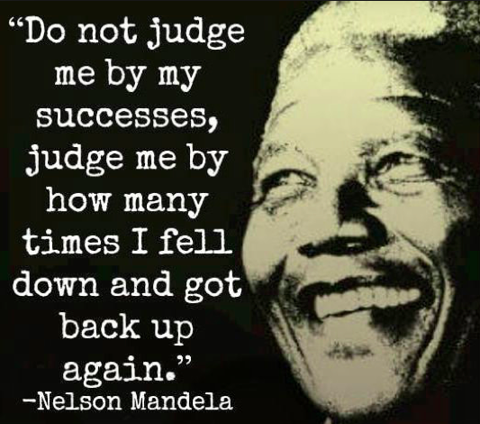

In a modern day and age, role models such as the ones illustrated above are far and few between. People are mostly concerned with adhering to what is considered fashionable, what comments are trending on social media, and choosing rather to emulate the antics of care-free and sometimes reckless celebrities.
In a well-constructed essay, discuss the characteristics of positive role models and the value they add to society. Your essay should include the following:
- A definition of what a positive role model means to you [2]
- A description of 5 qualities positive role models should emulate [5]
- An example of a role model you admire, and how they emulate some of the qualities you described above [3]

MEMORANDUM

SECTION A

Question 1to 5 (1 Mark for each correct answer)

  - D
  - A
  - C
  - B
  - D

2.1. Municipal
2.2. IEC
2.3. Jacob Zuma
2.4. Dictator
2.5. ANC

3.1. C
3.2. D
3.3. B
3.4. E
3.5. A

4.1. Acculturation
4.2. Victimisation
4.3. Reconciliation
4.4. 21
4.5. Discrimination

5.1. F
5.2. F
5.3. T
5.4. T
5.5. F

SECTION B
Question 6
6.1. Xenophobia [1]
6.2. Community:
Already strained resources are extended / people live in fear /Human rights are violated and communities become distrustful of each other [2]

South Africa:
It sets a bad example for the rest of the world, bringing shame onto a country that is known for its cornerstone constitution.
When a country’s citizens are so poorly governed, foreign investors will be less inclined to invest resources into the country [2]

6.3. a) Everyone has the right to equal protection
The state may not unfairly discriminate directly or indirectly against anyone on one or more grounds, including race, gender, sex, pregnancy, marital status, ethnic or social origin, colour, sexual orientation, age, disability, religion, conscience, belief, culture, language and birth. [2]

b) Everyone has the right to freedom and security of the person, which includes the right—
not to be deprived of freedom arbitrarily or without just cause;
not to be detained without trial;
to be free from all forms of violence from either public or private sources;
not to be tortured in any way; and
not to be treated or punished in a cruel, inhuman or degrading way.

Everyone has the right to bodily and psychological integrity, which includes the right—
to make decisions concerning reproduction;
to security in and control over their body; and
not to be subjected to medical or scientific experiments without their informed consent. [2]

  - Constitutional [1]

Question 7
7.1. Plagiarised; stole someone else’s intellectual property; committed fraud [1]
7.2. Could get zero for the assignment and fail a subject; could be noted on his academic record, which may affect his applications for studying or finding a job; could be expelled/blacklisted from an institution [2]
7.3. Paraphrase content into his own words; turn assignments into ‘Turn it In’ programmes to check whether he has adapted content enough; in-text references and clear bibliography; do not copy or paste from Google [2]
Question 8
8.1. Children are forced to grow up in violent neighbourhoods where they are exposed to violence; their right to a childhood and security is violated
Nowhere is safe for young children to play, so they are forced to stay indoors
Children are sometimes prevented from going to school because of gang violence
Children are forced to perform illegal and inappropriate services that place their well-being at risk [2]
8.2. They are easily influenced / not able to physically fight off an attack / easily caught up in the moment / easy to manipulate / gullible
If children come from homes where they are vulnerable to abuse or neglect, the gang might symbolise a family where they feel accepted and protected [2]
8.3.1. Association: Members of the community may be punished/killed for speaking to the police or from associating with the ‘opposition’
Movement: Due to gun violence, people are unable to leave their homes without worrying that they may fall victim to stray bullets as a result of gangs fighting; or that they may be attacked or accosted by gang members
Assembly: Gangs may control certain areas of communities, which prevent people from meeting under safe conditions; gang violence might also prevent community activists who are anti-gangsterism to form petition groups to demonstrate in communities [3]
8.4. Education: talks from recovered gang members to warn young children about the dangers
Opportunity: after-school projects and initiatives to prevent exposure to gangsterism where children are taught to dream and hope
School: Life Skill programmes to equip learners with skills to “say no” and handle conflict in a non-violent way [3]
SECTION C
Question 9
The impact on a victim’s emotional, psychological, and physical well-being : [3]
Emotional
- Lowers their self-esteem
- withdrawal; depression
- Feel ashamed
Psychological
- Fearful
- Negative Self-Concept: feel worthless
- Suicide
Physical
- Might not get tested
- Feel isolated
- Don’t educate themselves about their condition or seek medication

Ways to support people living with HIV [4]
- Help individuals to seek out treatment and to make the necessary lifestyle changes
- Provide them with a support network where they feel affirmed
- Encourage them to develop positive coping strategies
- Learn more about the HIV virus to understand their frame of reference
- Connect them with HIV counsellors should they require therapeutic support
Ways to prevent the stigmatisation of people living with HIV [3]
- Educate individuals about human rights
- Debunk myths related to HIV
- Educate individuals about HIV: it is now categorised as a chronic disease like diabetes for example etc.
- Lead by example when interact with people who are HIV positive

Question 10
- The importance of voting in a democracy taking into consideration South Africa’s history : [3]
Having the right to decide who represents you in government is the cornerstone of every democracy; Apartheid meant that a lot of people couldn’t vote

- Reasons why citizens of a country may feel apathetic about voting [3]
The don’t see immediate change; corruption; more negative stories are reported and people become disillusioned; See foreign countries faring better; don’t believe their vote will make a difference

- How you would encourage people to vote in an election [4]
They don’t really have a right to complain if they didn’t participate in voting
One vote can make a difference
Many people died or were imprisoned during Apartheid fighting for the right to vote
For changes you want to see, you need to actually vote for people who you believe can bring about those changes, instead of leaving it up to somebody else.

Question 11
A definition of what a role model means to you [2]
Basic definition: a person you look up to, who sets an example to be imitated.
Must refer to positive behaviour
A description of 5 qualities positive role models should emulate [5]
Some could include:
- Ability to inspire passion in others
- Compassion and acceptance
- Selflessness
- Clear set of values they live by (not just say)
- Perseverance to overcome obstacles
- Show respect
- Have humility; admit mistakes/weaknesses
- Don’t have a narrow view of things
An example of a role model you admire, and how they emulate some of the qualities you described above [3]
- 1 Mark for identifying a role model
- 2 Marks for describing how they are a positive role model (cannot simply repeat the qualities listed above)
- -1 Mark if do NOT connect their role model to any of the 5 qualities listed before

SPREAD OF COGNITIVE LEVELS – LIFE ORIENTATION
Term 1, 2 EXAM Items , GRADE 9, Cognitive Category (x)
FET Phase L = 40% (28); M = 40% (28); H = 20% (14), CAPS, pg. 26
GRADE 9

Ques. No./  Activity | Cognitive Level  LOW | Cognitive Level  MIDDLE | Cognitive Level  HIGH | Mark Allocation
1 | x |  |  | 5
2 | x |  |  | 5
3 | x |  |  | 5
4 | x |  |  | 5
5 | x |  |  | 5
6.1; | x |  |  | 1
6.2; 6.3; 6.4. |  | x |  | 9
7.1; 7.3 |  | x |  | 3
7.2. | x |  |  | 2
8.1; 8.2; 8.3.1.; 8.4 |  | x |  | 10
ESSAY QUESTION: 3 OPTIONS; CHOOSE 2
9 |  |  | x | 10
10 |  |  | x | 10
11 |  |  | x | 10
TOTAL | 28 | 22 | 20 | 70

