LIFE ORIENTATION
GRADE 12
Career & Career Choices
June 2016
Possible examination questions: Topic – Careers and Career Choices
REMINDER: Paper should include components of each topic covered in Term 1 & 2

SECTION A. (Compulsory)

1.1. Various options are provided as possible answers to the following questions. Choose the correct
answer and write only the letter next to the question number.

    - Your Curriculum Vitae should automatically include

- a list of referees.
- all reference letters and certificates.
- both A and B as well as a copy of your passport.
- none of the above – this information is provided at the interview.

1.1.2. CVs should be presented in the following way:
- Attractive and colourful with pictures to emphasise important areas.
- Black ink on white paper with no frills.
- However suits you, it does not matter what they look like, it matters what they say.
- In a flipfile.

    - The government agency that collects taxes on behalf of the government is.

- SARS
- NPA
- SGB
- SMT

1.1.4. In today’s world of work
- you need a business degree to be a success.
- change and continuous development is important.
- it is who you know and not what you know that gets you a job.
D. both A and B.

1.1.5. Which is not true for informal jobs?
- Informal jobs help to reduce unemployment.
- Most informal jobs are one-person owned or family undertakings.
- Examples of informal jobs are washing cars, gardening and selling fruit at a taxi rank.
- Informal jobs are registered and within government control and taxation.

1.1.6. Non-designated subjects are
- subjects that the universities do not count in their admission points.
- subjects that do not count when working out whether you are calculating whether you have achieved a D-Pass or a B-Pass but do count when you are working out points for tertiary institutions.
- subjects that do not require as much as work as designated subjects.
- none of the above, CAPS has done away with non-designated subjects.

1.1.7. The following is a project that addresses gender discrimination and human rights violations:
- Greenpeace
- Working on Fire
- 16 Days of Activism
- Red Door Initiatives

1.1.8 Local government and municipal councils
- have no power over laws.
- are allowed to draft local laws, known as by-laws.
- are allowed to contradict provincial laws if they are able to justify the contradiction.
- none of the above, there is no such sphere in the government.

1.1.9. The essence of effective communication is based on:
- Effective listening and the ability to express our thoughts clearly.
- Effective listening and responsiveness.
- Effective listening and emotional awareness.
- Effective emotional awareness and responsiveness.

1.1.10 Development which can carry on into the future is called:
- Sustainable development
- Sustainable management
- Environmental development
- Environmental degradation

[10]

Question 1.2: Answer the following questions by writing the answer next to the question number.

  - Define the following terms:

1.2.1 Nepotism (1)
1.2.2 Diploma Pass (1)
1.2.3 Propaganda (1)
1.2.4 Human Dignity (1)

    - List THREE study skills (3x1=3)

1.3 Name the type of pass the following learners achieved:

1.3.1 Sarah:
English 68%
Afrikaans 50%
Life Orientation 27%
Mathematics 72%
Physical Sciences 66%
Consumer Studies 52%
Design 25% (1)

1.3.2 Sipho:
English 48%
Afrikaans 50%
Life Orientation 63%
Mathematical Literacy 72%
Life Sciences 66%
Visual Arts 52%
CAT 75% (1)

1.3.3 Thandi:
English 45%
isiXhosa 57%
Life Orientation 75%
Mathematics 52%
Physical Science 32%
Drama 62%
CAT 30% (1)

[10]

TOTAL SECTION A: 20

SECTION B

Read the image below and answer all of the questions in this section.



2.1.1 Why would a prospective employer be so interested in accessing your Facebook profile? (4)
2.1.2 What should you do to ensure your Facebook profile does not negatively impact your employability? (4)
2.2
2.2.1 Why is there such great competition for jobs in today’s world of work? (3)

2.2.2 Discuss THREE factors that you can do as a school leaver that will ensure that you will be more employable in the world of work today.
(3x2 = 6)

[17]
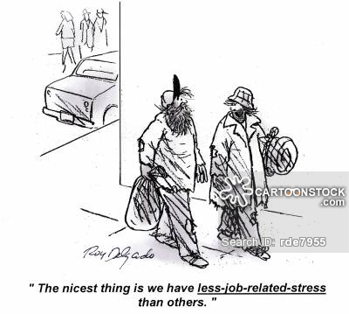
2.3
2.3.1 What is your understanding of the concept: stress (1)
2.3.2 Explain by means of examples, the difference between positive and negative stress. Give. (2x2=4)
2.3.3 Suggest THREE healthy strategies of dealing with stress. (3x2 = 6)
[12]
2.4 Read the following scenario and answer the questions that follow:
Kolani is a 18 year old boy in matric, he has always dreamed of working in the finance field as he believes he will look really good in a powerful black suit. Kolani has approached the school career counsellor to assist him with strategies to ensure he achieves his goals in matric but also in the years after school.

2.4.1 What is the difference between a ‘goal’ and a ‘dream’? (2)
2.4.2 Kolani wants to work in the Finance field. Explain the practical strategies he should use when
applying to achieve his career goals. (10)

[12]

SECTION B: 50

SECTION C

3.1
A husband and wife are arguing. The wife would like to get a job to for their children, a boy and a girl, to go to a private school. The husband says he is the head of the house and will decide about things relating to money. If she gets a job, she must bring the money to him, and he will decide how it is used. The wife is upset and cant understand her husband. However, after a few days the husband agrees the boy should go to private school, but not the daughter. For her, the local community school is good enough.

3.1.1 Would you say that the husband and wife are experiencing interpersonal conflict or intrapersonal conflict? Provide a reason for your choice. (2)

3.1.2 What are the sources of the conflict between the spouses? Name at least THREE sources. (3)
3.1.3 List five steps in resolving interpersonal conflict and explain how the husband and wife can practically implement these steps to resolve their conflict.
Make use of the example from the scenario to illustrate your answer (10)

[15]

3.2
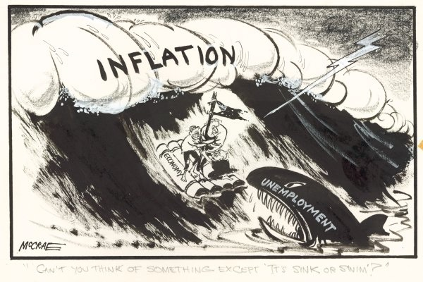
https://www.whitlam.org/__data/assets/image/0009/479052/Economy_cartoon.jpg

3.2.1. Explain why South Africa has such a high unemployment rate? (3)

3.2.2 What impact does the high youth unemployment rate have on the following: (3x2)
A) Economy
B) Infrastructure
C) Health Care
3.2.3. Suggest THREE strategies in which the youth can ensure that they do not become part of the unemployment statistics (3x2)

[15]
3.3. 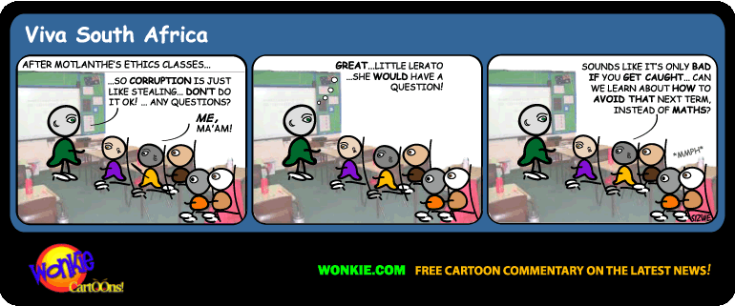

3.3.1. Explain by means of an example your understanding of corruption? (3)

3.3.2. Explain FOUR ways how corruption hampers economic development in a country? (4x2)(8)

3.3.3 Propose TWO ways in which your community can combat corruption (2x2)(4)

[15]

SECTION C: 45

MEMORANDUM
GRADE 12 CAREERS AND CAREER CHOICES (TERM 1&2)

SECTION A

1.1.1. A √
1.1.2. B √
1.1.3. A √
1.1.4. B √
1.1.5. D √
1.1.6. B √
1.1.7. C √
1.1.8. B √
1.1.9. A √
1.1.10. A √
10x1=(10)
[10]

1.2.1. Favouring one person over another for a job because they are family. √
1.2.2. National Senior Certificate with 40% for four designated subjects. √
1.2.3. Ideas or statements that are often false or exaggerated and that are spread in order to help a cause, a political leader, or a government. √
1.2.4. Not being humiliated / respecting other people√
1.2.5. flashcards√
Mind maps√
mnemonics√
summaries√
tables√
(3x1=3)
1.3.1. Fail/no pass√
1.3.2. B-pass√
1.3.3. B-pass√

[10]
SECTION B

- 2.1.1 Employers need to make sure that you are the right person for the job which goes further than just a certification – soft skills as well as values and ethics are essential
- So many people have degrees and certifications but not everybody will fit into the corporate identity of a company
- People skills, work ethic, conflict management is becoming more important in today’s world of work – Facebook could show an employer how strong a candidate is in these areas
- On your CV and during an interview you put forward a certain image, you do not highlight things that you do not want your employer to know
- Facebook gives the employer insight into who you really are
- Or any other response for ONE mark.
4x1 (4)

- 2.1.2 Make sure that your security settings are high
- Be careful about what you say – never ever insult somebody or discuss conflict
- Do not complain about your job
- Be careful about the links you connect to your status – employers will try to work out the kind of person you are through your interests
- Be careful about the photos that you download
- Any other relevant response for ONE mark.
4x1= (4)

2.2
- 2.2.1 There are far more people getting further education and training
- Globalisation – making the world far smaller and far more competitive
- Technology – makes the demand greater, things work fast and you have to keep up with the pace. If you don’t, someone else will
3x1 = (3)

- 2.2.2 Ensure marks are of a high standard
- This will allow you to be above the competition – there are many people achieving Grade 12 and going to study further

- Holiday work and work experience
- Allows prospective employer to see that you have practical ability and not just knowledge

- Achieving a qualification from a reputable institution
- Institutions that do not have a reputation will not have been heard of by prospective employers, therefore they will not trust the qualification
3x2 = (6)
[17]

- 2.3.1 Stress is a condition or feeling experienced when a person perceives that demands exceed the personal and social resources that the person has √
(1)

- 2.3.2 Eustress: a positive form of stress that helps us to perform and is usually experienced when we go through happy events e.g.
- graduation, sports matches.
- Distress: a negative form of stress usually experienced when we go through bad events e.g.
- death, divorce.
2x2 = (4)

- 2.3.3 (1)Exercise
- It helps to balance out the adrenaline pumped into your system during times of stress.
- It causes your body to release endorphins.
- It relaxes tense muscles.
- It helps you to sleep.
- (2) Be aware of your breathing
- Breathing exercises release tension from the body and clear the mind, improving both physical and mental wellness.
- We tend to breathe shallowly or even hold our hold our breath when we are feeling anxious. Sometimes we are not even aware of it.
- Shallow breathing limits your oxygen intake and adds further stress to your body, creating a vicious cycle.
- Breathing exercises can break this cycle.
- (3) Healthy diet
- Regular water intake helps circulate and break down food
- Keeps you hydrated
- Assist with joint lubrication
- OTHER coping mechanisms – laughter, sleeping
- Other relevant strategy ONE mark and explained TWO marks.
3x2 = (6)
[12]

- 2.4.1 Dream – could be a fantasy, it is a goal without a deadline or steps as to how the dream will be achieved.
- Goal – has actual steps in place, it considers obstacles or challengers and how to overcome them, it also has a set timeline and deadline.
2x1 = (2)

- 2.4.2 Identify future career goals – type of career or work (financial field accountant)
- Applied at HEIs (Higher education institutes) or place of work
- Applied for funding
- Done or will do work shadowing or volunteer work
- Live a balanced lifestyle/manage time/eat healthy/sleep enough/regular exercise
- Make time for physical activity and recreation
- Make a plan to pass NSC as well as possible (in Kolanis’ case he needs a B-pass)
- Draw up and follow a study timetable
- Started already with preparations for end-of-year exam/apply study skills
10x1 = (10)

[12]

SECTION C
3.1.1. Interpersonal conflict. √
- It is conflict between people, in this case between husband and wife.
(2x1)
(Award ONE mark for the correct type of conflict √ and ONE mark if it is explained correctly √ If the type of conflict is incorrect, NO marks are awarded for the explanation, even if it seems correct.)

3.1.2 The wife wants to get a job.
- The husband is very autocratic (seeing himself as the head of the house)
- The husband will control the family’s finances
- Only the boy is allowed to go to private school.
3x1 = (3)

3.1.3
- Step !: Listen to the other person’s side of the story until you are able to understand it. (The husband needs to give his wife the chance to explain why she feels private schooling will benefit their children in the long run – smaller classes, individual attention) √
- Step 2: Clarify what the disagreement is about and state the problem. (The wife needs to explain why she feels private schooling will benefit there kids considering the current unemployment rate, and her getting a job is not for her own benefit but more for their kids) √
- Step 3: Brainstorm and list all the possible solutions without assessing them. ( the parents need to sit down and write down what possible solutions to their problem, so why does the husband want to control all the money, why can the son attend private school not the daughter) √
- Step 4: Select solutions that is acceptable to both of you. Agree on who will do what. (even though the husband has agreed the son can attend private school, it still disadvantages the daughter thus
- they need to find a solution so that the daughter can also attend , possible address their budget) √
- Step 5: Implement the solution and evaluate the results. (after 6months or less they should sit down with their children to establish if the added expense has helped them, this should be done every term) √
Credit the learner with ONE mark per practical and relevant implementation of information from the scenario.
[15]

- 3.2.1 Poor education – mismatch between skills and labour
- Breakdown of apprenticeship system
- Minimum wage – difficult for employer and employee to negotiate a fair rate that suits both parties
- People live far from work – spend majority of wages on travel costs
- Cycle of poverty – you born into poverty thus near impossible to make a success.
3x1 = (3)

3.2.2
Economy: Lack of jobs results in more being depended on the state for grants (state funds) √
thus where monies could have been spent on other services like building schools, improving roads, more homes etc the monies are now needed to “fee” people as the state grant is the only means of income. √
Students who are qualified feel they ae entitled to top jobs with high salaries direct from varsity. √ thus many refuse to start at the bottom or rather resign from companies – instead of contributing to countries economy or paying of tax. √
Infrastructure: as frustration of job shortage increase and people unable to feed family, some may resort to violent protest action to get media and government attention. √ robots and buildings are often damaged, thus state now needs to repair it, monies not from budget thus the repair monies could have gone for other essentials in the country. √
Health care: more people not employed in poor areas. Often over crowded. √ these people are thus more likely to contract illnesses or need medication, this puts more pressure on state to provide free good quality health care. √
Any relevant response and well explained TWO marks.

3x2 (6)

- 3.2.2. Volunteering
- You can volunteer to feed the homeless in a soup kitchen. You will learn cooking skills and also be able to network, and will learn to work in a team √
- Part-time jobs
- You could work as a waiter during the busy holiday times when restaurants need more staff √
- Community work
- You could volunteer to be a safety officer at a school in your area √
- Entrepreneurship
- You can start a small business, for example, selling coffee and vetkoek at pension payout points where a lot of people will be queuing and the will be hungry and thirsty
- Informal jobs
- You can wash cars, do gardening, sell newspapers, babysit, make clothes, or sell fruit or sweets at a
- Taxi rank or next to the school
- (ONE mark allocated for solution and ONE mark for valid example)
3x2 = (6)
[15]

- 3.3.1. Corruption is the misuse of public power (by elected politician or appointed civil servant) for private gain.
- Corruption is the misuse of entrusted power (by heritage, education, marriage, election, appointment or whatever else) for private gain.
- Public money used for private gain – Example Nkandla, tax money used to build private home
3x1 = (3)

- 3.3.2. High prices to consumers
When entrepreneurs and businessmen are required to pay bribes before necessary permits are issued, they tend to view it as a cost of doing business and therefore pass that cost onto consumers (that is you and me) who suffer from high prices
- Reduced investment leads to reduced goods and services and inflation
In extreme cases, the extortion of bribes from entrepreneurs can be seen as a tax which can reduce the incentive to invest. Foreign entrepreneurs for example will shy away from corrupt countries because they claim the cost of doing business is too high when one factors in the bribes
- Reduced commitments from donor agencies
Corruption reduces the effectiveness of aid flows through the diversion of funds from their intended projects 4) Reduced tax revenues
Corruption also brings about loss of tax revenue when it takes the form of tax evasion or the improper use of discretionary tax exemptions.
- Inferior public infrastructure
The allocation of public procurement contracts through a corrupt system leads to inferior public infrastructure and services. For example corrupt bureaucrats might allow the use of cheap sub-standard materials in the construction of buildings or bridges.
- Poor maintenance of public infrastructure
Because of corruption, maintenance and repairs always takes a back seat to new projects. For fear of being exposed, corrupt officials prefer to approve new projects rather than spend to revamp the old corrupt projects they approved in the first place.
4x2 = (8)

- 3.3.3 The first tool is ‘education’. Those who are uneducated do not know about the process, provisions and procedures through which they can get justice. Corrupt public servants try to make fool of them and often demands for bribe. It is due to unawareness in the field of law, public rights and procedures thereof that a common and an uneducated suffer out of the corrupt society.
- Enforce accountability and transparency from government – government officials should make public spending more accessible.
2x2 = (4) [15]

