GRADE 12. DSS Term 1&2 (2016)
BANK OF QUESTIONS
By Gunter Hessler

Possible examination questions: Topic – Development of Self in Society
REMINDER: Paper should include components of each topic covered in Term 1 & 2
Note to teacher: Please ensure that your selection of questions is of such a nature that your question paper satisfies the requirements regarding Bloom’s taxonomy.

SECTION A (Compulsory)

Answer ALL the questions.

QUESTION 1: Multiple Choice

Various options are provided as answers to the following multiple-choice questions. Write down only the letter (A-D) of the most appropriate answer next to the relevant question number (1.1 -1.6) on the answer page, for example 1.7D.

1.1. Which definition best applies to eustress?

A a negative response you have to a stressor, which can depend on your current feelings of control, desirability, location and timing of the stressor.

B a stress that is objectively measured through, among other indicators, blood pressure rate, muscle tension and absenteeism rates.

C the stress that has a beneficial effect, being either psychological, physical or biochemical.

D persistent stress that is not resolved through coping or adaptation.

1.2 Which of the following is an example of eustress:

A the death of a family member.

B sleep problems.

C conflict in personal relationships.

D receiving a promotion or raise at work.

1.3 Which type of institution of higher learning is the most accessible to learners?

A Traditional Universities.

B Technical and Vocational Education and Training (TVET) institutions.

C Universities of Technology.

D Comprehensive Universities.

1.4 Which of the following Higher Education and Training directions has the most potential for addressing the huge skills shortage of South Africa’s youth?

A courses leading to bachelor degrees

B post graduate degrees

C technical or vocational training

D accountancy certificates.

1.5 Goal setting as a physical fitness skill is best described as the ability to:

A remember what to eat so that you have the energy to complete your routine.

B imagine how you will feel and how this fitness will change your life.

C stay motivated and want to do the training for yourself.

D surround yourself with friends who motivate and support you.

1.6 The reason why you should always be assertive is …

A because it is always going to be better for you and your relationship with the other person.

B because it allows you to say ‘yes’ to requests when you actually want to say ’no’.

C because it enables passing off the manipulation of others as meeting their wishes and desires.

D because it fails to consider the views or feelings of others.

[6 x 1 = 6]

Question 2: True or False
Please read the following statements and indicate whether they are TRUE or FALSE. Please indicate your answer with the words “True” or “False” and you must justify (explain) your answers if the statement is false.

2.1 The majority of young people in South Africa enroll in post-school education.
2.2 Umalusi is the new central application system for universities and Universities of Technology.
2.3 Say whether the following are effective conflict resolution strategies:
2.3.1 react calmly, non-defensively and respectfully.
2.3.2 act with the understanding that conflict is neither bad, wrong or a sign of failure.
2.3.3 don’t speak directly to the person with whom you are having a conflict but involve a third person.
[8]

Question 3: Short Answer

Answer the following questions by writing the answer next to the question number.

3.1 Explain the following:
3.1.1 coping mechanisms
3.1.2 stress management strategy (2 x 2 =4)
3.2 The symptoms of long-term stress show themselves in three ways, namely in physical ailments, negative emotions and behavioral problems.
3.2.1 Give an example of a physical symptom.
3.2.1 Give an example of a behavioral problem. (2 x 1=2 )
[4]

TOTAL FOR SECTION A - 20 marks

SECTION B

Question 4:
Answer the following questions in this section. Write your answers in full sentences.
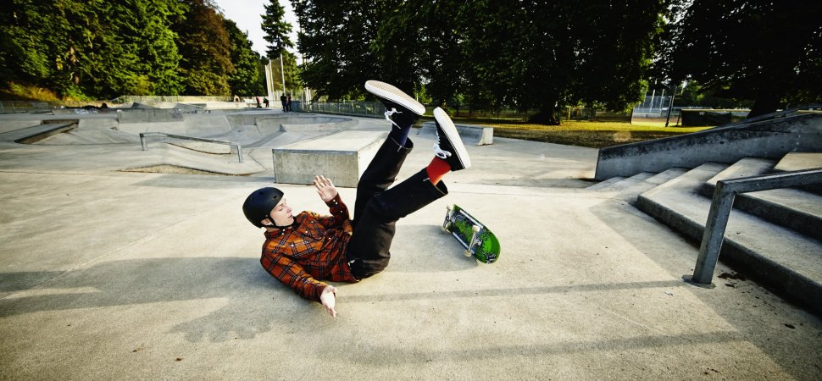
Your knee-jerk answer is probably something to do with your circumstances -- the time is not right. Sometimes that really is the answer. But often it's not. Often the real answer -- and I say this as someone who has totally been there -- is that you're afraid of failure. If you try and then fall flat on your face. if you give it your best and your best isn't good enough?
Surprisingly, this is a question that science can actually help answer. And happily, what psychologists have to say on the subject might give you a little more courage to chase your dreams. According to new research, you'd probably handle failure and embarrassment way better than you think you would. So why not just got for it?
To come to this conclusion, a team of Dutch researchers told study subjects they were going to complete a series of tests in pairs, informing them that if they scored above a certain level, each pair would earn rewards. Half of the participants then predicted how bad they'd feel if they failed. The other half actually took the tests and, whatever their actual performance, were told that they were personally responsible for their team's failure to earn the reward. How bad did they really feel, the researchers then asked them.
How good were the participants at guessing how bad failure would make them feel? In short, pretty terrible. Imagined failure apparently feels way worse than real-life failure.
"Forecasters overestimated how much guilt and shame they thought they would experience (as compared with the actual emotions reported by the experiencers)--this is a classic example of the intensity bias," notes the British Psychological Society Research Digest blog. What's the intensity bias? "A recurring finding in psychology is that people tend to overestimate the strength of their future emotions.
It's also worth pointing out a separate but relevant line of psychological research here. While science shows that we overestimate how much future failure will sting, research also proves that we underestimate how much we'll regret not doing something. Inaction seems safer in the moment, but in the long run it's what really bums us out, science shows.dreams today? [Jessica Stillman – Science: You’re better at getting over failure than you think. www.inc.com]
1. In the research study by the Dutch researchers the subjects were grouped into pairs. In your own words describe what each of the pair was asked to do. (3)
2. In your own words explain what ‘intensity bias’ is. (2)
3. What surprising conclusion did the scientific study reach? (2)
4. What strategies could you advise someone to use to deal with getting over failure? (2x2 = 4) [11]

Question 5:

Read the scenario:

Please answer the following questions in full sentences.

Happiness: Everyone wants it, yet relatively few seem to get enough of it. Good news and bad news: Unfortunately, approximately 50 percent of your happiness is determined by personality traits that are largely hereditary. Half of how happy you feel is basically outside your control.
Bummer.
But, that means 50 percent of your level of happiness is totally within your control: relationships, health, career, etc. So even if you're genetically disposed to be somewhat gloomy, you can still do things to make yourself a lot happier.

Like this:
1. Make good friends.
But there's a definite payoff to making real (not just professional or social media) friends. Increasing your number of friends correlates to higher subjective well being; doubling your number of friends is like increasing your income by 50 percent in terms of how happy you feel. Make real friends. You'll live a happier life.

2. Actively express thankfulness.
An easy method is to write down a few things you are grateful for every night. One study showed people who wrote down five things they were thankful for once a week were 25 percent happier after 10 weeks; ...

3. Actively pursue your goals.
Goals you don't pursue aren't goals, they're dreams, and dreams make you happy only when you're dreaming.
Pursuing goals, though, does make you happy.

4. Do what you excel at as often as you can.

5. Give.
While giving is usually considered unselfish, giving can also be more beneficial for the giver than the receiver.

6. Don't single-mindedly chase "stuff."
Money is important. Money does a lot of things. But after a certain point, money doesn't make people happier. After about R1,125,000 a year, money doesn't buy more (or less) happiness. "Perhaps R1,125,000 is the threshold beyond which further increases in income no longer improve individuals' ability to do what matters most to their emotional well-being, such as spending time with people they like, avoiding pain and disease, and enjoying leisure. Conclusion - don't chase as many things. Chase a few experiences instead.

7. Live the life you want to live.
Your hopes, your dreams, your goals--live your life your way. Surround yourself with people who support and care not for the "you" they want you to be but for the real you.

1. In his opening paragraph the writer demonstrates the principle underlying the topic he is going to explore. What do you think that principle is? (2)
2. What does the writer mean by ‘real friends’? (2)
3. Identify at least four other sources of happiness the author demonstrates in the remaining six factors. (4)
4. Under factor 6. (Don’t single-mindedly chase "stuff.") the author defines human well-being by giving three examples.
4.1 Do you agree/not agree with his examples and explain why. (3)
4.2 Provide a further example of human well-being and argue why it should be considered. (2)
[13]

Question 6:
Please read the questions that follow and answer in full sentences.

Adding the environmental dimension into your Lifestyle Plan.

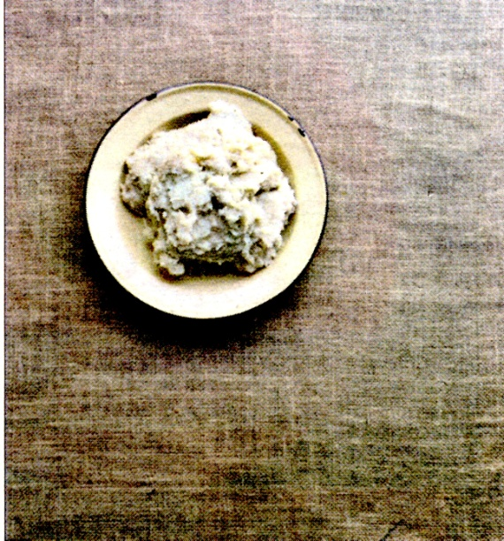
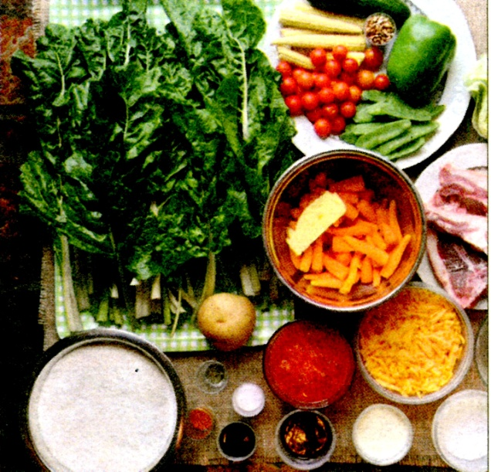
Images juxtapose (right) what an average family of five in Zwaziland have for dinner with what an average family of four in the Free State have. These photographs were captured by the Oranjezicht-based photographer, Eric Miller.

The images above were taken from the book, The Hungry Season: Feeding Southern Africa's Cities, for which he worked with journalist, Leonie Joubert. They traversed Southern Africa, visiting areas as far afield as Atlantis, the Eastern Cape, Durban, Maseru, Pretoria and Swaziland, in the hopes of answering the question: "In Southern Africa we produce enough calories and nutrients to have everyone in the region fully nourished, and yet we still have such high levels of hunger and malnutrition?"
Some eye-opening moments: says Leonie Joubert: "In Swaziland we saw the bowl of pap a family of five had as their food for the entire week. That was one of the things I will never forget."
Offering up some tips, Mr Miller adds: "Know where your food comes from and support people and organisations trying to create a better food system. Support organisations like Harvest of Hope and Ethical Co-op. Where possible, find ways of speaking out against large companies who profit from selling unhealthy food which they are targetting at children".
"By and large diets which are better for the environment are also healthier for you. Cut down on meat consumption, eat less processed food and up your intake of fresh vegetables and fruits. On average a family wastes up to one third of all the food they buy. Imagine if we didn't do that. Not only could you slash your monthly food bill by 30%, but the environmental footprint of your diet would also come down by 30%." 30%."

1. The extract raises questions about ‘why you should know where your food comes from’. How important do you think this question is to photographer Eric Miller? (2)
2. Evaluate the statement “if (they) didn’t …waste one third of all the food they buy… the environmental footprint of (their) diet would also come down by 30%(last paragraph).
2.1 Under what circumstances might this become true? (2)
2.2 Offer an example of your own how you could contribute to reducing our environmental footprint. (2)
[6]

TOTAL FOR SECTION B - 30 marks

SECTION C

Answer ANY TWO questions from this section.

QUESTION 7: Building Relationships
Humans are social beings. We enjoy being understood and accepted; feeling that we belong. Maybe that’s why our friends, family and romantic partners are so important to us.


Unfortunately, Western culture values individual achievement over personal relationships. We’re good at finding career success but less successful at connecting with other people. As a result, our relationships often suffer. One of our tasks a as adults is to build and sustain a solid long-term relationship with a partner.

Write an essay on building and sustaining relationships in which you do the following:

1. Give THREE characteristics of a strong relationship (3)
2. Discuss briefly the importance of effective communication in a relationship (6)
3. Outline the values and principles that are needed to build a long-term relationship. (6)
[15]

Question 8: Conflict Resolution


Conflicts are a normal part of any healthy relationship. Everyone needs to build the skills that are needed to turn conflicts into opportunities. In this essay develop your conflict resolution skills by answering the following questions:
1. How do you perceive conflict? Give three unhealthy responses to conflict and three healthy responses to conflict. (6)
2. Why is stress so dangerous in conflict situations? (3)
3. Briefly discuss the value of emotional awareness. (6)
[15]

Question 9: Stress Management

Stress management is an art every person needs to master for themselves, but having mastered it, it is as easy as pie to explain to others – but others don’t want to be taught until they have mastered it for themselves – how strange!
Write an essay on stress management in which you do the following:

1. How to raise your self-esteem by using positive self-talk. (5)
2. How to handle the moment of stress by using emergency stress-stoppers. (5)
3. Suggest or recommend relaxation exercises and use finding pleasure routines to reduce stress. (5)
[15]

Question 10: Personal Lifestyle Plan

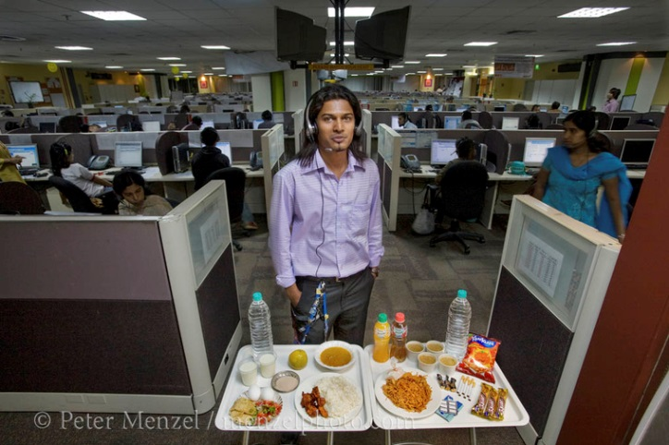
“If you are wrong, quickly admit it and take responsibility. You could say, “You’re absolutely right, it is my fault and here is what I’ll do to fix it.” Even if you’re NOT wrong, at least give them the benefit of the doubt, “I may be wrong, let’s look at the facts together.” It’s hard to argue with that!”

How would you go about developing your personal lifestyle plan?

Include the following aspects:

1. What will your relationship with work look like? (4)

2. How will you handle diet and fitness? (7)

3. How will you ensure that you are successful? (4)

[15]

TOTAL FOR SECTION C - 30 marks

[TOTAL: 80marks]

GRADE .12. DSS Term 1&2 (2016)
BANK OF QUESTIONS
By Gunter Hessler

MEMORANDUM

Blooms Levels: |  | Level 1: Remembering = LOW  Level 2: Understanding = LOW | Level 3: Applying = MIDDLE  Level 4: Analyzing = MIDDLE | Level 5: Evaluating = HIGH  Level 6: Creating = HIGH
Question No / Activity | Mark allocation | Cognitive level Low | Cognitive level Middle | Cognitive level High
Section A/B/C | Gr12 DSS Jun 16 | 30% | 40% | 30%
1.1 | 1 |  |  | 5
1.2 | 1 | 2
1.3 | 1 |  | 4
1.4 | 1 |  | 4
1.5 | 1 |  |  | 5
1.6 | 1 | 1
 | [6]
Question 2
2.1 | 2 |  |  | 5
2.2 | 2 |  |  | 5
2.3.1 | 1 | 2
2.3.2 | 1 | 2
2.3.3 | 2 |  | 3
 | [8]
Question 3
3.1.1 | 2 | 2
3.1.2 | 2 |  | 4
3.2.1 | 1 | 2
3.2.2 | 1 | 2
 | [6]=[20]
4.1 | 3 | 2
4.2 | 2 |  | 4
4.3 | 2 | 1 | 3
4.1.1 | 1 | 2
4.1.2 | 1 |  | 3
4.5 | 2 | 2
 | [11]
5.1. | 2 |  | 3
5.2. | 2 | 2
5.3. | 4 | 2
5.4.1 | 3 |  | 4
5.4.2 | 2 |  |  | 6
 | [13]
6.1 | 2 |  |  | 5
6.2.1 | 2 |  |  | 5
6.2.2 | 2 |  |  | 5
 | [6 = 30]
7.1 | 3 | 1
7.2 | 6 |  | 3
7.3 | 6 |  | 4
 | [15]
8.1 | 6 |  | 4
8.2 | 3 |  | 3
8.3 | 6 | 2
 | [15]
9.1 | 5 |  | 3
9.2 | 5 |  | 4
9.3 | 5 |  | 4
 | [15]
10.1 | 4 |  |  | 6
10.2 | 7 |  | 3
10.3 | 4 |  |  | 5
 | [15 = 30]
 | 110
TOTAL: | 80(90) | 16 | 20 | 11
Q on page= | 42 | 31% | 38% | 21%

SECTION A – 20 Marks

Question 1 | Multiple choice
1.1 | C | 
1.2 | D | 
1.3 | B | 
1.4 | C | 
1.5 | C | 
1.6 | A | 
 |  | [6]
Question 2 | True/False | Explanation
2.1 | F  | Learners in Post-school education have a low success rate,it is expensive, and many learners try for university courses even though many overrate their potential to succeed at such theoretical levels, neglect the vocational/apprenticeship fields, lose heart, any other suitable point 
2.2 | F  | Umalusi is responsible for verifying matric results OR a central application system for universities and Universities of Technology is required but has not been in place yet . 
2.3.1 | T 
2.3.2 | T 
2.3.3 | F  | Triangulation is a very poor conflict resolution attempt. 
 |  | [8]
Question 3 | Short Answer
1 |  | Coping mechanisms refer to your efforts to manage stress.(2)
2 |  | A stress management strategy is a plan of action to manage stressors in your life(2)
3 |  | Physical ailments: ulcers, cancer, high blood pressure, headaches, stomach cramps.(1)
4 |  | Behavioural problems: sleep difficulties, eating disorders, social withdrawal, absenteeism, substance abuse.(1)
 |  | [6]

SECTION B [30marks]
Question 4 | Case studies | Mark
1 | The one partner was asked to predict how bad they would feel if they failed;   the other person would write that test, and irrespective of their performance, would be told they had failed.   They were then asked to rate how bad they felt.  | 3
2 | Intensity bias is a tendency by people to overestimate the strength of future emotions.  | 2
3 | -that fear of failure was far more inhibiting than actual failure  | 2
4 | ) Wake up at least 1 hour before you have to be at a computer screen. E-mail is the mind killer.  ) Make a cup of tea (I like pu-erh) and sit down with a pen/pencil and paper.  ) Write down the 3-5 things — and no more — that are making you most anxious or uncomfortable. They’re often things that have been punted from one day’s to-do list to the next, to the next, to the next, and so on. Most important usually = most uncomfortable, with some chance of rejection or conflict.  ) For each item, ask yourself:  – “If this were the only thing I accomplished today, would I be satisfied with my day?”  – “Will moving this forward make all the other to-do’s unimportant or easier to knock off later?”  ) Look only at the items you’ve answered “yes” to for at least one of these questions.  ) Block out at 2-3 hours to focus on ONE of them for today. Let the rest of the urgent but less important stuff slide. It will still be there tomorrow.  7) TO BE CLEAR: Block out at 2-3 HOURS to focus on ONE of them for today. This is ONE BLOCK OF TIME. Cobbling together 10 minutes here and there to add up to 20 minutes does not work.  ) If you get distracted or start procrastinating, don’t freak out and downward spiral; just gently come back to your ONE to-do.  This certainly isn’t an exhaustive list of ways to overcome a fear of failure, but these three strategies – Face It, Externalize It, Ignore It – are a great place to start..  (Any other suitable strategy) | 4
Total |  | [11]
Question 5
1 | That people tend to focus on that which they do not have instead of what they do have: in the opening paragraph he moves from the 50% of happiness that is pre-programmed by our genes and instead concentrates on the 50% we can influence.  | 2
2 | make friendships with people you want to physically/socially want to spend time with.   | 2
3 | –expressing gratitude you feel to the people that make you happy to be alive,   Actively pursue goals and measure your incremental progress towards them,   Do what you are good at, often and well,   Give – without expecting reward   Don’t chase money for its own sake, but for what it will enable you to do   Stay in touch with yourself and work at your valued goals.  (Any 4) | 4
 | The author lists these as: emotional well-being, as avoiding pain and disease, and enjoying leasure. Accept any opinion and the reason must be argued.   | 3
 | The candidate must supply an example (health, etc) and must give a reason why it should be included  | 2
Total |  | [13]
Question 6
1 | Very important as he spent a year researching this question for his book.  | 2
2 | If people share the same diet across the world as they are increasingly coming to do, then changing diet or wastage ratios over a global effect.   | 2
3 | -using food that contributes less carbon to the atmosphere eg. Cutting out Beef, etc, walking instead of using a car; using public transport, Any other relevant point.  | 2
Total |  | [6]

SECTION C: ESSAY

 | Question 7: In this essay consider the following relationship building blocks:
1. | Give the characteristics of a strong relationship | 5
 | Some life coaches give 7 as essential: honesty, respect, love, passion, communication, friendship and understanding. (Any 5) 
2. | Give the characteristics of what a faltering relationship looks like | 5
 | Among others: not listening, losing trust, not honest about one’s wants, no longer giving, not letting go of the need to be right, being self-centered. (Any 5) 
3. | Outline the values and principles that are needed to build a long-term relationship. | 5

Being open in expressing wishes, thoughts and feelings and encouraging others to do likewise. 

Listening to the views of others and responding appropriately, whether in agreement with those views or not. 

Accepting responsibilities and being able to delegate to others. 

Regularly expressing appreciation of others for what they have done or are doing. 

Being able to admit to mistakes and apologise. 

Maintaining self-control. 

Behaving as an equal to others.. (Any 5) 
 | Total; | [15]
 | Question 8: In this essay develop your conflict resolution skills with a discussion on these three aspects:
1. | How do you perceive conflict? Give three unhealthy responses to conflict and three healthy responses to conflict. | 6
Unhealthy responses to conflict:
An inability to recognize and respond to the things that matter to the other person
Explosive, angry, hurtful, and resentful reactions
The withdrawal of love,  resulting in rejection, isolation, shaming, and fear of abandonment
An inability to compromise or see the other person’s side
The fear and avoidance of conflict; the expectation of bad outcomes  (Any 3) 

Healthy responses to conflict
The capacity to recognize and respond to the things that matter to the other person
Calm, non-defensive, and respectful reactions
A readiness to forgive and forget, and to move past the conflict without holding resentments or anger
The ability to seek compromise and avoid punishing
A belief that facing conflict head on is the best thing for both sides. (Any 6)
2. | Why is stress so dangerous in conflict situations? | 3
 | Conflict triggers strong emotions and can lead to hurt feelings, disappointment, and discomfort.  When handled in an unhealthy manner, it can cause irreparable rifts, resentments, and break-ups.  But when conflict is resolved in a healthy way, it increases our understanding of one another, builds trust, and strengthens our relationship bonds. 
3. | How can one manage emotion in conflict situations? | 6

Emotional awareness—the consciousness of your moment-to-moment emotional experience—and the ability to manage all of your feelings appropriately is the basis of a communication process that can resolve conflict. 

Emotional awareness helps you:

Understand what is really troubling other people

Understand yourself, including what is really troubling you

Stay motivated until the conflict is resolved

Communicate clearly and effectively

Attract and influence others  (Any 6)
 | Total | [15]
 | Question 9: In this essay give three ways of dealing with stress management:
1. | How to raise your self-esteem by using positive self-talk. | 5
Self-talk is one way to deal with stress. We all talk to ourselves; sometimes we talk out loud but usually we keep self-talk in our heads.  Self-talk can be positive ("I can do this" or "Things will work out") or negative ("I'll never get well" or "I'm so stupid").
Negative self-talk increases stress.  Positive self-talk helps you calm down and control stress. With practice, you can learn to turn negative thoughts into positive ones.  For example:

Negative Positive
"I can't do this." "I'll do the best I can."
"Everything is going wrong." "I can handle things if I take one step at a time."
"I hate it when this happens." "I know how to deal with this; I've done it before."

To help you feel better, practice positive self-talk every day — in the car, at your desk, before you go to bed or whenever you notice negative thoughts. 
Having trouble getting started? Try positive statements such as these:
"I've got this."/ "I can get help if I need it." 
Positive self-talk helps you relieve stress and deal with the situations that cause you stress. (Any 5)
2. | How to handle the moment of stress by using emergency stress-stoppers. | 5

There are many stressful situations — at work, at home, on the road and in public places. We may feel stress because of poor communication, too much work and everyday hassles like standing in line. Emergency stress stoppers help you deal with stress on the spot. 

You may need different stress stoppers for different situations and sometimes it helps to combine them. 

Count to 10 before you speak. 

Take three to five deep breaths. 

Walk away from the stressful situation, and say you'll handle it later. 

Go for a walk. 

Don't be afraid to say "I'm sorry" if you make a mistake. 

Set your watch five to 10 minutes ahead to avoid the stress of being late. 

Break down big problems into smaller parts. For example, answer one letter or phone call per day, instead of dealing with everything at once. 

Drive in the slow lane or avoid busy roads to help you stay calm while driving. 

Smell a rose, hug a loved one or smile at your neighbour. 

Consider meditation or prayer to break the negative cycle.  (Any 5) 
3. | How to use relaxation exercises and finding pleasure to reduce stress. | 5

Relaxation is more than sitting in your favourite chair watching TV. To relieve stress, relaxation should calm the tension in your mind and body. Some good forms of relaxation are yoga, tai chi (a series of slow, graceful movements) and meditation. 

Like most skills, relaxation takes practice. Many people join a class to learn and practice relaxation skills. 

Deep breathing is a form of relaxation you can learn and practice at home using the following steps. It's a good skill to practice as you start or end your day. With daily practice, you will soon be able to use this skill whenever you feel stress. 

Sit in a comfortable position with your feet on the floor and your hands in your lap or lie down. Close your eyes. 

Picture yourself in a peaceful place. Perhaps you're lying on the beach, walking in the mountains or floating in the clouds. Hold this scene in your mind.

Inhale and exhale. Focus on breathing slowly and deeply.

Continue to breathe slowly for 10 minutes or more.

Try to take at least five to 10 minutes every day for deep breathing or another form of relaxation. 

Or

When stress makes you feel bad, do something that makes you feel good. Doing things you enjoy is a natural way to fight off stress. 

You don't have to do a lot to find pleasure. Even if you're ill or down, you can find pleasure in simple things such as going for a drive, chatting with a friend or reading a good book. 

Try to do at least one thing every day that you enjoy, even if you only do it for 15 minutes. 

Such as:

Start an art project (oil paint, sketch, create a scrap book or finger paint with grandchildren).

Take up a hobby, new or old. 

Read a favourite book, short story, magazine or newspaper.

Have coffee or a meal with friends.

Play golf, tennis, ping-pong or bowl.

Sew, knit or crochet.

Listen to music during or after you practice relaxation.

Take a nature walk — listen to the birds, identify trees and flowers.

Make a list of everything you still want to do in life. 

Watch an old movie on TV or rent a video.

Take a class at your local college.

Play cards or board games with family and friends. 

(At least I point from the other group for the full 5 marks – Any 5)
 | Total | [15]
 | Question 10: How would you go about developing you personal lifestyle plan?
1. | What will your relationship with work look like? | 4
- also share a number of habits:
- don't create back-up plans. 
Back-up plans can help you sleep easier at night. Back-up plans can also create an easy out when times get tough.
You'll work a lot harder and a lot longer if your primary plan simply has to work because there is no other option. Total commitment--without a safety net--will spur you to work harder than you ever imagined possible.
If somehow the worst does happen (and the "worst" is never as bad as you think) trust that you will find a way to rebound. As long as you keep working hard and keep learning from your mistakes, you always will. 
- do the work... 
You can be good with a little effort. You can be really good with a little more effort.
But you can't be great--at anything--unless you put in an incredible amount of focused effort.
Scratch the surface of any person with rare skills and you'll find a person who has put thousands of hours of effort into developing those skills.
There are no shortcuts. There are no overnight successes.  Everyone has heard about the 10,000 hours principle but no one follows it... except remarkably successful people.
So start doing the work now. Time is wasting.
. ...and - work a lot more. 
Every extremely successful entrepreneur I know (personally) works more hours than the average person--a lot more. - have long lists of things - want to get done. So - have to put in lots of time.
Better yet, - want to put in lots of time. 
If you don't embrace a workload others would consider crazy then your goal doesn't mean that much to you--or it's not particularly difficult to achieve. Either way you won't be remarkably successful. (Any 4)
2. | How will you handle diet and fitness? | 7

"The correct diet is not about counting calories but finding balance." 

You need a holistic approach to health with greater emphasis on nutrition. Don’t confuse fitness goals with poor eating habits. 

You don’t need custom diet plans designed by certified nutritionists, unless the person has a specific medical condition.

Fitness studios are not necessary for taking workout routines, but considering available time and circumstances - can be useful; 

Every week should involve a non-work related physical exercise routine of some kind, such as running, cycling, etc.  Making this part of the commute also has advantages.  (Any other relevant points) (Any 7)
3. | How will you ensure that you are successful? | 4

- avoid the crowds. 

Conventional wisdom yields conventional results. Joining the crowd--no matter how trendy the crowd or "hot" the opportunity--is a recipe for mediocrity.

Remarkably successful people habitually do what other people won't do. - go where others won't go because there's a lot less competition and a much greater chance for success.

. - start at the end... 

Average success is often based on setting average goals.

Decide what you really want: to be the best, the fastest, the cheapest, the biggest, whatever. Aim for the ultimate. Decide where you want to end up. That is your goal.

Then you can work backwards and lay out every step along the way.

Never start small where goals are concerned. You'll make better decisions--and find it much easier to work a lot harder--when your ultimate goal is ultimate success.

- sell. 

I once asked a number of business owners and CEOs to name the one skill they felt contributed the most to their success. Each said the ability to sell.

Keep in mind selling isn't manipulating, pressuring, or cajoling. Selling is explaining the logic and benefits of a decision or position.  Selling is convincing other people to work with you. Selling is overcoming objections and roadblocks.

Selling is the foundation of business and personal success: knowing how to negotiate, to deal with "no,"  to maintain confidence and self-esteem in the face of rejection,  to communicate effectively with a wide range of people, to build long-term relationships... 

When you truly believe in your idea, or your company, or yourself then you don't need to have a huge ego or a huge personality. You don't need to "sell."

You just need to communicate. 

- are never too proud. 

To admit they made a mistake. To say they are sorry.  To have big dreams. To admit they owe their success to others. To poke fun at themselves. To ask for help.To fail.  (Any4)
 | Total | [15]

TOTAL FOR SECTION C: [30]
TOTAL [80]

