LIFE ORIENTATION
GRADE 10 Term 1&2 2019
Democracy & Human Rights
and Social and Environmental Responsibility
Note to Teacher: Please ensure that your selection of questions is of such a nature that your question paper satisfies the requirements regarding Bloom’s taxonomy.
REMINDER: Many of the exam questions are similar or overlap. This is a bank of questions from
which you must select / extract questions for your question paper.

Cognitive Table
 | LOW |  | MEDIUM |  | HIGH
Question | Remembering | Understanding | Applying | Analysing | Evaluating | Creating
1 | 5
2 |  | 10
3 | 5
4 |  |  | 9 | 6
5 |  |  | 7 | 8
6 |  | 3 |  |  | 8 | 4
7 |  | 3 |  |  | 10 | 2
Total marks | 26 |  | 30 |  | 24
Target | 30% |  | 40% |  | 30%

SECTION A: Compulsory
Answer all of the questions in this section.

Question 1:  Various options are given as possible answers to the following questions. Choose the correct answer and write only the letter (A - D) next to the question number (1.1 1 - 1.1.10) in the ANSWER BOOK, eg.1.6 E. |  | (1)
1.1. | A person who goes from one place to another specially to find work is known as a  - emigrant.  - immigrant.  - migrant.  - migrate. | (1)
1.2. | Chapter TWO of our constitution is also known as the  - Declaration of Independence  - Bill of Rights  - South African Schools Act  - Children’s Act | (1)
1.3. | An example of an international protection agency is  - UNICEF  - CODESA  - UNISA  - SAHRC | (1)
1.4. | Equality courts deal with matters covered by the  - Promotion of Equal and Fairness Treatment Act  - Promotion of Equality and Prevention of Unfair Discrimination Act  - Promotion of Equality and Fairness Act  - Promotion of the Prevention of Unfair and Fair Discrimination Act | (1)
1.5. | The Commission of Gender Equality  - Promotes children’s rights  - Promotes rights of indigenous people in South Africa  - Promotes rights of foreigners in South Africa  - Promotes gender equality | (1)
Question 2:
Provide answers to the following short questions in your answer books:

2.1. | What is the acronym for the Convention of the Elimination of Discrimination Against Workers? | (1)
2.2. | Do you have to be a registered lawyer to approach the Equality Court with a complaint? | (1)
2.3. | Provide one word for a widely held but fixed and oversimplified image or idea of a particular type of person or thing (for example, women are poor drivers. | (1)
2.4. | If a community has food that is healthy and accessible, then they have what is referred to as _________________. | (1)
2.5. | Provide one word for the fear and distrust of that which is perceived to be foreign or strange, particularly people from other countries. | (1)
2.6. | Name three kinds of thinking skills necessary to participate in civic life. | (3)
2.7. | A word for offering one’s time and skills to build the community, and not expecting remuneration for this. | (1)
2.8 | What is the opposite term to masculinity? | (1)
 |  | [10]
Question 3:

3.1. | State the basic human right that protects us from forced labour. | (1)
3.2. | State the basic human right that protects us from our homes being searched without a warrant. | (1)
3.3. | State the basic human right that protects those in same-sex marriages from discrimination. | (1)
3.4. | Give your understanding of the following: “discrimination against women”. | (1x2)
 |  | [5]
 | TOTAL FOR SECTION A: | [20]
SECTION B (Compulsory)
Answer all of the questions in this section. Write your answers in full sentences as far as possible.

Question 4:
Study the cartoon below and answer the questions that follow.
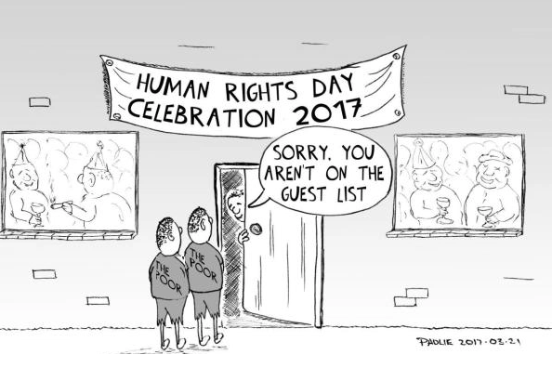

Source: https://cartoonsbypaulie.wordpress.com/2017/03/21/21-march-2017-human-rights-day-for-some/

4.1 | Determine which human right has been transgressed in this cartoon. Motivate your answer. | (1+1)(2)
4.2 | Explain how this cartoon illustrates the concept of discrimination against poor people. | (3)
4.3 | Explain the potential impact of this discriminatory treatment on these two people emotionally. | (3)
4.4. | Explain how the African philosophy of uBuntu is not upheld in this cartoon. | (2)
4.5 | Analyse how the people seen through the window (dancing and laughing) are not being responsible civillians. | (3)
4.6 | Suggest TWO ways how the people in the cartoon can act as responsible citizens. | (2)
 |  | [15]
Question 5:

Study the following advertisement and answer the questions that follow

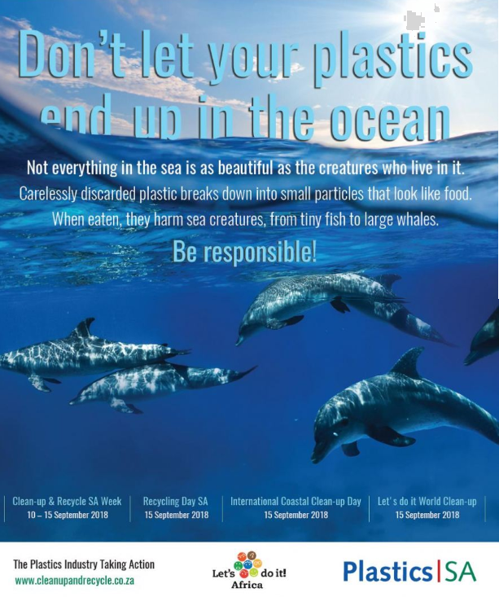

https://www.pressportal.co.za/energy-and-environment/story/14965/new-radio-and-tv-adverts-for-plastics-sa-focus-on-marine-litter.html

5.1 | Define the concept of environemtnal justice and explain how this advert illustrates the concept. | (1+2)(3)
5.2 | Explain the impact that resource depletement has on food security. | (2x2)(4)
5.3 | Discuss how food insecurity has the most significant negative impact on the poor in society. | (2x2)(4)
5.4 | Suggest TWO ways in which you can do to solve the problem of environmental injustice. | (2x2)(4)
 |  | [15]
SECTION C:
Answer any TWO questions in this Section. .

Question 6:
6. | Read the following extract.  Talent agent and actress Mary Ann Miller had to apologise after posting racist comments on a WhatsApp group for entertainment industry creatives. Miller was involved in a race row after criticising the spelling on an advert for an actors' workshop, which sparked a fight. She reportedly swore at black group members and said two other racist comments. Although Miller apologised for her remarks, she maintained that she was not a racist.  Source: https://www.timeslive.co.za/news/south-africa/2018-12-24-8-times-racists-were-exposed-in-sa-this-year/  Write paragraphs in which you discuss discriminatory behaviour. In your paragraphs, include the following  - Provide one word for the discriminating behaviour described in the extract and identify TWO human rights violations.  - Critically analyse which responsible actions Mrs Miller needs to take to ensure that she upholds the Bill of Rights with regards to equality, human dignity, freedom of expression and freedom of opinion.  - Recommend TWO ways how you can oppose discrimination at your school. | (1+2)(3)  (4x2)(8)  (2x2)(4)
 |  | [15]
Question 7:
7. | The following extract is taken from an article that appeared in an online newspaper on 08 January 2019.  Two political leaders have recently dared to address this taboo topic (Xenophobia). Johannesburg’s DA mayor, Herman Mashaba, and the trade union leader and founder of the new Socialist Revolutionary Workers Party, Zwelinzima Vavi. Mashaba has repeatedly stated that Johannesburg was getting “engulfed” by illegal migrants and that they should be treated as criminals. He was sharply rebuked by the ANC and the EFF.  Source: https://www.news24.com/Columnists/MaxduPreez/debating-illegal-immigration-where-do-we-draw-the-line-20190108  Write an essay in which you include the following:  - The definition of xenophobia and how what was said by Mashaba can be seen as xenophobia.  - Critically evaluate (FOUR reasons) why people attack people from other countries.  - Suggest TWO ways how you can address the issue. | (1+2)(3)  (4x2)(8)  (2x2)(4)
 |  | [15]
 | TOTAL FOR SECTION C: | [30]
 | EXAMINATION TOTAL: | [80]

MEMORANDUM
SECTION A:
Answer all of the questions in this section.

Question 1:  Multiple Choice  Choose the correct answer. Write only the question number and the correct letter. |  | (1)
1.1. | A person who goes from one place to another especially to find work is known as a  - emigrant.  - immigrant.  - migrant .  - migrate. | (1)
1.2. | Chapter TWO of our constitution is also known as the  - Declaration of Independence  - Bill of Rights  - South African Schools Act  - Children’s Act | (1)
1.3. | An example of an international protection agency is  - UNICEF  - CODESA  - UNISA  - SAHRC
1.4. | Equality courts deal with matters covered by the  - Promotion of Equal Treatment Act  - Promotion of Equality and Prevention of Unfair Discrimination Act  - Promotion of Equality and Fairness Act  - Promotion of the Prevention of Discrimination Act | (1)
1.5. | The CGE  - Promotes children’s rights  - Promotes rights of indigenous people in South Africa  - Promotes rights of foreigners in South Africa  - Promotes gender equality | (1)
Question 2:

2.1. | CEDAW | (1)
2.2. | No | (1)
2.3. | Stereotype | (1)
2.4. | Security | (1)
2.5. | Xenophobia | (1)
2.6. | Critical Social Constructive | (3)
2.7. | Volunteerism | (1)
2.8 | Femininity | (1)
 |  | [10]
Question 3:

3.1. | State the basic human right that protects us from forced labour.  The right to no slavery, servitude or forced labour OR the right to freedom | (1)
3.2. | State the basic human right that protects us from our homes being searched without a warrant.  The right to privacy | (1)
3.3. | State the basic human right that protects those in same-sex marriages from discrimination.  Freedom of belief, opinion and religion | (1)
3.4. | Define “discrimination against women”.  Treating a women in an unfair manner because of her gender | (2)
 |  | [5]
 | TOTAL FOR SECTION A: | [20]
SECTION B (Compulsory)
Answer all of the questions in this section. Write your answers in full sentences as far as possible.

Question 4:
Look at the cartoon below and answer the questions that follow.

Source: https://cartoonsbypaulie.wordpress.com/2017/03/21/21-march-2017-human-rights-day-for-some/

4.1 | Determine which human right has been transgressed in this cartoon and explain your answer.  The right to equality  The poor people are not being treated equally like everyone else in the picture | (2)
4.2 | Explain how this cartoon illustrates the concept of discrimination against poor people.  The poor people are not allowed in to the party  While everyone else is | (3)
4.3 | Explain the potential impact of this discriminatory treatment on these two people emotionally.  ANY THREE  Hurts people’s feelings  Makes people feel sad, lonely and afraid  Promotes fear and hatred in people  Makes us feel ashamed of ourselves  Makes people feel less than human | (3)
4.4 | Explain how the African philosophy of uBuntu is not upheld in this cartoon.  Ubuntu means caring and sharing  People are not being caring in that they are excluding people | (2)
4.5 | Analyse how the people seen through the window (dancing and laughing) are not showing civic responsibility  Civic responsibility means that you take actions on social and environmental issues  That you know rights come with responsibilities  These people are not being responsible but enjoying their rights | (3)
4.6 | Suggest TWO ways how the people in the cartoon can act as responsible citizens.  TWO points  They must learn their responsibilities.  Invite people in to the party.  Treat people equally, despite their social status. | (2)
 |  | [15]
Question 5:

https://www.pressportal.co.za/energy-and-environment/story/14965/new-radio-and-tv-adverts-for-plastics-sa-
focus-on-marine-litter.html

5.1 | Define the concept of environemtnal justice and explain how this advert illustrates the concept.  Environmental justice means putting right  the situation of environmental injustice  This advert illustrates this by telling us to be responsible for our oceans  And take part in various initiatives | (1+2)(3)
5.2 | Explain the impact that resource depletement has on food security.  Resource depletement decreases food security  Because there is not enough resources to make food | (2x2)(4)
5.3 | Discuss how food insecurity has the most significant negative impact on the poor in society.  Food insecurity increases food prices  The poor don’t have money  So it makes it difficult to buy food | (2x2)(4)
5.4 | Suggest TWO ways in which you can do to solve the problem of environmental injustice.  Any intelligent ideas for TWO marks  - Increase awareness of environmental issues at school  - take part in volunteer programmes  - recycle | (2x2)(4)
 |  | [15]
SECTION C:
Answer any TWO questions in this Section. .

Question 6:
6. | Read the following extract:  Talent agent and actress Mary Ann Miller had to apologise after posting racist comments on a WhatsApp group for entertainment industry creatives. Miller was involved in a race row after criticising the spelling on an advert for an actors' workshop which sparked a fight. She reportedly swore at black group members and said two other racist comments. Although Miller apologised for her remarks, she maintained that she was not a racist.  https://www.timeslive.co.za/news/south-africa/2018-12-24-8-times-racists-were-exposed-in-sa-this-year/  Write an essay in which you discuss discriminatory behaviour. In your essay, make sure you address the following points:  - Provide one word for the discriminating behaviour described in the extract and identify TWO human rights violations.  Racism  Right to equal and fair treatment has been violated  - Critically analyse which responsible actions Mrs Miller needs to take to ensure that she upholds the Bill of Rights with regards to equality, human dignity, freedom of expression and freedom of opinion.  Right to equality (any TWO)  She must treat others fairly  She must not discriminate against others  Human Dignity (any TWO)  Treat others with respect  Be kind and caring  Greet people and speak politely  Freedom of expression (any TWO)  Your opinion should not harm others  Avoid saying, showing or doing things that can cause offense  Do not spread or tell lies  Freedom of opinion (any TWO)  Respect the freedom of others to have their own opinions and beliefs  Show understanding and tolerance of others beliefs  - Recommend TWO ways how you can oppose discrimination at your school.  Any TWO intelligent ideas  Examples  Educate others about human rights  Stand up against bullying  Report bullying to authorities | (1+2)(3)  (4x2)(8)  (2x2)(4)
 |  | [15]
Question 7:
7. | The following extract is taken from an article that appeared in an online newspaper on 08 January 2019.  Two political leaders have recently dared to address this taboo topic (Xenophobia). Johannesburg’s DA mayor, Herman Mashaba, and the trade union leader and founder of the new Socialist Revolutionary Workers Party, Zwelinzima Vavi. Mashaba has repeatedly stated that Johannesburg was getting “engulfed” by illegal migrants from Nigeria, and that they should be treated as criminals. He was sharply rebuked by the ANC and the EFF.  https://www.news24.com/Columnists/MaxduPreez/debating-illegal-immigration-where-do-we-draw-the-line-20190108  Write an essay in which you address the following:  - The definition of xenophobia and how what was said by Mashaba can be seen as xenophobia.  Xenophobia is the dislike or prejudice against people from other countries  What he said can be seen as xenophobia because he is calling migrants/people from Nigeria  as criminals  - Critically evaluate (FOUR reasons) why people attack people from other countries.  Any FOUR  - There is a feeling that foreign nationals come to SA and take jobs in a country that is already struggling with unemployment.  - Many think that if they were not here doing those jobs then our unemployment issues would not be so bad.  - Many say that they are prepared to work under harsh conditions, for lower pay.  - This then counters all the work that has been done to create fairer, more equitable environments.  - Foreign national shop owners undercut prices taking business away from South African shop owners, and this causes conflict.  - Many say that the foreign nationals come to SA and get involved in criminal activities because they are here illegally – this is then a justification for violence.  - South Africa struggles with housing and resource issues – schools, medical facilities etc.  - People do not want to share these resources with others from outside the country.  - Some people feel that foreign nationals do not respect them and so therefore they do not deserve our respect.  - SA government taking a harsh stance on immigration has influenced attacks on foreigners.  - Some people do it because they feel like it is a good justification for criminal activity – if you are going to rob a store rather rob from a foreigner, it is more justified than robbing from a fellow South African.  - The history of Apartheid was a violent one and many South Africans are in dire situations and do not know how to remedy these situations. Foreign nationals are more vulnerable and so are easy victims to prey on. They could be used as scapegoats for what South Africans are dealing with.  - The violence in our history means that many people do not know how to effectively deal with their frustrations and problems.  - Recommend TWO ways how you can address the issue.  ANY TWO  - Education  - Hold leaders and those in power accountable for discrimination against foreign nationals  - Make xenophobic police cases a priority and ensure that the consequences are severe  - Work with communities, not against them. Discuss their concerns and work through those with them.  - Have support and policing units that are able to quickly respond to cases of xenophobia in order to limit the damage.  - Ensure that there are checks in place that stop foreign nationals from working jobs illegally or working under illegal conditions. | (1+2)(3)  (4x2)(8)  (2x2)(4)
 |  | [15]
 | TOTAL FOR SECTION C: | [30]
 | EXAMINATION TOTAL: | [80]

