GRADE 12 LIFE ORIENTATION
Career & Career Choices and Study skills
Term ONE and TWO
2019
Possible examination questions: Topic – Careers and Career Choices
REMINDER: Paper should include components of each topic covered in Term 1 & 2
SECTION A. (Compulsory)
Answer all the questions in this section.

Question 1

1.1. Various options are provided as possible answers to the following questions. Choose the correct
answer and write only the letter next to the question number.

1.1.1 Which of the following statements about tax returns is untrue?
- You need a tax number in order to complete your tax returns.
- Some people are exempt from paying tax and therefore do not have to complete their tax returns.
- If you fall into the required tax bracket, it is illegal not to complete your tax returns.
- You must go into the SARS offices the first time that you complete your tax returns. (1)

1.1.2 The acronym SAQA stands for:
- South African Qualifications Association
- South African Qualifications Authority
- South African Queries Association
- South African Quality Assessment (1)
1.1.3 If someone threatens you with physical violence if you do not give them money or favours, this is known as:
- Cronyism
- Fraud
- Extortion
D. Bribery (1)

1.1.4. An NSC is important because:
- It allows you to study at any HEI.
- You cannot have a job without it.
- An NSC is one of the basic requirements to study at HEI.
- Without it, you will never be successful. (1)

1.1.5. Corruption on a governmental level:
- Is not against the law as the rule of law states that all government officials are allowed legal pardon.
- Impacts not only the country and its economy but also the individuals and companies within the country.
- Is the use of a politician’s personal money to fund overly expensive initiatives.
- Is illegal. Active Citizenship demands that we stop it through violent protests. (1)
1.1.6. Which of the following is not true for School Based Assessment (SBA)
- Informal Assessment does not have to be recorded by the teacher.
- Not submitting a formal SBA task can result in an incomplete on your report.
- Informal Assessments should be happening every lesson to check your progress
- Formal SBA tasks count 50% of your final NSC mark. (1)
(6x1) [6]
1.2 Answer the following questions by writing the answer next to the question number
(1.2.1 – 1.2.4) in the answer book
Give ONE word/term for the following descriptions:

2.1 A high-level educational institution in which students study for degrees and academic research is done. | (1)
2.2 The money paid to SARS based on how much you earn. | (1)
2.3 The qualification you receive after completing and passing your final grade 12 exam. | (1)
2.4 A person who sets up a business, often taking on financial risks in the hope of profit. | (1)

Answer the following questions

1.3.1 Discuss how your social media accounts could hinder you getting a job. (2x2)(4)

1.3.2 Discuss TWO reasons why school leavers with a matric certificate find it difficult to find employment. (2x2)(4)
1.3.3 Briefly explain how the public protector can help you as a citizen of South Africa. (1x2)(2)

TOTAL SECTION A: 20

SECTION B
Question 2

Read the SARS tax table below and answer the questions that follow.

2019 tax year (1 March 2018 - 28 February 2019)
​Taxable income (R) | ​Rates of tax (R)
0 – 195 850 | 18% of taxable income
195 851 – 305 850 | 35 253 + 26% of taxable income above 195 850
305 851 – 423 300 | 63 853 + 31% of taxable income above 305 850
423 301 – 555 600 | 100 263 + 36% of taxable income above 423 300
555 601 – 708 310 | 147 891 + 39% of taxable income above 555 600
708 311 – 1 500 000 | 207 448 + 41% of taxable income above 708 310
1 500 001 and above | 532 041 + 45% of taxable income above 1 500 000

www.sars.gov.za

2.1 What does the acronym SARS stand for and what is SARS function in the country? (1+2)(3)
2.2 Briefly explain the term tax evasion and discuss why someone would intentionally choose to do this. (2+1)(3)
2.3 Explain TWO reasons why it is important for South Africans to pay tax. (2x2)(4)
2.4 Do you think the increasing tax scale listed above is fair? Give a well-motivated reason for your answer. (1+2)(3)

2.5 Evaluate why e-filing (SARS system of submitting tax returns online) is more efficient. (2)

[15]

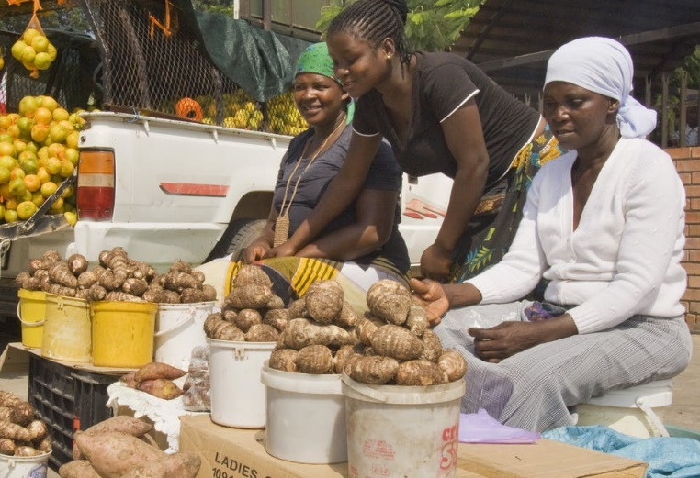
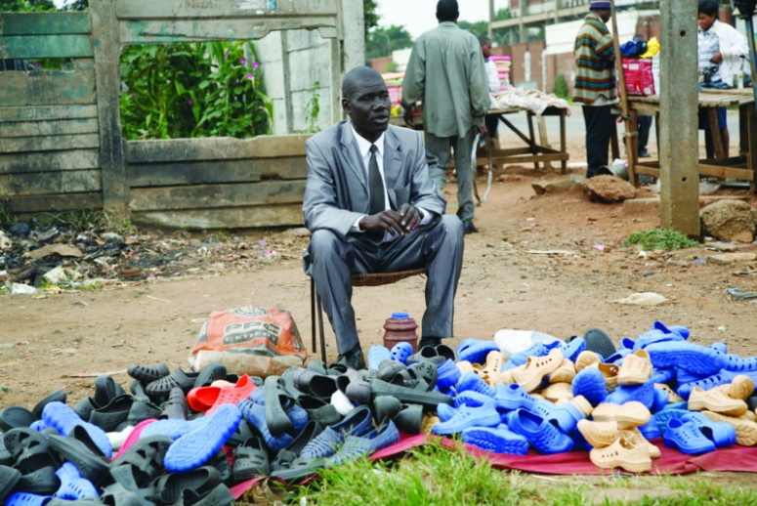
Question 3
Accessed from: http://zimbabwe-today.com Accessed from: https://southafricatoday.net
One in every six South Africans who has work, is working in the informal sector. Research shows unambiguously that the informal sector is an important source of employment.
Regrettably, for many decades, the sector has been forgotten and marginalised by economic analysis and policy. However, such an approach risks missing key elements of the "forgotten" world of informal enterprises — their potential, the constraints they face, their particular vulnerability, and the policy support they need to be viable. While SA’s informal sector is small compared with other developing countries, its informal enterprises provide livelihoods, work and income for more than 2.5-million workers and business owners.
Adapted from: www.businesslive.co.za/bd/opinion

  - Give a detailed explanation of the term informal job and explain how it can combat unemployment in South Africa. (1+2)(3)

  - Explain THREE reasons for the high unemployment level South Africa experiences. (3x2)(6)

  - Discuss TWO emotional consequences that the difficulties in the informal job sector have on people. (2x2)(4)

  - In your opinion, why should the informal sector be/not be more recognised by our economic leaders? (1x2)(2)
[15]

TOTAL SECTION B: 30

SECTION C

Answer any TWO questions in this section.

Note: Your response must be in paragraph format and should be written in full sentences.

Question 4:

Read the following extract and write a paragraph using the bullet points as a guide.


Your final year of high school is in full swing and for many scholars, this is the start of a period of great anxiety. Aside from the upcoming prelims and then final Grade 12 exams, there is also the perpetual question: what am I going to do after school? The good news is that there are many options available to young people who want to study or work after school.

Accessed from: www.ne1jobs.com

- Define the term ‘commitment to decision taken’ and explain why this is important for one’s after school options. (1+2)(3)

- Discuss THREE ways that high school is different to the working world. (3x2)(6)

- In your opinion, why do Matric learners find it difficult to commit to a career/ study path? (2x2)(4)
- Suggest ONE solution to help Matric learners commit to a career/ study path. (2)

[15]

Question 5:

Study the following cartoon and extract and write a paragraph using the bullet points as your guide.

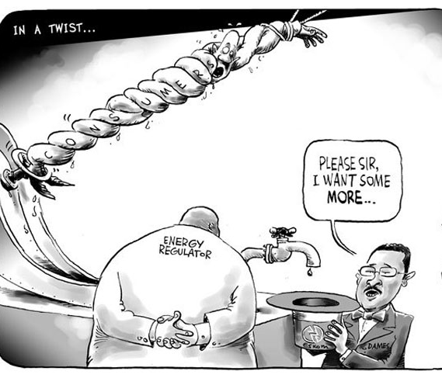
Political parties were debating President Cyril Ramaphosa's speech, when he addressed the nation on Thursday.
The challenges facing power utility Eskom and corruption featured strongly during the debate on the State of the Nation Address in Parliament.
The SONA debate is taking place just as Eskom is implementing a new round of load shedding. Political parties used this opportunity to voice their frustrations over the power outages. ANC Chief Whip Jackson Mthembu says he hopes government will act swiftly to put an end to load shedding.

“The crisis at Eskom is a cause for concern as it negatively affects our economic ambitions we are nonetheless hopeful that our government will act swiftly to arrest this situation especially the current episodes of loadshedding.”

Accessed from: www.zanews.co.za/cartoons Accessed from: www.sabcnews.com

- Define the concept corruption and explain how it could be linked to the Eskom load shedding situation. (1+2)(3)

- Explain THREE ways that load shedding is negatively impacting individuals and their communities (2x3)(6)

- Discuss TWO ways that load shedding is negatively impacting our economy. (2x2)(4)

- Suggest ONE strategy/ way that we as a country can fight corruption? (1x2)(2)

[15]

Question 6:
Study the following cartoon with its subtitle and write an essay using the bullet points as a guide.
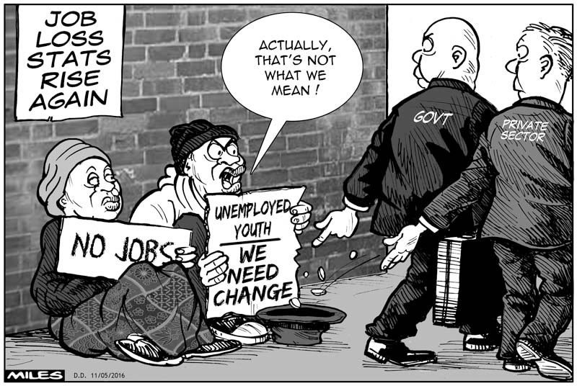

Scary statistics just released about unemployment in SA. Over 33 % and 3 out of five youth (between 15 and 34) have no jobs and probably didn't finish school. (May 2016)

Accessed on: 28 February 2019
http://cartoonsbymiles.blogspot.com/2016/05/short-changed.html

- Define the term unemployment and explain how it negatively impacts the South African economy. (1+2)(3)

- Discuss THREE possible negative impacts unemployment could have on the emotional/psychological well-being of our youth. (2x3)(6)

- Describe TWO strategies of change which could help turn around the situation of the youth in the cartoon and in our country. (2x2)(4)

- Give a well-motivated reason why you think the youth employment situation has changed positively or negatively since this cartoon was created in 2016. (2)

[15]
TOTAL SECTION C: 30

MEMORANDUM
GRADE 12 CAREERS AND CAREER CHOICES (TERM 1&2)

SECTION A

Question 1.1
1.1.1. D √
1.1.2. B √
1.1.3. C √
1.1.4. C √
1.1.5. B √
1.1.6. D√
(6x1)(6)

Question 2.1
1.2.1. University √
1.2.2. Income Tax √
1.2.3 NSC /or/ National Senior Certificate√
1.2.4. Entrepreneur √
(4x1)(4)

1.3.1 Discuss how your social media accounts could hinder you getting a job. (2x2)(4)

TWO marks for TWO well explained answers.

- If you post explicit images of yourself, √ the potential employer could see these and not hire you because it would give the company a bad name. √
- If you post images or statements implying a party-going persona, √ the company might feel that you have a poor work ethic. √
- If you or friends post hate speech or statements that reveal extreme views on topics such as religion, politics, etc. √ the company might not want to be associated with or work with someone who feels this way. √
- Allow for other logical and well-reasoned answers.

1.3.2 Discuss TWO reasons why school leavers with a matric certificate find it difficult to find employment.(2x2)(4)

- Many jobs require work experience, √and many school leavers did not have the time to work whilst at school and do not meet the minimum requirements for the job. √
- There are many more people looking for jobs than available jobs√ so companies are often demanding/ favouring qualifications higher than a matric certificate. √
- They may not have enough money for transport to and from work, √ which limits their job search to nearby areas where there may be fewer vacancies. √
- They may want to work in a certain field which is over saturated√ and do not want to consider more realistic options. √
- Allow for other logical and well-reasoned answers.

1.3.3 Briefly explain how the public protector can help you as a citizen of South Africa. (2)
- If anyone is unhappy with the way the state is running the country, √ they can report their grievances to the public protector. √
- The public protector has the ability to investigate any member of state or state organisation that is reported by citizens√ and take legal action to remedy state affairs. √
- Allow for other logical and well-reasoned responses.

TOTAL SECTION A : 20 marks

SECTION B

2.1 What does the acronym SARS stand for and what is SARS function in the country? (1+2)(3)
- South African Revenue Service. This service ensures that individuals and companies comply with tax laws and is in charge of collecting money from taxes.
2.2 Briefly explain the term tax evasion and discuss why someone would intentionally choose to do this. (2+1)(3)
- Tax evasion is not complying with tax procedures by either not paying the correct amount of tax or not submitting a tax return. People might not be happy with the government and feel this is a valid form of protest /or/ they may believe that they can get away with it.
2.3 Explain TWO reasons why it is important for South Africans to pay tax. (2x2)(4)

- Tax is the country’s main source of income, so if we don’t pay tax, the country cannot function correctly.
- Taxes support crucial services like the police force, government hospitals, etc. so without taxes, these people would not get paid and therefore we would not have these services.
- Taxes go towards road maintenance, so without taxes, our roads would constantly be in disrepair and dangerous.
- Allow for other logical and well-reasoned answers.
2.4 Do you think the increasing tax scale listed above is fair? Give a well-motivated reason for your answer. (1+2)(3)
Allow for any logical and well-reasoned response. Below are some examples. (ONE mark for opinion).
- This seems fair as those who earn more should help to support those in need as they have more than enough money to look after their basic needs.
- This seems fair as people who earn less money cannot be expected to pay the same as some higher earning South Africans – they can barely afford to pay for their basic needs.
- This seems unfair as a small percentage of the country is therefore forced to support majority of the country which means that the country cannot possibly get enough money.
- This seems unfair as people work hard for promotions to get more money and they seldom see the benefits of this hard work if they get taxed so heavily.

2.5 Evaluate why e-filing (SARS system of submitting tax returns online) is more efficient. (2)

Allow for any relevant and well-thought out arguments. Consider the following examples:
- This means that people do not have to go into SARS to pay taxes and there are therefore less people in the queues.
- Some people are unable to take time off of work to visit the SARS offices. The e-filing system allows them to complete their tax returns after work.

[15]

  - Give a detailed explanation of the term informal job and explain how it can combat unemployment in South Africa. (1+2)(3)

One mark for the definition of an informal job and 2 marks for a well-reasoned explanation.
- An informal job is:
  - a short-term contract job where the worker doesn’t get a lot of money.
  - where someone is not on a payroll because they earn so little, and therefore does not get taxed.
  - Working for an extremely small company, where the profit is very small.
  - Allow for other logical and well-reasoned answers.
- The informal sector provides short term jobs for those who do not have work, therefore allowing them to earn some money towards supporting themselves.
- People can work in informal jobs whilst they continue to look for other employment opportunities.
- Informal jobs contribute a small portion towards economic growth, which can result in a stronger economy and therefore more job opportunities.
- Informal businesses might grow into larger businesses and will need more employees to keep up with the growing demand, thus creating jobs.
- Allow for other logical and well-reasoned answers.

  - Explain THREE reasons for the high unemployment level South Africa experiences. (3x2)(6)

TWO marks for THREE well-reasoned responses
- Economic conditions such as inflation and recession can lead to fewer jobs because companies can’t afford to employ too many people.
- Advances in technology mean that some workers/ jobs are replaced by machines
- An unskilled work force means that many people do not have the right qualifications to apply for jobs.
- Some jobs might be over saturated, with too many people acquiring the skill to do this job.
- Many people live far away from where majority of the work opportunities are located. Thus many people cannot travel to get to their jobs without relocating.
- International trade - where companies overseas offer things for better prices than local companies. This means that local businesses are not supported and so they cannot create more jobs.
- Corruption which leads to nepotism (jobs for friends at overly high salaries) and takes away jobs from the poor or better qualified.
- Difficult for first-time or new entrants to enter the labour market because people with experience are preferred.
- Jobseekers become discouraged by lack of success and give up trying.
- Lack of entrepreneurship opportunities/ skills therefore jobs are not being created.
- Lack of job search skills and information means that people are not finding the jobs that are out there/ they are qualified for.
- Fewer opportunities to apply for/ get a job due to already being stuck in cycle of unemployment.
  - Allow for an example of this, e.g. many unemployed people cannot afford interview appropriate clothes and therefore do not get hired as they don’t meet the standards.
- The longer you are unemployed, the more difficult it is to become employed because people question why you were unemployed for so long.
- Allow for other logical and well-reasoned answers.

  - Discuss TWO emotional consequences that the difficulties in the informal job sector have on people. (2x2)(4)

- People in the informal sector do not have access to many resources and therefore struggle to make a profit.
- Informal work is often labour intensive which can affect one’s health.
- They have few resources to protect themselves/ their earnings and could be targeted by criminals.
- People don not always want to support informal jobs like hawkers because they believe that they do not belong in the community /or/ they believe that their goods/ services are not as good as more established companies.
- Allow for other logical and well-reasoned answers.

  - In your opinion, why should the informal sector be/not be more recognised by our economic leaders? (1x2)(2)

No mark for it should/ should not be more recognised. Allow for logical and well-reasoned answer and qualifier. Some examples to follow.
- Informal jobs should not be recognised as they do little to contribute towards the economy and supporting them would be a waste of resources that could be used on businesses that can help our economy more.
- Informal jobs should not be recognised right now as our country first needs to sort out big companies like Eskom and SABC, which affect the daily running of our country.
- Informal jobs should be recognised as they could turn into bigger companies with a little help and then create more jobs.
- Informal jobs should be recognised so that they are not so vulnerable and will therefore be more likely to succeed.
[15]

TOTAL SECTION B: 30

SECTION C

Question 4
Define the term ‘commitment to decision taken’ and explain why this is important for one’s after school options. (1+2)(3)
ONE mark for definition:
- To work hard towards your goal.
- To not give up on your chosen path, despite obstacles.
TWO marks for explanation:
- You will focus on your after-school opportunities and not be distracted by things like friends or relationships.
- You will work towards finding solutions to problems such as finances or low marks instead of giving up on your dreams.
- You will remain motivated to study hard as you know the importance of what you are working towards.
- You will not miss deadlines or be unprepared because you have researched how to achieve your goals after school.
- Allow for other logical and well-reasoned answers.

Discuss THREE ways that high school is different to the working world. (2x3)(6)
- In school your teacher gives you a lot of guidance for tasks and exams and work you need to know, whereas in the working world, you are expected to know what to do.
- In school, you are surrounded by friends and peers whereas in the working world, you might not find as many friends or work with people in the same age group as you.
- In school, the teacher is easily accessible for help or questions, whereas in the work place it might be difficult to ask seniors or your boss to help you.
- School is focused on learning new information while work expects you to put what you know into practice.
- At school, you are given clear guidelines on how to act whereas in the working environment, you might get a warning for doing something you didn’t know was against company regulations.
- In school, the teacher is responsible for helping you to pass, whereas in the working world, you are responsible for your own success or failure.
- Teachers know your name. If you are in a big company, it is very unlikely that those in charge will know you.
- You may get detention for being late for school but the penalties for being late at the work place are extreme and can result in a written warning.
- You have a uniform at school whilst you have a dress code at work.
- Allow for other logical and well-reasoned answers.

In your opinion, why do Matric learners find it difficult to commit to a career/ study path? (2x2)(4)

Allow for any TWO well-reasoned and logical answer. Some examples to follow:
- There is a lot of pressure to make the correct choice and so learners are scared to make the wrong decision.
- Many options cost a lot of money, so learners do not want to commit to something and find out later that it wasn’t what they expected.
- There are many people telling learners different things and so they get confused.
- They do not want to do what their parents/ friends/ teachers are suggesting but they do not have the courage to stand up for what they want to do, so they just stay quiet and don’t make a choice.
- There are so many opportunities so it is difficult to know what to do.
- Some learners are not mature enough to make such a big decision that will affect the rest of their life.
- Some learners may not have access to generational knowledge (e.g. family members who know what their study options are) or research opportunities and so they don’t know what their options are.

Suggest ONE solution to help Matric learners commit to a career/ study path. (2)

Allow for any well-reasoned and logical answer. Some examples to follow:

- Job-shadow at as many companies as possible, so that you can get a better idea of what the job is really about and put your mind at ease.
- Research bursaries and other financial opportunities so that you will not have to be held back by money.
- Believe in yourself and don’t let others tell you what to do as this is your life and happiness that is at stake.
- Consider studying/ working in a specific field instead of focusing on one job so that if you don’t enjoy the job, you can move to a new one within the field.
- Research as many careers and career fields as possible so that you can make a well-informed decision.

Question 5

Define the concept corruption and explain how it could be linked to the Eskom load shedding situation. (1+2)(3)

Corruption is the misuse of public power (by elected politician or appointed civil servant) for private gain.
- The people in charge of Eskom were trusted with tax-payers money and have instead used it to better themselves/ their own financial situation.
- Some employees might have been employed via nepotism and received too much money for their job /or/ were not qualified to do their job.
- Allow for other logical and well-reasoned answers.

Explain THREE ways that load shedding is negatively impacting individuals and their communities (2x3)(6)

- People are unable to get on with their daily lives as most household appliances are electronic.
- Learners may find it difficult to complete projects without the use of computers and the internet.
- Household alarms and security systems might not function properly, which could cause an increase in crime.
- Robots/ traffic lights do not function properly causing a build-up of traffic /or/ and increased risk of an accident.
- Schools cannot always teach effectively (without light in bigger classrooms or because lessons are structured around technology), therefore school time is not as productive.
- Appliances might start to break/ malfunction due to power surges when electricity returns.
- Allow for other logical and well-reasoned answers.

Discuss TWO ways that load shedding is negatively impacting our economy. (2x2)(4)
- Awkward load shedding times may mean that businesses close early, resulting in less work done that day.
- Many businesses are reliant on electricity to complete tasks which means a loss of profit.
- Less productivity means an increase in prices to compensate which will mean consumers can buy less.
- Businesses may decide to close down due to loss of profit, which means that more people are unemployed.
- Foreign investors will be turned away by the current state of the country and our businesses will lose financial backing.
- Allow for other logical and well-reasoned answers.

Suggest ONE strategy/ way that we as a country can fight corruption? (1x2)(2)

Allow for well-thought out and logical answers. Some examples to follow:
- We could hold a peaceful protest march to show those in power our displeasure.
- We could sign petitions to get the attention of those in power.
- We must vote for political parties that we feel would be less corrupt.
- We can contact the public protector with any information we have regarding corruption.
- We could start our own political party that does not stand for corruption.

[15]

Question 6

Define the term unemployment and explain how it negatively impacts the South African economy. (1+2) (3)

ONE mark for the definition
- Unemployment: the state of not having a job where you earn an income.

TWO marks for the explanation
- Unemployment causes poverty and poverty leads to more unemployment
- Investors become scared to invest their money because they may lose it. Investors then decide not to expand their businesses, or they retrench workers.
- If there are many unemployed people, there will be less money available to spend on luxuries such as holidays, travel, hotel accommodation and eating out. Hotels, restaurants and gift shops may have to close. This leads to further unemployment, because the people who work there, will then also be out of work.
- Allow for other logical and well-reasoned answers.

Discuss THREE possible negative impacts unemployment could have on the emotional/psychological well-being of our youth. (2x3)(6)

- Unemployment leads to a decrease in self-esteem as the youths might feel they have no purpose/ do not contribute towards society.
- They may be unable to pay off their study loans and could land up with unpaid debt/ black listed.
- They may turn to substance abuse to get away from their problems with finding a job.
- They may never get experience and will therefore always struggle to get a job.
- They will be unable to support themselves and might resort to a life of crime.
- They may become homeless as they cannot pay for accommodation.
- Allow for other logical and well-reasoned answers.

Describe TWO strategies of change which could help turn around the situation of the youth in the cartoon and in our country. (2x2)(4)

- We need to create more jobs by supporting local enterprises.
- Corruption needs to be weeded out of governmental structures so that money can go towards creating jobs.
- We need to educate our youth to create their own jobs by becoming entrepreneurs.
- Allow for other logical and well-reasoned answers.

Give a well-motivated reason why you think the youth employment situation has changed positively or negatively since this cartoon was created in 2016. (2)
No mark for positive or negative. Allow for well-reasoned and logical answers. Some examples to follow:
- It has not changed at all because youths out of varsity are still struggling to find work and no one is helping them.
- It has gotten worse because the government is even more corrupt and there is even less money to help create jobs.
- It has gotten worse because government-run companies such as Eskom and SABC are under severe financial struggle meaning many more employees are losing jobs, thus unemployment is getting worse overall.

[15]

TOTAL SECTION C: 30

