GRADE 11 LIFE ORIENTATION
TOPIC: DEMOCRACY AND HUMAN RIGHTS (DHR)
SOCIAL AND ENVIRONMENTAL RESPONSIBILITY (SER)

NOVEMBER 2019
1 ½ HOURS 80 MARKS

NOTE TO TEACHERS: Remember, this is a bank of questions and therefore may contain some overlaps and might not fully adhere to the weighting of Bloom’s Taxonomy. Keep this is mind when selecting questions for your paper. Use the table below to help you when choosing your questions.

Weighting (suggested) | Weighting (Actual) | Cognitive level | Bloom’s taxonomy
30% (24 marks) | 26 marks | Lower Order | Level 1&2
40% (32 marks) | 34 marks | Middle Order | Level 3&4
30% (24 marks) | 20 marks | Higher Order | Level 5&6
All essay questions are weighted the same so no matter which essay question combo a learner chooses, they will still have the same weighting out of 80.

REMINDER: Final paper should include components of each topic covered in Terms 1-4.
______________________________________________________________

INSTRUCTIONS AND INFORMATION
- The question paper consists of THREE sections, namely SECTION A, SECTION B and SECTION C.
- The questions in SECTION A and SECTION B are compulsory.
- Answer any TWO questions in SECTION C.
- Read ALL the questions carefully.
- Number the answers correctly according to the numbering system used in this question paper. Start each question on a new page.
- Write neatly and legibly.

SECTION A. (Compulsory)
Answer all the questions in this section.

Question 1
Various options are provided as possible answers to the following questions. Choose the correct answer and write only the letter (A–D) next to the question number (1.1.1 – 1.1.5) in the ANSWER BOOK, for example 1.1.6. D.

    - According to the Bill of Rights, the freedom of speech, religion and opinion allows:

- Someone can stone homosexuals as part of their religion.
- A religious leader to threaten another religious leader on social media.
- For fair discrimination based on religious beliefs and opinions.
- Anyone to practice their own religion even if it infringes on other’s rights.
(Lower Order)
    - Which religion actively promotes gender equality?

- Baha’i faith
- Islam
- Christianity
- Judaism
(Lower Order)
    - Living in a harmonious society would not include:

- People living in homogenous communities for safety reasons.
- People not fighting despite differences in race or religion.
- Speaking out against injustices and discrimination.
- Disagreeing with different religious or cultural beliefs.
(Lower Order)

1.1.4. You have to respect someone’s beliefs even if they:

- Degrade or abuse children under the age of 18.
- Participate in hate speech on social media.
- Have religious beliefs that conflict with yours.
- Discriminate against their classmates.
(Lower Order)

1.1.5. Abortion is not:

- legal according to the Termination of Pregnancy Act of 1996.
- against the South African Constitution; everyone has freedom to choose.
- legal, unless a woman has been raped or the baby has an abnormality.
- a moral or religious dilemma as men have the right to choose as well.
(Lower Order)
(5x1)[5]

1.2. Give ONE word/term for the following descriptions. Write only the word/term next to the question numbers (1.2.1 to 1.2.5) in the ANSWER BOOK.

1.2.1 A set of beliefs about the cause, nature and purpose of the universe.  (Lower Order) |  | (1)
1.2.2 The practice of killing someone who is sick or injured to stop their suffering. (Lower Order) |  | (1)
1.2.3 How to prepare meat as prescribed by Muslim law.  (Lower Order) |  | (1)
1.2.4 The religion that believes in Brahman – the unity of everything.  (Lower Order) |  | (1)
1.2.5 The right often used to argue against abortion.  (Lower Order) | (1)
(5x1)[5]

1.3 Answer the following questions by writing the answer next to the question numbers (1.3.1 to 1.3.4) in the ANSWER BOOK.

1.3.1 Mention TWO ways that diverse religions and belief systems contribute to a harmonious society. (2x1)(2)
(Lower Order)

1.3.2 List TWO religions that do not eat pork. (2x1)(2)
(Lower Order)

1.3.3 Discuss TWO instances when male or female circumcision could be considered inhumane. (2x2)(4)
(Middle Order)

1.3.4 Suggest ONE way in which the Buddhist religion contributes towards a more peaceful and harmonious community. (1x2)(2)
(Higher Order)

TOTAL SECTION A: 20

SECTION B (Compulsory)

Answer ALL the questions in this section. Write your answers in full sentences.

Question 2

Study the pictures below and answer the questions that follow.

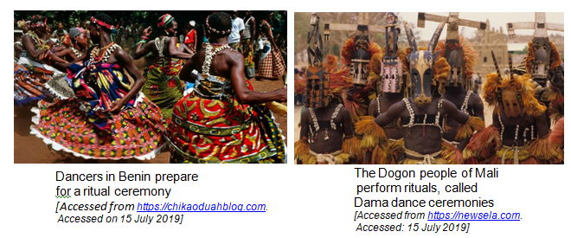

2.1 List THREE principles that African Traditional Religion (ATR) is based on. (1x3)(3)
(Lower Order)
2.2 Explain THREE ways ATR contributes towards a harmonious society. (3x2)(6)
(Middle Order)
2.3 Discuss TWO reasons why the number of people practicing ATR is decreasing. (2x2)(4)
(Middle Order)

2.4 Evaluate why putting all African traditions under one label could be considered problematic. (1x2)(2)
(Higher Order)

[15]

Question 3
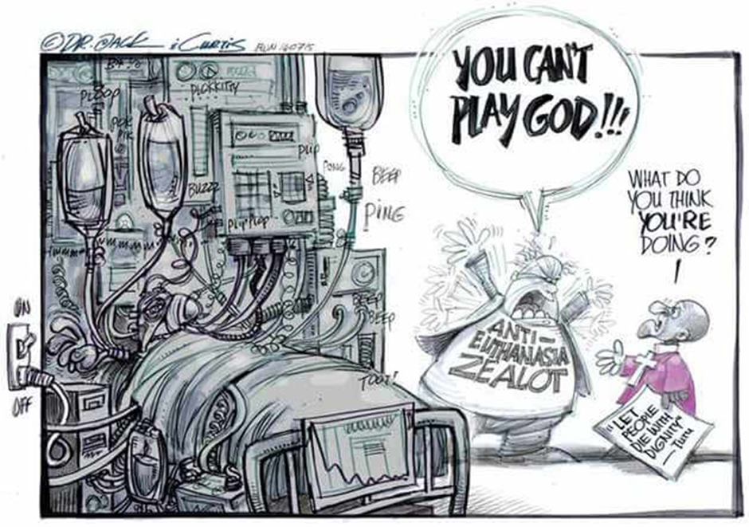
Study the cartoon and text below and answer the questions that follow.
Muddling withdrawing life support vs euthanasia
The euthanasia activist group so-called ‘Dignity SA’ as well as Judge Fabricius judgment of 4th May 2015 repeatedly muddle the ‘active killing’ with withdrawing life support. Yesterday, the issue of Nelson Mandela’s prolonged time on life support was criticised at a panel discussion hosted by Wits medical school by speakers both for and against euthanasia.
An ‘Eye Witness News’ cartoon frequently used by euthanasia activists shows former Archbishop Bishop Tutu accusing an ‘anti-euthanasia zealot’ of ‘playing God’ next to a man wired up to life support. This cartoon completely mis-represents the anti-euthanasia position and muddles the ethical issues.
[Adapted from https://euthanasiaexposed.co.za. Accessed on 15 July 2019]

  - Provide a definition for the term ‘euthanasia’ and mention TWO reasons people would consider this a viable option. (1+2)(3)
(Lower Order)

  - Explain why euthanasia could be considered a moral dilemma. (1x2)(2)
(Middle Order)

  - Discuss THREE ways in which family and friends could be affected by euthanasia of a family member. (3x2)(6)
(Middle Order)

  - Critically discuss why euthanasia is still illegal in South Africa. (2x2)(4)
(Higher Order)
[15]
SECTION C (Choice)

Answer any TWO questions in this section.

Your responses must consist of paragraphs. Marks will only be allocated for responses written in full sentences.

Question 4:

Study the extract below and answer the question that follows.

China's medicinal tiger bones and rhino horns: Tradition or travesty?
Last week China's State Council said the country would reverse a ban on the trade of products made from tigers and rhinos. Officials in Beijing said that trade volume would be "controlled" and tiger bones and rhino horns would only be obtained from animals in captivity for use in "medical research or healing."
There was no reason given for removing the ban and the announcement drew condemnation from wildlife activists along with doctors of traditional Chinese medicine and Chinese consumers. Tiger bones and rhino horns may have a role in traditional Chinese medicine, but critics say that trendy health products with no medical value made from endangered animals are only a status symbol for the wealthy
[Adapted from https://www.dw.com. Accessed on 14 July 2019]

Write paragraphs on harmful cultural practices.

Use the following as a guideline:

- Define the term inhumane cultural practice and describe TWO ways the above ban could be considered an inhumane cultural practice. (1+2)(3)
(Lower Order)

- Discuss THREE reasons why people continue with cultural practices even though they cause harm to other living creatures. (2x3)(6)
(Middle Order)
- Recommend TWO ways an active citizen could help to stop inhumane cultural practices. In your answers, also indicate how EACH action may help prevent inhumane cultural practices. (2X3)(6)
(Higher Order)

[15]
Question 5:

Study the following extract and answer the question that follows.

7 brutal religious and cultural practices that exist even today
Being maimed, burnt, killed in the name of religion is not history. The apparent 'progressive' world we live in still practises some horrific brutal rituals, which in spite of being banned by governments worldwide see a large number of participants even today.
Mumbai-based psychiatrist Dr Harish Shetty explains what pushes humans into such activities by saying, “Man is a beast with really strong urges. Regression in culturally approved situations is normal. Some cultures attempt to impose control over communities. Even today mentally challenged people are beaten up in rural areas.” Another example is Female Genital Mutilation (FGM). This ritual with both a religious as well as a cultural background, exists even today. It is Practised in around 27 countries in the sub-Saharan and North-east Africa and a few Asian countries including India among the Bohra community.
[Adapted from https://www.dnaindia.com. Accessed on 14 July 2019]

Write paragraphs on inhumane cultural practices in Africa.

Use the following as a guideline:

- Define the term female genital mutilation and mention TWO ways this can negatively affect a woman’s health. (1+2)(3)
(Lower Order)

- Explain THREE reasons people might not speak out against female genital mutilation or other inhumane practices. (3x2)(6)
(Middle Order)

- Suggest TWO practical ways the government could counteract inhumane cultural practices that still exist in African countries. In your answers, also indicate how EACH suggestion would decrease inhumane cultural practices. (2x3)(6)
(Higher Order)
[15]

Question 6:
Study the following extract and answer the question that follows.

The Riz Test: How Muslims are misrepresented in film and TV
(The Conversation) — In a speech to the UK’s House of Commons in March 2017, actor and rapper Riz Ahmed, a Muslim, delivered a message about the importance of diversity and representation in the media:
What people are looking for is a message that they belong. Every time you see yourself it’s a message that you matter, that you’re part of the national story.
But when it comes to the “national story”, the one about Muslims is pretty grim. The pressing issue of Islamophobia is both fuelled and defined by the misrepresentation and stereotyping of Muslims in the media. Instead of challenging the images of the “oppressed” Muslim woman, or the violent Middle Eastern man that propagate our media, mainstream films often reinforce them. But films are also platforms with the potential to create change through alternative narratives. Our visual culture can play a crucial role in the way we understand the world.
[Adapted from https://religionnews.com. Accessed on 15 July 2019]

Write paragraphs on how Islam has been negatively portrayed in the media.

Use the following as a guideline:

- Define the term Islam and mention TWO facts about this religion. (1+2)(3)
(Lower Order)

- Discuss THREE ways Islam is negatively portrayed in the media. (3x2)(6)
(Middle Order)

- Suggest TWO ways the media could positively change the way Muslims are viewed around the world. In your answers, also indicate how EACH positive change could positively impact the self-esteem of Islamic youth. (2x3)(6)
(Higher Order)

[15]
TOTAL SECTION C: 30
GRAND TOTAL: 80

MEMO
SECTION A. (Compulsory)

Question 1

1.1.1 C

1.1.2 A

1.1.3 A

1.1.4. C

1.1.5. B (5)

1.2.1 Religion
1.2.2 Euthanasia
1.2.3 Halal
1.2.4 Hinduism
1.2.5 Right to Life (5)

1.3.1 Mention TWO ways that diverse religions and belief systems contribute to a harmonious society. (2x1)(2)
(Lower Order)
- Promotes peace and tollerance
- Gives people a moral code to live by
- Gives people a sense of belonging to the community
- Encourages people to learn about others and their religion
- Teaches friendship, understanding and respect
- Help to those less fortunate/ uplift community

1.3.2 List TWO religions that do not eat pork. (2x1)(2)
(Lower Order)
- Judaism
- Islam

1.3.3 Discuss TWO instances when male or female circumcision could be considered inhumane. (2x2)(4)
(Middle Order)
- Often not performed by a trained healthcare practitioner, so disease or infection can occur.
- In the case of females, there is permanent damage to sex organs making future sexual relationships unpleasant and even painful.
- Sometimes performed without aesthetic so procedure is unnecessarily painful.
- If surgical implements are not cleaned correctly, it could lead to transmission of HIV.

1.3.4 Suggest ONE way in which the Buddhist religion contributes towards a
more peaceful and harmonious community. (1x2)(2)
(Higher Order)
- They would see each community member as valuable to the community as they would not be focusing on things, they don’t like about their religion
- They would not be trying to find faults with the religious beliefs of others/ trying to convert them which would lead to less disagreements within the community.
- Because a Buddhist accepts others despite their beliefs, they would make others feel a sense of belonging.
- Allow for alternative, well-reasoned answers.

TOTAL SECTION A: 20

SECTION B (Compulsory)
Answer all the questions in this section.

Question 2

2.1 List THREE principles that African Traditional Religion (ATR) is based on. (3)
(Lower Order)
- Communal way of life
- Ancestors and ancestor worship
- Belief in a creator
- Kinship, including ancestors, as a basic organizational principle
- Performance of rituals at birth /or/ becoming an adult /or/ marriage /or/ death.
- Cleansing rituals involving slaughtering of cattle or goats
2.2 Explain THREE ways ATR contributes towards a harmonious society. (3x2)(6)
(Middle Order)
- ATR encourages responsibility towards God, society, nature and the living (even unborn). This adds to the community as it decreases greed and selfishness /or/ it means that people look after each other and put others first.
- ATR links the past and present in a meaningful way, allowing all generations to feel a sense of belonging or a sense of kinship.
- ATR promotes peace with many practicing negotiation and mediation which means that people will not be having meaningless arguments /or/ fighting amongst themselves.
- Allow for other relevant answers.
2.3 Discuss TWO reasons why the number of people practicing ATR is decreasing. (2x2)(4)
(Middle Order)
- Other more well-known religions are more easily accessible as they have set buildings/places of worship.
- Religions such as Christianity are more widely spoken about in the media making it seem more relevant to the younger generations.
- Colonization started the process when it forced African people to convert to Christianity. Many people still feel they need to practice Christianity to fit in with the Western world.
- Some of the rituals may seem outdated in the Western society we live in, meaning that younger generations are looking for ‘more acceptable’ religions that fit in with their lifestyle.

2.4 Evaluate why putting all African traditions under one label could be considered problematic. (1x2)(2)
(Higher Order)
- It encourages people to think that all people in Africa are the same and have the same rituals leading to blanket generalizations and stereotypes.
- It leads to a lack of knowledge/misinformation as people will think they know about all African cultures when they only know about one or two.
- It could lead to people causing offence or unintentionally disrespecting someone’s belief system as they could treat them according the cultural beliefs they think they follow when they actually follow something completely different.
- Allow for alternative, well-reasoned answers.

[15]

Question 3

  - Provide a definition for the term ‘euthanasia’ and mention TWO reasons people would consider this a viable option. (1+2)(3)
(Lower Order)
- Practice of killing someone who is sick or injured to stop their suffering.
  - People feel that their quality of life is not worth the pain.
  - They do not want their loved ones to suffer
  - They do not want to be a financial burden to their loved ones
  - People are afraid of being abandoned by their loved ones
  - Allow for alternative answers.

  - Explain why euthanasia could be considered a moral dilemma. (2x1)(2)
(Middle Order)
- People have differing views on the right to end someone’s life so by practicing euthanasia, you could be in conflict with those around you.
- People may have differing/ conflicting views within themselves, (for example their religion may say they should not take life, but they don’t enjoy seeing someone suffer.) This could put them in a state of uncertainty about what is right.
- Some people could take advantage of those who are unable to defend themselves and attempt to pass of non-consensual euthanasia as mercy killing when it was rather for personal gain.
- Allow for alternative, well-reasoned answers.

  - Discuss THREE ways in which family and friends could be affected by euthanasia of a family member. (3x2)(6)
(Middle Order)
- They may be against the decision which causes conflict.
- They will be left behind and must deal with the trauma of loss.
- They may feel guilt over not being ‘good enough’ to justify staying alive despite the pain.
- They may feel guilty if they enabled the euthanasia.

  - Critically discuss why euthanasia is still illegal in South Africa. (2x2)(4)
(Higher Order)
- It can be abused by those who want to profit from someone else’s death.
- It puts doctors in an awkward position of having to kill someone when they swore to save lives.
- People might have found an alternative if they had stayed alive thus wasting a life that they could have lived in comfort.
- It is too traumatic for family members and friends who could live with guilt for the rest of their lives.
- It could lead to many legal issues between family members and friends who did not support the decision.
- Allow for alternative, well-reasoned answers.
[15]
TOTAL SECTION B: 30
SECTION C (Choice)

Question 4:

Define the term inhumane cultural practice and mention two ways the reversal of the above ban could be considered to aid inhumane cultural practice. (1+2)(3)
(Lower Order)
- A rite or ritual/ part of a culture that causes harm to the environment, animals or others around us.
  - This leads to poaching
  - Often animals are killed in a painful manner
  - These animals are getting close to extinct which can harm the environment
  - Allow for alternative answers.

Discuss THREE reasons why people continue with cultural practices even though they cause harm to other living creatures. (3X2)(6)
(Middle Order)
- They have deep roots in their culture and do not feel they can let go of these practices.
- They have grown up participating in these practices and don’t view them as inhumane/ view them as the norm.
- They believe that the result of such a practice is worth more than the suffering of the animal/ being.
- Allow for alternative, well-reasoned responses.

Recommend TWO ways an active citizen could help to stop inhumane cultural practices. In your answers, also indicate how EACH action may help prevent inhumane cultural practices. (3x2)(6)
(Higher Order)
- They could contact community leaders and ask them to discourage these practices with other community members. People will take discouragement more seriously if it comes from community leaders and stop.
- They could set a good example by voicing their disappointment and outrage over such behaviours. People will be too ashamed to continue if they are constantly held shamed for their actions.
- They could create flyers or other forms of media to raise awareness. More people will be available/ knowledgeable enough to fight against inhumane cultural practices.
- They could hand out pamphlets or host talks to educate people on the dangers and problems with these practices. This way people will realise the problems with their behaviour and stop.
- They could report suspicious activity/ illegal activities to the police and other authorities so that they can arrest/ fine people who are participating in these practices. This way people will stop to avoid consequences.
- Allow for alternative, well-reasoned answers.

[15]
Question 5:

Define the term female genital mutilation and mention TWO ways this can negatively affect a woman’s health. (1+2)(3)
(Lower Order)
- Ritual cutting or removal of some or all of the external female genitalia.
  - Infections can occur – especially if unsterile tools are used.
  - Sexual intercourse can become extremely painful
  - Complications during childbirth
  - Increased risk of HIV
  - Allow for alternative answers

Discuss THREE reasons people might not speak out against female genital mutilation or other inhumane practices. (3x2)(6)
(Middle Order)
- They are afraid of repercussions from religious or cultural leaders who would get angry with them for going against their believes.
- They feel it is normal because everyone around them participates.
- They have been brought up with these practices, so they don’t feel they are wrong.
- They have no one to speak to as the people around them support these practices.
- The people who have authority over them do not allow them the freedom to complain.
- Allow for alternative, well-reasoned answers.

Suggest TWO practical ways the government could counteract inhumane cultural practices that still exist in African countries. In your answers, also indicate how EACH suggestion would decrease inhumane cultural practices. (2x3)(6)
(Higher Order)
- The government should host educational talks/ create educational media for those who don’t have access to education. This means that no one is practicing because of ignorance.
- The government needs to implement harsher penalties in areas on the fringes of the society that feel they are above the law so that people are too scared to partake.
- They should follow through with existing penalties in areas that are the most affected so that people don’t feel that they can get away with breaking bans.
- The government should hold negotiation meetings for those who feel that people are trying to infringe on their culture. These meetings could aim to collaborate on suitable alternative cultural practices and expressions that are not inhumane.
- Allow for alternative, well-reasoned answers.
[15]
Question 6:
Define the term Islam and mention TWO facts about this religion. (1+2)(3)
(Lower Order)
- A religion that worships Allah /or/ a religion that follows the teachings of Allah as revealed through Mohamed.
  - It preaches peace, compassion, racial harmony and love
  - Holy book is the Qur’an
  - They do not eat pork
  - All food must be Halal
  - The greeting is Assalamu alaikum /or/ peace be to you
  - Allow for alternative answers

Discuss THREE ways Islam is negatively portrayed in the media. (3x2)(6)
(Middle Order)
- In crime dramas, Specifically in American ones, the terrorists or bad guys are mostly Islamic, creating the idea that Islam supports terrorism.
- Islamic beliefs, rituals are over simplified so that people get a misrepresented idea of the culture and religion/or/ creates a stereotypical or generalised idea of Muslims.
- Islamic relationships are often portrayed as sexist or with the woman being inferior and oppressed. This gives the idea that Muslim men to not respect women or abuse them.
- Video games often have Muslim gun men or bombers that they player must defeat. This creates the idea that Islam as a religion promotes violence or Muslims are an extremely violent and trigger-happy people.
- Stereotypes normalise problematic behaviours making those people practice these behaviours feel they are correct or justified.
- It creates an otherness and divide between cultures as people cannot see a way to relate to a culture that is so opposed to their own views.
- Allow for alternative, well-reasoned answers.

Suggest TWO ways the media could positively change the way Muslims are viewed around the world. In your answers, also indicate how EACH positive change could positively impact the self-esteem of Islamic youth. (2x3)(6)
(Higher Order)
- Portray relationships where women have power whilst staying true to their religion so that we set a good example /or/ so that people do not misunderstand the power dynamics within a Muslim relationship. Islamic girls could have strong and moral role models to aspire towards.
- Have other ‘bad guys’ so that Islamic people are not always targeted in airports, borders, etc. It can allow them to feel that their religion is worthy of respect by others in the community, allowing them to feel a higher level of self-worth.
- Have Muslim men and women fighting with the good guys against terrorism to defeat the stereotypes. It can give them positive role models to look up to so that they don’t have to look up to people they cannot identify with or understand.
- Focus on the positive aspects of Islam so that other religions can feel a connection with people who practice this faith. They can grow up not feeling like they have to hide their religion in case people get scared of them or misunderstand them and rather give them a sense of pride.
- Allow for alternative, well-reasoned answers.

[15]

