Grade 9 Life Orientation

TOPIC: CONSTITUTIONAL RIGHTS
AND RESPONSIBILITIES
(CRR)

Term 1 & 2
2020

Reminder: This Question Paper should include components of
each topic covered in term ONE and TWO.
i.e. The June Grade 9 Question Paper should include
questions from each topic covered in Term 1 and 2.
Possible examination questions: Topic – Constitutional Rights and Responsibilities
NOTE: This examination will comprehensively address the content, knowledge and skills covered during the first and second terms (CAPS, Outline for
Examinations, pg. 28)
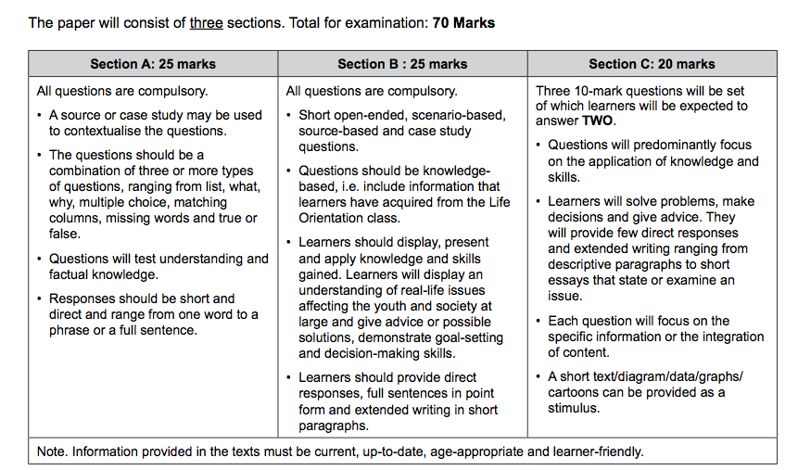
SECTION A: 25 MARKS
Answer ALL the questions in this section.

Question 1: Multiple Choice (5 marks)
Choose the correct answer and write down the letter only.
1.1. We celebrate public holidays because:

A. the country has worked hard and needs some time off
B. it is a way to remember someone who has died
C. it promotes culture and unity among the people of South Africa
D. having a few days rest is part of our democratic rights (1)

1.2. Which one of the following is NOT a basic human right:

A. Transport
B. Equality
C. Human dignity
D. Privacy (1)

1.3. Which one of the following is INCORRECT with regards to the rule of law:

A. Protects the rights of citizens
B. Limits the power of citizens
C. Limits the power of government
D. Maintains order (1)

1.4. Archbishop Desmond Tutu is considered a constitutional role-model because:

A. he is the archbishop of South Africa.
B. he is friends with the Dalai Lama.
C. he upholds the democratic values of human dignity, equality and freedom.
D. All of the above
(1)
1.5. Being a leader means that:

A. you need to be elected into that position.
B. you focus on making everyone happy.
C. you are confident in your decisions
D. you inspire others through your living example.
(1)
(5x1)[5]
(All Lower Order)

Question 2: Give an explanation of a concept (5 marks)

Provide a definition or explanation of the concept:

2.1 Define the concept of a “value”. (1)
2.2 What does it mean ‘to respect the rights of others’? (1)
2.3 Explain the term ‘discrimination’. (1)
2.4. Define “accountability”. (1)
2.5. Explain what the ‘Bill of Rights’ is. (1)
[5]
(All Lower Order)

Question 3: Matching Columns (5 marks)
Match the statements in COLUMN A that best matches each concept in Column B. Write only the appropriate letter (A - G) next to the number (3.1 – 3.5).

Column A | Column B
3.1. 27 April | - Women’s Day
3.2. 16 June | - Heritage Day
3.3. 9 August | - Human rights Day
3.4. 24 September | - Freedom Day
3.5. 21 March | - Youth Day
 | - Nelson Mandela Day
 | - Reconciliation Day
(5x1)[5]
(All Lower Order)

Question 4: Answer the following questions based on the Scenario / Case Study below (10 marks)

How your core values can guide you in your daily decisions

You’re sitting in a class at school. You’re tired and hope this lesson will end soon. It’s not that you’re totally disinterested, but it’s a revision lesson that’s covering content that was covered in the beginning of the year. You feel that it’s a waste of time, and you want to move on to your next lesson. You like your teacher, but sometimes he rambles a bit on the same point.
After the lesson ends and everyone runs off to their next lesson, you overhear two peers making a shocking statement about your teacher.
Your mind begins to replay the comment and you find it inconceivable how two people could ever say something like this about another person. Your internal dialogue concludes that what you heard was a racist remark about your teacher.
Your core values fire off an alarm that this isn’t right and is not acceptable.
Adapted from https://www.theglobeandmail.com/business/careers/workplace-award/article-how-your-core-values-can-guide-you-in-your-daily-decisions/ Accessed 09 December 2019

4.1 Which human rights is a racist remark violating? (2x1)(2)
(Lower Order)
4.2 Describe in TWO ways how the person might have felt when
over-hearing the comment about the teacher and why the person
felt that way. (2x2)(4)
(Middle Order)
4.3 Suggest ONE practical action on how someone can deal with
the human rights violation above. (1x2)(2)
(Higher Order)

4.4. Evaluate whether a good role model stems from their values. (1x2)(2)
(Higher Order)
[10]
TOTAL SECTION A: 25 MARKS

SECTION B: 25 MARKS

Answer ALL the questions in this section. Write your answers in full sentences.
Question 5: PROVIDE THE TERM (5 marks)
Give the term for EACH of the following descriptions. Write only the term next to the question numbers (5.1. to 5.5.).
5.1. Renewing of a relationship between unfriendly groups. (1)
5.2. A place that hears about issues like unfair discimination and hate speech. (1)
5.3. A major international multi-sport event involving athletes with a range of
disabilities. (1)
5.4. The belief that men are better than women. . (1)
5.5. Someone in government, and in other contexts who is considered bad or
dishonest. (1)

[5]
Question 6: (5 marks)
Fill in the missing words in the sentences below. You need only write the correct answers.

6.1. Your values are the qualities that _________ you and help you make
good decisions (1)

6.2. In South Africa we have a government that is elected democratically
and has to govern according to the _________________ (1)

6.3. The ________________ means that the same laws apply to all people at
all times. (1)

6.4. All adult citizens in South Africa have the right to _______ in elections. (1)

6.5. ______________ role models are people who show us how to live our
lives according to the constitutional values. (1)

[5]

Question 7: Setting Goals and giving advice to the youth (10 marks)
Demonstrate goal setting and giving advice on the following situations:

7.1. Advise ONE way how someone can work towards being a positive role
model. (1x2)(2)

7.2. Suggest how you can plan and participate in a National celebration
day. (1x2)(2)
7.3. Give TWO ways how you can apply the constitutional values to your
daily lives. (2x1)(2)
7.4. Describe ONE way how you can care for someone living with
HIV/AIDS? (1x2)(2)
7.5. Evaluate the importance of your values. (1x2)(2)
[10]

Question 8: Give advice (5 marks)

What Is a Negative Role Model?
Negative role models can be public figures, such as celebrities, whose poor behavior and decisions set a negative example for children. They exert an influence similar to that of positive role models, but they differ when it comes to the type of behavior being modeled. According to Roots of Action, positive role models typically inspire a "growth mindset," encouraging kids to work hard and accomplish goals through perseverance. Negative role models are more likely to inspire a "prevention mindset," which encourages kids to pursue avoidance strategies to prevent negative outcomes. Examples of avoidance strategies include cheating on a test to avoid failing or abusing drugs or alcohol to block out life's challenges.

Adapted from https://www.reference.com/world-view/negative-role-model-ecd29fac49546e3f Accessed 10 December 2019]

8.1. Discuss the role that negative role models may play in a person’s life.
(1x2)(2)
(Middle Order)
8.2. Evaluate how role models are chosen and establish how you would
avoid the negative influence of your role model. (1+2)(3)
(Higher Order)

[5]

TOTAL SECTION B: 25 MARKS

Section C: 20 MARKS
Remember to answer any TWO questions in this section. Write your answers in full sentences
Question 9: (10 marks)
Examine the extract below and follow the instructions below.

Kristoff in 'Frozen 2' Is Getting Love for Being the Perfect Role Model for Non-Toxic Masculinity in a Disney Movie

For decades, the "princes," or male leads, in Disney films have been focused on rescuing princesses. Thankfully, with Frozen 2—which hit theaters November 22 2019 —Disney has finally entered the new millennium, featuring a love interest who stands by the strong female lead instead of feeling compelled to step in for her. Kristoff (voiced by Jonathan Groff) is pretty much the Disney "prince" we've always dreamed of.

Jonathan Groff told EW that he sees his character's portrayal in the Frozen sequel as "an enduring, supportive partner," and that's "a beautiful thing to have in an animated movie, both as an example for women of what they deserve and for men to take a page from Kristoff’s book."
Kristen Bell, who lends her voice to Anna, chatted with Jimmy Fallon on The Tonight Show earlier this month, noting, "The thing I'm proudest of is the way they represented Kristoff. ... Little boys don't often see representation of other boys having really big loving feelings." She also said that when she heard the line "I'm here for you, what do you need?" she stood up out of her seat, wondering, "Does anyone know how profound that line is?"

https://www.parents.com/news/kristoff-in-frozen-2-is-getting-love-for-being-the-perfect-example-of-non-toxic-masculinity/ Accessed 09 December 2019

- Define a role model AND briefly explain one positive attribute of a role model.
(1+1)(2)
(Lower Order)
- Discuss TWO possible reasons why movies like ‘Frozen 2’ are important for representing men and their role in a relationship with their partner differently to how it has been in the past. (2x2)(4)
(Middle Order)

- Assess the importance of having role models in our lives (2x2)(4)
(Higher Order)
[10]
Question 10: (10 marks)
Examine the image below and use the points that follow to write your essay:
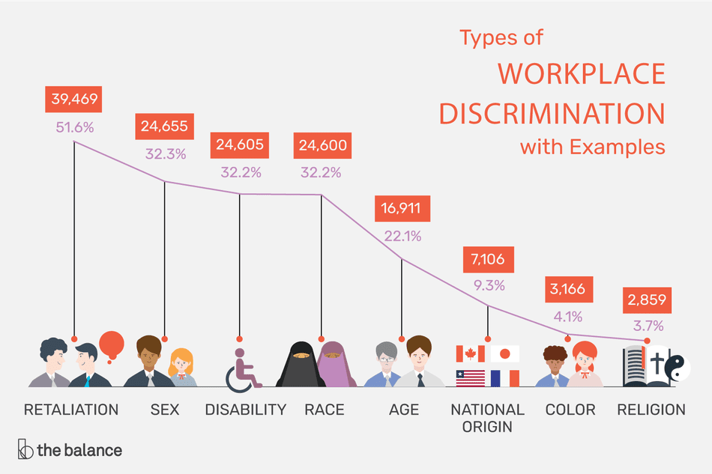
[https://www.thebalancecareers.com/types-of-employment-discrimination-with-examples-2060914 Accessed 10 Decomber 2019]

- Explain the concept of “unfair discrimination”. (2x1)(2)
(Lower Order)

- Discuss TWO possible reasons why it is important to treat people
with a disability equally and what that means? (2x2)(4)
(Middle Order)
- Recommend TWO practical ways how the inclusion of persons with disabilities can be promoted in a school? (2x2)(4)
(Higher Order)

[10]

Question 11: (10 marks)
Study the extract below and answer the questions that follow:

MICHA - BEING BORN WITH HIV

Hi, I’m Micha. I’m 15 years old and I was born with HIV. I found out I was positive when I was about 7. I always had to take meds but I never knew what for. My mom always told me not to let anyone touch my blood and stuff, but I had no idea what she was talking about.
But now I am fully aware of my status and it honestly doesn’t bother me too much. I still have sleep overs and do things any other teen girl would do. I HAVE NO LIMITATIONS
I am still very quiet about my status to my friends. No one at my school knows because there’s too much of a risk of someone telling. But otherwise, I don’t let my HIV affect me in any way. I live the life of a normal teen, I have many friends, and have all the fun in the world. HIV doesn’t have to limit your life. I surely don’t let it!
Adapted from https://www.avert.org/living-with-hiv/stories/micha Accessed 10 December 2019]

- List TWO reasons why people with HIV/AIDS often aren’t treated with
equal rights. (2x1)(2)
(Lower Order)

- Identify TWO rights/needs that people living with HIV/AIDS would need addressed in order to manage their illness. (2x2)(4)
(Middle Order)

- Suggest TWO practical strategies that can be implemented to assist people living with HIV/AIDS to be treated more equally in schools. (2x2)(4)
(Higher Order)

[10]

[TOTAL SECTION C: 20 MARKS]
TOTAL 70 MARKS
MEMORANDUM
SECTION A: 25 MARKS
Answer ALL the questions in this section.
Question 1: Multiple Choice (5 marks)
Choose the correct answer and write down the letter only.
1.1. We celebrate public holidays because:

A. the country has worked hard and needs some time off
B. it is a way to remember someone who has died
C. it promotes culture and unity among the people of South Africa
D. having a few days rest is part of our democratic rights (1)

1.2. Which one of the following is NOT a basic human right:

A. Transport
B. Equality
C. Human dignity
D. Privacy (1)

1.3. Which one of the following is INCORRECT with regards to the rule of law:

A. Protects the rights of citizens
B. Limits the power of citizens
C. Limits the power of government
D. Maintains order (1)

1.4. Archbishop Desmond Tutu is considered a constitutional role-model because:

A. he is the archbishop of South Africa.
B. he is friends with the Dalai Lama.
C. he upholds the democratic values of human dignity, equality and freedom.
D. All of the above
(1)
1.5. Being a leader means that:

A. you need to be elected into that position.
B. you focus on making everyone happy.
C. you are confident in your decisions
D. you inspire others through your living example.
(1)
(5x1)[5]
(All Lower Order)

Question 2: Give an explanation of a concept (5 marks)

Provide a definition or explanation of the concept:

2.1 Define the concept of a “value” . (1)
Something that we believe is important ✓ in life if we value something we take care of and protect it ✓
2.2 What does it mean to respect the rights of others? (1)
Make sure that their rights are upheld and that we don’t infringe on those rights ✓
2.3 Explain the term “discrimination” (1)
the unjust or prejudicial treatment of different categories of people, especially on the grounds of race, age, or sex.✓

2.4. Define “accountability”. (1)
Accountability is when you are responsible for your actions ✓ you are
expected to give a reason for something ✓
2.5. Explain what the ‘Bill of Rights’ is. (1)
Contains the rights of all people in the country ✓
[5]
(All Lower Order)

Question 3: Matching Columns (5 marks)
Match the statements in COLUMN A that best matches each concept in Column B. Write only the appropriate letter (A - G) next to the number (3.1 – 3.5).
Column A | Column B
3.1. 27 April D | - Women’s Day
3.2. 16 June E | - Heritage Day
3.3. 9 August A | - Human rights Day
3.4. 24 September B | - Freedom Day
3.5. 21 March C | - Youth Day
 | - Nelson Mandela Day
 | - Reconciliation Day
(5x1)[5]
(All Lower Order)
Question 4: Answer the following questions based on the Scenario / Case Study below (10 marks)

How your core values can guide you in your daily decisions

You’re sitting in a class at school. You’re tired and hope this lesson will end soon. It’s not that you’re totally disinterested, but it’s a revision lesson that’s covering content that was covered in the beginning of the year. You feel that it’s a waste of time, and you want to move on to your next lesson. You like your teacher, but sometimes he rambles a bit on the same point.
After the lesson ends and everyone runs off to their next lesson, you overhear two peers making a shocking statement about your teacher. You’re likely the only one who heard it, as you were walking directly behind them. They don’t seem to notice that you heard the comment.
Your mind begins to replay the comment and you find it inconceivable how two people could ever say something like this about another person. Your internal dialogue concludes that what you heard was a racist remark about your teacher.
Your core values fire off an alarm that this isn’t right and is not acceptable.
Adapted from https://www.theglobeandmail.com/business/careers/workplace-award/article-how-your-core-values-can-guide-you-in-your-daily-decisions/ Accessed 09 December 2019

4.1 Which human rights is a racist remark violating? (2x1)(2)
(Lower Order)
Right to equality ✓ Right to dignity ✓
4.2 Describe in TWO ways how the person might have felt when over-hearing the comment about the teacher and why the person felt that way. (2x2)(4)
(Middle Order)
The person felt it wasn’t right ✓ it was unacceptable ✓
The person felt this way because they value the constitutional values ✓ of treating people with equality, respect and dignity. ✓ They did not agree with treating someone else this way ✓
It made them feel uncomfortable ✓ it went against their inner values ✓ and caused inner conflict as they felt that something should be done about it ✓ that someone else shouldn’t be treated that way ✓
It made them upset/angry ✓ that other people could speak of someone in this manner ✓
4.3 Suggest ONE practical action on how someone can deal with the
human rights violation above. (1x2)(2)
(Higher Order)
Respect yourself and the rights of others ✓ address this with your peers ✓
You should address the matter with you peers ✓ If you don’t it will continue to make you feel uncomfortable as they have gone against your inner values ✓
Speak to an adult who you trust who can advise you on the situation ✓ so that you can speak up against such violations ✓

4.4. Evaluate whether a good role model stems from their values. (1x2)(2)
(Higher Order)
Yes ✓ A person’s values are expressed by their words and deeds ✓ if the person has good values then they generally do good deeds and things to those around them ✓
Our behaviour is an outward expression of our inner values ✓ if we are a good role model then we generally have good values within ✓ that people aspire to be like or look up to ✓
[10]
TOTAL SECTION A: 25 MARKS

SECTION B: 25 MARKS

Answer ALL the questions in this section. Write your answers in full sentences.
Question 5: PROVIDE THE TERM (5 marks)
Give the term for EACH of the following descriptions. Write only the term next to the question numbers (5.1. to 5.5.).
5.1. Renewing a relationship between unfriendly groups. (1)
Reconciliation ✓
5.2. A place that hears about issues like unfair discimination and hate speech. (1)

High Court/Equality Court/CCMA ✓

5.3. A major international multi-sport event involving athletes with a range of disabilities (1)

Paralympics ✓

5.4. The belief that men are better than women . (1)

Sexism/chauvinism ✓

5.5. Someone in government and in other contexts who is considered bad or
dishonest. (1)
Corrupt ✓
[5]

Question 6 (5 marks)
Fill in the missing words in the sentences below. You need only write the correct answers.

6.1. Your values are the qualities that _________ you and help you make
good decisions (1)
Guide/motivate/encourage/direct ✓

6.2. In South Africa we have a government that is elected democratically
and has to govern according to the _________________ (1)
Constituition ✓

6.3. The ________________ means that the same laws apply to all people at
all times. (1)
Rule of law ✓

6.4. All adult citizens in South Africa have the right to _______ in elections. (1)
vote ✓

6.5. ______________ role models are people who show us how to live our
lives according to the constitutional values. (1) Positive ✓
[5]
Question 7: Setting Goals and giving advice to the youth (10 marks)
Demonstrate goal setting and giving advice on the following situations:

7.1. Advise ONE way how someone can work towards being a positive
role model. (1x2)(2)

Lead by example ✓ and ensure that your actions are respectful and exemplary. ✓
Do not be afraid to be different ✓ that doing the right thing may mean you are sometimes standing on your own ✓
show respect for everyone ✓ and communicate with everyone ✓ be knowledgeable and well rounded ✓ have humility ✓ go beyond what is expected of you ✓

7.2. Suggest how you can plan and participate in a National celebration
day. (1x2)(2)
You can learn about why the day is celebrated ✓ you can do something to commemorate the day ✓ like doing something to celebrate the different cultures on Heritage Day ✓ (learners can be awarded a mark for specific examples given)
7.3. Give TWO ways how you can apply the constitutional values to your
daily lives. (2x1)(2)
Always treat people with dignity and respect ✓ treat all people as equals ✓ show respect for others' rights ✓ stand up for your own rights ✓
7.4. Describe ONE way how can you care for someone living with
HIV/AIDS (1x2)(2)
People living with HIV need care and support from their friends ✓ they need to feel loved and accepted ✓ that you won’t treat them differently because of their status ✓ you need to encourage them with their healthy lifestyle habits ✓ Encourage them to get treatment if they are sick ✓ being knowledgeable about HIV so that you are informed about it and are able to speak openly about it ✓

7.5. Evaluate the importance of your values. (1x2)(2)
Values inform our thoughts, words and actions ✓ they help us set goals and work on the life we want to create ✓
it helps us make decisions ✓ we make decisions that are in line with our values and what is important to us ✓
it helps us stay true to ourselves ✓ we behave in accordance to our values ✓ stops us from poor decision making that is incongruent with who we are ✓
we don’t make decisions against our values and if we do it makes us feel uncomfortable or unsettled ✓
helps us to treat people better✓

Question 8: Give advice (5 marks)

What Is a Negative Role Model?
Negative role models can be public figures, such as celebrities, whose poor behavior and decisions set a negative example for children. They exert an influence similar to that of positive role models, but they differ when it comes to the type of behavior being modeled. According to Roots of Action, positive role models typically inspire a "growth mindset," encouraging kids to work hard and accomplish goals through perseverance. Negative role models are more likely to inspire a "prevention mindset," which encourages kids to pursue avoidance strategies to prevent negative outcomes. Examples of avoidance strategies include cheating on a test to avoid failing or abusing drugs or alcohol to block out life's challenges.

Adapted from https://www.reference.com/world-view/negative-role-model-ecd29fac49546e3f Accessed 10 December 2019]

8.1. Discuss the role that negative role models may play in a person’s life.
(1x2)(2)
(Middle Order)
Negative role models may still motivate children, but they often do so by offering unproductive strategies to avoid failure. ✓
Children may come to view the behavior of negative role models as safe, conventional and acceptable, ✓ causing them to normalize negative behavior, such as violence, sexism or racism. ✓
It could result in children using avoidance strategies ✓ to avoid negative outcomes ✓ that may not be healthy ✓
It could result in children making risky behaviour ✓ in an effort to be like their role model ✓

8.2. Evaluate how role models are chosen and establish how you would
avoid the negative influence of your role model. (1+2)(3)
(Higher Order)
Role models are chosen by accordance to what we aspire to be like and the values we have ✓
If a person is in line with what we want in life and the values we have then they will become a role model for someone ✓ this can be positive and negative. ✓

You could aspire to their qualities that you value ✓ and not the whole person to avoid the influence of a negative role model ✓
You would need to have clear values beforehand ✓ to know that the behaviour of chosen role model is not in line with your values ✓ and therefore not want to behave similarly ✓
[5]

TOTAL SECTION B: 25 MARKS

Section C: 20 MARKS

Remember to answer any TWO questions in this section. Write your answers in full sentences
Question 9: (10 marks)
Examine the image below and follow the instructions below.

Kristoff in 'Frozen 2' Is Getting Love for Being the Perfect Role Model for Non-Toxic Masculinity in a Disney Movie

For decades, the "princes," or male leads, in Disney films have been focused on rescuing princesses.

Thankfully, with Frozen 2—which hit theaters November 22 2019 —Disney has finally entered the new millennium, featuring a love interest who stands by the strong female lead instead of feeling compelled to step in for her. Kristoff (voiced by Jonathan Groff) is pretty much the Disney "prince" we've always dreamed of.

Jonathan Groff told EW that he sees his character's portrayal in the Frozen sequel as "an enduring, supportive partner," and that's "a beautiful thing to have in an animated movie, both as an example for women of what they deserve and for men to take a page from Kristoff’s book."
Kristen Bell, who lends her voice to Anna, chatted with Jimmy Fallon on The Tonight Show earlier this month, noting, "The thing I'm proudest of is the way they represented Kristoff. ... Little boys don't often see representation of other boys having really big loving feelings." She also said that when she heard the line "I'm here for you, what do you need?" she stood up out of her seat, wondering, "Does anyone know how profound that line is?"

https://www.parents.com/news/kristoff-in-frozen-2-is-getting-love-for-being-the-perfect-example-of-non-toxic-masculinity/ Accessed 09 December 2019

- Define a role model AND briefly explain one positive attribute of a
role model. (1+1)(2)
(Lower Order)
A role model is a person looked to by others ✓ as an example to be imitated, someone looked up to by those who aspire ✓ to be “like them”. Generally, someone who has achieved something ✓ or has acted in a way that is inspirational to those who are interested in them ✓ and what they stand for. ✓

A positive role model is kind, caring, generous, respectful, helps others etc ✓

- Discuss TWO possible reasons why movies like ‘Frozen 2’ are important
for representing men and their role in a relationship with their partner
differently to how it has been in the past. (2x2)(4)
(Middle Order)
It is important for boys to have role models such as these ✓ we need to reduce the impact of gender stereotypes ✓ toxic masculinity ✓ and other negative perceptions of men in society ✓ that men can play a more sensitive and supportive role with their partners ✓
It also shows women that they deserve more from their partners ✓ that men aren’t supposed to treat women in a sexist way ✓ and they should be encouraging women to grow and be great ✓ that women aren’t a damsel in distress that needs saving ✓
It can help alleviate the impact of gender based violence ✓ and women being treated badly in general ✓
It can help boys be more sensitive ✓ and don’t feel like they have to act in a “masculine” way to be considered manly ✓ it changes the way women and men see men ✓ and creates positive role models for boys and men to look up to ✓

- Assess the importance of having role models in our lives (2x2)(4)
(Higher Order)
It’s important to look up to qualities that people may have ✓ but not to hold the person up on a pedestal.✓ People are human after all ✓ - they are bound to make mistakes ✓

It’s important to have people to look up to as they inspire us ✓ to be better versions of ourselves ✓ but we need to also remember that they are also human and with their flaws ✓ it would be better to look up to their characteristics, qualities and values that they portray in their lives ✓ rather than the person themself. ✓ They are bound to disappoint at some stage ✓

[10]

Question 10: (10 marks)
Examine the image below and use the points that follow to write your essay:
[https://www.thebalancecareers.com/types-of-employment-discrimination-with-examples-2060914 Accessed 10 Decomber 2019]

- Explain the concept of “unfair discrimination”. (2x1)(2)
(Lower Order)
Unfair discrimination infringes on the rights of the person and is one-sided ✓
It withholds benefit or opportunity for the person ✓
(Learners can also be awarded marks if they use an example that explains the concept). ✓✓
- Discuss TWO possible reasons why it is important to treat people
with a disability equally and what that means? (2x2)(4)
(Middle Order)
All people need to be treated equally (right to equality) regardless of their disability ✓. That means that there needs to be provisions ✓ in place so that they are not discriminated against ✓ and that their rights are not being disrespected.✓
It means that they need to be treated the same way as you would want to be treated ✓ with equal access and equal opportunities ✓
They want to be treated the same ✓ not to be patronised ✓ or assumed that they need assistance ✓ ask before you assist them ✓
people with disability are often treated badly or harshly. ✓ because they are seen as inferior or unable ✓ they want to be seen the same ✓ as a person not as a disability ✓

- Recommend TWO practical ways how the inclusion of persons with disabilities can be promoted in a school? (2x2)(4)
(Higher Order)
All people have the right to equal access to services and opportunities. ✓ Those with special needs may need a teacher who is trained to help them.✓
There can be a zero tolerance for people treating people with a disability harshly ✓ or unfairly ✓ learners can be encouraged to include those with a disability ✓
Schools can do educational talks/programmes/assemblies on various disabilities ✓ to help make learners more aware. They tend to not include when they don’t understand a disability ✓
Schools can put provisions in place for people with disabilities ✓ e.g. wheelchair ramps/access for those who need it ✓
[10]

Question 11: (10 marks)
Study the extract below and answer the questions that follow:

MICHA - BEING BORN WITH HIV

Hi, I’m Micha. I’m 15 years old and I was born with HIV. I found out I was positive when I was about 7. I always had to take meds but I never knew what for. My mom always told me not to let anyone touch my blood and stuff, but I had no idea what she was talking about.
But now I am fully aware of my status and it honestly doesn’t bother me too much. I still have sleep overs and do things any other teen girl would do. I HAVE NO LIMITATIONS
I am still very quiet about my status to my friends. No one at my school knows because there’s too much of a risk of someone telling. But otherwise, I don’t let my HIV affect me in any way. I live the life of a normal teen, I have many friends, and have all the fun in the world. HIV doesn’t have to limit your life. I surely don’t let it!
Adapted from https://www.avert.org/living-with-hiv/stories/micha Accessed 10 December 2019]

- List TWO reasons why people with HIV/AIDS often aren’t treated with
equal rights. (2x1)(2)
(Lower Order)
They are often treated differently because there is a very negative stigma ✓ attached to the disease.
People are afraid of those living with HIV/AIDS as they don’t always know enough about it and are worried they might get it ✓
There is a high cost associated with the health care of the disease ✓
Sometimes people don’t want to hire them because they are afraid they will be absent too much due to illness ✓ or pass it on to someone else ✓

- Identify TWO rights/needs that people living with HIV/AIDS would need addressed in order to manage their illness.
(2x2)(4)
(Middle Order)

They need access to health care and counselling - including advice on diet, ARV’s and counselling. Their caregivers also need help. Everyone involved needs to deal with feelings of depression, grief and trauma - all need access to counselling services.

People with HIV need access to information - accurate information to understand and manage their illness. Informed choices about treatment etc.

Have the right to privacy - right to keep medical info private. Health care workers may not share your info or treat you differently if you are HIV-positive.✓

- Suggest TWO practical strategies that can be implemented to assist people living with HIV/AIDS to be treated more equally in schools.
(2x2)(4)
(Higher Order)

Education and awareness of HIV ✓ so that it can be spoken about openly and the stigma attached can be eradicated ✓ they want to feel the same as everyone else ✓
They can be provided with support and encouragement ✓ so that it can help reduce the stress and stressful situations ✓ encourage them to get medical treatment if they are sick ✓
The school can provide healthy food at the school tuckshop ✓ so that they get a healthy and balanced diet ✓
The school can provide a good support and catch up system ✓ to assist learners when they are sick or absent from school ✓
The school can provide a support group or counselling ✓ for those who are struggling to deal with the feelings of depression, grief , trauma etc ✓

[10]

[TOTAL SECTION C: 20 MARKS]

