Grade 8 Life Orientation Exam
Constitutional Rights and Responsibilities Term 3&4
2020

Reminder: This Question Paper includes components of CRR
from terms THREE and FOUR. The NOVEMBER Grade 8
Question Paper should include questions from each
topic.
LIFE ORIENTATION GRADE 8
November Exam 2020
Possible examination questions: Topic – Constitutional Rights and Responsibilities
For Grade 8: Ensure Cognitive Levels in final paper are 40% LO, 40% MO and 20% HO
NOTE: This examination will comprehensively address the content, knowledge and skills covered during the first and second terms (CAPS, Outline for
Examinations, pg. 28)
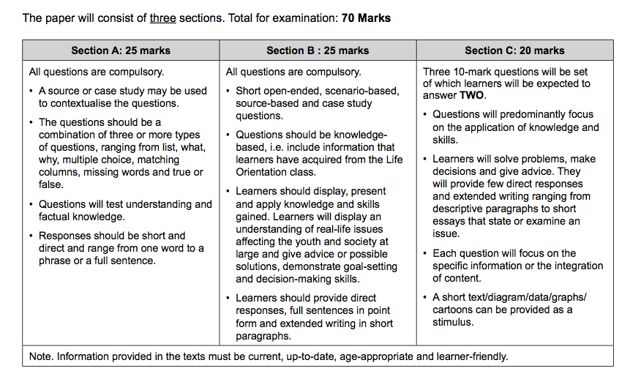

SECTION A: 25 MARKS
Answer ALL the questions in this section.
Question 1: Multiple Choice (5 marks)
Choose the correct answer and write down the letter only.
1.1. Factors that promote nation building include:

A Employment, empowerment, education, tourism
B Sport, empowerment, illiteracy, inflation
C Empowerment, multiculturalism, power, crime
D Sport, diversity, literacy, inflation (1)

1.2. Which of the following organisations DOES NOT deal with complaints
about violations of human rights:

A. South African Human Rights Commission
B. The South African Relations Commission
C. Public Protector
D. Commission for Gender Equality (1)

1.3. “People being harmed and discriminated against who are from Malawi “
is an example of :

A. Genocide
B. Nation building
C. Xenophobia
D. Apartheid (1)

1.4. The segregation policies use to discriminate against non-white citizens in South Africa is known as:

A. Genocide
B. Nation building
C. Xenophobia
D. Apartheid (1)

1.5. Which is an example of ‘gender equity’:

A. Allowing a boys and girls soccer team at the school.
B. Discouraging girls to play sport because it is unfeminine
C. Allowing a gender pay gap and paying one gender more
D. Giving a male a promotion because he is the best man for the job

(1)
(5x1)(5)
(All Lower Order)

Question 2: Give an explanation of a concept: (5 marks)

Provide a definition or explanation of the concept:

2.1 What are ‘human rights’? (1)
2.2 Explain what ‘Gender Equity’ means. (1)
2.3 Define ‘sexual harassment’. (1)
2.4. Why is South Africa referred to as the ‘Rainbow nation’ (1)
2.5. What does ‘cultural norms’ refer to? (1)
(5)
(All Lower Order)

Question 3: Matching Columns (5 marks)
Match the concept in COLUMN A that best matches each statement in Column B. Write only the appropriate letter (A - G) next to the number (3.1 – 3.5).

Column A | Column B
3.1. Labour relations | A. The government cannot listen to your calls.
3.2. Freedom and security | B. You have the right to present petitions peacefully.
3.3. Assembly and demonstration | C. All people must be treated equally.
3.4. Personal Privacy | D. You have the right to be treated fairly at work and you can go on strike.
3.5. Slavery, servitude and forced labour | E. You have the right to be free of all forms of violence.
 | F. Your citizenship can never be taken away from you.
 | G. You don’t have the right to choose who you work for.
(5x1)(5)
(All Lower Order)

Question 4: Answer the following questions based on the Case Study below:
(10 marks)

Racism still rife in schools

We were sitting in our Life Orientation class discussing culture and diversity and we were encouraged to share our cultures with the other learners in the class. At first I felt nervous to speak. But I shared about my culture and traditions of animal slaughters and traditional parties. The other learners gasped and reacted in a shocked way. They made awful comments on “how can you do that” and “you people are so weird”. I remember feeling hurt and confused. How in 2020, could people be so discriminative, narrow-minded and hurtful. It continued after that with comments like “if you didn’t speak with a black accent you’d probably get a better English oral mark”. When I spoke up people would just say, “it’s just a joke, relax, why are you getting so uptight”.

Source: Anonymous

4.1 Name TWO human rights being violated in the case study above. (2x1)(2)
(Lower Order)
4.2 Explain TWO reasons why racism exists today despite South Africa
being a democratic country since 1994. (2x2)(4)
(Middle Order)
4.3 Discuss whether the comments are something this person should just
ignore or whether they should do something about it and what can be
done to change this type of thinking and this treatment of people in
the school and ensure respect for diversity. (1x2)(2)
(Middle Order)
4.4. Recommend ONE practical way how schools can eradicate racism in schools
and promote respect for other cultures and diversity. (1x2)(2)
(Higher Order)
(10)
[TOTAL SECTION A: 25 MARKS]

SECTION B: 25 MARKS

Answer ALL the questions in this section. Write your answers in full sentences.
Question 5: Provide the Term (5 marks)
Give the term for EACH of the following descriptions. Write only the term next to the question numbers (5.1. to 5.5.)
5.1. Working together towards strengthening all the systems and attitudes
that give people human rights where we have a strong nation of which
we can be proud. (1)

5.2. The planned extermination of ethnic, racial or religious group of people. (1)

5.3. Beliefs, thoughts and actions based on the idea that one race is
innately superior to another. (1)

5.4. Any act or threat that causes physical, sexual or psychological harm
because of gender. (1)

5.5. The term used to describe the different languages, traditions and religions
of all our cultures. (1)
(5)
(All Lower Order)
Question 6: (5 marks)
Fill in the missing words or concepts for the following statements or sentences:

6.1. _____________ is a very powerful tool for building national identity and
harmony because we feel united when a South African team or person
does well at an international event. We celebrate and we are able to
forget our differences. (1)
6.2. The __________________ is the highest law in the land and states how
the government must be made up and how the country must be run. (1)
6.3. If someone has been discriminated against we say that their rights have
been _____________________ . (1)
6.4. Victims of gender-based violence suffer from __________ harm as well as
physical harm. (1)
6.5. There is a misconception that gender based violence can’t happen to men.
This causes men to be _____________ to report it as they may not be
taken seriously. (1)
(5)
(All Lower Order)
Question 7: (10 marks)

7.1. List TWO ways how you can be positive about nation building in
your community. (2x1)(2)
(Lower Order)
7.2. Identify ONE way that you can support nation building at school. (1x2)(2)
(Middle Order)
7.3. Suggest ONE resource for help, where someone who is a survivor of sexual
abuse or gender based violence can go for help. (1x2)(2)
(Higher Order)
7.4. Discuss ONE way you might identify someone who may have been
a victim of gender-based violence? (1x2)(2)
(Middle Order)
7.5. Advise ONE way how one can respect cultural differences. (1x2)(2)
(Higher Order)
(10)
Question 8: Give advice (5 marks)
Standing up against a culture
We were all sitting around at break time discussing an EMS test that we had just written the lesson before break. Joshua said, “that test was tough”. Kennedy nodded his head in agreement and said, “I think I did ok, but that was not easy at all”. Then another learner that was part of the group said, “jeepers, that test raped me”. We all went our separate ways and carried on with school and lessons for the rest of the day. Later that night I thought about it. It really bothered me that the word “raped” was used in such a casual and matter-fact way which had very little to do with actually being raped. I had a very uneasy feeling in my stomach. It wasn’t ok.
Source: Anonymous

8.1. Give ONE reason why this experience bothered this person? (1)
(Lower Order)

8.2. Suggest TWO ways how young people can be assertive when they witness
sexist comments (2x2)(4)
(Higher Order)
(5)
[TOTAL SECTION B: 25 MARKS]

SECTION C: 20 MARKS
Remember to answer any TWO questions in this section. Write your answers in full sentences
Question 9: (10 marks)
Examine the extract below and follow the instructions below.

Minister Nathi Mthethwa: National Convention on Nation Building, Social Cohesion and Safe Communities
The concept of nation building and social cohesion project precedes the dawn of democracy in 1994. That is, the mass democratic movement was always seized with the question as to what kind of society South Africa should be once it is liberated from its colonialism and apartheid. And nowhere is this more self-evident than in the series of papers on the National Question.

[Adapted from https://www.gov.za/speeches/ation-building-social-cohesion-6-feb-2020-0000 Accessed 11 June 2020]

- Explain the purpose of ‘nation building’. (1x2)(2)
(Lower Order)

- Discuss TWO reasons why human rights are an important component of
nation building. (2x2)(4)
(Middle Order)
- Suggest TWO ways that you as an individual can promote nation building. (2x2)(4)
(Higher Order)
(10)

Question 10: (10 marks)
Read the extract below and use the points that follow to write your essay:

Men and Boys Must Take Action to End Gender-Based Violence
Gender-based violence (GBV) is a widely known problem that is mainly perpetrated by men, and community members and individuals who tolerate negative masculine practices widely in Tanzania. Ending violence in our communities is a responsibility of the whole community and it is significant that men and boys are active participants and promoters of change to get rid of the current status quo. On the same scale, it is also critical to combat not only the individual instances of violence, but also the systemic forms of violence, as violence does not occur in a vacuum but rather in a society that condones and encourages it.
[Adapted from https://genderjustice.org.za/news-item/men-and-boys-must-take-action-to-end-gender-based-violence/ Accessed 11 June 2020]

- Name TWO emotional effects that someone might experience
who has suffered from gender based violence. (2x1)(2)
(Lower Order)

- Discuss TWO reasons why South Africa still struggles with high
levels of gender based violence despite having excellent laws
and human rights in place to protect them? (2x2)(4)
(Middle Order)
- Suggest TWO strategies that men and boys can do to be part of the
solution to gender based violence. (2x2)(4)
(Higher Order)
(10)

Question 11: (10 marks)
Study the image below and answer the questions that follow:
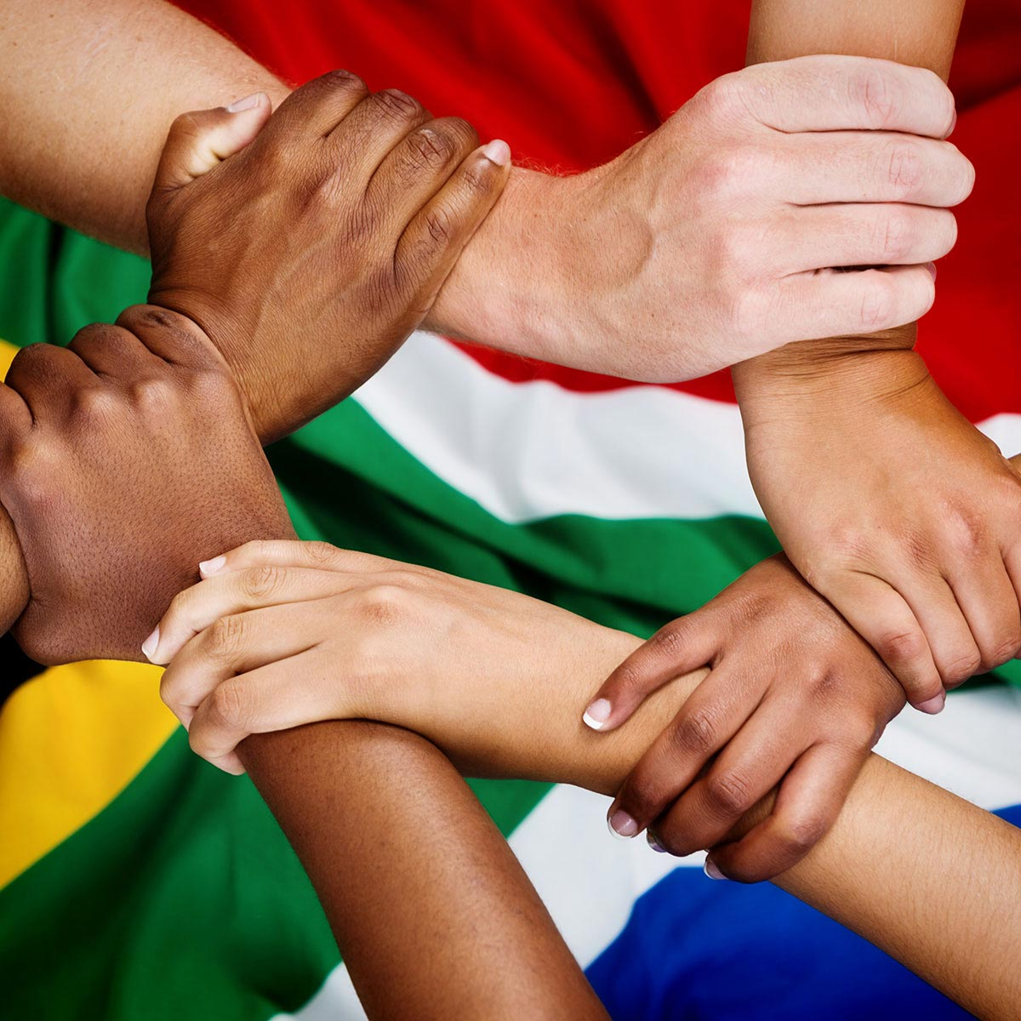
https://www.inclusionsouthafrica.co.za [Accessed 11 June 2020]

- Explain what ‘unity in diversity’ means? (1x2)(2)
(Lower Order)

- Explain TWO ways how the human right of ‘freedom of religion, belief
and opinion’ promotes diversity and contributes to nation building. (2x2)(4)
(Middle Order)

- Recommend TWO ways South African teens can appreciate and
celebrate diversity and in this way help with nation building. (2x2)(4)
(Higher Order)

(10)

[TOTAL SECTION C: 20 MARKS]

MEMORANDUM
SECTION A: 25 MARKS
Answer ALL the questions in this section.
Question 1: Multiple Choice (5 marks)
Choose the correct answer and write down the letter only.
1.1. Factors that promote nation building include:

A Employment, empowerment, education, tourism
B Sport, empowerment, illiteracy, inflation
C Empowerment, multiculturalism, power, crime
D Sport, diversity, literacy, inflation (1)

1.2. Which of the following organisations DOES NOT deal with complaints
about violations of human rights:

A. South African Human Rights Commission
B. The South African Relations Commission
C. Public Protector
D. Commission for Gender Equality (1)

1.3. “People being harmed and discriminated against who are from Malawi “
is an example of :

A. Genocide
B. Nation building
C. Xenophobia
D. Apartheid (1)

1.4. The segregation policies used to discriminate against non-white citizens in
South Africa is known as:

A. Genocide
B. Nation building
C. Xenophobia
D. Apartheid (1)

1.5. Which is an example of ‘gender equity’:

A. Allowing a boys and girls soccer team at the school.
B. Discouraging girls to play sport because it is unfeminine
C. Allowing a gender pay gap and paying one gender more
D. Giving a male a promotion because he is the best man for the job
(1)
(5x1)(5)
(All Lower Order)

Question 2: Give an explanation of a concept: (5 marks)

Provide a definition or explanation of the concept:

2.1 What are ‘human rights’? (1)
Rights and freedoms that everyone has from birth because they are humans OR
Fundamental rights that people are entitled to because they are human
OR
They are universal rights and the same for everyone regardless of race, culture and gender. ✓
2.2 Explain what ‘Gender Equity’ means. (1)
That men and women have equal opportunities and rights and are treated equally ✓

2.3 Define ‘sexual harassment’. (1)
Any unwanted sexual words or actions ✓
2.4. Why is South Africa referred to as the ‘Rainbow nation’ (1)
Our society is made up of people from many different nations ✓ like the many different colours of a rainbow / the diversity of cultures
2.5. What does ‘cultural norms’ refer to? (1)
It refers to pattern of behaviour or values that everyone in a particular culture follows as normal behaviour ✓
OR
They can also be viewed as traditions ✓
(5)
(All Lower Order)

Question 3: Matching Columns (5 marks)
Match the concept in COLUMN A that best matches each statement in Column B. Write only the appropriate letter (A - G) next to the number (3.1 – 3.5).

Column A | Column B
3.1. Labour relations (D) | A. The government cannot listen to your calls.
3.2. Freedom and security (E) | B. You have the right to present petitions peacefully.
3.3. Assembly and demonstration (B) | C. All people must be treated equally.
3.4. Personal Privacy (A) | D. You have the right to be treated fairly at work and you can go on strike.
3.5. Slavery, servitude and forced labour (G) | E. You have the right to be free of all forms of violence.
 | F. Your citizenship can never be taken away from you.
 | G. You don’t have the right to choose who you work for.
(5x1)(5)
(All Lower Order)

Question 4: Answer the following questions based on the Case Study below:
(10 marks)

Racism still rife in schools

We were sitting in our Life Orientation class discussing culture and diversity and we were encouraged to share our cultures with the other learners in the class. At first I felt nervous to speak. But I shared about my culture and traditions of animal slaughters and traditional parties. The other learners gasped and reacted in a shocked way. They made awful comments on “how can you do that” and “you people are so weird”. I remember feeling hurt and confused. How in 2020, could people be so discriminative, narrow-minded and hurtful. It continued after that with comments like “if you didn’t speak with a black accent you’d probably get a better English oral mark”. When I spoke up people would just say, “it’s just a joke, relax, why are you getting so uptight”.

Source: Anonymous

4.1 Name TWO human rights being violated in the case study above. (2x1)(2)
(Lower Order)
Any TWO of the below or any relevant answers for ONE mark each
- Right to dignity ✓
- Right to equality ✓
- Right to language and culture ✓
4.2 Explain TWO reasons why racism exists today despite South Africa being a
democratic country since 1994. (2x2)(4)
(Middle Order)
Any TWO of the below or any relevant answers for TWO marks each
(i.e. ONE mark for statement and ONE mark for qualifier / explanation)
There’s an assumption that all South Africans should just adopt a Westernized way of thinking ✓ they don’t allow for people to still have their culture and heritage as part of who they are ✓
They think that is a problem that only exists in the past ✓ but the problem is it has infiltrated mindsets since the past and it still needs to be corrected ✓

4.3 Discuss whether the comments are something this person should just
ignore or whether they should do something about it and what can be done
to change this type of thinking and this treatment of people in the
school and ensure respect for diversity. (1x2)(2)
(Middle Order)
Any ONE of the below or any relevant answer for TWO marks
(i.e. ONE mark for statement and ONE mark for qualifier / explanation)
They should definitely do something like: Reported this to a teacher ✓ so that the issue can be addressed and taken further. ✓
Create a petition and take it to the management of the school✓ so that they can address these types of racism in the school ✓
4.4. Recommend ONE practical way how schools can eradicate racism in
schools and promote respect for other cultures and diversity. (1x2)(2)
(Higher Order)
Any ONE of the below or any relevant answer for TWO marks
(i.e. ONE mark for statement and ONE mark for qualifier / explanation)
Educate school community on the problem ✓ to become aware of their implied bias – their unconscious bias and beliefs✓

Create awareness✓ shift the current mindset that learners and teachers may have on these topics✓
Training and recruiting of teachers that reflect the diversity of students, ✓ so that teachers can disrupt the rigid narratives of racism ✓

Educate every learner to do their part in promoting inclusion, justice, dignity and combat racism in all its manifestations,✓ by encouraging them to report it✓
(10)
[TOTAL SECTION A: 25 MARKS]

SECTION B: 25 MARKS

Answer ALL the questions in this section. Write your answers in full sentences.
Question 5: Provide the Term (5 marks)
Give the term for EACH of the following descriptions. Write only the term next to the question numbers (5.1. to 5.5.).
5.1. Working together towards strengthening all the systems and attitudes
that give people human rights where we have a strong nation of which
we can be proud. (1)
Nation building ✓

5.2. The planned extermination of ethnic, racial or religious group of people. (1)

Genocide ✓

5.3. Beliefs, thoughts and actions based on the idea that one race is
innately superior to another. (1)

Racism ✓

5.4. Any act or threat that causes physical, sexual or psychological harm
because of gender. (1)

Gender based violence / domestic violence / sexual harassment ✓

5.5. The term used to describe the different languages, traditions and religions
of all our cultures (1)

Cultural diversity ✓
(5)
(All Lower Order)

Question 6: (5 marks)
Fill in the missing words or concepts from the following statements or sentences:

6.1. _____________ is a very powerful tool for building national identity and
harmony because we feel united when a South African team or person
does well at an international event. We celebrate and we are able to
forget our differences. (1)
Sport ✓
6.2. The __________________ is the highest law in the land and states how
the government must be made up and how the country must be run. (1)
Constitution ✓
6.3. If someone has been discriminated against we say that their rights have
been _____________________ . (1)
Violated ✓
6.4. Victims of gender-based violence suffer from __________ harm as well as
physical harm. (1)
Emotional / Psychological / Verbal ✓
6.5. There is a misconception that gender based violence can’t happen to men.
This causes men to be _____________ to report it as they may not be
taken seriously. (1)
fearful / afraid / hesitant ✓
(5)
(All Lower Order)

Question 7: (10 marks)

7.1. List TWO ways how you can be positive about nation building in
your community. (2x1)(2)
(Lower Order)

Any TWO of the below or any relevant answers for ONE mark each

- Talk positively about the country and its people ✓
- Support the leadership within the country ✓
- Keep your community clean, do not litter, recycle and re-use ✓
- Show pride in your community and neighborhood ✓
- Help and support others /volunteer ✓
- Promote law and order ✓
- Practice UBUNTU in everyday life
- Appreciate and respect different cultures /genders/religions
- Become knowledgeable – to understand other cultures that enrich society

7.2. Identify ONE way that you can support nation building at school. (1x2)(2)
(Middle Order)
Any ONE of the below or any relevant answer for TWO marks
(i.e. ONE mark for statement and ONE mark for qualifier / explanation)

Celebrating national events with enthusiasm ✓ and be positive and passionate about the our diversity to celebrate diversity ✓

Learn about South afican history ✓ to best understand events that unfolded and have compassion for people ✓

Learn about the concept of nation building✓ so that you can be positive and proud of your country ✓

get involved in school activities and outreaches to help other people ✓ It provides a platform for people to talk about these issues ✓

7.3. Suggest ONE resource for help, where someone who is a survivor of sexual
abuse or gender based violence can go for help. (1x2)(2)
(Higher Order)

Any ONE of the below or any relevant answer for TWO marks
(i.e. ONE mark for statement and ONE mark for qualifier / explanation)
Police ✓, because they offer medical attention; shelter and victim counselling✓

Counsellor / counselling centres✓ who provides counselling and education to help in cases of domestic violence and trauma ✓
Rape crisis ✓ to talk about the incident and find emotional / psychological support✓
POWA✓, they offer temporary shelter for and legal help to women who have experienced violence✓
Childline South Africa✓, they are a non-profit organization that helps abused children and their families with a free counselling service✓

Any NPO or NGO that deals with violence / sexual abuse / including legal advice ✓ their intention / target is often to reduce secondary victimisation and to build a case ready for successful prosecution. ✓

7.4. Discuss ONE way you might identify someone who may have been
a victim of gender-based violence? (1x2)(2)
(Middle Order)
Any ONE of the below or any relevant answer for TWO marks
(i.e. ONE mark for statement and ONE mark for qualifier / explanation)
They may have physical signs: beatings / wounds etc ✓ which in many cases are hidden from public✓
They may become withdrawn and distant from other people ✓ because they are shy and afraid people may notice that they are being abused✓

They may avoid people or situations or family member who are perpetrators✓ that remind them of the assault or avoid contact / repeat of violent acts ✓
They may act scared and afraid✓ of people similar to their abuser ✓
They are depressed / prefer to be alone / do not attend social gatherings ✓ because they are afraid people may ask / do not want to answer questions ✓

7.5. Advise ONE way how you can respect cultural differences. (1x2)(2)
(Higher Order)
Any ONE of the below or any relevant answer for TWO marks
(i.e. ONE mark for statement and ONE mark for qualifier / explanation)
Become aware of the differences✓ so that you can use this knowledge to respect differences ✓
Share and experience other cultures - like foods and traditions ✓ it shows your willingness to recognize other cultures and how they have enriched South African society ✓
Establish relationships and friendships with people from other cultures✓ so that you can experience different cultures firsthand - to show respect for our differences ✓

Question 8: Give advice (5 marks)
Standing up against a culture
We were all sitting around at break time discussing an EMS test that we had just written the lesson before break. Joshua said, “that test was tough”. Kennedy nodded his head in agreement and said, “I think I did ok, but that was not easy at all”. Then another learner that was part of the group said, “jeepers, that test raped me”. We all went our separate ways and carried on with school and lessons for the rest of the day. Later that night I thought about it. It really bothered me that the word “raped” was used in such a casual and matter-fact way which had very little to do with actually being raped. I had a very uneasy feeling in my stomach. It wasn’t ok.
Source: Anonymous

8.1. Give ONE reason why this experience bothered this person (1)
(Lower Order)
Any valid explanation for ONE mark
- It perpetuates the rape and sexist culture using derogatory and sexist comments in a flippant manner ✓
- By being silent you allow the behaviour to continue ✓
- Not saying something might imply that you are ok with such behaviour ✓

8.2. Suggest TWO ways how young people can be assertive when they witness sexist comments (2x2)(4)
(Higher Order)
Any TWO of the below or any relevant answers for TWO marks each
(i.e. ONE mark for statement and ONE mark for qualifier / explanation)
They could just comment that it sounds sexist ✓ thereby making their position clear that they don’t support such comments✓

They could ask what was meant by that comment ✓ thereby giving the person an opportunity to rephrase or correct themselves while still making it clear that they do not approve of such comments. ✓

They could take the person aside so they don’t feel attacked and get defensive ✓ before sharing with them that their comments were sexist and inappropriate. ✓
(5)

[TOTAL SECTION B: 25 MARKS]

Section C: 20 MARKS
Remember to answer any TWO questions in this section. Write your answers in full sentences
Question 9: (10 marks)
Examine the extract below and follow the instructions below.

Minister Nathi Mthethwa: National Convention on Nation Building, Social Cohesion and Safe Communities
The concept of nation building and social cohesion project precedes the dawn of democracy in 1994. That is, the mass democratic movement was always seized with the question as to what kind of society South Africa should be once it is liberated from its colonialism and apartheid. And nowhere is this more self-evident than in the series of papers on the National Question.

[Adapted from https://www.gov.za/speeches/ation-building-social-cohesion-6-feb-2020-0000 Accessed 11 June 2020]

- Explain the purpose of ‘nation building’. (1x2)(2)
(Lower Order)
Any valid statement for TWO marks
The purpose is to unify people ✓ and help them live in harmony ✓
OR
To make people proud of their country ✓ so that people are positive about the future ✓
- Discuss TWO reasons why human rights are an important component of
nation building. (2x2)(4)
(Middle Order)
Any TWO of the below or any relevant answers for TWO marks each
(i.e. ONE mark for statement and ONE mark for qualifier / explanation)
When every person's rights are being met ✓ we have a stronger country of which we can be proud. ✓
With rights come responsibilities ✓ when we are acting as responsible citizens we are building the nation ✓
Stand up for others who can’t stand up for themselves or whose human rights are being abused ✓ showing support and reducing the problems ✓
When we allow human rights violations to continue ✓ we are not promoting nation building ✓
Human Rights and knowing our rights ✓ helps us to know what injustice is and how to eliminate it ✓
When we know what our rights are and take our responsibilities seriously ✓ we promote nation building ✓

- Suggest TWO ways that you as an individual can promote nation building. (2x2)(4)
(Higher Order)
Any TWO of the below or any relevant answers for TWO marks each
(i.e. ONE mark for statement and ONE mark for qualifier / explanation)
Lead by example ✓ show others that you are proud and positive about your country and it’s future ✓
Talk about it with other people ✓ so that they can learn more about it through discussion and debate ✓
Get involved in community service and outreach ✓ that makes this country a better place for all citizens ✓
Stand up for others who can’t stand up for themselves or whose human rights are being abused ✓ showing support and reducing the problems ✓
Become actively involved in campaigns / celebrations / workshops ✓ because it might help to respect difference and celebrate our similarities (unity in diversity) ✓
Join different organizations from various religions✓ to become part of their contribution to social development (raising money for projects / become volunteer / improve housing to the poor) ✓
(10)
Question 10: (10 marks)
Read the extract below and use the points that follow to write your essay:

Men and Boys Must Take Action to End Gender-Based Violence
Gender-based violence (GBV) is a widely known problem that is mainly perpetrated by men, and community members and individuals who tolerate negative masculine practices widely in Tanzania. Ending violence in our communities is a responsibility of the whole community and it is significant that men and boys are active participants and promoters of change to get rid of the current status quo. On the same scale, it is also critical to combat not only the individual instances of violence, but also the systemic forms of violence, as violence does not occur in a vacuum but rather in a society that condones and encourages it.
[Adapted from https://genderjustice.org.za/news-item/men-and-boys-must-take-action-to-end-gender-based-violence/ Accessed 11 June 2020]

- Name TWO emotional effects that someone might experience
who has suffered from gender based violence. (2x1)(2)
(Lower Order)

Any TWO of the below or any relevant answers for ONE mark each
Shock✓ Disbelief ✓ sad ✓ depressed ✓ ashamed ✓ powerless ✓ lose self confidence ✓ and self esteem ✓
- Discuss TWO reasons why South Africa still struggles with high
levels of gender based violence despite having excellent laws
and human rights in place to protect them? (2x2)(4)
(Middle Order)
Any TWO of the below or any relevant answers for TWO marks each
(i.e. ONE mark for statement and ONE mark for qualifier / explanation)
The laws are there but just because they are written; do not mean they are followed. ✓ people think they don’t need to follow laws or that they don’t apply to them ✓

There are not enough resources to follow up when crimes have been committed. ✓ so the people responsible aren’t always caught or punished ✓

The implementation of the laws is not always effective. ✓ it makes people afraid to come forward and report it ✓

Women are too afraid to come forward ✓ because of what might happen to them if they do ✓

Gender-based violence is so entrenched in our society and country and culture ✓ that resolving it is going to take more than laws/the affected people see it as normal ✓ (Violence is so part of our country)

We need to educate about it, empower men and women to be able to move past living their lives this way. ✓ Some of the gender-based violence is connected to cultural practice. It is difficult for people to reject cultural practices that have been around for generations. ✓ (Patriarchal society)

- Suggest TWO strategies that men and boys can do to be part of the
solution to gender based violence. (2x2)(4)
(Higher Order)

Any TWO of the below or any relevant answers for TWO marks each
(i.e. ONE mark for statement and ONE mark for qualifier / explanation)
Be educated on it ✓ and the stereotypes that exist and how they can change their mindset on women and the treatment of women ✓
Speak up ✓ they can openly speak up for women who have suffered and help them ✓ they can also call out on a culture and comments that perpetuate the idea that women are less than men in society ✓
Challenge toxic masculinity and gender inequality ✓ through discussion/awareness programmes/protests etc ✓
Fathers / Mothers / Brothers and Adults can teach their sons/boys how to treat women ✓ lead by example so the cycle can be broken ✓
(10)

Question 11: (10 marks)
Study the image below and answer the questions that follow:
https://www.inclusionsouthafrica.co.za [Accessed 11 June 2020]

- Explain what ‘unity in diversity’ means? (1x2)(2)
(Lower Order)
Any valid statement for TWO marks
We are one nation✓ but we have different cultures, different religions, different languages✓
It is the idea that we can all be different ✓ and still feel as one ✓
We can all have differences but all be human ✓ or south african citizens - one unifying aspect but differences within that ✓

- Explain TWO ways how the human right of ‘freedom of religion, belief and opinion’ promotes diversity and contributes to nation building. (2x2)(4)
(Middle Order)

Any TWO of the below or any relevant answers for TWO marks each
(i.e. ONE mark for statement and ONE mark for qualifier / explanation)
You can believe in whatever you want and follow the religion of your choice ✓ this promotes diversity because it allows people to follow religions and beliefs that are different ✓

It creates a society where having a different belief and religion is acceptable and encouraged ✓ so that we as a nation are more tolerant and respectful towards each other.

By law you are encouraged to respect the rights of everyone✓ even those who have a different religion, belief or opinion to your own ✓

It contributes to nation building because it creates a society where everyone should feel accepted ✓ and feel like they can be who they want to be / they belong ✓

It makes people feel that even if they have a different belief or religion ✓ they are still part of the country and there is unity in that ✓

It creates harmony in our country ✓ if people are allowed to follow their own belief and religion without feeling discriminated against ✓

- Recommend TWO ways South African teens can appreciate and
celebrate diversity and in this way help with nation building. (2x2)(4)
(Higher Order)

Any TWO of the below or any relevant answers for TWO marks each
(i.e. ONE mark for statement and ONE mark for qualifier / explanation)
Respect others and their practices and beliefs. ✓ through your words and actions ✓

Stand up for their right to practice and live their culture. ✓ and don’t be a bystander if you see someone else discriminating against that ✓

Do not be afraid to make friends across religions and cultures. ✓ so that you learn more about their cultures and religions so that you can be more diverse in your opinions and understanding of others ✓

Learn about the other learners in your class, talk to them about what they believe and how they live their lives.✓ If you do not understand something, ask them.✓

Join in a cultural celebration and take any opportunity to join any celebration ✓ so that you can experience it and learn more ✓
(10)

[TOTAL SECTION C: 20 MARKS]

