Grade 8 Life Orientation Exam
Health, Social and Environmental Responsibility 3&4
2020

Reminder: This Question Paper includes components of HSER’s from terms THREE and FOUR. The November Grade 8 Question Paper should include questions from each topic.

LIFE ORIENTATION GRADE 8
November Exam 2020
Possible examination questions: Topic – Health, Social and Environmental Responsibility
For Grade 8: Ensure Cognitive Levels in final paper are 40% LO, 40% MO and 20% HO
NOTE: This examination will comprehensively address the content, knowledge and skills covered during the first and second terms (CAPS, Outline for
Examinations, pg. 28)
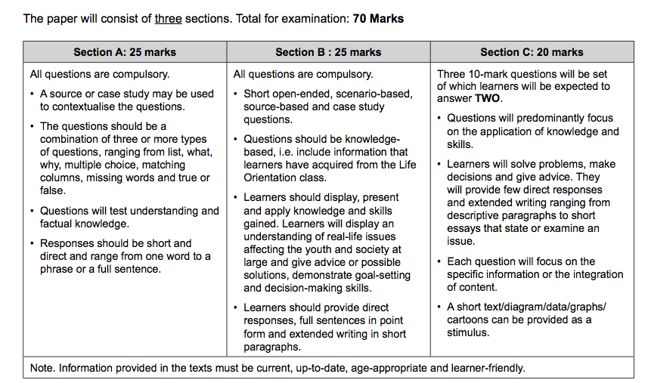

SECTION A: 25 MARKS
Answer ALL the questions in this section.
Question 1: Multiple Choice (5 marks)
Choose the correct answer and write down the letter only.
1.1. Which of the following is INCORRECT with regards to ARV / Antiretroviral
medication:

A. It is possible for a HIV-positive person to live longer
B. These drugs slow down the rate at which HIV spread
C. These drugs have no known side effects
D. These drugs require regular check-ups and blood tests (1)

1.2. One can build up your immune system when you are HIV-positive through:

A. Smoking, but not drinking
B. Eating healthy foods
C. Smoking and drinking
D. Pushing yourself with exercise (1)

1.3. HIV/AIDS is spread through:

A. Contact with HIV-positive bodily fluids such as blood, semen and vaginal fluids
B. Swimming in a pool with someone who is HIV-positive
C. Being bitten by a mosquito that is carrying HIV-positive blood
D. Hugging someone who is HIV-positive (1)

1.4. Animals that are classified as endangered are:

A. Animals that are difficult to find or track down
B. Animals that carry viruses that are harmful to humans
C. Animals that are kept in zoos
D. Animals that are at serious risk of becoming extinct (1)

1.5. Ways to decrease one’s carbon footprint include:

A. Eating more meat on Mondays
B. Using metal straws
C. Buy local and plant based foods
D. Using a fireplace to keep warm (1)
(5x1)(5)
(All Lower Order)

Question 2: Give an explanation of a concept: (5 marks)

Provide a definition or explanation of the concept:

2.1 Explain the term “sustainable resource” in terms of a healthy environment. (1)
2.2 Explain what “Earth Day” is about. (1)

2.3 What does “environmental justice” mean? (1)

2.4. What does “stigma” refer to in terms of those diagnosed with HIV/AIDS. (1)

2.5. Why are HIV-positive people vulnerable to opportunistic infections? (1)
(5)
(All Lower Order)

Question 3: Matching Columns (5 marks)
Match the concept in COLUMN A that best matches each statement in Column B. Write only the appropriate letter (A - G) next to the number (3.1 – 3.5).

Column A | Column B
3.1. Poaching | A. Change in atmospheric conditions/patterns from increased levels of carbon dioxide in the Earth’s atmosphere
3.2. Carbon footprint | B. Changes in Earth’s temperature from ozone layer depletion
3.3. Climate change | C. The removal of forestry or vegetation for human use
3.4. Environmental Act | D. A law or policy that South Africa has to address environmental issues
3.5. Deforestation | E. The illegal hunting, killing or capturing of wild animals for monetary gain.
 | F. The South African right to a healthy environment
 | G. Total amount of greenhouse gases that a person contributes towards in their lifetime
(5x1)(5)
(All Lower Order)

Question 4: Answer the following questions based on the Case Study below:
(10 marks)

SELF-STIGMA MADE ME FEEL DEPRESSED

The 1st of December 2016 was the day I was diagnosed with HIV. l was so worried that I almost cried. I went into the examination room. The doctor came in, and asked me how my day was going and I told her it was okay. Then she told me that my sexual health tests all came back negative except one, HIV. My heart instantly dropped and didn't have anything to say, I felt completely depressed. She told me to take all the time I needed to take to cry or just stay in the room. Then she walked out. I was in the room by myself, wondering what to do next. I decided to get up and go to work. On the way there I was crying and shaking, I just didn’t know what I should do.

Adapted from https://www.avert.org/living-with-hiv/stories/ricardo Accessed 08 June 2020

4.1 Briefly explain the most common ways how HIV is spread among young
people. (2x1)(2)
(Lower Order)
4.2 Discuss TWO ways how someone who is HIV-positive might manage
their illness. (2x2)(4)
(Middle Order)
4.3 Identify ONE way that young people can prevent being infected with HIV. (1x2)(2)
(Middle Order)
4.4 Recommend ONE way how a member of the First Aid team at school can
practice safety with regards to HIV/AIDS. (1x2)(2)
(Higher Order)
(10) [TOTAL SECTION A: 25 MARKS]

SECTION B: 25 MARKS

Answer ALL the questions in this section. Write your answers in full sentences.
Question 5: Provide the Term (5 marks)
Give the term for EACH of the following descriptions. Write only the term next to the question numbers (5.1. to 5.5.).
5.1. A system made up of the community of all living organisms and their
environment. (1)
5.2. A resource that cannot continue or be continued for a long time. (1)

5.3. Reduction in emissions of carbon dioxide or other greenhouse gases
made in order to compensate for emissions made elsewhere. (1)

5.4. The illegal hunting, killing or capturing of wild animals for monetary gain. (1)

5.5. Medication used to help manage the rate of infection for HIV-positive
people. (1)
(5)
(All Lower Order)
Question 6: (5 marks)
Fill in the missing words or concepts from the following statements or sentences:

6.1. Our constitution states that every South African has the __________ to an
environment that is not harmful to their health or well-being (1)
6.2. We can produce more _______________ by planting trees. (1)
6.3. AIDS is caused by the ________________________ virus . (1)
6.4. The HIV virus affects people’s ____________ systems, leaving them unable
to fight disease or infection. (1)
6.5. The three R’s: ‘Reduce, Reuse, and _________ ’ is a slogan illustrating
strategies one can utilise to reduce waste and conserve resources. (1)
(5)
(All Lower Order)

Question 7: (10 marks)
7.1. State TWO ways that we can be more responsible with wildfires. (2x1)(2)
(Lower Order)

7.2. Give TWO ways you can reduce your carbon footprint. (2x1)(2)
(Lower Order)

7.3. Discuss ONE way how you can be more environmentally responsible at
school. (1x2)(2)
(Middle Order)

7.4. Identify TWO ways that someone can manage their HIV/AIDS to improve their
immune system. (2x1)(2)
(Lower Order)
7.5. Determine how having the attitude of “it won’t happen to me” is
detrimental to the fight against HIV/AIDS. (1x2)(2)
(Higher Order)
(10)
Question 8: Give advice (5 marks)

My Friend Has HIV. How Can I Help?
There are many people living with HIV. Although there is no cure for HIV, people with HIV who get good medical care can live a long and healthy life. If you have a friend with HIV, just keep being a friend! That is what your friend needs most.

[Adapted from https://kidshealth.org/en/teens/friend-hiv.html Accessed 08 June 2020]

8.1. Your friend has recently disclosed that they think that they might be
HIV-positive. List ONE thing that you can do to help your friend? (1)
(Lower Order)

8.2. Discuss TWO ways that you can help your friend if people say
mean things about HIV or about his / her HIV status. (2x2)(4)
(Middle Order)

(5)

[TOTAL SECTION B: 25 MARKS]

SECTION C: 20 MARKS
Remember to answer any TWO questions in this section. Write your answers in full sentences
Question 9: (10 marks)
Study the extract and follow the instructions below.
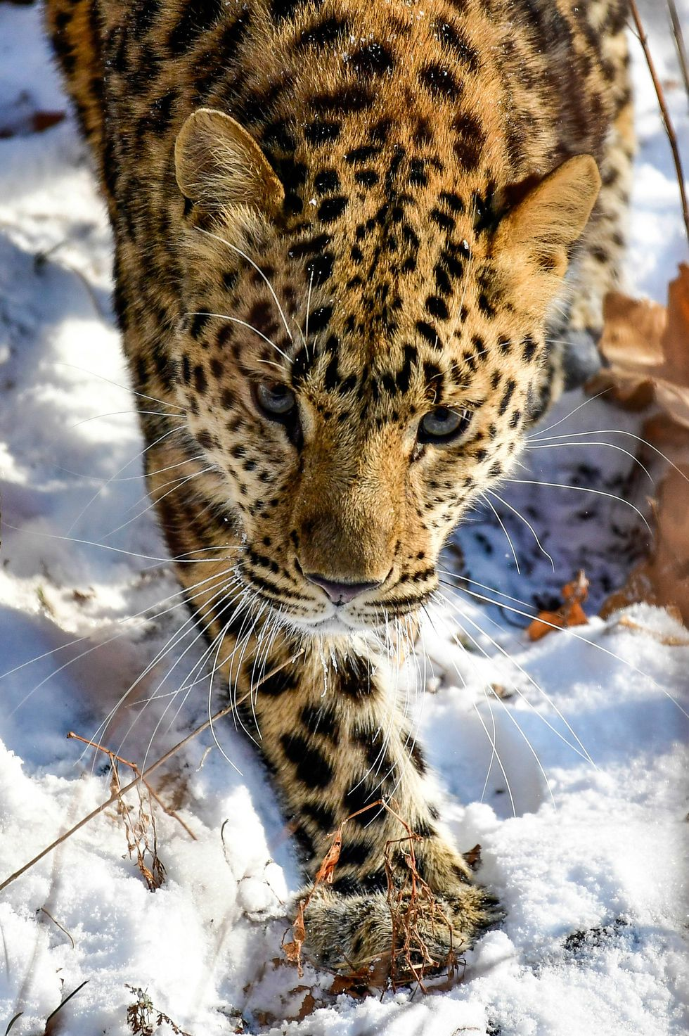
Animals that are almost Extinct
The Holocene Extinction, or the Sixth Extinction, has cost the world thousands of beloved species due to human activity. While some could return from the brink with modern science, others will never be seen on Earth again. Human intervention brought these species to near annihilation, now it will take human intervention to save them.
[Adapted from https://www.popularmechanics.com/science/animals/g20955197/animals-almost-extinct/ Accessed 08 June 2020]

- Explain what it means when animals are being ‘exploited’ (1x2)(2)
(Lower Order)

- Discuss TWO environmental health issues that contribute towards the
destruction of animals' natural habitat. (2x2)(4)
(Middle Order)
- Critically discuss TWO actions that can be taken to prevent animals
from becoming extinct. (2x2)(4)
(Higher Order)
(10)

Question 10: (10 marks)
Read the extract below and use the points that follow to write your essay:
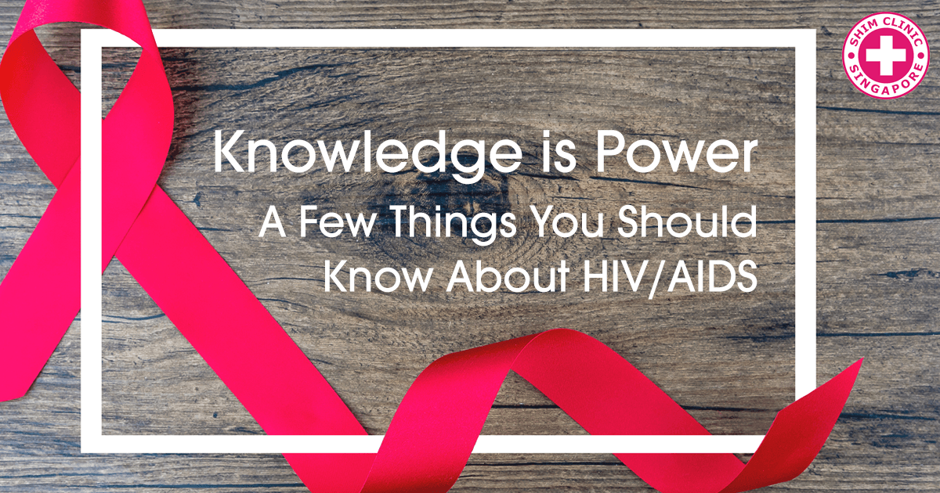

HIV, unlike infections such as Chlamydia, which are easy to treat, does not have a cure. If left untreated, it can have fatal consequences.
Yet it is not a death sentence. With treatment, the viral load can decrease to undetectable levels. In addition, not only is it manageable, it is preventable

[Adapted from https://www.shimclinic.com/blog/knowledge-is-power-a-few-things-you-should-know-about-hiv-aids Accessed 08 June 2020]

- Explain the difference between HIV and AIDS. (1+1)(2)
(Lower Order)

- Describe TWO ways friends and family members can care for and
support people living with HIV? (2x2)(4)
(Middle Order)
- Critically discuss TWO ways how being educated about HIV/AIDS can help you to make better choices. (2x2)(4)
(Higher Order)
(10)

Question 11: (10 marks)
Study the image below and answer the questions that follow:

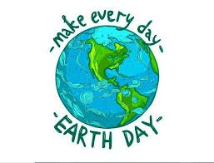
https://www.sustainable.pitt.edu/earth-day-2020/ Accessed 08 June 2020

- Explain “Earth Day”. (1x2)(2)
(Lower Order)
- While there have been some positives to the impact of the
Coronavirus environmentally like the reduction of carbon emissions
through transport. There have also been some negatives.
Explain TWO ways how the Coronavirus has had a NEGATIVE impact on the environment. (2x2)(4)
(Middle Order)

- Suggest TWO practical ways we could celebrate Earth Day. (2x2)(4)
(Higher Order)

(10)

[TOTAL SECTION C: 20 MARKS]

MEMORANDUM
SECTION A: 25 MARKS
Answer ALL the questions in this section.
Question 1: Multiple Choice (5 marks)
Choose the correct answer and write down the letter only.
1.1. Which of the following is INCORRECT with regards to ARV / Antiretroviral
medication:

A. It is possible for a HIV-positive person to live longer
B. These drugs slow down the rate at which HIV spread
C. These drugs have no known side effects
D. These drugs require regular check-ups and blood tests (1)

1.2. One can build up your immune system when you are HIV-positive through:

A. Smoking, but not drinking
B. Eating healthy foods
C. Smoking and drinking
D. Pushing yourself with exercise (1)

1.3. HIV / AIDS is spread through:

A. Contact with infected HIV-positive bodily fluids such as blood, semen and vaginal fluids
B. Swimming in a pool with someone who is HIV-positive
C. Being bitten by a mosquito that is carrying HIV-positive blood
D. Hugging someone who is HIV-positive (1)

1.4. Animals that are classified as endangered are:

A. Animals that are difficult to find or track down
B. Animals that carry viruses that are harmful to humans
C. Animals that are kept in zoos
D. Animals that are at serious risk of becoming extinct (1)

1.5. Ways to decrease one’s carbon footprint include:

A. Eating more meat on Mondays
B. Using metal straws .
C. Buy local and plant based foods.
D. Using a fireplace to keep warm. (1)
(5x1)(5)
(All Lower Order)

Question 2: Give an explanation of a concept: (5 marks)

Provide a definition or explanation of the concept:

2.1 Explain the term “sustainable resource” in terms of a healthy environment. (1)
The resource is able to be maintained at a certain level or rate / it can replenish itself without causing depletion or damage ✓
2.2 Explain what “Earth Day” is about. (1)
A global movement where people come together to work together, highlight and address environmental issues ✓

2.3 What does “environmental justice” mean? (1)
Protecting our natural resources for the generations that come after us ✓
2.4. What does “stigma” refer to in terms of those diagnosed with HIV/AIDS. (1)
A mark of disgrace / judgment / negative association with someone who is HIV positive or has HIV / AIDS ✓
OR
People treat you and respond to you in a negative way in light of your HIV status ✓
2.5. Why are HIV-positive people vulnerable to opportunistic infections? (1)

The HIV infection weakens their immune system so much that they are susceptible to disease or illness that can kill them like TB ✓
(5)
(All Lower Order)

Question 3: Matching Columns (5 marks)
Match the concept in COLUMN A that best matches each statement in Column B. Write only the appropriate letter (A - G) next to the number (3.1 – 3.5).

Column A | Column B
3.1. Poaching (E) | A. Change in atmospheric conditions / patterns from increased levels of carbon dioxide in the Earth’s atmosphere
3.2. Carbon footprint (G) | B. Changes in Earth’s temperature from ozone layer depletion
3.3. Climate change (A) | C. The removal of forestry or vegetation for human use
3.4. Environmental Act (D) | D. A law or policy that South Africa has to address environmental issues
3.5. Deforestation (C) | E. The illegal hunting, killing or capturing of wild animals for monetary gain.
 | F. The South African right to a healthy environment
 | G. Total amount of greenhouse gases that a person contributes towards in their lifetime
(5x1)(5)
(All Lower Order)
Question 4: Answer the following questions based on the Case Study below:
(10 marks)

SELF-STIGMA MADE ME FEEL DEPRESSED

The 1st of December 2016 was the day I was diagnosed with HIV. l was so worried that I almost cried. I went into the examination room. The doctor came in, and asked me how my day was going and I told her it was okay. Then she told me that my sexual health tests all came back negative except one, HIV. My heart instantly dropped and didn't have anything to say, I felt completely depressed. She told me to take all the time I needed to take to cry or just stay in the room. Then she walked out. I was in the room by myself, wondering what to do next. I decided to get up and go to work. On the way there I was crying and shaking, I just didn’t know what I should do.

Adapted from https://www.avert.org/living-with-hiv/stories/ricardo Accessed 08 June 2020

4.1 Briefly explain the most common ways how HIV is spread among young people. (2x1)(2)
(Lower Order)
Any TWO of the below or any valid answers for ONE mark each
- Spread through bodily fluids such as blood, semen and vaginal fluid ✓
- Having unsafe sex is the most likely way that HIV spreads among young people ✓
4.2 Discuss TWO ways how someone who is HIV-positive might manage
their illness. (2x2)(4)
(Middle Order)
Any TWO of the below or any relevant answers for TWO marks each
(i.e. ONE mark for statement and ONE mark for qualifier / explanation)
Through medication ✓ taking ARV’s to reduce infection rate and slow down the onset of AIDS and keep the immune system strong ✓
Through healthy living ✓ getting enough fresh air, healthy food, rest and a normal active life to strengthen one’s immune system ✓
Get support from people who care about you ✓ so that you feeling positive and emotionally strong to manage your status ✓
Focus on a positive attitude ✓ and the future so that you can look forward to things and be motivated to stay healthy ✓

4.3 Identify ONE way that young people can prevent being infected with HIV.
(1x2)(2)
(Middle Order)
Any ONE of the below or any relevant answer for TWO marks
(i.e. ONE mark for statement and ONE mark for qualifier / explanation)

Abstain from sex ✓ because it is the most and only safe (100%) and way to prevent being infected✓
Use condoms every time you have sex, ✓ but it is important to educate yourself about how to use them the right way. ✓
Use condoms or Never resuse a condom and always negotiate your safety and use a condom when you do have sex ✓ because if condoms are used in the right way every time you have sex, they are highly effective in preventing HIV infection✓
Choose less risky sexual behaviors, ✓because sexual activities that doesn’t involve contact with body fluids (semen, vaginal fluid, or blood) carry no risk of HIV transmission ✓
Be faithful to one partner✓ because in the case of multiple partners; you may not know whether the partner may have other sexually transmitted diseases (STDs), might increase your risk of HIV transmission✓

Do not share items that could have infected blood on them (like razors, injection needles etc) ✓ because you are at very high risk of getting HIV if you use a needle or razor after someone with HIV has used them. ✓

4.4. Recommend ONE way how a member of the First Aid team at school can
practice safety with regards to HIV / AIDS (1x2)(2)
(Higher Order)
Any ONE of the below or any relevant answer for TWO marks
(i.e. ONE mark for statement and ONE mark for qualifier / explanation)

Realise that anyone you are treating could be HIV positive ✓ and take the necessary precautions ✓
Wear gloves ✓ when working with wounds / covering open wounds and washing and cleaning blood on skin ✓
(10)
[TOTAL SECTION A: 25 MARKS]

SECTION B: 25 MARKS

Answer ALL the questions in this section. Write your answers in full sentences.
Question 5: Provide the Term (5 marks)
Give the term for EACH of the following descriptions. Write only the term next to the question numbers (5.1. to 5.5.).
5.1. A system made up of the community of all living organisms and their
environment. (1)
Ecosystem ✓

5.2. A resource that cannot continue or be continued for a long time. (1)

Unsustainable / Non-renewable ✓

5.3. Reduction in emissions of carbon dioxide or other greenhouse gases
made in order to compensate for emissions made elsewhere. (1)

carbon offset✓

5.4. The illegal hunting, killing or capturing of wild animals for monetary gain. (1)

poaching ✓

5.5. Medication used to help manage the rate of infection for HIV-positive
people. (1)

ARV / ART / Antiretroviral treatment / therapy ✓
(5)
(All Lower Order)
Question 6: (5 marks)
Fill in the missing words or concepts from the following statements or sentences:
6.1. Our constitution states that every South African has the __________ to an
environment that is not harmful to their health or well-being (1)
right ✓
6.2. We can produce more _______________ by planting trees. (1)
oxygen ✓
6.3. AIDS is caused by the ________________________ virus . (1)
Human Immuno-deficiency ✓
6.4. The HIV virus affects people’s ____________ systems, leaving them
unable to fight disease or infection. (1)
immune ✓
6.5. The three R’s: ‘Reduce, Reuse, and _________ ’ is a slogan illustrating
strategies one can utilise to reduce waste and conserve resources. (1)
Recycle ✓
(5)
(All Lower Order)

Question 7: (10 marks)

7.1 State TWO ways that we can be more responsible with wildfires. (2x1)(2)
(Lower Order)
Any TWO of the below or any relevant answers for ONE mark each
- Create firebreaks ✓
- Provide easy access for fire hydrants or emergency services ✓
- Only braai / light fires in safe and designated areas ✓
- Don’t use fireworks or other material that is likely to cause uncontrollable fires ✓
- Use heating / cooking / lighting devices safely and responsibly ✓
- Be aware of safety exits ✓

7.2. Give TWO ways you can reduce your carbon footprint. (2x1)(2)
(Lower Order)

Any TWO of the below or any relevant answers for ONE mark each
- Recycle ✓
- Use less transport / walk / cycle / carpool ✓
- Use less fossil fuels through less electricity ✓
- Find more renewable energy solutions like solar panels ✓

7.3. Discuss ONE way how you can be more environmentally responsible at
school. (1x2)(2)
(Middle Order)
Any ONE of the below or any relevant answer for TWO marks
(i.e. ONE mark for statement and ONE mark for qualifier / explanation)
Create awareness on the different things that people do at school ✓ that can impact on the environment through talks / workshops / clubs / societies etc ✓
Help put more recycling bins around the school✓ to make recycling easier and more accessible ✓
Encourage the tuckshop to rather use materials that are more environmentally friendly ✓ which will cause less damage to the environment ✓
Organise environmentally responsible outings to various places that can assist the earth ✓ this could encourage other people to get involved and create awareness ✓

7.4. Identify TWO ways that someone can manage their HIV/AIDS to improve their
immune system (2x1)(2)
(Lower Order)
Any TWO of the below or any relevant answer for ONE mark each
- Life a healthy lifestyle/fresh air/healthy food / enough rest / active lifestyle ✓
- Manage the ART / ARV treatment well ✓
- Stay positive / have a positive outlook on your life and the future ✓
- Make sure that you have support from others ✓
- Keep your emotional health intact ✓

7.5. Determine how having the attitude of “it won’t happen to me” is
detrimental to the fight against HIV/AIDS. (1x2)(2)
(Higher Order)
Any ONE of the below or any relevant answer for TWO marks
(i.e. ONE mark for statement and ONE mark for qualifier / explanation)
People are more likely to be less cautious ✓ and engage in risky behaviour and therefore possibly contract the virus
People often think they are in control of everything that happens in their lives, ✓ they have the attitude or mindset that it won’t happen to them ✓

Question 8: Give advice (5 marks)

My Friend Has HIV. How Can I Help?
There are many people living with HIV. Although there is no cure for HIV, people with HIV who get good medical care can live a long and healthy life. If you have a friend with HIV, just keep being a friend! That is what your friend needs most.

[Adapted from https://kidshealth.org/en/teens/friend-hiv.html Accessed 08 June 2020]

8.1. Your friend has recently disclosed that they think that they might be
HIV-positive. List ONE thing that you can do to help your friend? (1)
(Lower Order)

Any ONE of the below or any relevant answer for ONE mark

- Be there for them as a friend to talk to – an emotional support ✓
- Don’t disclose their status to anyone else ✓
- Still do things together as friends ✓
- Be a good influence on your friend ✓
- Offer to help them with schoolwork if they need to miss school for any illness related excuse ✓
- Advise them on where they can go to get assistance with managing the disease as well as go with them for support if necessary ✓

8.2. Discuss TWO ways that you can help your friend if people say
mean things about HIV or about his / her HIV status. (2x2)(4)
(Middle Order)
Any TWO of the below or any relevant answers for TWO marks each
(i.e. ONE mark for statement and ONE mark for qualifier / explanation)
- Help her understand that stigma and mistreatment of people living with HIV/AIDS often comes from fear and ignorance, ✓ and is not always intentionally to hurt. ✓
- Help educate these people about HIV/AIDS ✓ so that they don’t fear or misunderstand it ✓
- Speak to an adult or someone who can help her manage this situation✓ if things get too mean or out of hand ✓
- Encourage your friend to speak to a counsellor / psychologist✓ to help them cope with their status and these reactions from people ✓
- Lead by example / show your friend that their status makes no difference to you✓ and continue to have the friendship you’ve always had and do the same things you would normally do ✓
(5)
[TOTAL SECTION B: 25 MARKS]
SECTION C: 20 MARKS
Remember to answer any TWO questions in this section. Write your answers in full sentences
Question 9: (10 marks)
Study the extract and follow the instructions below.
Animals that are almost Extinct
The Holocene Extinction, or the Sixth Extinction, has cost the world thousands of beloved species due to human activity. While some could return from the brink with modern science, others will never be seen on Earth again. Human intervention brought these species to near annihilation, now it will take human intervention to save them.
[Adapted from https://www.popularmechanics.com/science/animals/g20955197/animals-almost-extinct/ Accessed 08 June 2020]

- Explain what it means when animals are being ‘exploited’ (1x2)(2)
(Lower Order)
Any valid answer for TWO marks
Causing animals to become endangered ✓ and perhaps extinct / animal
endangerment / extinction usually for monetary purposes / profit ✓
E.g. poaching rhino horns for trade or Asian medicinal use

- Discuss TWO environmental health issues that contribute towards the
destruction of animals' natural habitat. (2x2)(4)
(Middle Order)
Any TWO of the below or any relevant answers for TWO marks each
(i.e. ONE mark for statement and ONE mark for qualifier / explanation)
Global Warming ✓: E.g. Polar Bear habitat disappearing / melting, which means they drown having to swim far to find land; they also encroach on land where there are people and get hunted / killed for fear they will attack people. ✓
Over population ✓: Animals that live in the jungle and forests, which are being cleared to make space for human development ✓.
Deforestation ✓ the removal of forest for land use for human consumption ✓ or use – farming / agriculture etc which was natural habitat for animals ✓
Pollution ✓ pollution of environments which damages ecosystems and causes ill health or death of animals reliant on those ✓

- Critically discuss TWO actions that can be taken to prevent animals from
becoming extinct. (2x2)(4)
(Higher Order)
Any TWO of the below or any relevant answers for TWO marks each
(i.e. ONE mark for statement and ONE mark for qualifier / explanation)
Adhere to laws that protect these animals from becoming extinct✓ so that people are deterred from harming these animals ✓

The use of sanctuaries✓ to ensure the species is preserved ✓
Harsher consequences ✓ to prevent the unlawful destruction of their habitat or poaching ✓

Education / campaigns of the youth and general public ✓ so that we can do more to prevent the destruction of their habitats ✓
(10)

Question 10: (10 marks)
Read the extract below and use the points that follow to write your essay:

HIV, unlike infections such as Chlamydia, which are easy to treat, does not have a cure. If left untreated, it can have fatal consequences.
Yet it is not a death sentence. With treatment, the viral load can decrease to undetectable levels. In addition, not only is it manageable, it is preventable

[Adapted from https://www.shimclinic.com/blog/knowledge-is-power-a-few-things-you-should-know-about-hiv-aids Accessed 08 June 2020]

- Explain the difference between HIV and AIDS. (1+1)(2)
(Lower Order)
Any valid answer for TWO marks
HIV - refers to the viral infection, which weakens the immune system ✓
AIDS - is known as the final stage of HIV infection where the immune system is
too weak to fight off opportunistic/acquired infections ✓

- Describe TWO ways friends and family members can care for and
support people living with HIV? (2x2)(4)
(Middle Order)
Any TWO of the below or any relevant answers for TWO marks each
(i.e. ONE mark for statement and ONE mark for qualifier / explanation)

Encourage them to disclose to their loved ones, ✓ so that they don’t need to battle the disease alone. ✓
Ensure that they lead a healthy lifestyle and take the correct medication ✓ to boost their immune systems and stay healthy ✓
Assist them to network with counselling services ✓ to debrief and process the news ✓
Don’t use language that could make them feel alienated or judged ✓ so that they feel supported and cared for ✓
Support and care for them emotionally ✓ so that they feel they are not alone and can handle this struggle ✓

- Critically discuss TWO ways how being educated about HIV / AIDS can help you to make better choices. (2x2)(4)
(Higher Order)
Any TWO of the below or any relevant answers for TWO marks each
(i.e. ONE mark for statement and ONE mark for qualifier / explanation)
With education about how HIV is spread ✓ people are more empowered to make better lifestyle decisions like practicing safe sex and reduce infection rates and stop the spread ✓
With education comes a decrease in stigmatisation ✓ where people learn to work with and not fear people who may be infected with the virus ✓ and learn to care and support for those who have it ✓

The better the education about the disease the incidence of infection may decrease, ✓ and society is stronger in terms of health security ✓

If you are informed about HIV/AIDS and know your status then you can manage a healthier lifestyle ✓ and live a longer life with a lower infection rate ✓
(10)

Question 11: (10 marks)
Study the image below and answer the questions that follow:

https://www.sustainable.pitt.edu/earth-day-2020/ Accessed 08 June 2020

- Explain “Earth Day”. (1x2)(2)
(Lower Order)

Any valid answer for TWO marks
It is a global movement whereby people from around the world work together to highlight and address environmental issues ✓ that we as humans are responsible for finding solutions to the earth’s problems ✓

- While there have been some positives to the impact of the Coronavirus environmentally like the reduction of carbon emissions through
transport. There have also been some negatives.
Explain TWO ways how the Coronavirus has had a NEGATIVE impact on the environment. (2x2)(4)
(Middle Order)
Any TWO of the below or any relevant answers for TWO marks each
(i.e. ONE mark for statement and ONE mark for qualifier / explanation)
Volumes of recyclable waste has risen ✓ people staying at home have been unable to recycle and have thrown waste away that could have been recycled ✓
More plastic bags are being used in shops ✓ as people are fearful of the virus spreading on reusable bags ✓
Masks are being thrown away ✓ and not reused only further increasing the problem of pollution ✓
Environmental workers have been unable to work during lockdown ✓ causing possible problems to ecosystems and endangered species by systems being unmonitored and a rise in illegal activity ✓
- Suggest TWO practical ways we could celebrate Earth Day. (2x2)(4)
(Higher Order)

Any TWO of the below or any relevant answers for TWO marks each
(i.e. ONE mark for statement and ONE mark for qualifier / explanation)
Plant trees ✓ so that we can remember the importance of being kind to the earth ✓
Do research on how to attract birds and bees to your garden or area ✓ so that you can help the natural ecosystem to function more efficiently ✓
Do research on making a compost heap ✓ instead of throwing these components away and making bigger rubbish dumps ✓
Organise a swap class ✓ where you can swap things you don’t need and maybe other people want so that they don’t land up in the rubbish dumps ✓
Develop and implement a programme/intervention to help be kinder to the environment ✓ and help other people to get involved to ✓ (10)

[TOTAL SECTION C: 20 MARKS]

