Grade 10 Life Orientation Exam Bank

Development of Self in Society (DSS) Terms 1 & 3

2020

1 ½ HOURS 100 MARKS

NOTE TO TEACHERS: Remember, this is a bank of questions and therefore may contain some overlaps. Keep this is mind when selecting questions for your paper. Use the table below to help you when choosing your questions.

Weighting (suggested) | Weighting (Actual) | Cognitive level | Bloom’s taxonomy
30% (30 marks) | 30 marks | Lower Order | Level 1&2
40% (40 marks) | 40 marks | Middle Order | Level 3&4
30% (30 marks) | 30 marks | Higher Order | Level 5&6

The spread of the cognitive levels of the three questions in Section C is the same.

REMINDER: Final paper should include components of each topic covered in ALL terms for 2020.

This Question Paper includes components of DSS from Terms 1 & 3. See also Teenactiv’s Grade 10 Term 1&2 DSS Exam Paper & MEMO for components covering term ONE.
______________________________________________________________
INSTRUCTIONS AND INFORMATION
- The question paper consists of THREE sections, namely SECTION A, SECTION B and SECTION C.
- The questions in SECTION A and SECTION B are compulsory.
- Answer any TWO questions in SECTION C.
- Read ALL the questions carefully.
- Number the answers correctly according to the numbering system used in this question paper. Start each question on a new page.
- Write neatly and legibly.
- This paper consists of 8 pages and 6 questions. (18 pages including Memo)

SECTION A: 20 MARKS

Answer all the questions in this section (Compulsory)

Question 1

Various options are provided as possible answers to the following questions. Choose the correct answer and write only the letter (A–D) next to the question number (1.1.1 – 1.1.5) in the answer book, for example 1.1.6. E.

1.1.1 Responsible sexual decisions to optimise personal potential includes:
- Being sure that your partner consents to all sexual activity between you.
- The use of recreational substances before having sexual intercourse.
- Realising that your morals and values can be changed around your friends.
- Sending naked selfies or sexting instead of having sexual intercourse.
(Lower Order)

1.1.2 Online learning helped those with a visual learning style because:
- They were able to ask their teachers for help via emails or text.
- Teachers could prerecord their voices for learners to play back.
- The increased use of videos, pictures and slides was distracting.
- It was easier to provide colour images to help learner’s imaginations.
(Lower Order)

1.1.3 How did the nationwide lockdown help South Africa during the pandemic?
- It allowed the government more time create better political tactics.
- The curve was flattened because fewer people were at home.
- Those living with comorbidities were given access to a cure first.
- It allowed medical facilities time to gather information and supplies.
(Lower Order)

1.1.4. Living in poverty can impact teenager’s life roles because:
- The death rate is so high, that child-headed households are common.
- Many impoverished teenagers are able to buy their way into university.
- Parents living in poverty often cannot fulfil their teenagers’ basic needs.
- Impoverished teenagers may have to take on volunteer work to earn money.
(Lower Order)

1.1.5. Which of the following is NOT a healthy way to increase self-esteem?
- Trusting encouragement and positivity from reliable friends.
- Ignoring imperfections by turning to recreational substances use.
- Talking to family members about troubles and finding solutions.
- Creating a self-appreciation diary to write positive affirmations.
(Lower Order) (5x1)(5)

1.2. Give ONE word/term for EACH of the following descriptions. Write only the word/term next to the question numbers (1.2.1 to 1.2.5) in the ANSWER BOOK.

1.2.1 Specific permission for something sexual to happen between partners.  (Lower Order) | (1)
1.2.2 A comorbid condition that links to high blood sugar. People with this condition are at higher risk of contracting Covid-19.  (Lower Order) | (1)
1.2.3 The practice of assigning a woman or man specific attributes or characteristics based on their biological sex.  (Lower Order) | (1)
1.2.4 The practice of restraining oneself from sex.  (Lower Order) | (1)
1.2.5 A set of attributes, behaviours, and roles generally associated with women and girl.  (Lower Order) | (1)
(5x1)(5)

1.3 Answer the following questions by writing the answer next to the question numbers (1.3.1 to 1.3.4) in the ANSWER BOOK/ FOLIO provided. Write your answers in full sentences.

1.3.1 Mention TWO positive ways how families may have used the lockdown to bond. (2x1)(2)
(Lower Order)

1.3.2 Discuss ONE protocol put into place to ensure the safety of learners at school. (1x2)(2)
(Middle Order)

1.3.3 Describe TWO time management strategies learners could use to prepare for exams. (2x2)(4)
(Middle Order)

1.3.4 Recommend ONE strategy learners could put into place to continue their self-development during Covid 19. (2x1)(2)
(Higher Order)
(10)
[TOTAL SECTION A: 20 MARKS]

SECTION B: 40 MARKS

Answer ALL the questions in this section (Compulsory)
Write your answers in full sentences.
Question 2

Read the case study below and answer the questions that follow.
In Focus: Gender equality matters in COVID-19 response
The COVID-19 pandemic is not just a health issue. It is a profound shock to our societies and economies, and women are at the heart of care and response efforts underway. As front-line responders, health professionals, community volunteers, transport and logistics managers, scientists and more, women are making critical contributions to address the outbreak every day.
COVID-19 Response
The majority of caregivers, at home and in our communities, are also women. Additionally, they are at increased risk of infection and loss of livelihood, and existing trends point to less access to sexual and reproductive health and rise in domestic violence during crisis. UN Women is bringing up-to-date information and analysis on how and why gender matters in COVID-19 response.
[Adapted from https://www.unwomen.org on 19 September 2020]

2.1 Define the term ‘gender inequality’ and state THREE gender inequalities that have been highlighted by Covid-19. (1+3)(4)
(Lower Order)

2.2 Provide TWO stereotypical gender roles that can still be found in South African society. (2x1)(2)
(Lower Order)

2.3 Discuss TWO ways that women are more at risk of contracting STIs because of power imbalance. (2x2)(4)
(Middle Order)

2.4 Describe THREE psychological effects women in abusive relationships may experience. (3x2)(6) (Middle Order)

2.5 Suggest TWO ways that women who are both medical professionals and primary caregivers could find a work-home balance during the pandemic. (2x2)(4)
(Higher Order) (20)
Question 3
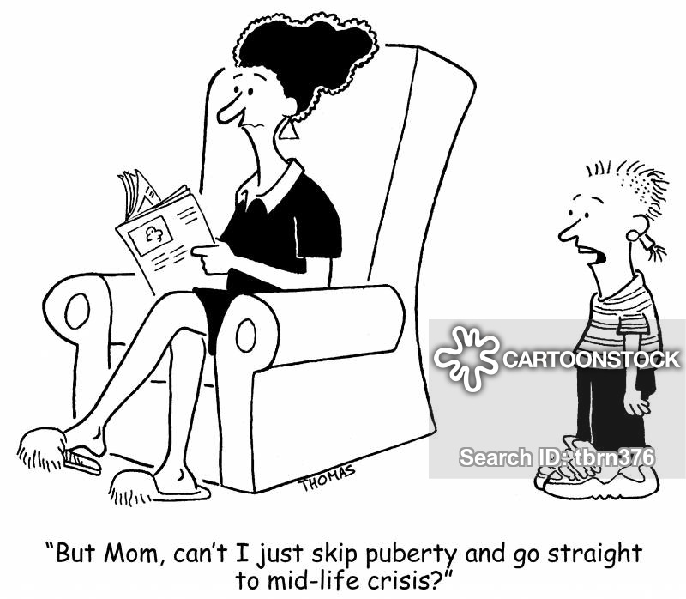
Refer to the cartoon below and answer the questions that follow.

[Accessed from: https://www.cartoonstock.com on 09 October 2020]

  - Define the term ‘puberty’ and provide TWO hormones responsible for the physical changes associated with puberty. (1+2)(3)
(Lower Order)

  - Mention THREE physical changes all genders face during puberty. (3x1)(3)
(Lower Order)

  - Explain TWO emotional skills that adolescents develop during puberty. (2x2)(4)
(Middle Order)

  - Discuss TWO reasons why physical changes during puberty could lead to social insecurity. (2x2)(4)
(Middle Order)

  - Suggest THREE self-care strategies learners could implement to help themselves cope with the changes of puberty. (3x2)(6)
(Higher Order)
(20)
[TOTAL SECTION B: 40 MARKS]

SECTION C: 40 MARKS

Remember to answer any TWO questions in this section.
Your responses must consist of paragraphs. Marks will only be allocated for responses written in full sentences.

Question 4:

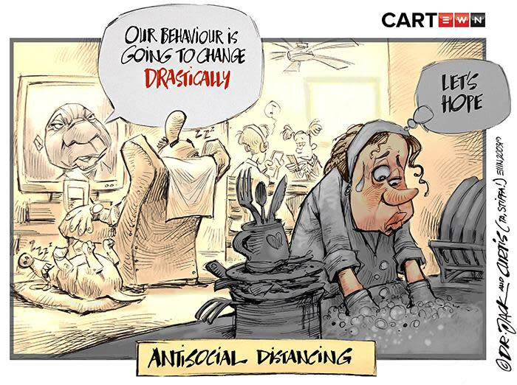
Study the following cartoon and answer the question that follows.
[Accessed from: https://brightside.me Accessed on: 25 September 2020]

Use the following as a guideline:

- Define the term ‘social changes’ and state TWO social changes that adolescents experience towards their parents during puberty. (1+2)(3)
(Lower Order)

- Discuss FOUR ways that lockdown may have put strain on family relationships. (4x2)(8)
(Middle Order)

- Suggest THREE activities that families could try to improve their social interactions. In your answers, also indicate how EACH suggestion can lead to a closer family unit. (3x3)(9)
(Higher Order)

(20)

Question 5:

Study the following image and answer the question that follows.

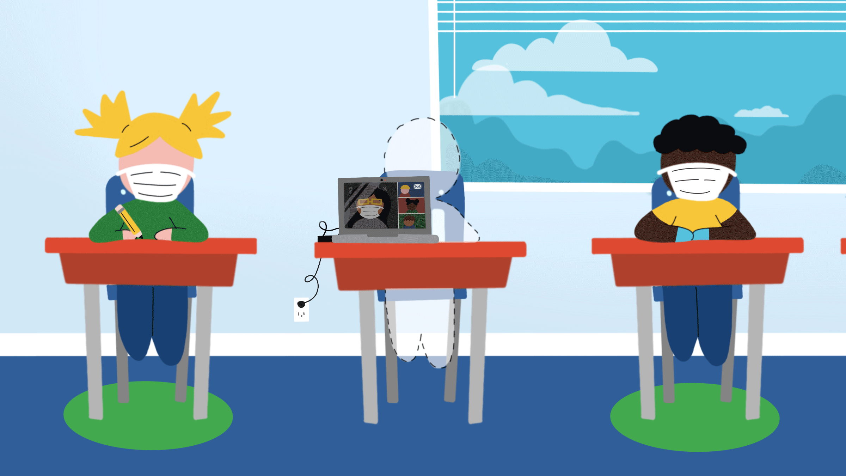

[Accessed from: https://www.ipsos.com on 25 August 2020]

Write paragraphs on study skills during Covid-19.

Use the following as a guideline:

- Define the term ‘study skills’ and provide TWO reasons why effective study skills are even more important during Covid 19. (1+2)(3)
(Lower Order)

- Discuss FOUR ways how the Covid 19 pandemic and the loss of instructional time has disrupted learner’s ability to be successful this year. (4x2)(8)
(Middle Order)

- Suggest THREE possible strategies teachers could put into place to help learners get through the content for the year. In your answers, also indicate how EACH strategy will help learners to get through the content. (3x3)(9)
(Higher Order)

(20)
Question 6:
Study the following extract and answer the question that follows.
Young Entrepreneurs Share Their Start-Up Secrets
“I learnt to design and sew while assisting my mother who was a seamstress, and that is when I realised that I had a talent to create,” Thabo Khumalo explains. “But I never knew I was an entrepreneur.” Thabo Khumalo started his company ToVch in 2010 and has since appeared in South African Fashion Week, Soweto Fashion Week and Mpumalanga Fashion Week.
Khumalo has a small but engaged audience, who he communicates directly with. “The brand has a dedicated audience, and the social media presence also allows me to continuously scan the fashion environment to keep up with external forces.”
One of the most challenging aspects of launching his businesses was marketing the brand with limited funds. He used social media and word-of-mouth to market. “On social media, people share your brand with others simply because they want to,” says Khumalo. “It’s a powerful platform, and it does not cost anything.” Khumalo built up his company using support from a strong online network, which became his marketing strategy.
[Adapted from: https://www.experthub.info Accessed on 02 October 2020]

Write paragraphs on life roles of teenage entrepreneurs

Use the following as a guideline.

- Define the term ‘life role’ and name extra TWO responsibilities entrepreneurial teenagers would face because of their business. (1+2)(3)
(Lower Order)

- Explain FOUR ways that the life role of entrepreneur could negatively impact Thabo’s relationships with his loved ones. (4x2)(8)
(Middle Order)

- Recommend THREE ways how any entrepreneur could balance the their life role as an entrepreneur with their life role as a learner. In your answers, indicate how EACH recommendation could lead to a greater personal success for the entrepreneur. (3x3)(9)
(Higher Order)
(20)

[TOTAL SECTION C: 40 MARKS]
TOTAL = 20 + 40 + 40 = 100

MEMORANDUM
SECTION A: 20 MARKS
Answer all the questions in this section (Compulsory)

Question 1

Various options are provided as possible answers to the following questions. Choose the correct answer and write only the letter (A–D) next to the question number (1.1.1 – 1.1.5) in the answer book, for example 1.1.6. E.

    - Responsible sexual decisions to optimise personal potential includes:
- Being sure that your partner consents to all sexual activity between you.
- The use of recreational substances before having sexual intercourse.
- Realising that your morals and values can be changed around your friends.
- Sending naked selfies or sexting instead of having sexual intercourse.
(Lower Order)

    - Online learning helped those with a visual learning style because:
- They were able to ask their teachers for help via emails or text.
- Teachers could prerecord their voices for learners to play back.
- The increased use of videos, pictures and slides was distracting.
- It was easier to provide colour images to help learner’s imaginations.
(Lower Order)

    - How did the nationwide lockdown help South Africa during the pandemic?
- It allowed the government more time create better political tactics.
- The curve was flattened because fewer people were at home.
- Those living with comorbidities were given access to a cure first.
- It allowed medical facilities time to gather information and supplies.
(Lower Order)

1.1.4. Living in poverty can impact teenager’s life roles because:
- The death rate is so high, that child-headed households are common.
- Many impoverished teenagers are able to buy their way into university.
- Parents living in poverty often cannot fulfil their teenagers’ basic needs.
- Impoverished teenagers may have to take on volunteer work to earn money.
(Lower Order)

1.1.5. Which of the following is NOT a healthy way to increase self-esteem?
- Trusting encouragement and positivity from reliable friends.
- Ignoring imperfections by turning to recreational substances use.
- Talking to family members about troubles and finding solutions.
- Creating a self-appreciation diary to write positive affirmations.
(Lower Order) (5x1)(5)

1.2. Give ONE word/term for EACH of the following descriptions. Write only the word/term next to the question numbers (1.2.1 to 1.2.5) in the ANSWER BOOK.

1.2.1 Specific permission for something sexual to happen between partners.  Consent (Lower Order) | (1)
1.2.2 A comorbid condition that links to high blood sugar. People with this condition are at higher risk of contracting Covid-19.  Social Distance (Lower Order) | (1)
1.2.3 The practice of assigning a woman or man specific attributes or characteristics based on their biological sex.  Gender Stereotypes / Gender Roles (Lower Order) | (1)
1.2.4 The practice of restraining oneself from sex.  Abstinence (Lower Order) | (1)
1.2.5 A set of attributes, behaviours, and roles generally associated with women and girl.  Femininity (Lower Order) | (1)
(5x1)(5)

1.3 Answer the following questions by writing the answer next to the question numbers (1.3.1 to 1.3.4) in the ANSWER BOOK/ FOLIO provided. Write your answers in full sentences.

1.3.1 Mention TWO positive ways how families used lockdown to bond. (2x1)(2)
(Lower Order)
Any TWO of the below or any relevant answers for ONE mark each

- Family centred arts and crafts
- Games evenings
- Host a family Olympics using house equipment
- Digital scrapbooking old photos

1.3.2 Discuss ONE protocol put into place to ensure the safety of learners at school. (1x2)(2)
(Middle Order)
Any ONE of the below or any relevant answer for TWO marks
(i.e. ONE mark for statement and ONE mark for qualifier / explanation)

- Schools must screen learners and teachers that enter the school to ensure that no one is symptomatic.
- Learners need to have their hands sprayed with sanitizer regularly to help kill off the virus.
- Wearing masks to ensure that learners who may be infected are less likely to spread the virus through breathing, coughing or sneezing.
- Teachers will remind learners to keep a 1.5 meter distance at all times to try and decrease the chances of the virus being spread through contact with another human.
- All surfaces that get touched regularly will get disinfected to decrease the likelihood of picking up the virus through touching surfaces.

1.3.3 Describe TWO time management strategies learners could use to prepare for exams. (2x2)(4)
(Middle Order)
Any TWO of the below or any relevant answers for TWO marks each
(i.e. ONE mark for statement and ONE mark for qualifier / explanation)

- Learners could create a study timetable to ensure that they have enough time to allocate to each subject.
- Avoid procrastination/ delaying studying until the last moment as this creates unnecessary stress /or/ could lead to insufficient time to cover all topics/work.
- Factor in times for breaks when planning study sessions so that their brains are as fresh as possible at all times and can retain the maximum amount of information.
- Set goals for each study session to help with motivation and focus.
- Go over work/ create summaries each day after school so that there is less to study closer to the time.
- Schedule social blocks AFTER studying has been completed/ study goals have been met so that they aren’t tempted to put off studying to remain in a social situation.
- Avoid the following time consumers: computer games, cell phone texts, social media, etc. because these will take up more time than expected/ take away valuable time from studying.

1.3.4 Recommend ONE strategy learners could put into place to continue their self-development during Covid 19. (1x2)(2)
(Higher Order)

Any ONE of the below or any relevant answer for TWO marks
(i.e. ONE mark for statement and ONE mark for qualifier / explanation)

- They could use lockdown/ isolation periods to work on things that interest them and increase their knowledge in these areas.
- Listen to Podcasts on personal growth to help them to stay motivated and self-aware during Covid-19.
- Read books on self-development and impliment new practices that they suggest.
- Start/ continue a journal of their developmental goals/ journey and reflect on progress made during lockdown/ pandemic.
[TOTAL SECTION A: 20 MARKS]

SECTION B: 40 MARKS

Answer ALL the questions in this section (Compulsory)
Write your answers in full sentences.
Question 2

2.1 Define the term ‘gender inequality’ and state THREE gender inequalities that have been highlighted by Covid-19. (1+3)(4)
(Lower Order)
Gender inequality the idea that men and women are not equal/ not treated the same and that gender affects an individual's living experience.

Any THREE of the below or any relevant answers for ONE mark each
  - Women are often expected to look after the household during lockdown, despite other family members being at home.
  - More women are experiencing gender-based violence.
  - Women are more likely to be retrenched.
  - Women took on the role of child raising

2.2 Provide TWO stereotypical gender roles that can still be found in South African society. (2x1)(2)
(Lower Order)

Any TWO of the below or any relevant answers for ONE mark each

- Men should not cook /or/ women should be responsible for cooking and cleaning.
- Women should not work in a job that allows them to earn more than men
- Women should look after the children
- Women should remain sexually pure /or/ men should be sexually experienced

2.3 Discuss TWO ways that women are more at risk of contracting STIs because of power imbalance. (2x2)(4)
(Middle Order)
Any TWO of the below or any relevant answers for TWO marks each
(i.e. ONE mark for statement and ONE mark for qualifier / explanation)

- People believe that women cannot say no to their husbands/ must accept that their husbands want to have unsafe sex which means that they stand more of a chance of contracting STIs through contact.
- Women are more at risk of sexual assault which would usually result in physical trauma. This makes it more likely to contract STIs through the ‘wounds.’
- It is more acceptable for men to be sexually promiscuous/ unfaithful whilst in a relationship, which means that he could bring home STIs to his partner.

2.4 Describe THREE psychological effects women in abusive relationships may experience. (3x2)(6) (Middle Order)

Any THREE of the below or any relevant answers for TWO marks each
(i.e. ONE mark for statement and ONE mark for qualifier / explanation)

- They may become depressed because of the emotional strain of prolonged trauma /or/ because they cannot see any hope to get out of their situation.
- They may feel a sense of worthlessness as their abuser may have told them that they are not worthy /or/ they don’t believe that someone of worth would be abused.
- They may suffer from PTSD after prolonged exposure. They have been programed to related certain stimuli to pain and will react accordingly.
- They may struggle to relate to others or be in social situations as they feel too vulnerable or scared.
- They may feel ashamed of what is happening to them and try to cover up any evidence.
- They may face internal conflict because they try to change who they are or become someone that they aren’t to please their abuser.

2.5 Suggest TWO ways that women who are both medical professionals and primary caregivers could find a work-home balance during the pandemic. (2x2)(4)
(Higher Order)

Any TWO of the below or any relevant answers for TWO marks each
(i.e. ONE mark for statement and ONE mark for qualifier / explanation)

- They could plan ahead so that they are prepared for those days where they are very busy with work.
- They could ask for help from family and friends if they feel that they cannot cope with the demands of their job.
- They could schedule specific times to spend with their family to ensure that they do not lose touch with those that they love.
- They can create routines so that it becomes easier to function/ work within those routines on days where they are tired.
(20)

Question 3

  - Define the term ‘puberty’ and provide TWO hormones responsible for the physical changes associated with puberty. (1+2)(3)
(Lower Order)
Puberty: the period during which adolescents reach sexual maturity and become capable of reproduction

Any TWO of the below or any relevant answers for ONE mark each

  - Gonadotrophin releasing hormone (GnRH)
  - Follicle Stimulating Hormone (FSH)
  - Luteinizing Hormone (LH)

  - Mention THREE physical changes all genders face during puberty. (3x1)(3)
(Lower Order)

Any THREE of the below or any relevant answers for ONE mark each

- Increased body hair
- Pubic hair
- Oily hair/ dry hair
- Oily skin/ pimples
- Weight loss/ gain
- Increased height

  - Explain TWO emotional skills that adolescents develop during puberty. (2x2)(4)
(Middle Order)

Any TWO of the below or any relevant answers for TWO marks each
(i.e. ONE mark for statement and ONE mark for qualifier / explanation)

- They start to care about their friends and loved ones as they recognise the value that they add to their life.
- They start to develop romantic interests/ relationships as they find that some people are better suited for them than others.
- They can empathise with other people’s struggles and treat them with care and kindness when they recognise that the person is in a bad space.
- They are able to better identify their own emotions and communicate these with others.

  - Discuss TWO reasons why physical changes during puberty could lead to social insecurity. (2x2)(4)
(Middle Order)
Any TWO of the below or any relevant answers for TWO marks each
(i.e. ONE mark for statement and ONE mark for qualifier / explanation)

- Teens are unable to keep up with the physical changes that are happening so quickly which makes them feel shy about wearing certain clothes around others.
- They may feel ugly due to pimples or oily skin and hair which could make them want to hide from others so that they don’t see their imperfections /or/ makes them constantly worried about other’s judging them.
- They can feel low self-esteem as they feel that their physical changes are not as attractive as their peers.
- They could become insecure or think that something is wrong with them if their physical changes happen differently or later.

  - Suggest THREE self-care strategies learners could implement to help themselves cope with the changes of puberty. (3x2)(6)
(Higher Order)

Any THREE of the below or any relevant answers for TWO marks each
(i.e. ONE mark for statement and ONE mark for qualifier / explanation)

- They could create a set self-care routine that includes keeping a journal. This could give them an outlet when their feelings become too much.
- They could establish a facecare routine that works for their skin type. This will decrease the likelihood of blocked pores causing pimples.
- They can take time to exercise so that their body is able to get rid of excess hormones.
- Take time to relax and take a break from the stress of fitting in so that they can feel revitalized and ready to deal with outside influences again.
- They can follow a healthy diet to ensure that their body is functioning optimally to get through the changes.
- They can drink more water to flush their system and decrease pimples/ acne.
- Ensure that they make time to do things that they enjoy/ are important to them so that they can focus more on pleasing themselves instead of others/ their friends.
- They could repeat positive affirmations daily to allow them to create a positive mindset about the changes.
- Take time to spend with loved ones so that they can emotionally recharge from all the changes /or/ they are surrounded by people who make them feel good about themselves. [20]
[TOTAL SECTION B: 40 MARKS]
SECTION C: 40 MARKS
Remember to answer any TWO questions in this section.
Your responses must consist of paragraphs. Marks will only be allocated for responses written in full sentences.

Define the term ‘social changes’ and state TWO social changes that adolescents experience towards their parents during puberty. (1+2)(3)
(Lower Order)
Social change: way human interactions and relationships transform

Any TWO of the below or any relevant answers for ONE mark each

  - They become more private
  - They don’t need their parents to celebrate every achievement
  - They prefer to spend time on their own or with friends.
  - They could communicate less with their parents.

Discuss FOUR ways that lockdown may have put strain on family relationships. (4x2)(8)
(Middle Order)
Any FOUR of the below or any relevant answers for TWO marks each
(i.e. ONE mark for statement and ONE mark for qualifier / explanation)

- Because they must spend so much time together, they may get tired of seeing each other /or/ run out of things to say to each other.
- Limited resources to do schoolwork could create frustration if children need to borrow things, such as laptops, that their parents need to use for work.
- Family members could get used to having each other around and certain members may become dependent on the help of others.
- Certain members may become lazy due to stress over the virus and not carry their workload. This will frustrate the hardworking family members.
- Family members could become comfortable around one another and not put effort in to spend time with one another. This could result in family members not knowing each other/ having deep relationships any longer.

Suggest THREE activities that families could try to improve their social interactions. In your answers, also indicate how EACH suggestion can lead to a closer family unit. (3x3)(9)
(Higher Order)
Any THREE of the below or any relevant answers for THREE marks each
(i.e. ONE mark for statement, ONE mark for qualifier / explanation, ONE mark for outcome)

- Families could schedule times that they spend together doing activities that they enjoy. This would help them to associate each other with fun experiences.
- Families could sit around the dinner table and have conversations with each other about different topics. This could result in them knowing each other on deeper and different levels.
- Families could exercise together and motivate each other to stay fit. This would help them to become healthier as a family.
- Members could take turns to nominate something fun to do everyday and organise that they entire family gets involved. This would help family members develop interests in things that the other members enjoy/ appreciate.

[20]

Question 5:

Define the term ‘study skills’ and provide TWO reasons why effective study skills are even more important during Covid 19. (1+2)(3)
(Lower Order)

Study Skills: methods and techniques that aid effective learning.

Any TWO of the below or any relevant answers for ONE mark each

  - The disjointed year has made it difficult to keep track of work.
  - The changes in the curriculum means that some work has changed
  - Learners may need to revise work from lockdown that they do not understand.

Discuss FOUR ways how the Covid 19 pandemic and the loss of instructional time has disrupted learner’s ability to be successful this year. (4x2)(8)
(Middle Order)
Any FOUR of the below or any relevant answers for TWO marks each
(i.e. ONE mark for statement and ONE mark for qualifier / explanation)

- Many learners were unable to get online during lockdown, so they were unable to learn the work.
- Some learners learn better when they listen to a teacher, which made it difficult for them to retain the knowledge.
- Some schools did not have the facilities to offer online lessons which meant that whole schools were behind on work.
- Many learners lacked motivation to study because they were home and so they did not cover enough work.
- Some learners needed an adult to remind them to study/ help structure their work time and so they were unable to keep on top of the workload and fell behind.
- Some learners felt overwhelmed because of the virus /or/ the amount of work that they needed to cover on their own, which made it difficult for them to get into the correct frame of mind for work.

Suggest THREE possible strategies teachers could put into place to help learners get through the content for the year. In your answers, also indicate how EACH strategy will help learners to get through the content. (3x3)(9)
(Higher Order)
Any THREE of the below or any relevant answers for THREE marks each
(i.e. ONE mark for statement, ONE mark for qualifier / explanation, ONE mark for outcome)

- Teachers could host lessons after school to focus on work that they don’t have time for in class. This would mean that they could cover the work properly instead of skimming through it.
- They could record themselves teaching lessons that are particularly tricky for learners, so that learners can access them when they have time. This will allow learners to get through all the work when they are the most alert.
- Any work that was available during lockdown should be printed or provided to those who were unable to access it during lockdown. This will prevent these learners from being behind the others.
- Teachers could create WhatsApp groups/ use social media that takes up very little data, to share resources with their classes. This would allow the teacher to focus on teaching instead of writing down notes which takes up a lot of academic time.
[20]

Question 6:

Define the term ‘life role’ and name extra TWO responsibilities entrepreneurial teenagers would face because of their business. (1+2)(3)
(Lower Order)
Life role: duties or expectations from society and oneself, based on the stage of life and situation of an individual.

Any TWO of the below or any relevant answers for ONE mark each

  - Managing finances
  - Looking after potential employees
  - Keeping customers happy
  - Planning for delivery of goods/ services
  - Dealing with problems that may arise within the business

Explain FOUR ways that the life role of entrepreneur could negatively impact Thabo’s relationships with his loved ones. (4x2)(8)
(Middle Order)

Any FOUR of the below or any relevant answers for TWO marks each
(i.e. ONE mark for statement and ONE mark for qualifier / explanation)

- He could be so busy with extra work, that he has no time to spend with his loved ones.
- When Thabo is with his loved ones, he may be focused on/ stressing about his business and not mentally present.
- He may have to leave social gatherings to sort out potential problems/ deal with unhappy clients.
- He may be so tired when he is with his loved ones that he doesn’t have any energy to put into the relationship.
- Many of his loved ones/ friends may struggle to understand him because his responsibilities and priorities are so different from theirs.
- He may struggle to relate to his peers who have fewer responsibilities and are therefore possibly less mature.

Recommend THREE ways that any entrepreneur could balance their life role as an entrepreneur with their life role as a learner. In your answers, indicate how
EACH recommendation could lead to a greater personal success for the entrepreneur. (3x3)(9)
(Higher Order)
Any THREE of the below or any relevant answers for THREE marks each
(i.e. ONE mark for statement, ONE mark for qualifier / explanation, ONE mark for outcome)

- They could schedule specific times for work and schoolwork and stick to these times strictly. This will allow them to focus on both and not fall behind.
- They could explain to their teachers that they are also running a business and ask for help in class. This will free up more after school time for them to focus on his business.
- They could study subjects that will help them with his business such as art and business studies. This would make it easy for them to concentrate on their schoolwork as it is relevant to their business.
- They could create a work – school routine that allows them to focus their time on the relevant responsibility without even thinking about it. This will take up less mental energy and leave them less tired.
- They may want to employ a part time staff member to takeover some of their work responsibilities while they focus on school. This will allow for all responsibilities to get attended to timeously and with less stress.
[20]

[TOTAL SECTION C: 40 MARKS]
TOTAL = 20 + 40 + 40 = 100

