GRADE 11 LIFE ORIENTATION

TOPIC:
DEVELOPMENT OF SELF AND SOCIETY (DSS)
&
STUDY SKILLS (SS)

Term 1 & 2
2020

2 HOURS 100 MARKS

NOTE TO TEACHERS: Remember, this is a bank of questions and therefore may contain some overlaps and might not fully adhere to the weighting of Bloom’s Taxonomy. Keep this is mind when selecting questions for your paper. Use the table below to help you when choosing your questions.

Weighting (suggested) | Weighting (Actual) | Cognitive level | Bloom’s taxonomy
30% (30 marks) | 30 marks | Lower Order | Level 1&2
40% (40 marks) | 40 marks | Middle Order | Level 3&4
30% (30 marks) | 30marks | Higher Order | Level 5&6
All essay questions are weighted the same so no matter which essay question combo a learner chooses, they will still have the same weighting so no learner will be disadvantaged.

REMINDER: Final paper should include components of each topic covered in Terms 1-2.
______________________________________________________________
INSTRUCTIONS AND INFORMATION
- The question paper consists of THREE sections, namely SECTION A, SECTION B and SECTION C.
- The questions in SECTION A and SECTION B are compulsory.
- Answer any TWO questions in SECTION C.
- Read ALL the questions carefully.
- Number the answers correctly according to the numbering system used in this question paper. Start each question on a new page.
- Write neatly and legibly.
- This paper consists of 8 pages and 6 questions. (18 pages including Memo)
SECTION A. (Compulsory)
Answer all the questions in this section.
Question 1

Various options are provided as possible answers to the following questions. Choose the correct answer and write only the letter (A–D) next to the question number (1.1.1 – 1.1.5) in the answer book, for example 1.1.6. E.

1.1.1 Which of the following is a sign of a healthy relationship?
- Parents who encourage their children to do well at school and sport.
- A partner who checks their significant other’s phone hidden messages.
- A girlfriend slapping her boyfriend because he cheated on her.
- A boss asking an employee for favours in exchange for a promotion.
(Lower Order)

1.1.2 A SMART goal should be timely so that:
- People know this goal is not truly a priority for you.
- Other people’s goals can be more important than yours.
- There is a deadline to create motivation and urgency.
- You have an unreasonable time limit to push yourself.
(Lower Order)

1.1.3 What should you NOT take into account when setting your goals?
- Your personal morals and values that you live by every day.
- Constitutional laws and values to uphold harmony in the country.
- What you can realistically achieve in the time you have available.
- Pressure from the parents to do something that makes you unhappy.
(Lower Order)

1.1.4. When writing an exam, it is good practice to:
- Give as much information as possible, even if it doesn’t link to the topic.
- Give more than one answer for a multiple-choice question.
- Not worry about lines between answers and numbering systems.
- Spend time to read the question carefully so that you understand properly.
(Lower Order)

1.1.5. The type of relationship a learner has with their teachers is classified as:
- Casual
- Friends
- Family
- Formal
(Lower Order)
(5x1)[5]

1.2. Give ONE word/term for EACH of the following descriptions. Write only the word/term next to the question numbers (1.2.1 to 1.2.5) in the ANSWER BOOK.

1.2.1 The type of goal that can be accomplished in a week or a month.  (Lower Order) | (1)
1.2.2 To organise things so that you deal with the most important things first.  (Lower Order) | (1)
1.2.3 The question word that asks for the exact meaning of the term or words without providing a discussion.  (Lower Order) | (1)
1.2.4 A detailed strategy of when you will revise your work for the exams.  (Lower Order) | (1)
1.2.. The beliefs, practices and values of a distinct group of people that also influences relationships.  (Lower Order) | (1)
(5x1)[5]

1.3 Answer the following questions by writing the answer next to the question numbers (1.3.1 to 1.3.4) in the ANSWER BOOK/ FOLIO provided. Write your answers in full sentences.

1.3.1 List TWO boundaries teenagers could put into place to ensure that they have healthy friendships. (2x1)(2)
(Lower Order)

1.3.2 Discuss ONE reason why partners should speak about their goals for a relationship before they get married. (1x2)(2)
(Middle Order)

1.3.3 Explain TWO reasons why a teenager might not be able to keep a good working relationship with their teacher. (2x2)(4)
(Middle Order)

1.3.4 Suggest ONE exam writing skill learners might put into place if they cannot answer a question in an exam. (1x2)(2)
(Higher Order)
TOTAL SECTION A: 20

SECTION B (Compulsory)
Answer all the questions in this section.
Question 2

Read the case study below and answer the questions that follow.
A Relationship Expert Explains How Social Media Affects Your Love Life
How would we even live without social media? In a world where our phones are the first and last thing we see every day, it's no wonder social media can affect our relationships, both online and off. "Research shows that, on average, we spend two or more hours a day on social media," explains communication expert and author Leslie Shore. She warns that fostering relationships online can hurt our relationships offline, but they can also make us less able to communicate. "Those who have limited experience in reading people do not have the same level of social intelligence previous generations possess," she says.
"If this becomes the new normal, building strong, deep relationships will take more time and will be more difficult to maintain."
[Adapted from https://www.mydomaine.com relationships Accessed on 20 February 2020]
2.1 Define the term ‘romantic relationship’ and mention THREE ways teenagers could use social media to initiate and develop a romantic relationship (1+3)(4)
(Lower Order)

2.2 Provide TWO reasons why teenagers might find it easier to have a relationship via social media. (2x1)(2)
(Lower Order)

2.3 Describe TWO potential risks of developing a romantic relationship over social media. (2x2)(4)
(Middle Order)

2.4 Explain TWO ways how social media could decrease our chances of building strong, deep romantic relationships. (2x2)(4) (Middle Order)

2.5 Suggest THREE actions parents could take to ensure that their child does not end up in a romantic relationship that is purely based over social media. (3x2)(6)
(Higher Order) [20]
Question 3
Refer to the extract below and answer the questions that follow.
Protecting Teens from Abusive Relationships and Dating Violence
It is a sad fact that today's youth are much more likely to be exposed to violence and abuse than youth of previous generations. Approximately 9.8% of youth reported an experience of physical dating violence in the last year. Dating and romantic relationships are characterized by emotional and physical intimacy. Because both emotional and physical intimacy occur in private between two people, violence and abuse can remain well hidden and may continue over a long period of time. Dating and relationship violence includes any type of physical, sexual, or emotional abuse that occurs between dating partners
Anyone, of any age or gender, can become a victim of dating and relationship violence and dating violence is reported in both heterosexual and same-sex couples.
[Adapted from: https://www.mentalhelp.ne Accessed on 08 March 2020]

  - Define the term ‘abusive relationship’ and mention TWO rights that are violated by abuse within a relationship. (1+2)(3)
(Lower Order)

  - Provide THREE reasons someone in an abusive high school relationship would stay with their partner, despite the abuse. (3x1)(3)
(Lower Order)

  - Describe the THREE warning signs that teens can use to identify friends that are in abusive relationships.
(3x2)(6)
(Middle Order)

  - Discuss TWO possible emotional effects and abusive relationship could have on a teenager. (2x2)(4)
(Middle Order)

  - Assess TWO possible reasons how technology could have made abusive relationships more common for today’s teenagers. (2x2)(4)
(Higher Order)
[20]
TOTAL SECTION B: 40

SECTION C
Answer any TWO questions in this section.

Your responses must consist of paragraphs. Marks will only be allocated for responses written in full sentences.

Question 4:

Study the following extract and answer the question that follows.
Lady Zamar Has Opened Up About Being Abused in a Past Relationship

Yesterday, one of South Africa's biggest house singer-songwriters, Lady Zamar, took to social media to share her experiences with gender-based violence at the hands of her previous partner. In a thread she posted on Twitter, Lady Zamar spoke about how she was emotionally, physically and sexually abused and how she had struggled to come to terms with the fact that it had happened to her. "Some people won't believe me...I'm not asking for anyone to believe me," she said that she needed to share her truth and put an end to all the "articles, speculation and articles that don't concern [her]". This shows how values and beliefs differ in a relationship, and how media has an impact on our relationships.
The news has divided South Africans. As has been the case with women who've participated in movements such as #MenAreTrash, #AmINext and #MeToo, some South Africans feel Lady Zamar simply wants to "discredit" her ex and have asked why she's only speaking up now.
[Adapted from: https://www.okayafrica.com Accessed on 08 March 2020 ADAPTED]
Write paragraphs on unhealthy relationships.

Use the following as a guideline:

- Define the term ‘victim blaming’ and state TWO reasons the why the South African public’s negative reaction to Lady Zamar’s announcement can be considered a form of victim blaming. (1+2)(3)
(Lower Order)

- Discuss FOUR reasons why it is important for celebrities to speak out against abusive relationships. (4x2)(8)
(Middle Order)

- Recommend THREE ways South African citizens can show support for victims of abusive relationships through the media. In your answers, also indicate how EACH recommendation could help boost a victim’s mental and emotional well-being. (3x3)(9)
(Higher Order)
[20]
Question 5:

Study the following picture and answer the question that follows.

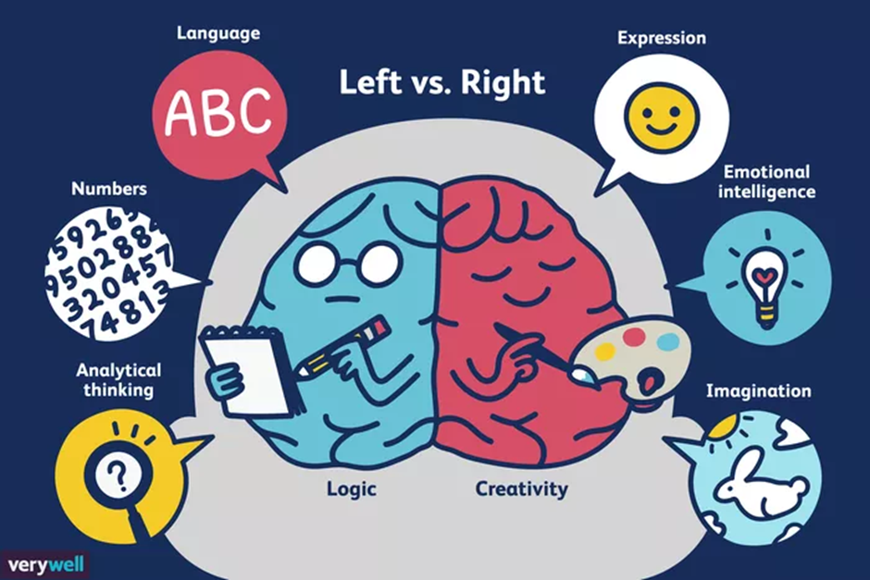
[Accessed on: https://www.verywellmind.com Accessed on 05 March 2020]

Write paragraphs on study strategies for left and right brain dominant individuals.

Use the following as a guideline:

- Define the term ‘study strategy’ and identify TWO study strategies a creative, right brain teenager might use for an upcoming test. (1+2)(3)
(Lower Order)

- Discuss FOUR ways how knowing their study style before tests start could help learners better prepare for tests. (4x2)(8)
(Middle Order)

- Suggest THREE strategies schools could put into place to make learners more aware of different study strategies. In your answers, indicate how EACH suggestion could make learners more likely to apply different study strategies. (3x3)(9)
(Higher Order)

[20]
Question 6:
Study the following cartoon and answer the question that follows.
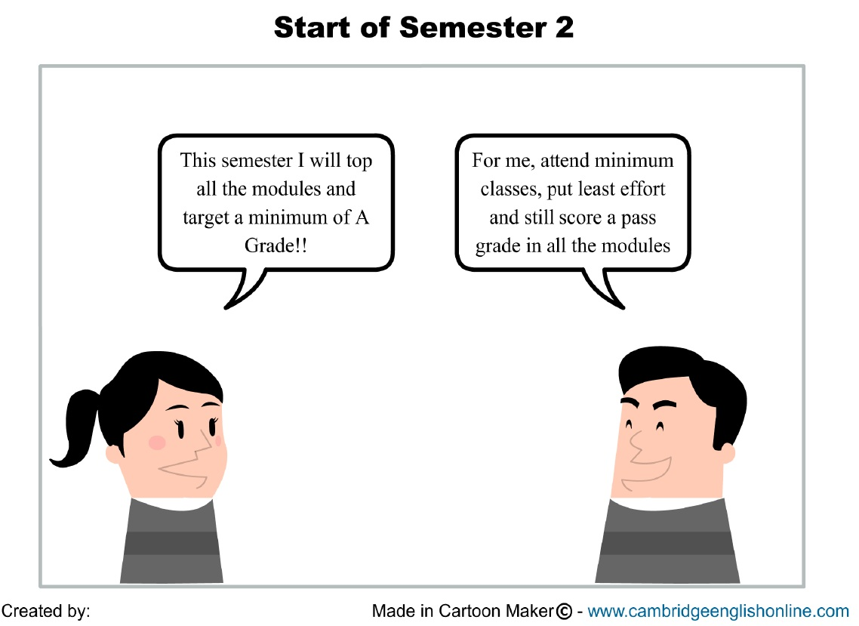

[Accessed from https://krishnadaspgcert.wordpress.com Accessed on 05 March 2020]
Write paragraphs on the importance of goal setting at school.

Use the following as a guideline.

- Define the term ‘prioritising’ and list TWO reasons why prioritising school-related goals is important for learners in grade 11. (1+2)(3)
(Lower Order)

- Explain FOUR detrimental effects romantic relationships could have a on gr11 learners reaching their academic goals. (4x2)(8)
(Middle Order)

- Evaluate THREE time management strategies that learners can put into place to reach their goals. In your answers, indicate how EACH strategy could help the learners reach their academic goals. (3x3)(9)
(Higher Order)
[20]

TOTAL SECTION C: 40
TOTAL = 20 + 40 + 40 = 100

MEMORANDUM

SECTION A

Question 1.1
1.1.1. A
1.1.2. C
1.1.3. D
1.1.4. D
1.1.5. D
(5x1)(5)

Question 2.1
1.2.1. Short term (goal)
1.2.2. Prioritise
1.2.3 Define
1.2.4. Study Plan
1.2.5 Culture
(5x1)(5)

1.3.1 List TWO boundaries teenagers could put into place to ensure that they have healthy friendships. (2x1)(2)
(Lower Order)
- No forms of abuse (physical/ emotional/ verbal/ sexual)
- Confidential information remains between friends
- Privacy is respected
- Discuss problems with each other directly instead of speaking about it to others/ behind their back.
- Set time to be together and apart
- Tolerate each other’s viewpoints
- Allow for alternative answers.

1.3.2 Discuss ONE reason why partners should speak about their goals for a relationship before they get married. (1x2)(2)
(Middle Order)
- This ensures that they are both in agreement on important goals like careers or when to have children, so that they don’t find out that their goals are incompatible after they have committed to one another.
- If their goals don’t align straight away, they could collaborate to find a solution before their differing goals ruin their relationship.
- Allow for alternative answers.

1.3.3 Explain TWO reasons why a teenager might not be able to keep a good working relationship with their teacher. (2x2)(4)
- They may not have had good role models, so they don’t know what a working relationship looks like.
- The boundaries may be unclear, which could result in miscommunication or inappropriate conduct.
- They may have negative past experiences with authority figures which makes it difficult for them to work with the teacher as they fear a similar situation will occur.
- They are surrounded by their peers who put pressure on them. This pressure may take precedence over the teacher’s wishes if they have a low self-esteem/ need to prove themselves.
- Allow for alternative, well-reasoned responses.
(Middle Order)

1.3.4 Suggest ONE exam writing skill learners might put into place if they cannot answer a question in an exam. (1x2)(2)
(Higher Order)
- They might answer the questions that they know first and then return to the difficult question at the end.
- They might try stress reducing techniques such as breathing to calm their nerves and help them think about the question without panic.
- They might break the question down into its different parts to help them understand it better.
- They may try to reword it, so that it is simpler for them to understand and answer.
- They may analyse the question words which may give the learner a clearer idea of the requirements.
- Allow for alternative, well-reasoned responses.
TOTAL SECTION A: 20

SECTION B (Compulsory)
Answer all the questions in this section.
Question 2

2.1 Define the term ‘romantic relationship’ and mention THREE ways teenagers could use social media to initiate and develop a romantic relationship (1+3)(4)
(Lower Order)
- A relationship with another person based on love and attraction.
  - This person could like/ comment on something that they have posted.
  - They may meet them on a dating site.
  - They may get to know them through a mutual friend’s social media page.
  - They may follow similar stories/ channels/ pages on social media.
  - Their posts could come up on their feed/ they may like the things that they post.
  - Allow for alternative responses.

2.2 Provide TWO reasons why teenagers might find it easier to have a relationship via social media. (2x1)(2)
(Lower Order)
- Their peers are not watching them/ there is less social pressure.
- It is more difficult for their parents to monitor.
- They are more comfortable with social media as they use it so regularly.
- It is cheaper than going on dates to see the person.
- They can be the person that they want to be as no one is around to judge them.
- Allow for alternative responses.

2.3 Describe TWO potential risks of developing a romantic relationship over social media. (2x2)(4)
(Middle Order)
- They are more likely to send inappropriate photos of themselves which is illegal as they are under 18.
- The person may not be the person they claim they are (catfishing) which could put the teenager at risk of being taken advantage of.
- It could be unsafe when the teenager eventually decides to meet them in person as they may try to abduct them or hurt them in some way.
- Anything they post to that person is published and cannot be erased, which means that it be used against them later /or/ it could cause them to get into legal trouble.
- Allow for alternative, well-reasoned responses.

2.4 Explain TWO ways how social media could decrease our chances of building strong, deep romantic relationships. (2x2)(4) (Middle Order)
- It is difficult to get to know a person’s true personality over social media as we don’t see how they physically and emotionally react to situations.
- We could be so busy on social media, building up and maintaining new relationships that we don’t spend quality time working on the relationship with the person that we love.
- Because we are always seeing the best features of people on social media, we expect our loved one to be like this in real life and get frustrated with them when they have flaws.
- We expect our relationships to be like the perfect posts or photos that we see on social media and so we give up on the relationship in times of difficulty /or/ we don’t know how to work through problems in our relationship.
- Allow for alternative, well-reasoned answers.

2.5 Suggest THREE actions parents could take to ensure that their child does not end up in a romantic relationship that is purely based over social media. (3x2)(6)
(Higher Order)
- They could educate their child on the dangers of social media so that the child is wary of the potential negative consequences.
- Parents could show their children how to use social media responsibly, so that they have the tools to keep themselves safe.
- They could set certain parameters or boundaries for social media usage so that their child does not have unlimited access to social media sites.
- Parents could foster an open relationship with their children where their children trust them enough to be open about new relationships, and parents can therefore give advice about new online relationships.
- Parents could friend or follow their child on social media so that they are more aware of the people their child interacts with.
- If their child does start an online relationship, the parents could suggest that they meet as a family in a controlled environment, which will ensure that the child is safe, and the family can also get to know the person.
- Allow for alternative, well-reasoned answers.

- t
[20]
Question 3

  - Define the term ‘abusive relationship’ and mention TWO rights that are violated by abuse within a relationship. (1+2)(3)
(Lower Order)

- Abusive relationship: One or both partners seek to gain control over the other by manipulating or dominating them.
  - The right to Privacy
  - The right to Safety and Security
  - The right to Freedom
  - The right to Freedom of Expression
  - The right to Human Dignity
  - Allow for alternative, reasonable answers.

  - Provide THREE reasons someone in an abusive high school relationship would stay with their partner, despite the abuse. (3x1)(3)
(Lower Order)
- The are reliant on them financially.
- They believe that they deserve the abuse.
- Their upbringing may have led them to believe abuse is socially acceptable.
- They don’t want to be alone.
- They fear the retaliation if they end the relationship.
- They believe that the social status of being in a relationship with the abuser is worth the abuse.

  - Describe the THREE warning signs that teens can use to identify friends that are in abusive relationships.
(3x2)(6)
(Middle Order)
- They have constant unexplained injuries that they try to cover up /or/ reason away with silly excuses.
- Their smiles and laughter seem forced, as though they are not actually as happy as they pretend to be.
- They could wear more conservative clothing, as though they are trying to cover up injuries.
- They are becoming someone that the other person would like them to be and don’t seem happy about it.
- They lose touch with friends and become withdrawn from social settings.
- They seem less confident as though they have been broken down.
- They are constantly distracted and distanced from conversations as though they are worried /or/ have less emotional investment.
- They are overly worried about how their partner will react to silly things (walking on eggshells) as though they fear their reaction.
- They are constantly seeking their partners approval through their actions or words.
- Even when they are not with their partner, they are constantly on the phone with them as though they cannot handle being apart.
- Allow for alternative, well-reasoned answers.

  - Discuss TWO possible emotional effects and abusive relationship could have on a teenager. (2x2)(4)
(Middle Order)
- They may become scared that others will also treat them in an abusive manner.
- They may lose their confidence and self-esteem as they believe they ‘deserve’ the abuse /or/ they don’t want to put themselves out there and risk further abuse.
- They may feel ashamed of what is happening and feel they are not strong enough/ man enough/ woman enough to prevent it.
- They may doubt themselves because they don’t want to do something ‘wrong.’
- They lose trust in others and withdraw from friends and family.
- Allow for alternative, well-reasoned responses.

  - Assess TWO possible reasons how technology could have made abusive relationships more common for today’s teenagers. (2x2)(4)
(Higher Order)
- We have become desensitised to abuse and violence because reality TV shows and dramas have made it seem normal.
- It is easier to invade someone’s privacy by hacking their technology /or/ placing trackers on their personal belongings.
- Because of the ‘openness’ of social media, many teens feel that they are entitled to know everything about their partner, even if the partner doesn’t want to share.
- It is easier to abuse or cyberbully someone via technology as you cannot see the person’s reactions, so it doesn’t seem as real /or/ you feel invincible because there is a screen protecting you.
- It is easier for teenagers to meet men and women far older than them via social media which could lead to things like grooming or sexual abuse.
- Allow for alternative, well-reasoned responses.

[20]
TOTAL SECTION B: 40

SECTION C

Question 4:

Define the term ‘victim blaming’ and state TWO reasons the why the South African public’s negative reaction to Lady Zamar’s announcement can be considered a form of victim blaming. (1+2)(3)
(Lower Order)
- Victim Blaming: When the victim of a crime or any wrongful act is held entirely or partially at fault for the harm that befell them.
  - By asking why it wasn’t reported sooner, they are implying that she should have done something differently.
  - By trying to discredit her experience they are punishing her for being a victim.
  - When they imply that she is lying, they are taking away her story as a ‘victim’/survivor.
  - Allow for alternative responses.

Discuss FOUR reasons why it is important for celebrities to speak out against abusive relationships. (4x2)(8)
(Middle Order)
- They are role models to many young people and so, they will help to show the new generation that abuse is not acceptable within a relationship.
- They have many followers on social media, which means that more people will see their messages and become aware of the problem.
- If people see them standing up, when they have so much to lose, it could encourage others to have the confidence to stand up as well.
- Other victims/ survivors will see these powerful people have gone through trauma and survived, which may give them the courage to share their stories and seek justice as well.
- They have more money and social power at their disposal, which means that they have more resources to combat the issue.
- Allow for alternative, well-reasoned responses.

Recommend THREE ways South African citizens can show support for victims of abusive relationships through the media. In your answers, also indicate how EACH recommendation could help boost a victim’s mental and emotional well-being. (3x3)(9)
(Higher Order)
- South Africans could write letters to the press, expressing concern and understanding for those who have experienced abuse within relationships. This would allow survivors to see that they are not being looked down on or judged by their peers.
- They could start anonymous private chats on social media where victims/ survivors can share their stories privately without fear of judgement. This would allow survivors to release some of their trauma related stress.
- They could share information regarding where to get help on their social media feeds so that there is more chance of people seeing the information. This would make it more likely for the victims/ survivors to get the help and comfort that they need.
- South Africans could express positive comments for those who have chosen to speak up about their experiences via social media. This would create a culture where speaking out against abuse is acceptable and even encouraged which would make victims feel more comfortable speaking out /or/ would make them feel less isolated.
- Allow for alternative, well-reasoned responses.

[20]
Question 5:

Define the term ‘study strategy’ and identify TWO study strategies a creative, right brain teenager might use for an upcoming test. (1+2)(3)
(Lower Order)
- Study Strategy: approaches applied to learning for a test or exam.
  - mind maps with pictures
  - summarise notes through songs
  - colourful notes
  - decorative flash cards
  - turn study material into a game
  - allow for alternative answers.

Discuss FOUR ways how knowing their study style before tests start could help learners better prepare for tests. (4x2)(8)
(Middle Order)
- Maximises the amount of information you can learn in a shorter time, which means that learners will be more likely to get through all the work.
- They will be studying correctly for their way of learning from the beginning which means that they are more likely to retain all the information they need.
- They will be able to devise a reasonable and workable study strategy which will allow them to feel more in control and less stressed for their upcoming tests.
- They can do research on study strategies best suited for their study style before they start studying. This will expose them to new and more effective study strategies for them. / ensure that they maximise their ability to retain information.
- Learners will feel more comfortable and enjoy studying more which makes them more likely to study for their tests in advance.
- Learners will be working in a way that plays to their strengths which will give them more confidence and self-esteem.
- Allow for alternative, well-reasoned responses.

Suggest THREE strategies schools could put into place to make learners more aware of different study strategies. In your answers, indicate how EACH suggestion could make learner’s more likely to apply different study strategies. (3x3)(9)
(Higher Order)
- Schools could provide examples of different strategies during their LO lessons, where learners are able to learn exactly what how to use each strategy. Through this, learners would be more informed and aware of the options available to them.
- Schools could ask each subject to give demonstrations of study strategies that work best for that subject. This would allow learners to see a practical application of relevant study strategies and how to apply them. Learners would then feel more confident to make use of these strategies as they have seen them in action.
- They could provide study opportunities where learners could have guided practice sessions with different study methods. Learners could try out different strategies and see which ones work best for them. In this way, learners don’t have to use their own valuable time figuring out which strategies work for them as they have done this in class, so it is easy for them to just choose from the ones they already used and liked.
- Schools could host \courses for parents and learners so that everyone in the family can become informed. This way parents can help guide and remind their children in a well-informed manner. Learners will feel supported and confident enough to try new things because they have a support base to provide assistance should they need it.
- Teachers could record themselves demonstrating the study skills and post these online so that learners can play it back at their own time. When using these new skills, learners will be able to go over any points that they are uncertain about, making them feel more comfortable.
- Allow for alternative, well-reasoned responses.

[20]

Question 6:

Define the term ‘prioritising’ and list TWO reasons why prioritising school-related goals is important for learners in grade 11. (1+2)(3)
(Lower Order)
- Prioritising: to designate or treat (something) as being very or most important so that we do this task first.
  - This means that they will not allow their social life will not disrupt their goals.
  - They will not give up on their goals when they hit adversity.
  - This ensures that they will set themselves up for academic success.
  - Allow for alternative responses.

- Explain FOUR detrimental effects romantic relationships could have a on gr11 learners reaching their academic goals. (4x2)(8)
(Middle Order)
- Their partner may distract them from studying by asking them to spend extra time with them.
- They may be influenced into not caring about their marks if their partner does not prioritise academics.
- They may have troubles in their relationship, which will mentally and emotionally drain them, so they don’t have any energy to focus on studies.
- They may engage in sexual activity and fall pregnant/ cause their partner to fall pregnant. The resulting stress will make it difficult to concentrate on studies /or/ when the baby arrives, there is even less time to focus on studies.
- Their partner may be going through a difficult time, which means that they feel the need to support their partner in the time they should be spending on schoolwork.
- Their partner could peer-pressure them into risky behaviours such as substance abuse, which could alter their thought patterns /or/ give them health problems /or/ get them addicted and thus make it difficult to study.
- Allow for alternative, well- reasoned answers

Evaluate THREE time management strategies that learners can put into place to reach their goals. In your answers, indicate how EACH strategy could help the learners reach their academic goals. (3x3)(9)
(Higher Order)
- They could create a study timetable to ensure that they allocate enough time to study each subject. This would ensure that the learners have worked through all their work and will get the best marks possible.
- Start revising before exams start by setting aside time for subject revision each day. This will ensure that by the time exams arrive, learners have a thorough understanding of the work and can perform at their best.
- Make lists of things to accomplish each day so that learners have a clear idea of what they need to do and can stay on track. This allows learners to remain focused and not leave out important tasks.
- Get the most important or most challenging tasks done earlier in the day wherever possible when learners are fresh and most productive. Not only will learners understand their work better, they will also have less stress for the rest of the day and be able to focus on their other tasks better.
- Set reminders on their calendar or cell-phone to inform them about important project dates ahead of the time. This will give learners enough time to work through their project carefully or ask the teachers questions if necessary.
- Start projects or tasks on the day that they receive them so that the information is fresh in their head. This will help learners get through the project or task quicker as they know what is expected.
- Allow for alternative, well-reasoned responses.
[20]
TOTAL SECTION C: 40
TOTAL = 20 + 40 + 40 = 100

