GRADE 12 LIFE ORIENTATION

TOPIC: DEMOCRACY AND HUMAN RIGHTS & SOCIAL AND ENVIRONMENTAL RESPONSIBILITY
(DHR + SER)

Term 1 & 2
2020

1 ½ HOURS 80 MARKS

NOTE TO TEACHERS: Remember, this is a bank of questions and therefore may contain some overlaps and might not fully adhere to the weighting of Bloom’s Taxonomy. Keep this is mind when selecting questions for your paper. Use the table below to help you when choosing your questions.

Weighting (suggested) | Weighting (Actual) | Cognitive level | Bloom’s taxonomy
30% (24 marks) | 24 marks | Lower Order | Level 1&2
40% (32 marks) | 32 marks | Middle Order | Level 3&4
30% (24 marks) | 24 marks | Higher Order | Level 5&6

All essay questions are weighted the same so no matter which essay question combo a learner chooses, they will still have the same weighting out of 80.

REMINDER: Final paper should include components of each topic covered in Terms 1&2.
______________________________________________________________
INSTRUCTIONS AND INFORMATION
- The question paper consists of THREE sections, namely SECTION A, SECTION B and SECTION C.
- The questions in SECTION A and SECTION B are compulsory.
- Answer any TWO questions in SECTION C.
- Read ALL the questions carefully.
- Number the answers correctly according to the numbering system used in this question paper. Start each question on a new page.
- Write neatly and legibly.

SECTION A. (Compulsory)
Answer all the questions in this section.
Question 1

Various options are provided as possible answers to the following questions. Choose the correct answer and write only the letter (A–D) next to the question number (1.1.1 – 1.1.5) in the answer book, for example 1.1.3. E.

1.1.1 As part of a democracy, everyone has the right to access any information…
- unless it is in the government’s possession.
- that is required to exercise human rights.
- that could insight war or public violence.
- except if it is deemed to be disturbing to society.
(Lower Order)

1.1.2 Which of the following would fall under responsible citizenship?
- Shaming petty criminals by posting their personal information on social media.
- Taking the opportunity to vote without researching the running parties.
- Watching the news to stay informed so you can petition for necessary change.
- Forwarding all the stories you read on social media, even if it’s fake news.
(Lower Order)

1.1.3 Which of the following is considered a human right’s violation?
- Creating separate areas for men and women to exercise in a gym.
- Disallowing someone to work for your company based on their HIV status.
- Providing someone in a wheelchair with a seat close to an entrance.
- Not marrying someone because you don’t share their religious beliefs.
(Lower Order)

1.1.4. Identify which one of the following would NOT be a community service the municipality would be expected to fulfil.
- Providing basic services such as water to those who can’t afford it.
- Build and maintain libraries and schools with the community.
- Look after abandoned pets and pets whose owners can’t afford them.
- Ensuring that school learners have necessities like textbooks and phones.
(Lower Order)

1.1.5. Which of the following is considered defamation of character?
- Falsely accusing a political figure of embezzling money.
- Publishing factual information regarding a company’s fraud.
- A journalist acknowledging mistakes in their press release.
- An editor who edits out unimportant pieces of a quote.
(Lower Order)
(1x5)[5]

1.2. Give ONE word/term for EACH of the following descriptions. Write only the word/term next to the question numbers (1.2.1 to 1.2.5) in the ANSWER BOOK.

1.2.1 Research to measure and monitor something to determine if a particular action has had or will have an effect on the situation.  (Lower Order) | (1)
1.2.2 Usually sets out the purpose and aim of a business, company or organisation to say what they want to achieve.  (Lower Order) | (1)
1.2.3 Photojournalists who follow or chase after celebrities and politicians in their public and private lives, looking for scandal.  (Lower Order) | (1)
1.2.4 The right of every individual to hold opinions without interference and to seek, receive and impart information through any media.  (Lower Order) | (1)
1.2.5 The suppression or prohibition of any media that is considered obscene, politically unacceptable, or a threat to security.  (Lower Order) | (1)
(1x5)[5]

1.3 Answer the following questions by writing the answer next to the question numbers (1.3.1 to 1.3.4) in the ANSWER BOOK/ FOLIO provided. Write your answers in full sentences.

1.3.1 List TWO limitations on freedom of expression. (2x1)(2)
(Lower Order)

1.3.2 Discuss how The Protection of Information Bill (POIB) could be problematic. (1x2)(2)
(Middle Order)

1.3.3 Explain TWO ways social media has made it easier for the public to be active citizens. (2x2)(4)
(Middle Order)

1.3.4 Suggest how ‘fake news’ can harm democracy. (1x2)(2)
(Higher Order)

[10]
TOTAL SECTION A: 20

SECTION B (Compulsory)
Answer all the questions in this section.
Question 2

Read the case study below and answer the questions that follow.
Four children die after eating toxic substance at Eastern Cape dumping site
Written by Canny Maphanga on 06 January 2020
Four children in the Eastern Cape have died after consuming a toxic substance at a dumping site in NU30, Motherwell, on Sunday afternoon.
The children were apparently playing at the dump, which is close to their homes, and ate some foodstuff they found there. There are rumours doing the rounds that they ate tainted chips and cheese, but the police were unable to confirm until further tests could be done.
Residents blamed for illegal dumping after 4 kids die from toxic food
Written by: Joseph Chirume on 08 January 2020
After residents in Motherwell blamed the municipality for the deaths of the four children who ate toxic substances, municipal spokesperson Mthubanzi Mniki told GroundUp that the municipality always cleaned dumpsites in all areas of the municipality. Instead, he blamed residents for illegal dumping.
"The problem is residents continue to dump, even in places where there is provision of skip bins. People throw their waste outside the bins, even when they are not full. We urge them to dump in those bins to curb health hazard cases."
[Adapted from https://www.news24 Accessed on 25 December 2019]
2.1 Define the National Environmental Management Act of 1998 and mention TWO ways that this act is carried out by the municipality. (2+1)(3)
(Lower Order)
2.2 Mention the TWO levels of government that are above the municipal government. (2x1)(2)
(Lower Order)

2.3 Explain how residents of the community did not live up to their environmental responsibility. (1x2)(2)
(Middle Order)

2.4 Discuss TWO dangers illegal dumping can have on the community. (2x2)(4) (Middle Order)

2.5 Suggest TWO impact studies that could be implemented to help prevent illegal dumping in the community in future. (2x2)(4)
(Higher Order)
[15]
Question 3
Refer to the adapted article below and answer the questions that follow.

Annual Charade: Women’s Month is no cause for celebration
By Karabo Mafolo 1 September 2019
Politicians use 9 August as a day to pay tribute to the women of 1956 while saying nothing about how to make South Africa safer for women today.
Every year without fail the importance of respecting and advocating for women’s rights is relegated to the month of August. Women’s Day itself, 9 August, holds significance because on this day in 1956 thousands of women marched to the Union Buildings in Pretoria to protest against the pass laws.
Over the years this historic occasion has been reduced to pink-themed events and ill-conceived campaigns of men in heels and lipstick. At the provincial legislature debate on gender-based violence and femicide on 15 August 2019, Speaker Masixole Mnqasela said the debate was taking place “because it’s the right thing to do since it’s Women’s Month”.
[Adapted from: https://www.dailymaverick.co.za Accessed on 02 January 2019]

  - Define the term ‘campaign’ and explain how the above situation is an example of a campaign. (1+2)(3)
(Lower Order + Middle Order)

  - Provide TWO ways that the above campaign has failed the women in South Africa. (2x2)(4)
(Middle Order)

  - Describe how the media is used to combat human right violations.
(1x2)(2)
(Middle Order)

  - Assess whether print or electronic media would be better suited for the above campaign. (1x2)(2)
(Higher Order)

  - Suggest TWO alternative campaigns that could yield better results to decrease violence against women. (2x2)(4)
(Higher Order)
[15]
TOTAL SECTION B: 30

SECTION C (Choice)

Answer any TWO questions in this section.

Your responses must consist of paragraphs. Marks will only be allocated for responses written in full sentences.

Question 4:

Study the following extract and answer the question that follows.
Forget New Year’s resolutions! Create a Personal Mission Statement
By Dayna Mason, 02 January 2020
As we deal with the new year, many of us are resolving to change something about our lives. Maybe we want to lose a few kilograms or eat healthier but what if, instead of focusing on small goals, we looked at the bigger picture, and asked ourselves, “What do I actually want from my life?”
Most corporations have a mission statement, which helps them stay aligned with the goals and values they deem most important for the company. So why can’t we have a personal mission statement that can help us stay aligned with who we are and the impact we want to make on the world. When we are trying to figure out our next best step, we can reread the words of our mission statement to help guide that decision.
[Adapted from https://waterlandblog.com Accessed on 20 January 2020]

Write paragraphs on the importance of personal mission statements.

Use the following as a guideline:

- Define the term ‘personal mission statement’ and state TWO reasons why it is important for matrics to create a personal mission statement. (1+2)(3)
(Lower Order)

- Discuss THREE social influences that could positively influence the values of matrics during their final year. (3x2)(6)
(Middle Order)

- Suggest TWO ways a personal mission statement can encourage matrics to become active citizens. In your answers, also indicate how EACH suggestion could lead a matric to become a more active citizen. (2x3)(6)
(Higher Order)

[15]

Question 5:

Study the following extract and answer the question that follows.
Jon Qwelane, a well-known journalist is being prosecuted from the column he for the Sunday Sun, in 2008, the target being the gay community. Understandably this column is in conflict with the Constitution that guarantees equality to all and as such, triggered widespread protest. It was argued that Mr Qwelane had advocated hatred against a particular group of people, namely, homosexuals, and the column was intended to be hurtful, harmful, incited harm, and promoted hatred.
Many believe the article infringed upon various constitutionally guaranteed human rights and freedoms of homosexuals; and sought to demoralise homosexuals by and by dehumanising and "criminalising" the gay and lesbian community.
The matter wound its way to the High Court which found that the offending statements against gay people amounted to hate speech, as envisaged in section 10(1) of the Promotion of Equality and Prevention of Unfair Discrimination Act 4 of 2000 (PEPUDA) which provides that "subject to the proviso in section 12, no person may publish, propagate, advocate or communicate words based on one or more of the prohibited grounds, against any person, that could reasonably be construed to demonstrate a clear intention to – (a) be hurtful; (b) be harmful or to incite harm; promote or propagate hatred".
[Adapted from https://www.news24.com Accessed on 30 December 2019]

Write paragraphs on hate speech in the media.

Use the following as a guideline:

- Define the term ‘hate speech’ and provide TWO reasons why hate speech has become so prevalent in the media. (1+2)(3)
(Lower Order)

- Discuss THREE ways that the hate speech in the 2008 column infringed on the constitutional rights of the LBGTQIA+ community. (3x2)(6)
(Middle Order)

- Suggest TWO ways that the LBGTQIA+ community could take action against hate speech. In your answers, also indicate how EACH suggestion could lead to less hate speech. (2x3)(6)
(Higher Order)

[15]

Question 6:

Study the following cartoon and answer the question that follows.
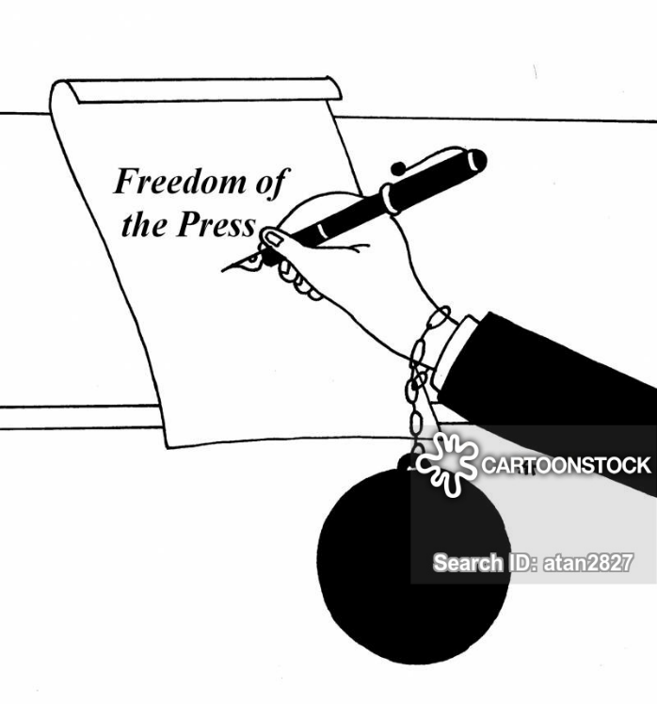
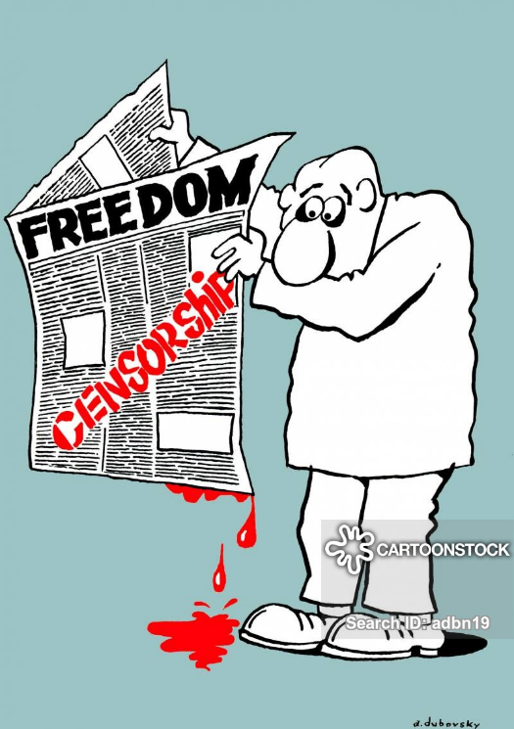

[Accessed on: https://www.cartoonstock.com Accessed on 20 January 2019]

Write paragraphs on censorship in the media.

Use the following as a guideline.

- Define the term ‘censorship’ and list TWO instances where authorities are allowed to censor the media. (1+2)(3)
(Lower Order)

- Describe THREE ways that censorship could be detrimental to a democratic society. (2x3)(6)
(Middle Order)

- Recommend TWO ways that responsible citizens could express their displeasure over censorship. In your answers, indicate how EACH recommendation could decrease the likelihood of censorship. (2x3)(6)
(Higher Order)
[15]

TOTAL SECTION C: 30
TOTAL = 20 + 30 + 30 = 80
MEMORANDUM

SECTION A

Question 1.1
1.1.1. B
1.1.2. C
1.1.3. B
1.1.4. D
1.1.5. A
[5]

Question 1.2
1.2.1. Impact Study
1.2.2. Mission
1.2.3 Paparazzi
1.2.4. Freedom of speech/ freedom of expression
1.2.5 Censorship
(5x1)[5]

1.3 Answer the following questions by writing the answer next to the question numbers (1.3.1 to 1.3.4) in the ANSWER BOOK/ FOLIO provided. Write your answers in full sentences.

1.3.1 List TWO limitations on freedom of expression. (2x1)(2)
(Lower Order)
  - May not include hate speech
  - May not incite violence or war
  - May not include defamation of character
  - May not violate copy right laws
  - May not expose minors to obscene or pornographic content
  - May not violate non-disclosure agreements or disclose trade secrets.

1.3.2 Discuss how The Protection of Information Bill (POIB) could be problematic. (1x2)(2)
(Middle Order)

- The bill makes it difficult for investigative journalists or whistle-blowers to expose corruption, which could lead to an increase in corruption in the country. /or/ which could lead them to leave their jobs.
- It makes it difficult for responsible citizens to make informed decisions as they don’t have all the facts.
- It may breed distrust in the public as they cannot trust if the information they have received is complete and factual.
- Allow for alternative, logical answers.

1.3.3 Explain TWO ways social media has made it easier for the public to be active citizens. (2x2)(4)
(Middle Order)

- Social media allows citizens to access information quicker, which means they are informed about current events as they happen /or/ they are aware of human rights violations.
- Social media spreads information from around the world, which allows active citizens to understand global issues.
- Social media allows citizens to share information easily which means that they can create more awareness in the populace.
- Social media holds many different sides of the information, which allows active citizens to read extensively and form a well-rounded opinion that is less likely to be biased.
- Social media allows people to express their views in chats underneath articles, posts, etc. This creates a dialogue where active citizens can create strategies for change.
- Allow for alternative, well-reasoned responses.

1.3.4 Suggest how ‘fake news’ can harm democracy. (1x2)(2)
(Higher Order)

- People may lose trust in the media that spreads fake news, making them less likely to stay informed and active citizens.
- People may be unable to identify fake news and feel anger towards the country, government, or persons reported in the fake news.
- People may protest against something that is false, which negatively effects the running of the country.
- Other countries may get access to the fake news and feel that South Africa is not a safe investment, leading them to pull funding.
- Allow for alternative, well-reasoned responses.

[10]

TOTAL SECTION A: 20

SECTION B (Compulsory)
Answer all the questions in this section.
Question 2

2.1 Define the National Environmental Management Act of 1998 and mention TWO ways that this act is carried out by the municipality. (1+2)(3)
(Lower Order)

- Nation Environmental Management Act governs how citizens and officials interact with the environment so that it will remain safe and clean.
  - Waste collection
  - Ensuring that there are enough bins in the area
  - Water sanitation
  - Providing people to clear litter from community areas.
  - Keeping streets and gutters clear of debris
  - Issue fines to people or companies negatively impacting the environment at a community level.
  - Putting up signs in areas affected by waste and poor sanitation
  - Allow for alternative answers

2.2 Mention the TWO levels of government that are above the municipal government. (2x1)(2)
(Lower Order)

- Provincial and National

2.3 Explain how residents of the community did not live up to their environmental responsibility. (2x1)(2)
(Middle Order)

- They did not dispose of waste in the correct areas/ bins, so it was lying around for the children to pick up and eat.
- They did not hold a cleanup day to ensure that litter was removed from the area so it would be safe for all.
- They did not speak to their community members about the dumping problem to come up with a solution for the community.
- Allow for alternative, well-reasoned responses.

2.4 Discuss TWO dangers illegal dumping can have on the community. (2x2)(4)
(Middle Order)
- Dangerous or toxic substances may be consumed, leading to illness or death.
- Sharp objects could by lying on the ground which could lead to injury.
- Refuse could find its way into open water systems which could infect people who drink the water /or/ damage the ecosystems in the water.
- Medical waste could be left in the open for people to consume. This could cause ill health.
- Liquid waste could seep into the soil, making the soil infertile.
- Can cause the area to smell, which decreases property value.
- Toxic fumes could enter the air which could cause illness for community members who must breathe it in on a daily basis.
- Drains and gutters may be blocked causing roadside floods.
- Litter can poison or suffocate wildlife, leading to decaying bodies and pests /or/ which can unbalance the ecosystem in the area if it happens to many of the same animal.
- Allow for alternative, well-reasoned responses.

2.5 Suggest TWO impact studies that could be implemented to help prevent illegal dumping in the community in future. (2x2)(4)
(Higher Order)

- Measure the amount of waste in the area to see how much work/ labour should be dedicated to cleaning up the community.
- Interview community members to see how they view the situation so that campaigns can be targeted to address negative mindsets effectively.
- Get data on how many bins there are in the area vs how many people are dumping waste and calculate how many more bins would be needed in the area to solve the problem.
- Conduct a census to see how many people use correct disposal methods or why they use incorrect methods. This could help to streamline information campaigns to target the correct people and give them correct alternatives.
- Allow for alternative, well-reasoned answers.

[15]

Question 3

  - Define the term ‘campaign’ and explain how the above situation is an example of a campaign. (1+2)(3)
(Lower Order+ Higher Order)
- Campaign: work in an organized and active way towards a particular social or political goal. /or/ a movement to change thoughts/ behaviours and create public action.
- The day is dedicated to the struggles of women, causing the public to reflect and gain awareness.
- Woman’s day celebrations bring attention to gender-based violence against women, with the idea that women will not accept this /or/ men will stand up for the women in their lives.
- Women’s day focuses on the negatives of human rights violations, e.g. lack of education or safety for women. This educates the public with the hope that they will push for social change.
- Allow for alternative, well-reasoned answers.

  - Provide TWO ways that the above campaign has failed the women in South Africa. (2x2)(4)
(Middle Order)
- This campaign only lasts for the month of August, which means that it is not at the forefront of people’s minds all year around and they therefore may not push for change all year around.
- Many people fail to see the significance, rather dressing up than taking it seriously. This may lead the public to take it as a joke and not act out against the violation of women’s rights.
- South Africa is still unsafe for women, meaning that many people are not internalising the message of this campaign.
- Allow for alternative, well-reasoned responses.

  - Describe how the media is used to combat human right violations. (1x2)(2)
(Middle Order)

- It publishes issues regularly, which creates awareness about the issue constantly.
- It reports issues on a global scale, which means it is far more likely to find a solution from a broader pool of helpers.
- It keeps active citizens up to date so that they can make informed decisions before taking action.
- Reports human rights issues to the public, so that they can be aware of what is happening.
- Can spread news of campaigns creating more action and support for these causes.
- Allows people to hold discussions on social media platforms, increasing the chance of a solution.
- Can publish tips or preventative measures so that victims/ survivors can be empowered to act against the perpetrators.
- It creates a platform to spread stories quickly so that action can be taken immediately.
- It can spread helplines or authority’s contact info so that the populace can report wrong doings quickly and safely.
- Allow for alternative, well-reasoned answers.

  - Assess whether print or electronic media would be better suited for the above campaign. (1x2)(2)
(Higher Order)

- Women’s rights are mainly an issue in poorer communities; therefore print would be better to reach those who don’t have the resources to access electronic media.
- Women’s rights are such a big/ widespread issue, that electronic media can reach as many people as possible.
- Women’s right movements are very active in suburban and urban areas, so electronic media would be able to reach women out of these areas.

  - Suggest TWO alternative campaigns that could yield better results to decrease violence against women. (2x2)(4)
(Higher Order)

- Peaceful protests and petition which could call more people to action /or/ create greater awareness of the issue.
- Aim the campaign at specific, problems that could have been identified by an impact study. This means that the correct/ crucial problems are targeted.
- Create a WhatsApp or social media message that is easier to share and will therefore get more followers.
- Allow for alternative, well-reasoned responses.
[15]
TOTAL SECTION B: 30

SECTION C (Choice)

Answer any TWO questions in this section.

Your responses must consist of paragraphs. Marks will only be allocated for responses written in full sentences.

Question 4:

Define the term ‘personal mission statement and state TWO reasons why it is important for matrics to create a personal mission statement. (1+2)(3)
(Lower Order)

- Personal mission statement defines an individual’s objectives in life and their approach to obtaining those objectives.
  - Gives them a clear purpose/ something to aim for after school
  - Keeps them motivated to complete their year
  - Uncover what is really important to them so they don’t waste valuable time
  - Simplifies decision making process when deciding what to do after school
  - Helps them focus on their goals for the year or afterwards
  - Holds them accountable for decisions and actions if they don’t reach their goals
  - Allow for alternative, logical answers.

Discuss THREE social influences that could positively influence the values of matrics during their final year. (3x2)(6)
(Middle Order)

- Supportive parents can help them define right from wrong by modeling correct behaviours so that the value academic excellence above excessive partying or substance abuse.
- Society has a very high expectation for academic achievements Matrics will try to live up these expectations because they value the same academic standard.
- Involvement in religious activities or groups set down ground rules for positive behaviour such as abstinence or avoiding substance abuse that matrics feel they must work towards to maintain a good life.
- The goals and expectations of their friends could inspire matrics to attempt to reach a higher standard.
- Allow for alternative, well-reasoned responses.

Suggest TWO ways a personal mission statement can encourage matrics to become active citizens. In your answers, also indicate how EACH suggestion could lead a matric to become a more active citizen. (2x3)(6)
(Higher Order)

- It helps matrics discover the causes that are important for them and define their standpoint in relation to these causes. This makes it easier for them to take a stand for what they believe in.
- Matrics would have put a lot of thought into creating a mission statement so it will be something they are passionate about. Their strong beliefs and passion will lend them the courage to act on what they believe in.
- It helps matrics to realise potential problems within the community and imagine how they would like these problems to be solved. This will give them motivation to become part of the change they would like to see.
- Gives matrics something concrete to work towards even when outside forces try to discourage them. This will give them the motivation to keep trying to create positive change despite potential adversity.
- Allow for alternative, well-reasoned answers.

[15]

Question 5:

Define the term ‘hate speech’ and provide TWO reasons hate speech has become so prevalent in the media. (1+2)(3)
(Lower Order)

- Hate Speech: public speech that encourages violence or negative feelings towards a group or individual based on gender, race, religious beliefs, culture, etc.
  - Internet has made it easy for anyone to publish anything
  - People feel bolder on social media as there is a screen between them and the person they are targeting/ a sense of anonymity
  - There are very few repercussions
  - There is a culture of defamation/ naming and shaming on social media
  - It is so quick to publish on social media today that people don’t always take the time to second guess what they are about to publish before they hit the ‘post’ button.
  - Allow for alternative, logical answers.

Discuss THREE ways that the hate speech in the 2008 column infringed on the constitutional rights of the LBGTQIA+ community. (3x2)(6)
(Middle Order)

- It took away their right to human dignity by making them seem to be criminals because of their sexual preferences.
- It infringed on their right to equality by singling them out and making them something ‘other’ or not the norm/ not accepted.
- It potentially made them feel unsafe as it incited hatred and violence against them
- It took away their right to freedom of expression by making the way they live their lives into something ‘wrong’ or immoral.
- Allow for alternative, well-reasoned responses.

Suggest TWO ways that the LBGTQIA+ community could take action against hate speech. In your answers, also indicate how EACH suggestion could lead to less hate speech. (2x3)(6)
(Higher Order)

- They could create a campaign to spread awareness of what it means to be homosexual. This would decrease myths about homosexuality leading to less misinformed hatred of something people don’t understand /or/ could help to normalise homosexuality so that society doesn’t see it as something other or abnormal that they must be separated from.
- They could hold a walk or march to bring awareness to the struggles faced by homosexuals/ the LBGTQIA+ community. If people saw the extent of the injustice, they would be more likely to stand against it.
- The LGBTQIA+ community could host talks or create societies where people can discuss the problems they are facing. This could hopefully create a greater understanding in the population, leading to less hatred or animosity.
- They could talk on radio or TV to expose those who target them to their side of the story. This could clear up misconceptions or create understanding so they may no longer feel the need to incite hatred and violence.
- They could create online platforms or social networking groups to create a dialogue about issues faced by LBGTQIA+. This could allow all citizens to voice their concerns and help to contribute to a solution.
- Allow for alternative, well-reasoned responses.
[15]

Question 6:

Define the term ‘censorship’ and list TWO instances where authorities are allowed to censor the media. (1+2)(3)
(Lower Order)

- Censorship: Stopping the media from publishing news that is considered unacceptable /or/ the suppression or prohibition of any parts of books, films, news, etc. that are considered obscene, politically unacceptable, or a threat to security
- The following can be censored:
  - They feel it is propaganda for war
  - It is an incitement of imminent (upcoming) violence
  - The media was advocating hatred that was based on race, ethnicity, gender or religion
  - There was incitement to cause harm
  - In included defamation of character
  - The information was deemed sensitive for young viewers

Describe THREE ways that censorship could be detrimental to a democratic society. (2x3)(6)
(Middle Order)

- Makes it difficult for citizens to make informed decisions as they don’t have all the information.
- Can leave state open to corruption and exploitation because these acts are hidden by censorship.
- Can stagnate the academic development of a country as they do not have access to the same information as the rest of the world.
- May silence certain voices as their comments on social media are edited or not published.
- Creates a level of inequality between those whose words are censored and those who have freedom to post as they please.
- Allow for alternative, well-reasoned responses.

Recommend TWO ways that responsible citizens could express their displeasure over censorship. In your answers, indicate how EACH recommendation could decrease the likelihood of censorship. (2x3)(6)
(Higher Order)

- They could host a peaceful protest or march, to cause disruption/ halt services in the country. This would encourage authorities to take views seriously to decrease the amount of time spent on disruption.
- They could sign a petition to send to authorities in charge of censorship. This would encourage authorities to create change when they see how much support the movement has.
- They could boycott media that supports the censorship so that these companies lose money. These companies would have to change if they wanted to get profits again.
- They could call for a meeting with authorities to raise their concerns face to face. This might encourage authorities to change their mind as they have a better understanding of the other side’s story.
- Allow for alternative, well-reasoned responses.
[15]

TOTAL SECTION C: 30
TOTAL = 20 + 30 + 30 = 80

