GRADE 12 LIFE ORIENTATION

TOPIC: DEVELOPMENT OF SELF IN SOCIETY & STUDY SKILLS
(DSS + SS)

Term 1 & 2
2020

1 ½ HOURS 80 MARKS

NOTE TO TEACHERS: Remember, this is a bank of questions and therefore may contain some overlaps and might not fully adhere to the weighting of Bloom’s Taxonomy. Keep this is mind when selecting questions for your paper. Use the table below to help you when choosing your questions.

Weighting (suggested) | Weighting (Actual) | Cognitive level | Bloom’s taxonomy
30% (24 marks) | 26 marks | Lower Order | Level 1&2
40% (32 marks) | 30 marks | Middle Order | Level 3&4
30% (24 marks) | 24 marks | Higher Order | Level 5&6
All essay questions are weighted the same so no matter which essay question combo a learner chooses, they will still have the same weighting out of 80.

REMINDER: Final paper should include components of each topic covered in Terms 1 and 2.
______________________________________________________________
INSTRUCTIONS AND INFORMATION
- The question paper consists of THREE sections, namely SECTION A, SECTION B and SECTION C.
- The questions in SECTION A and SECTION B are compulsory.
- Answer any TWO questions in SECTION C.
- Read ALL the questions carefully.
- Number the answers correctly according to the numbering system used in this question paper. Start each question on a new page.
- Write neatly and legibly.

SECTION A. (Compulsory)
Answer all the questions in this section.

Question 1

Various options are provided as possible answers to the following questions. Choose the correct answer and write only the letter (A–D) next to the question number (1.1.1 – 1.1.5) in the answer book, for example 1.1.3. E.

1.1.1 Which of the following hormones are responsible for the stress response?
- Adrenalin only
- Adrenalin and Cortisol
- Human Growth Hormone and Cortisol
- Progesterone and Oestrogen
(Lower Order)
1.1.2 During a final exam, a learner finds that his mind has gone blank. How can he deal with this in a healthy manner?
- Explain to the invigilator that he is psychologically unwell and ask for a rewrite.
- Take a nap and hope that he will remember what he studied when he wakes.
- Ask the invigilator for help with understanding the questions in the paper.
- Read the paper again and leave any difficult questions until the end.
(Lower Order)

1.1.3 Which of the following is a good tip for those who are experiencing acute stress in a classroom?
- Make small, purposeful movements to get rid of stress hormones.
- Try to put off facing the stressor until it is unavoidable.
- Chew gum even though it is against school policy.
- Avoid eye contact with classmates to decrease stress response.
(Lower Order)

1.1.4. To obtain an NSC exam, a study plan is important because:
- It keeps learners focused and motivated to achieve their goals.
- Learners can maximise time and study until the night before the exam.
- Breaks will be minimised so that learners can work consistently.
- Parents will stop nagging learners, therefore decreasing stressors.
(Lower Order)

1.1.5. When you are unable to concentrate in class due to the construction work going on outside, this is an example of a(n) ___________ stressor.
- Psychosocial
- Emotional
- Physical
- Environmental
(Lower Order) (5x1)[5]

1.2. Give ONE word/term for EACH of the following descriptions. Write only the word / term next to the question numbers (1.2.1 to 1.2.5) in the ANSWER BOOK.

1.2.1 A memory aid or tool that helps one remember study material with a pattern of letters, numbers, or relatable associations.  (Lower Order) | (1)
1.2.2 A disagreement between two or more people, which can lead to an argument.  (Lower Order) | (1)
1.2.3 The act of conveying information between people using both verbal and non-verbal methods.  (Lower Order) | (1)
1.2.4 A sudden, short term stress that occurs in the moment.  (Lower Order) | (1)
1.2.5 The name of the qualification received once a learner has passed grade 12.  (Lower Order) | (1)
(5x1)[5]

1.3 Answer the following questions by writing the answer next to the question numbers (1.3.1 to 1.3.4) in the ANSWER BOOK/ FOLIO provided. Write your answers in full sentences.

1.3.1 List TWO potentially stressful changes matrics will be facing in their final year of school. (2x1)(2)
(Lower Order)

1.3.2 Differentiate between chronic stress and eustress. (1x2)(2)
(Lower Order)
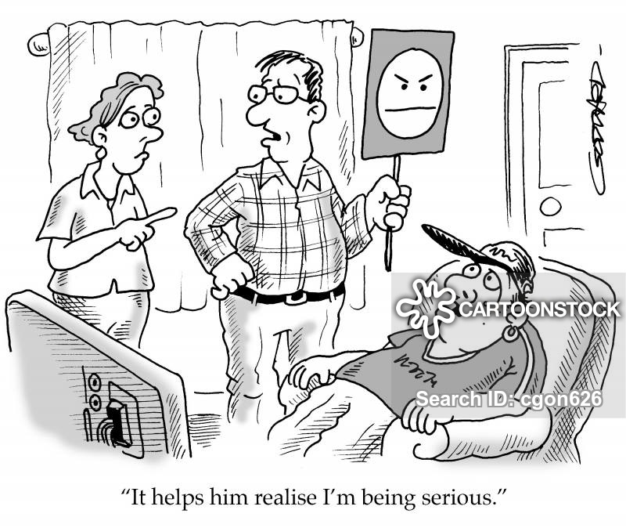

[Accessed from: https://www.cartoonstock.com Accessed on 16 December 2019]

1.3.3 Refer to the cartoon above when answering the following questions regarding communication.

a) Explain TWO ways how social media has made it difficult for parents and teenagers to communicate effectively. (2x2)(4) (Middle Order)

b) Evaluate how a positive attitude can contribute towards effective communication strategies in a parent-child relationship. (1x2)(2)
(Higher Order)
[10]

TOTAL SECTION A: 20

SECTION B (Compulsory)
Answer all the questions in this section.

Question 2

Read the case study below and answer the questions that follow.
Underage drinking and the signs
Pay attention to teenagers with signs of stress, anxiety and depression. Teenagers sometimes feel overwhelmed by life and may then turn to alcohol for solace if they don’t have a healthy outlet for frustration, social anxiety, depression, anger and all the other emotions that are part and parcel of growing.
Alcohol is a very powerful anxiolytic drug which reduces symptoms of stress and anxiety. After initial exposure to alcohol, teenagers start to believe it can ward off their painful feelings.
Furthermore, if their lives aren’t going well, they figure they have nothing to lose by using alcohol. Teens with undiagnosed and unmanaged anxiety problems are at particular risk for abusing alcohol.
Alcohol works quickly. The initial effects feel really good, especially for teens who want to get rid of their bad feelings. The problem is that when the effects wear off, the negative feelings return even stronger.
[Adapted from https://www.iol.co.za Accessed on 25 December 2019]

2.1 Define the term ‘stress management’ and outline how alcohol abuse could be seen as a negative stress management technique. (2+1)(3)
(Lower Order)

2.2 Provide TWO potential social stressors matriculants may face that could lead them to abuse alcohol. (2x1)(2)
(Lower Order)

2.3 Explain how alcohol abuse could negatively affect the body’s stress response. (2x1)(2)
(Middle Order)

2.4 Discuss TWO ways how societal expectations with regards to your matric results could affect you emotionally and therefore lead to alcohol abuse. (2x2)(4) (Middle Order)

2.5 Suggest TWO ways that schools could encourage their learners to stay away from alcohol as a form of stress management. (2x2)(4)
(Higher Order) [15]
Question 3
Refer to the adapted article below and answer the questions that follow.
Eastern Cape pupil stabbed to death in fight over missing cellphone
Published: September 14, 2018 By: Tammy Petersen
A teenager is in police custody for the murder of a fellow learner at an Eastern Cape school, following a stabbing during a fight over a missing cellphone.
Police spokesperson said a 16-year-old pupil had been arrested after the 18-year-old victim died at a local hospital on Thursday.
[Adapted from: https://www.news24.com Accessed on 25 December 2019]

  - Define the term ‘conflict resolution’ and explain how the above situation is an example of bad conflict resolution. (1+2)(3)
(Lower Order + Middle Order)

  - Describe TWO alternative conflict resolution techniques that the learners could have used to solve the problem of the missing cellphone peacefully. (2x2)(4)
(Middle Order)

  - Explain how positive conflict resolution could have produced a more positive outcome in the above situation. (1x2)(2)
(Middle Order)

  - Assess how a fellow learner calling an adult for help could have stopped the death of the 18-year-old. (1x2)(2)
(Higher Order)

  - Suggest TWO strategies learners could put into place to decrease the culture of violent conflict resolutions within their schools. (2x2)(4)
(Higher Order)
[15]

TOTAL SECTION B: 30
SECTION C (Choice)

Answer any TWO questions in this section.

Your responses must consist of paragraphs. Marks will only be allocated for responses written in full sentences.

Question 4:

Study the following extract and answer the question that follows.
Regardless of whether you’re a recent graduate or fresh out of school, heading into the big bad world of full-time work can be overwhelming. All of a sudden you are ripped away from your comfort zone, saddled with new responsibilities and effectively told to fend for yourself; scary, right? Well, that fear is a good thing. Starting your first job represents the beginnings of true independence, where you begin to make your own way in the world and forge a career for yourself. Therefore, before you dive in head first, you want to ensure you are as prepared as possible.
[Adapted from https://www.careeraddict.com/first-job-tips Accessed on 23 December 2019]

Write paragraphs on eustress when facing changes after matric.

Use the following as a guideline:

- Define the term ‘eustress’ and state TWO ways how eustress could be beneficial. (1+2)(3)
(Lower Order)

- Discuss THREE ways that eustress can help a matriculant during the search for a job. (3x2)(6)
(Middle Order)

- Propose TWO strategies matriculants could put into place to adapt to possible changes in the world of work. In your answers, also indicate how EACH proposition could lead to less stress during this time of change being part of the work force. (2x3)(6)
(Higher Order)

[15]

Question 5:

Study the following extract and answer the question that follows.
Coping with First Year University Stress
By South African Depression and Anxiety Group, 10 January 2018
It’s always very overwhelming to enter a University. You have left the comfortable familiarities such as certain subjects and meaningful friendships at high school, and family support so a new transition takes place. Unfortunately, being away from close school friends may leave you feeling empty and sad. Being faced with a new range of subjects can also be uncomfortable. It may even lead to a “starting all over again” mentality after 12 years of working with subjects you were familiar with.
However, the shift into a new learning environment can leave room for mental illnesses such as Anxiety or Depression, and students need to be aware of this. Some interesting statistics relating to a global study were released by the University Of Stellenbosch in 2015. 12% of South African university students suffer from moderate to severe Depression symptoms and 15% of them suffer from moderate to severe Anxiety.
[Adapted from http://www.sadag.org Accessed on 26 December 2019]

Write paragraphs on chronic stress in first year university students.

Use the following as a guideline:

- Define the term ‘chronic stress’ and state TWO physical symptoms of chronic stress. (1+2)(3)
(Lower Order)

- Discuss THREE challenges first year students could face which could lead to chronic stress. (3x2)(6)
(Middle Order)

- Suggest TWO ways that first year students could eliminate their social stressors in a healthy way before they develop anxiety or depression. In your answers, indicate how EACH suggestion could decrease chances of anxiety and depression. (2x3)(6)
(Higher Order)

[15]

Question 6:
Study the following cartoon and answer the question that follows.
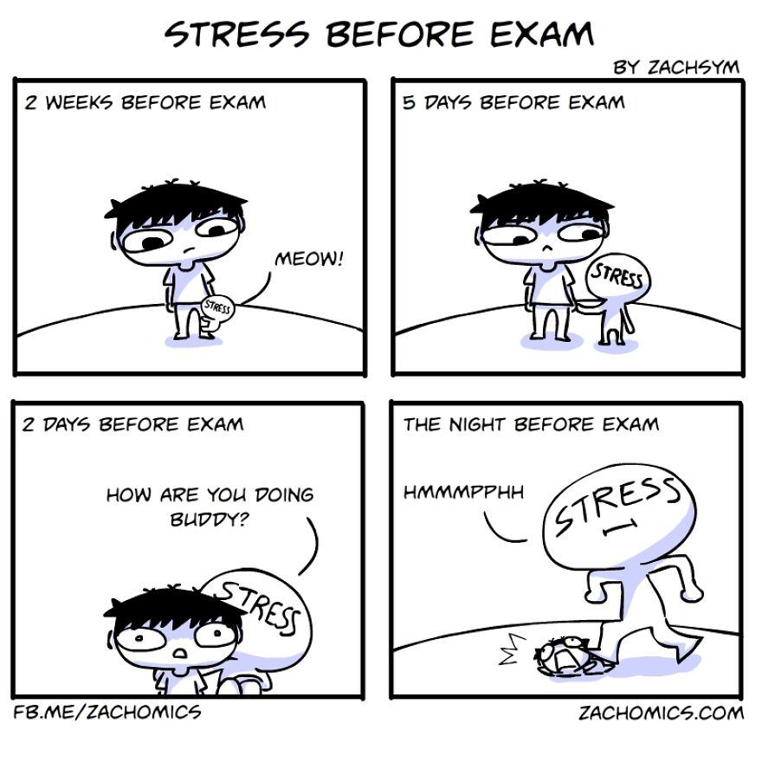
[Accessed on: www.zachomics.com Accessed on 24 December 2019]

Write paragraphs on how exam techniques and study habits can decrease exam related stress.

Use the following as a guideline.

- Define the term ‘time management’ and outline TWO ways time management can help avoid exam stress. (1+2)(3)
(Lower Order)

- Explain THREE exam writing techniques that a matric learner could put into place during a stressful exam. (3x2)(6)
(Middle Order)

- Recommend TWO study habits matric learners could put into practice to ensure that they are not cramming the night before their exam. In your answers, indicate how EACH recommendation could decrease the likelihood of cramming. (2x3)(6)
(Higher Order)
[15]
TOTAL SECTION C: 30
TOTAL = 20 + 30 + 30 = 80
MEMORANDUM

SECTION A

Question 1.1.
1.1.1. B
1.1.2. D
1.1.3. A
1.1.4. B
1.1.5. D
[5]

Question 1.2
1.2.1. Mnemonics
1.2.2. Interpersonal conflict
1.2.3 Communication
1.2.4. Acute stress
1.2.5 National Senior Certificate/ NSC
(5x1)[5]

1.3.1 List TWO potentially stressful changes matrics will be facing in their final year of school. (2x1)(2)
(Lower Order)
- Applying for university
- Looking to move away from home
- Leaving school
- Finding a job
- Relationship changes, e.g. breakups, new friendships, life roles at home and in school may change.
- Allow for alternative answers

1.3.2 Differentiate between chronic stress and eustress. (1x2)(2)
(Lower Order)
- Chronic stress is bad for one’s body because of its prolonged nature and physical symptoms whereas eustress is good as it keeps one motivated and working towards their goals.

1.3.3 Refer to the cartoon above when answering the following questions regarding communication.

a) Explain TWO ways how social media has made it difficult for parents and teenagers to communicate effectively. (2x2)(4) (Middle Order)
- It has decreased face to face communication time which means that parents and teenagers do not know each other as well as they should /or/ have not developed very deep bonds.
- Parents and teens may communicate more often over social media, which means that they may misunderstand each other more often due to lack of body language and other cues.
- People have not developed enough face to face communication skills because they are mostly communicating via social media. This means that they may handle face to face communication badly due to lack of experience.
- Because majority of teenagers are on social media more often than their parents, this means that their interests and communication styles may differ drastically, leading to more tension and miscommunication.
- Allow for alternative, well-reasoned answers.

b) Evaluate how a positive attitude can contribute towards effective communication strategies in a parent-child relationship. (1x2)(2)
(Higher Order)
- Remaining positive allows one to see the other’s point of view, which would help both parents and children to understand the other’s point of view.
- Remaining positive will allow one to not get angry during a conflict situation which would make it easier to handle conflict rationally and come to a solution.
- Positivity would allow one to understand and accept criticism without getting offended or upset. This would prevent unnecessary rifts in the relationship.
- Allow for alternative, well-reasoned answers

[10]

TOTAL SECTION A: 20

SECTION B

Question 2:

2.1 Define the term ‘stress management’ and outline how alcohol abuse could be seen as a negative stress management technique. (2+1)(3)
(Lower Order)

- Stress management: techniques aimed at controlling a person's level of stress, especially chronic stress, for the purpose of improving everyday functioning.
  - Alcohol abuse has negative effects on one’s health
  - Alcohol abuse does not make the problem go away
  - Often the stressor will seem worse after the effects of alcohol have worn off.
  - Allow for alternative answers

2.2 Provide TWO potential social stressors matriculants may face that could lead them to abuse alcohol. (2x1)(2)
(Lower Order)
- Relationship trouble/ breakups/ fights
- Change of roles within relationships
- Pressure from parents/ teachers/ society to perform well academically or at sporting/ cultural activities
- Bullying/ horrible remarks from peers/ discrimination
- Peer pressure
- Social media’s expectations/ high standards/ social media highlighting only the positive aspects of people’s lives – makes learners feel that their lives aren’t good enough.
- Public speaking
- Parents or family discussing financial strain
- Allow for alternative relevant answers

2.3 Explain how alcohol abuse could negatively affect the body’s stress response. (2x1)(2)
(Middle Order)
- Alcohol depresses or inhibits the body’s ability to function and deal with the stress hormones making the stress response seem worse than it is.
- Alcohol stimulates the body’s stress response making the symptoms worse.
- Allow for alternative, well-reasoned answers.

2.4 Discuss TWO ways how societal expectations with regards to your matric results could affect you emotionally and therefore lead to alcohol abuse. (2x2)(4) (Middle Order)
- Parents may set unreasonably high expectations for their children which may cause learners to drink as they feel they will always be a failure in their parents’ eyes.
- The media creates a lot of hype around matric results, even posting results in newspapers this means that learners feel they are being compared to others around the country and they cannot live up to this.
- Many people ask how matric is going/ are interested in the marks of the matrics which constantly reminds them of the academic expectations.
- Society has a perception that matric results are final which adds pressure to matrics who feel that they cannot make a mistake.
- Job applications/ tertiary institution applications ask for matric results which makes matrics feel that their whole future will only be determined by their matric results.
- Allow for other relevant, well-reasoned responses.

2.5 Suggest TWO ways that schools could encourage their learners to stay away from alcohol as a form of stress management. (2x2)(4)
(Higher Order)
- Have posters around the school to explain the negative health effects of alcohol.
- Train peer-councilors or ambassadors who can create awareness of the dangers of alcohol through dialogue.
- Have the school councilor or trained teachers speak to learners who are at risk with the aim of working through the stressors /or/ allowing them to vent negative emotions in a safe space.
- Educate learners in their Life Orientation lessons on the dangers of alcohol abuse /or/ on alternative healthy methods of stress management.
- Have a secret box where learners can drop names of peers who are at risk so that the teachers or councilors can speak to them.
- Allow for alternative, well-reasoned answers.
[15]

Question 3:

  - Define the term ‘conflict resolution’ and explain how the above situation is an example of bad conflict resolution. (1+2)(3)
(Lower Order + Middle Order)
- Process of resolving an argument or dispute.
  - The learners did not make use of healthy conflict management techniques to come to a peaceful conclusion/ solution to find the phone.
  - The learners resorted to violence instead of working through the problem rationally.
  - The learners did not keep the potential consequences of their actions in mind when they dealt with the problem in an aggressive manner.
  - The phone is probably still missing, and they are both worse off after this conflict.
  - Allow for alternative, well-reasoned answers.

  - Describe TWO alternative conflict resolution techniques that the learners could have used to solve the problem of the missing cellphone peacefully. (2x2)(4)
(Middle Order)
- They could have tried to find the correct time for both of them, when they are both not stressed or feeling angry about the situation.
- They could have taken deep breaths to try and calm their emotional response.
- They could have stopped the conflict when they realised it was getting too violent and postponed it for a calmer time.
- They could have used ‘I statements’ to try decrease the chances of offence.
- They could have avoided attacking the other person with their words or actions as this only leads to more tension and aggression.
- They could have been honest about their negative emotions over the cellphone so that the other person would also respond with honesty.
- They could ensure that their body language is open and passive to not encourage further aggression.
- They could listen to the other person’s reasoning or point of view to avoid miscommunication /or/ which allows them to understand why something happened making it easier to solve the problem.

  - Explain how positive conflict resolution could have produced a more positive outcome in the above situation.
(1x2)(2)
(Middle Order)
- They may have put their anger aside leading to a more peaceful resolution.
- They may have had the clarity of mind to work together to find the phone.
- Allow for alternative, well-reasoned answers.

  - Assess how a fellow learner calling an adult for help could have stopped the death of the 18-year-old. (1x2)(2)
(Higher Order)
- By calling a teacher with authority, this teacher could have potentially disciplined the learners, causing them to stop for fear or repercussions.
- An adult may have been able to find the school councillor who would have been able to talk the learners down from their aggressive standpoints /or/ may have been able to facilitate more healthy conflict resolution techniques so that the dispute was resolved peacefully.
- The police could have been notified that there was a learner on school grounds with a weapon. This could have led to the arrest of the learner before the other learner was stabbed.
- Allow for alternative, well-reasoned answers.

  - Suggest TWO strategies learners could put into place to decrease the culture of violent conflict resolutions within their schools. (2x2)(4)
(Higher Order)
- They could form a society or committee that stands against violence amongst learners.
- They could create a campaign/ posters to spread awareness of the negative outcomes of violence.
- They could ask teachers to speak about topics like violence more often in their classes. This way learners would be better educated by professionals on the negatives of violence.
- They could do a presentation in assembly/ in front of the school to educate their fellow learners on the dangers of violence.
- They could ask the principal for permission to invite an outside speaker to the school who could give the learners a more realistic account of the consequences of violence.
- With the councillor, they could create a social media page where learners can share their stories /or/ get help from adults if they are going through violence.
- They could have an online discussion page (with strict no bullying rules) that will allow for safe discourse around the topic of violence and how it can be solved.
- Allow for alternative, well-reasoned responses
[15]

SECTION C

Question 4

Write paragraphs on eustress when facing changes after matric.

Use the following as a guideline:

Define the term ‘eustress’ and state TWO ways how eustress could be beneficial. (1+2)(3)
(Lower Order)
- Eustress: a positive form of stress /or/ stress that has a beneficial effect on health, motivation, performance, and emotional well-being
  - We get tasks completed timeously
  - We reach our goals
  - Encourages us to work hard if something is important to us
  - Allow for alternative answers.

Discuss THREE ways that eustress can help a matriculant during the search for a job. (3x2)(6)
(Middle Order)
- Eustress will keep them focused on the task of finding a job instead of getting distracted by their social life.
- Eustress will keep them motivated to find a job so that they don’t spend all their time doing nothing.
- Eustress will mean that they meet application deadlines on time so that they stand a higher chance of getting the job.
- Eustress will ensure that they have a sense of fulfillment once they have met the challenge of finding a job or meeting a deadline.
- Eustress will ensure that they create a sense of purpose for themselves, instead of feeling lost and aimless.
- Eustress will encourage them to set concrete goals that they must meet during their job search.

Propose TWO strategies matriculants could put into place to adapt to possible changes in the world of work. In your answers, also indicate how EACH proposition could lead to less stress during this time of change being part of the work force. (2x3)(6)
(Higher Order)
- Start planning for changes in employment/ job search before they occur by creating alternative options in case the outcome is not the desired one. This will make matriculants feel mentally and emotionally prepared/ empowered to deal with the rejection whilst looking for a job or working for a boss.
- Matriculants must accept the change in status or job expectations and allow themselves to feel negative emotions if necessary. This means that negative emotions do not build up and get expressed in unhealthy and stressful ways towards boss or colleagues.
- Matrics may find it easier to understand the change after admitting the change to human resources or work councillor /or/ gathering information about the change. By gaining further understanding, they make it less scary and it becomes more possible to deal with.
- Matrics could consider what the exact consequences are, if they make a mistake on the job or lose a job, either through talking to a professional /or/ by writing it down in a diary. This would make the change seem more logical and help to create a strategic plan to deal with the change.
- Matrics should also take credit for positive change and negative changes at work instead of disempowering themselves by attributing their successes and failure to colleagues or their boss. By taking ownership of the decisions that lead to the change, matriculants can take back control of the outcome.
- Create realistic short-term work/ employment goals to help you get through the period of change. This will help matrics feel more in control of the situation. /or/ This will give matrics a sense of accomplishment.
- Matrics could change their mindset to believing that change is not always negative. This could lead to more positive steps and getting involved with the new work place. If matrics do this, they may feel more positive, and proud of themselves, especially when they navigate the change successfully.
- Allow for alternative, well-reasoned responses.

[15]

Question 5:

Write paragraphs on chronic stress in first year university students.

Use the following as a guideline:

Define the term ‘chronic stress’ and state TWO physical symptoms of chronic stress. (1+2)(3)
(Lower Order)
- Chronic stress: constant state of alertness for stressors /or/ negative long-term stress.
  - Headaches
  - Digestive problems
  - Lack of sleep/ trouble sleeping
  - Fatigue
  - Muscle tension
  - Low immune system/ frequent illness
  - Allow for alternative answers

Discuss THREE challenges first year students could face which could lead to chronic stress. (3x2)(6)
(Middle Order)
- No parents around and so they are responsible for looking after themselves.
- Higher academic level in first year and so the potential to fail is higher.
- More financial stress as first year is often more expensive /or/ they have to pay for part or all of their expenses.
- Friends may not be at the same institution, so they don’t have a support system /or/ have to go through the stress of meeting people and making new friends.
- The workload is much more meaning late nights and less socialising which increases susceptibility to stress symptoms.
- Allow for alternative, well-reasoned responses.

Suggest TWO ways that first year students could eliminate their social stressors in a healthy way before they develop anxiety or depression. In your answers, indicate how EACH suggestion could decrease chances of anxiety and depression. (2x3)(6)
(Higher Order)
- Try to anticipate possible stressors before they become a problem and develop a plan of action to deal with them. This will create a sense of control over the situation /or/ empower the student.
- Identify all the stressors and create a checklist to deal with each one. As the student checks off each stressor, they will feel a sense of accomplishment to battle against the negative emotions.
- Use stress management techniques to clear your mind /or/ keep your body healthy whilst trying to deal with the stressors. This will allow students to not be as negatively affected by the stress response.
- Talk to a professional /or/ someone you can trust to help you see the situation from a different perspective and come up with new solutions. This will get negative emotions off the student’s chest /or/ help them to feel less emotional about their stressors.
- Break each stressor down into smaller parts that the students can then handle step by step instead of one big problem. This will make the stressor seem less scary and more manageable /or/ increases self-assurance that the task can be overcome.
- Be assertive if the stressor is a person or their actions. Ask them to compromise /or/ collaborate to find a solution. This will ensure that the relationship is stronger (healthy relationships help fight off psychological difficulties such as depression and anxiety) /or/ make the student feel good about the conflict being resolved peacefully.
- Manage time better by prioritising stressors instead of letting them build up. Getting the stressors out of the way will create a sense of accomplishment /or/ there will be less stress to deplete their emotional resources.
- Allow for alternative, well-reasoned responses.
[15]

Question 6:

Write paragraphs on how exam techniques and study habits can decrease exam related stress.

Use the following as a guideline.

Define the term ‘time management’ and outline TWO ways time management can help avoid exam stress. (1+2)(3)
(Lower Order)
- Time management: the ability to structure your time so that you can make use of it effectively.
  - Learners don’t have to lose sleep to cramming the night before.
  - Learners will feel in control as they have studied well in advance
  - Learners will not feel overwhelmed by too much work
  - Learners will worry less about their progress
  - Learners can plan for stress management techniques
  - Learners will be able to create a healthy eating an exercise plan whilst studying
  - Allow for alternative responses

Explain THREE exam writing techniques that a matric learner could put into place during a stressful exam. (3x2)(6)
(Middle Order)
- Learners should read all the questions carefully so that they don’t overlook key instructions due to stress.
- Matrics should manage their time during the exam so that they complete all the questions.
- If they have time, they should plan their answers beforehand so that the answers make sense /or/ the question is answered correctly.
- Read through their answers to avoid silly mistakes /or/ leaving out sections by mistake.
- They can visualise the study material /or/ their teacher teaching the content to help jog their memory.
- Take a deep breath /or/ squeeze something to help get rid of stress hormones whilst writing.
- If learners don’t know the answer, they should always attempt to write down something by using logic.
- Allow for alternative, well-reasoned answers.

Recommend TWO study habits matric learners could put into practice to ensure that they are not cramming the night before their exam. In your answers, indicate how EACH recommendation could decrease the likelihood of cramming. (2x3)(6)
(Higher Order)
- Create a comprehensive study timetable which allocates specific times for each subject. This would help learners feel prepared the night before their exam, so they don’t need to study then.
- Learners could pay attention in class which will mean less study time at home. Learners will understand the work from the start, leading to less need to study the night before. /or/ less study time at home means it is easier to complete prior to the night before the exam.
- Practice self-discipline to avoid procrastination by sticking to any plan they have set. This will ensure learners have completed their work in advance.
- Study a smaller amount each day, as smaller chunks of work seem less daunting or demotivating. This will motivate the learner to start studying in advance.
- Have an accountability buddy who will contact the learner regularly to check their progress. The learner will start studying earlier so as they are constantly reminded /or/ they don’t want to disappoint their accountability buddy.
- Create a study group where learners teach each other the work. Learners will be forced to study to keep up with the group.
- Allow for alternative, well-reasoned answers.

TOTAL SECTION C: 30

TOTAL = 20 + 30 + 30 = 80

