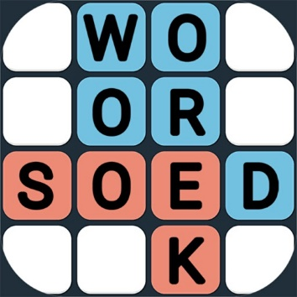
Les 1 – Werkkaart
DEFINISIES en WOORDSOEK
Gee 'n definisie vir die woorde hieronder in jou
werkboek en vind dit dan in die woordsoektog wat volg:

GRONDWET | KULTUREEL | KULTUUR
DIVERSITEIT | ETNIES | GESLAG
ERFENIS | WET | NORME
RAS | GODSDIENS | RESPEK
VERDRAAGSAAMHEID | TRADISIE | WAARDES

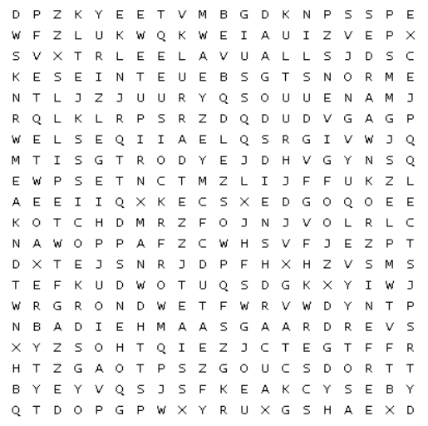

DEFINISIES

GRONDWET: _________________________________________________________________________
KULTUREEL: _________________________________________________________________________
KULTUUR: ___________________________________________________________________________
DIVERSITEIT: _________________________________________________________________________
ETNIES: _____________________________________________________________________________
GESLAG: ____________________________________________________________________________
ERFENIS: ____________________________________________________________________________
WET: ________________________________________________________________________________
NORME: _____________________________________________________________________________
RAS: ________________________________________________________________________________
GODSDIENS: _________________________________________________________________________
RESPEK: ____________________________________________________________________________
VERDRAAGSAAMHEID: ________________________________________________________________
TRADISIE: ____________________________________________________________________________
WAARDES: ___________________________________________________________________________

