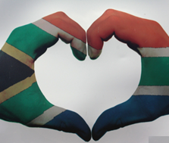
Grondwetlike regte en verantwoordelikhede
Les 1 - Werkkaart
Kwartaal 2: Week 1 - 3
Voltooi hierdie werkkaart soos die les vorder:
Vrae wat ek nog na hierdie les het:
____________________________________________________________________________________________________________________________________________________________________________________
Watter REGTE is die belangrikste vir die JEUG in Suid-Afrika?
________________________________________________________________________________________________________________________________________________________________________________________________________________________________________________________________________________________________________________
Hoekom is MENSEREGTE belangrik?
________________________________________________________________________________________________________________________________________________________________________
Wat is jou begrip van die term MENSEREGTE?
________________________________________________________________________________________________________________________________________________________________________
Wat is REGTE en VERANTWOORDELIKHEDE?
Gee 'n voorbeeld van elkeen.
________________________________________________________________________________________________________________________________________________________________________________________________________________________________________________________________________________________________________________________________________________________________________________________________________________________________________________________________________________________________


Aktiwiteit 1: Informele Assessering

Vraag 1:

- Definieer die terme 'diskriminasie' en 'menseregte'. (2x1)(2)

- Bespreek die verband tussen regte en verantwoordelikhede. (2x2)(4)

