
Lesson 3 – Worksheet
 | Activity 1: Littering Campaign  Complete the following activity in pairs.

Based on the video you watched (Litter Less Campaign (https://www.youtube.com/watch?v=r7GhhgoJFRI&t=76s) and the information presented in Slides 4-5 of the Lesson 3 – PowerPoint, answer the following questions.
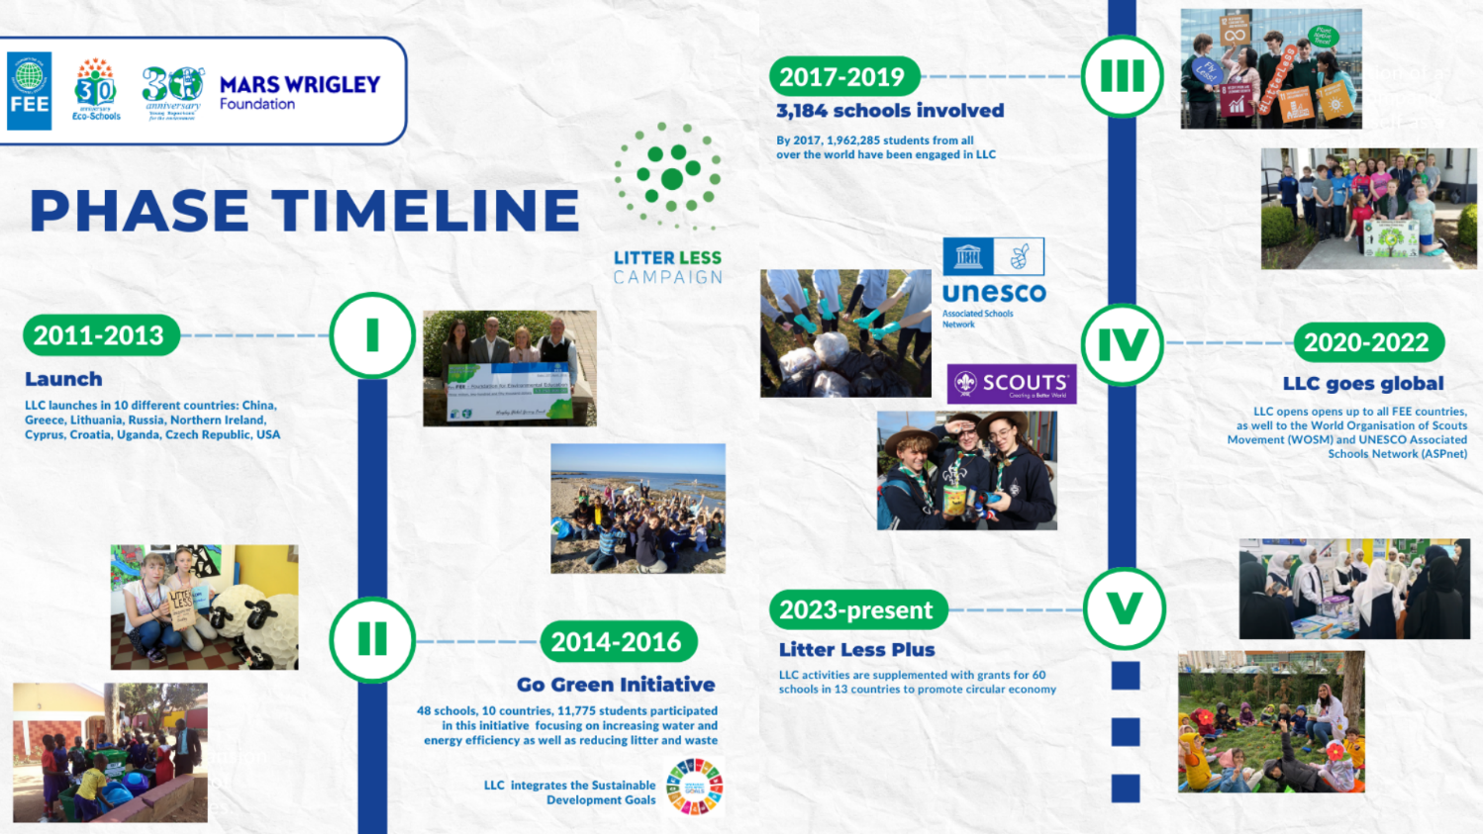
[Adapted from: https://www.fee.global/litter-less-campaign-about Accessed on: 1 March 2025]

1.1 Identify the focus of this campaign.
____________________________________________________________________________________________________________________________________________________________________________

1.2 How long has this initiative been in existence and how many schools have been impacted according to the phase timeline?
______________________________________________________________________________________
1.3 Who is the target group of this campaign and what have they learnt through this campaign?
____________________________________________________________________________________________________________________________________________________________________________

1.4 Study the statistics provided below, then turn to your partner and discuss your opinion. Together, rate the campaign’s effectiveness on a scale from 1 to 5, where: 1 = Not effective at all and 5 = Very effective. Give TWO reasons for your rating.
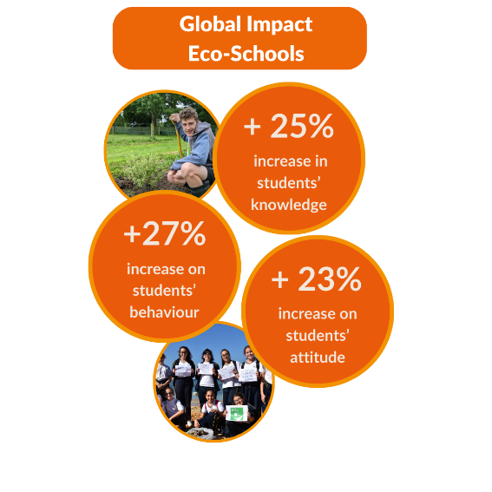
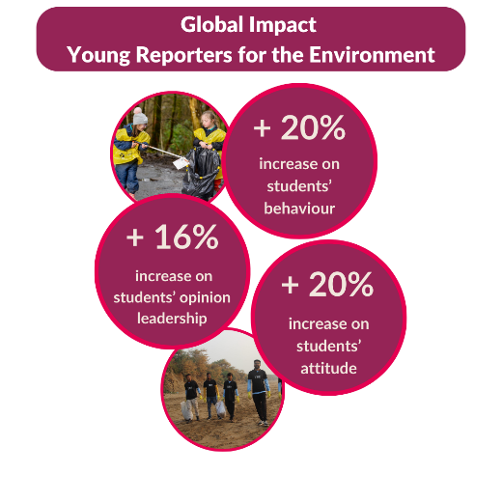

[Taken from: https://www.fee.global/litter-less-campaign-about Accessed on: 1 March 2025]

_______________________________________________________________________________________________________________________________________________________________________________________________________________________________________________________________________________________

1.5 Explain how each of the below images helps to show whether the campaign was effective. What does each image tell you about the campaign’s impact or success?
1.5.1: Image 1
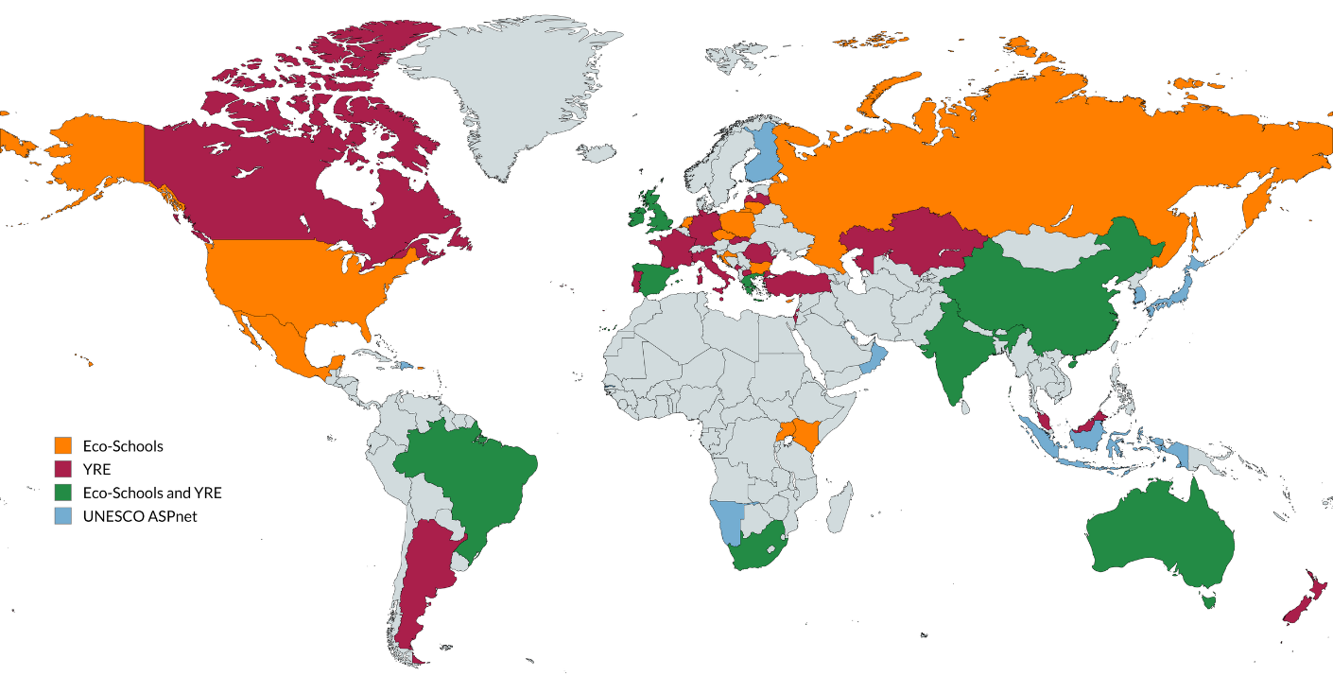
[Taken from: https://www.fee.global/litter-less-campaign-about Accessed on: 1 March 2025]

1.5.1 ______________________________________________________________________________________ ______________________________________________________________________________________
______________________________________________________________________________________

1.5.2: Image 2


[Taken from: https://www.fee.global/litter-less-publications Accessed on: 1 March 2025]

1.5.2 ______________________________________________________________________________________ ______________________________________________________________________________________
______________________________________________________________________________________

1.5.3: Image 3
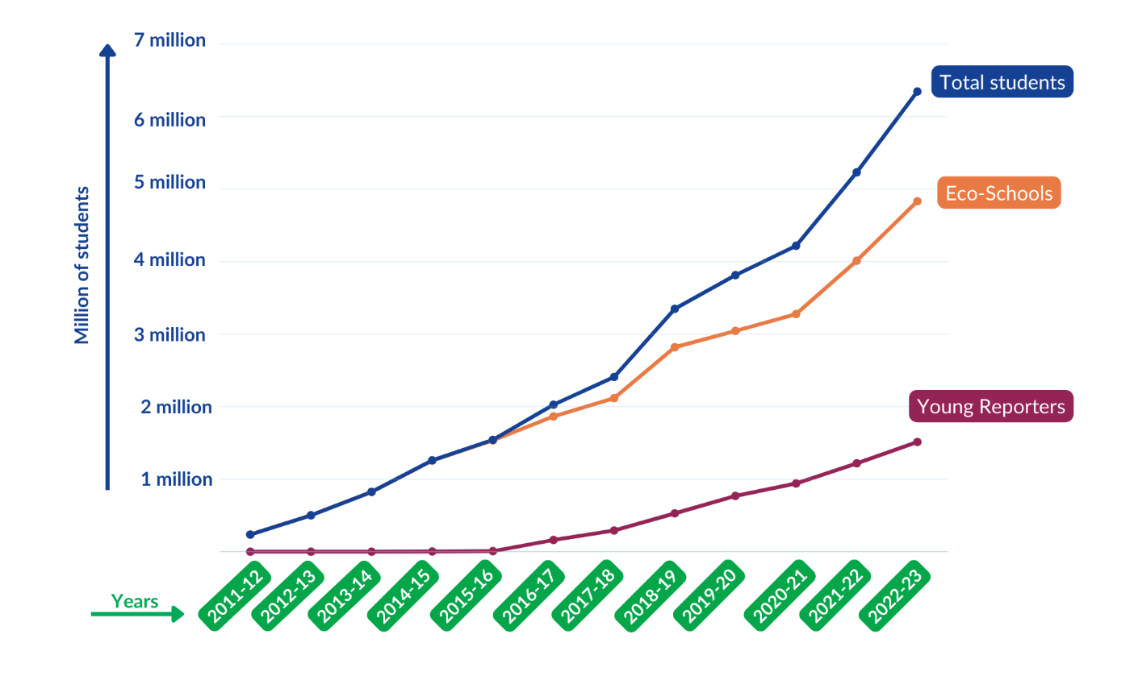
[Taken from: https://www.fee.global/litter-less-campaign-about Accessed on: 1 March 2025]

1.5.3 ______________________________________________________________________________________ ______________________________________________________________________________________
______________________________________________________________________________________

Activity 2: Case Study
Complete the following activity in groups.

2.1 Read the Case Study that was assigned to your group and answer the following questions. Ensure that each group member takes notes, as you will need these notes for the next activity.

2.1.1 Identify: Elaborate on some of the challenges which the campaign is trying to address.
______________________________________________________________________________________________________________________________________________________________________________________________________________________________________________________________________________________________________________________________________________________________________________________________________________________________________________
2.1.2 Understand: Which key stakeholders are involved in this initiative? Why is it important that these stakeholders are involved?
__________________________________________________________________________________________________________________________________________________________________________________________________________________________________________________________________
2.1.3 Understand: In what way can this initiative be seen as an intervention and educational programme?
______________________________________________________________________________________________________________________________________________________________________________________________________________________________________________________________________________________________________________________________________________________________________________________________________________________________________________

2.1.4 Evaluate: How does this initiative aim to promote safe and healthy living?
______________________________________________________________________________________________________________________________________________________________________________________________________________________________________________________________________________________________________________________________________________________________________________________________________________________________________________

2.2 As a group, discuss and write down FIVE questions that could be used to evaluate how effective these campaigns were.
Here are two examples to get you started:
- Was the campaign's content shared widely on social media?
- What level of engagement did the campaign achieve (e.g., likes, shares, comments, event attendance)?

Our questions:
- ___________________________________________________________________________
- ___________________________________________________________________________
- ___________________________________________________________________________
- ___________________________________________________________________________
- ___________________________________________________________________________

Activity 3: Homework
Complete the following activity individually.

Below you will find a sample of a question from each of the sections you would encounter in the exam paper. Answer them to the best of your ability before the next lesson.

Section A
  - Various options are provided as a possible answer to the following question. Choose the correct
answer and write only the letter (A–D) next to the question number (1.1.1), for example, 1.1.2. D.

1.1.1 Which of the following is a responsibility of the national government to share news on human rights violations?

- Post educational information about human rights violations.
- Share unverified examples of violations across all platforms.
- Spread sensationalised information on human rights violations.
- Create defamatory accounts that mimic human rights violators. (1)
(SER - Lower Order)
______________________________________________________________________________

1.2 Answer the following question by writing the answer next to the question number (1.2.1) in the Write your answers in full sentences.
1.2.1 Recommend how impact studies could make campaigns against human rights
violations more effective. (1 x 2) (2)
(SER - Lower Order)
___________________________________________________________________________________________________________________________________________________________________________________________________________________________
[3]

Section B
Question 2
Read the extract below and answer the questions that follow.
Fearless and independent: SA courts applauded for holding the line

Human rights violation and conflict resolution

South African courts have been described as “battlegrounds for contesting political forces,” a view which is supported by a study comparing the judicial systems of South Africa, Malawi, and Namibia.

Courts are meant to hold the line and protect citizens from human rights violations. To achieve this, legal practitioners must always conduct themselves in a manner that reflects the seriousness of their roles, the responsible exercise of power, and the proper fulfilment of their duties. Similarly, all other levels of government are expected to uphold the law as they carry out their constitutional responsibilities, ensuring safe and healthy living conditions for all.

Although this is how the system is meant to function, some individuals within the government and other branches of the state are involved in corrupt activities that undermine the Constitution of the Republic of South Africa. Even judges, magistrates, and other law enforcement officials are not immune to allegations of fraud and corruption.

Scientific reports indicate that a significant number of legal officials have encountered various forms of corruption, and many citizens feel let down by the courts, as justice is not being served equally. This growing dissatisfaction could lead to increased conflict and tension within the judicial system.

[Adapted from https://africanlii.org/articles/2022-05-06/carmel-rickard/state-of-the-judiciary-new-report-on-malawi-namibia-south-africa Accessed: 10 March 2025]

2.1 Define the term ‘human rights violations’ and mention TWO ways in which courts can
help protect citizens from human rights violations. (1 + 2) (3)
(DHR – Lower Order)
__________________________________________________________________________________________________________________________________________________________________________________________________________________________________________________________________________________________________________________________________________________________________________________________________________________________________________________________________________________________

2.2 Provide THREE responsibilities that should be upheld by the municipal government. (3 x 1) (3)
(SER – Lower Order)
____________________________________________________________________________________________________________________________________________________________________________________________________________________________________________________________________________________________________________________________

2.3 Describe FOUR forms of corruption which may have been experienced by legal
officials. (4 x 2) (8)
(CCC – Middle Order)
_______________________________________________________________________________________________________________________________________________________________________________________________________________________________________________________________________________________________________________________________________________________________________________________________________________________________________________________________________________________________________________________________________________________________________________________________________________________________________________________________________________________________________________________________________

2.4 Suggest THREE methods legal officials could use to diffuse possible conflict situations
between themselves and citizens making use of the court system. (3 x 2) (6)
(DSS – Higher Order)
_______________________________________________________________________________________________________________________________________________________________________________________________________________________________________________________________________________________________________________________________________________________________________________________________________________________________________________________________________________________________________________________________________________________________________________________________________________________________________________________________________________________________________________________________________
[20]

Section C
Question 3
Study the image below and answer the questions that follow.
Unhealthy environments can increase our stress
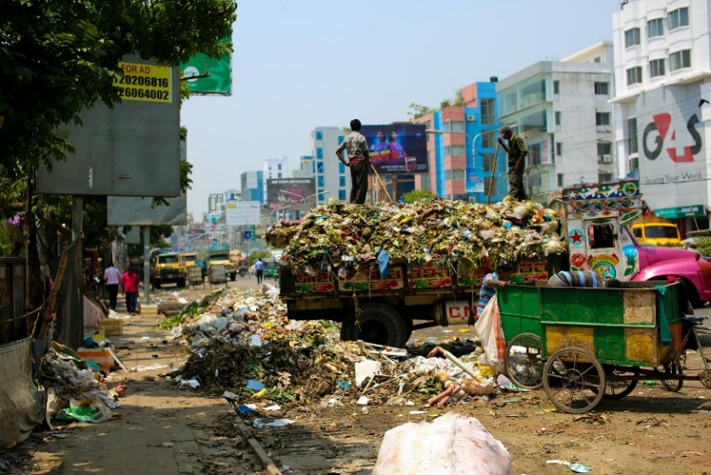

[Taken from: https://www.pexels.com/photo/photo-of-a-dump-truck-across-buildings-2382894/
Accessed: 10 March 2025]

Write paragraphs on environmental stressors and ways of keeping the environment clean for human habitation.
Use the following as a guideline:
- Define the term ‘environmental stressor’ and provide THREE negative emotional effects
caused by being subjected to environmental stressors over a long period of time. (1 + 3) (4)
(DSS – Lower Order)

- Analyse ways in which the media could be used to create positive environmental
change in communities with unhealthy environments. (2 x 4) (8)
(DHR – Middle Order)

- Critically discuss how community members could encourage each other to use safe
environmental practices. (2 x 4) (8)
(SER – Higher Order)

[20]

[Grand Total: 43]

Activity 4: Reflection
Complete the following activity individually.

Consider the FOUR campaigns that were shared in Activity 2. If you had to come up with a campaign on an environmental or social issue that you feel strongly about, what would that issue be?

