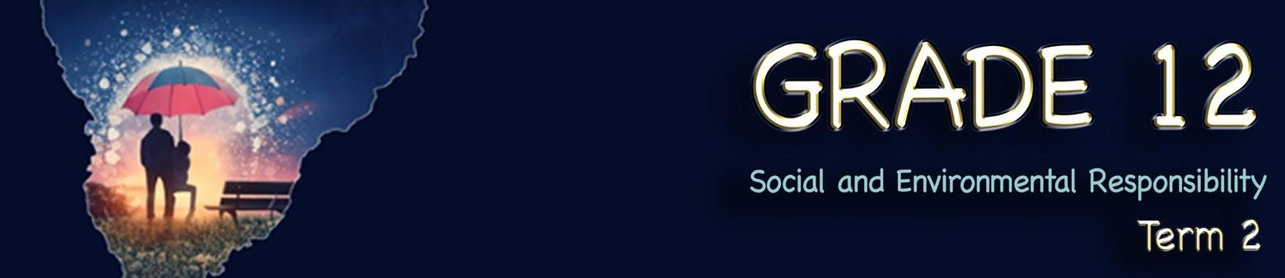
Lesson 3 – Worksheet MEMO
 | Activity 1: Littering Campaign  Complete the following activity in pairs.

Based on the video you watched (Litter Less Campaign (https://www.youtube.com/watch?v=r7GhhgoJFRI&t=76s) and the information presented in Slides 4-5 of the Lesson 3 – PowerPoint, answer the following questions.
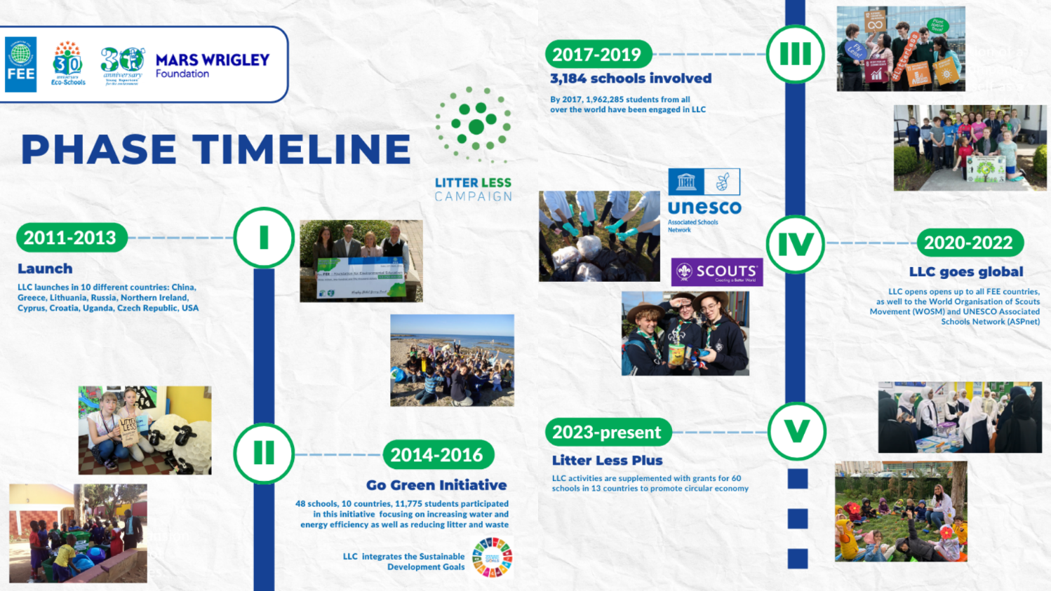
[Adapted from: https://www.fee.global/litter-less-campaign-about Accessed on: 1 March 2025]

1.1 Identify the focus of this campaign.
This is an educational campaign aimed at young children to create awareness and teach them about litter and the impact it has on their environment.

1.2 How long has this initiative been in existence and how many schools have been impacted according to the phase timeline?
Since 2011. Since 2023, 60 schools in 13 countries received grants to participate in the programme.
In 2017-2019 there were 3,184 schools involved.

1.3 Who is the target group of this campaign and what have they learnt through this campaign?
Young children in primary schools. By their involvement, learners become more aware of their own environments and hopefully become part of the solution to pollution in their community.

1.4 Study the statistics provided below, then turn to your partner and discuss your opinion. Together, rate the campaign’s effectiveness on a scale from 1 to 5, where: 1 = Not effective at all and 5 = Very effective. Give TWO reasons for your rating.
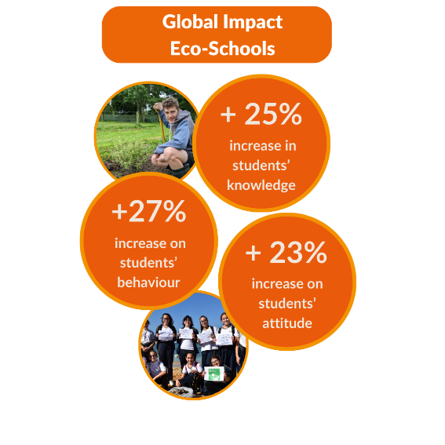
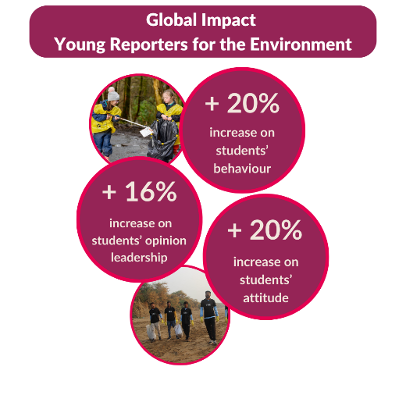

[Taken from: https://www.fee.global/litter-less-campaign-about Accessed on: 1 March 2025]

Example response:
I would rate it a 5, as there is strong evidence from the statistics showing how many learners have been reached since the start of the campaign. There has also been a noticeable improvement in learners' attitudes toward their local environment.

1.5 Explain how each of the below images helps to show whether the campaign was effective. What does each image tell you about the campaign’s impact or success?
1.5.1: Image 1
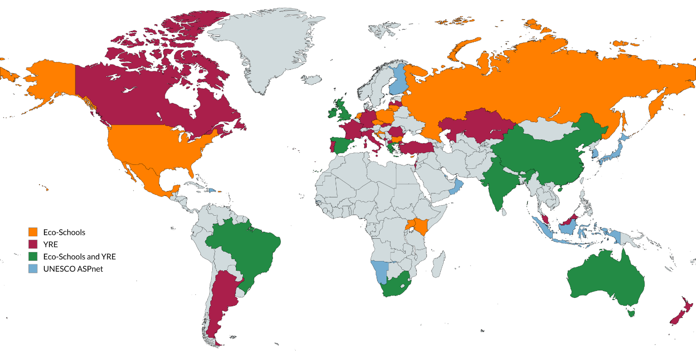
[Taken from: https://www.fee.global/litter-less-campaign-about Accessed on: 1 March 2025]

1.5.1 This image shows how widespread the campaign has become since its inception, impacting countries from around the world.

1.5.2: Image 2
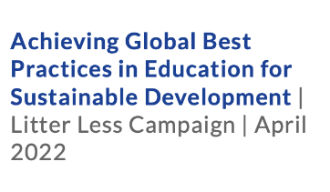
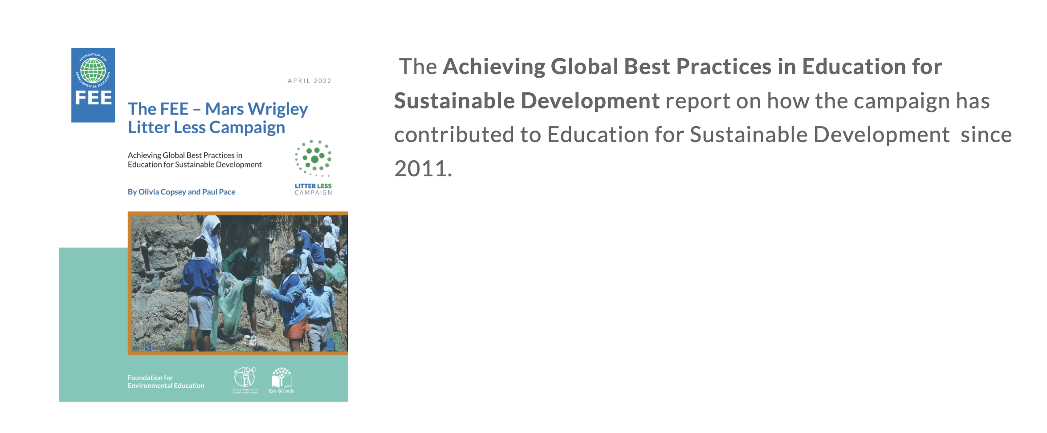
[Taken from: https://www.fee.global/litter-less-publications Accessed on: 1 March 2025]

1.5.2 A report has been written with detailed evidence of the impact the campaign has had. This would indicate an awareness of evaluating the effectiveness of their plans and making changes where necessary.

1.5.3: Image 3
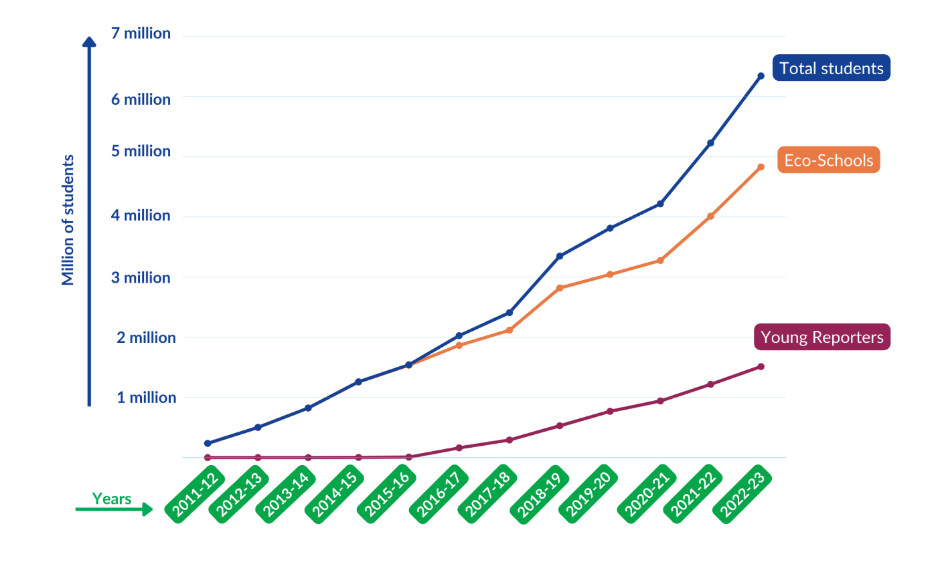
[Taken from: https://www.fee.global/litter-less-campaign-about Accessed on: 1 March 2025]

1.5.3 As time has passed since 2011, every year there are more learners taking part in the campaign. This shows that there has been consistent growth every year.
Activity 2: Case Study
Complete the following activity in groups.

2.1 Read the Case Study that was assigned to your group and answer the following questions. Ensure that each group member takes notes, as you will need these notes for the next activity.

2.1.1 Identify: Elaborate on some of the challenges which the campaign is trying to address.
______________________________________________________________________________________________________________________________________________________________________________________________________________________________________________________________________________________________________________________________________________________________________________________________________________________________________________
2.1.2 Understand: Which key stakeholders are involved in this initiative? Why is it important that these stakeholders are involved?
__________________________________________________________________________________________________________________________________________________________________________________________________________________________________________________________________
2.1.3 Understand: In what way can this initiative be seen as an intervention and educational programme?
______________________________________________________________________________________________________________________________________________________________________________________________________________________________________________________________________________________________________________________________________________________________________________________________________________________________________________

2.1.4 Evaluate: How does this initiative aim to promote safe and healthy living?
______________________________________________________________________________________________________________________________________________________________________________________________________________________________________________________________________________________________________________________________________________________________________________________________________________________________________________
- Please refer to the Lesson 3 – Activity 2 Case Studies MEMO document for possible answers.
2.2 As a group, discuss and write down FIVE questions that could be used to evaluate how effective these campaigns were.
Here are two examples to get you started:
- Was the campaign's content shared widely on social media?
- What level of engagement did the campaign achieve (e.g., likes, shares, comments, event attendance)?

Our questions:
Possible responses:
- How many people were exposed to the campaign (e.g., through media, social media, or events)?
- What percentage of the target audience is aware of the campaign's message?
- Was the campaign able to reach the intended demographic or community groups?
- How did the campaign's reach compare to similar past campaigns?
- Did the campaign successfully encourage the desired behaviour change (e.g., increased recycling, reduced carbon footprint, etc.)?
- Are there measurable changes in the target audience's behaviour (e.g., more people using eco-friendly products, donating to a cause, etc.)?
- How sustainable are the changes in behaviour? Have the effects persisted after the campaign ended?
- Were there opportunities for individuals to actively participate (e.g., signing petitions, attending rallies, volunteering)?
- How did the campaign foster interaction with the audience?
- Was the campaign's message clear and easy to understand?
- How well did the campaign’s messaging resonate with the target audience?
- Did the campaign appeal emotionally or intellectually to its audience?
- Did the campaign effectively engage key stakeholders, such as community organisations, influencers, or policymakers?
- Were there any partnerships or collaborations that enhanced the campaign's reach or impact?
- How well did the campaign leverage media (e.g., television, radio, print, online platforms)?
- How frequently was the campaign covered by news outlets or mentioned in media?
- Did the campaign achieve its social or environmental goals (e.g., reducing pollution, increasing awareness of a social issue)?
- What are the measurable outcomes of the campaign in the community or the environment (e.g., cleaner streets, increased awareness of a social justice issue)?
- Were any unintended negative impacts of the campaign observed?
- Was the campaign cost-effective?
- Did it deliver a high return on investment?
- Were resources (e.g., financial, human, time) used efficiently throughout the campaign?
- How well did the campaign stay within its budget, and were there any major financial challenges?
- What feedback did the target audience provide about the campaign (e.g., through surveys and focus groups)?
- Did the campaign address the concerns or needs of the community effectively?
- Were participants satisfied with the campaign's execution and outcomes?
- What long-term impact did the campaign have (e.g., lasting behaviour changes, policy changes)?
- Has the campaign had a lasting influence on the public’s views or practices in the relevant area (social/environmental)?
- Will the campaign's efforts be sustained or built upon in the future?

Activity 3: Homework
Complete the following activity individually.

Below you will find a sample of a question from each of the sections you would encounter in the exam paper. Answer them to the best of your ability before the next lesson.

Section A
  - Various options are provided as a possible answer to the following question. Choose the correct
answer and write only the letter (A–D) next to the question number (1.1.1), for example, 1.1.2. D.

1.1.1 Which of the following is a responsibility of the national government to share news on human rights violations?

- Post educational information about human rights violations.
- Share unverified examples of violations across all platforms.
- Spread sensationalised information on human rights violations.
- Create defamatory accounts that mimic human rights violators. (1)
(SER - Lower Order)
A ()

1.2 Answer the following question by writing the answer next to the question number (1.2.1) in the Write your answers in full sentences.
1.2.1 Recommend how impact studies could make campaigns against human rights
violations more effective. (1 x 2) (2)
(SER - Lower Order)
Impact studies could…
- help identify the areas where the human rights campaign has been successful/where improvements are needed, () which can help to refine the campaign strategies/interventions. ()
- assess the extent to which the campaign has contributed to changes in attitudes/behaviours/policies/practices () so that stakeholders/community workers know if/when they can complete the campaign/consider it successful. ()
- demonstrate the value/effectiveness of the campaign to donors/partners/stakeholders () so that they can continue to get resources/finances to keep going. ()
- be used to assess the unintended consequences of the campaign/potential risks/negative impacts, () and thus take corrective measures to avoid such consequences. ()
- provide valuable information to help the campaigners better understand the context in which the campaign is operating () so that they can factor in the social/economic/political factors that influence human rights issues and adapt their strategies accordingly. ()
- be used to identify the strengths and weaknesses of the campaign/its interventions, () and provide recommendations for improving the effectiveness of the campaign. ()
- provide a platform for sharing information/insights on the violations, () thus helping the campaigners to connect with other organisations working on human rights issues. ()
Any ONE of the above for TWO marks
(i.e. ONE mark for statement and ONE mark for qualifier/explanation)
[3]
Section B
Question 2
Read the extract below and answer the questions that follow.
Fearless and independent: SA courts applauded for holding the line

Human rights violation and conflict resolution

South African courts have been described as “battlegrounds for contesting political forces,” a view which is supported by a study comparing the judicial systems of South Africa, Malawi, and Namibia.

Courts are meant to hold the line and protect citizens from human rights violations. To achieve this, legal practitioners must always conduct themselves in a manner that reflects the seriousness of their roles, the responsible exercise of power, and the proper fulfilment of their duties. Similarly, all other levels of government are expected to uphold the law as they carry out their constitutional responsibilities, ensuring safe and healthy living conditions for all.

Although this is how the system is meant to function, some individuals within the government and other branches of the state are involved in corrupt activities that undermine the Constitution of the Republic of South Africa. Even judges, magistrates, and other law enforcement officials are not immune to allegations of fraud and corruption.

Scientific reports indicate that a significant number of legal officials have encountered various forms of corruption, and many citizens feel let down by the courts, as justice is not being served equally. This growing dissatisfaction could lead to increased conflict and tension within the judicial system.

[Adapted from https://africanlii.org/articles/2022-05-06/carmel-rickard/state-of-the-judiciary-new-report-on-malawi-namibia-south-africa Accessed: 10 March 2025]

2.1 Define the term ‘human rights violations’ and mention TWO ways in which courts can
help protect citizens from human rights violations. (1 + 2) (3)
(DHR – Lower Order)
Human rights violations refer to…
- actions/words that deny citizens their democratic freedoms. ()
- when people in authority/positions of power use their influence to abuse/undermine those who are vulnerable. ()
- behaviours between citizens where one individual/group denies another individual/group their ability to move about/think freely. ()
- any acts by the state/individuals that restrict the exercise of individuals’ rights in the Constitution of the Republic of South Africa. ()
- any behaviour/expression/words whose intention is to cast aspersions on the dignity of another person. ()

Any ONE of the above for ONE mark

AND
Courts can…
- ensure that laws of the state are consistently upheld. ()
- incarcerate serious offenders so that they cannot harm other citizens ()
- punish human rights violators severely enough that they avoid repeating their actions. ()
- institute rehabilitation measures for certain individuals so that they can become valuable contributors towards society. ()
- hold all citizens accountable, no matter their level of power/political influence. ()
- represent the needs of all members of society, no matter their socio-economic circumstances. ()

Any TWO of the above for ONE mark each

2.2 Provide THREE responsibilities that should be upheld by the municipal government. (3 x 1) (3)
(SER – Lower Order)
The municipal government should …
- provide local communities with a democratic/accountable governing body. ()
- ensure basic services are equitably/sufficiently provided to communities in a sustainable manner. ()
- promote social and economic development within communities. ()
- educate community members on how to maintain a safe and healthy environment. ()
- encourage community members/community organisations to involve themselves in the running of communities. ()
Any THREE of the above for ONE mark each

2.3 Describe FOUR forms of corruption which may have been experienced by legal
officials. (4 x 2) (8)
(CCC – Middle Order)
Legal officials may have …
- encountered an offer of a financial bribe/incentive () to ensure that certain decisions went in the favour of an individual/group. ()
- come across a person in authority who attempted to use his/her influence () in order to obtain sensitive information on a case. ()
- crossed paths with superiors trying to use their professional power to pull strings () so that the outcome of a case could be in their favour/a decision will benefit them. ()
- stumbled upon an attempt to steal/misappropriate public funds/resources which should have been used for legal proceedings for all () but instead were used for the personal benefit of an individual/group. ()
- experienced nepotism/cronyism/appointment of family/friends into positions of power within the court system () so that these individuals can back each other in legal decisions. ()
- seen granting of special favours/treatment to someone who doesn’t deserve them, () which takes away opportunities from those who are more worthy. ()
- suffered from threats/use of force against them () so that they have no choice but to sway the decision/not provide their best when representing someone/not provide witness to violations. ()

Any FOUR of the above for TWO marks each
(i.e. ONE mark for statement and ONE mark for qualifier/explanation)

2.4 Suggest THREE methods legal officials could use to diffuse possible conflict situations
between themselves and citizens making use of the court system. (3 x 2) (6)
(DSS – Higher Order)
Legal officials could …
- schedule a later time to talk about the issue at hand () so that they can dedicate their full attention to solving the problem when they are not busy with other things. ()
- ask the upset citizens to take a deep breath to regain their calm/take a deep breath themselves () so that all parties involved can deal with the conflict in a rational manner. ()
- make use of “I” statements () so that the citizens don’t feel attacked/go on the defensive. ()
- maintain eye contact () so that the citizens know that they have the legal official’s full attention/their views are important. ()
- ensure that their body language is open/not aggressive () so that citizens don’t feel unsafe/the need to escalate the situation to violence. ()
- stop the conflict situation if it starts to get aggressive/violent and ask to resume at a later point () so that both parties can cool down/not escalate the conflict further. ()
- paraphrase the citizen’s points/complaints to ensure that the legal officials completely understand the citizen’s point () and can effectively handle the actual problem. ()
- allow the citizens to state their problem first () so that they can get all their negative feelings out of the way to be more open to hearing the legal official’s solutions. ()
Any THREE of the above for TWO marks each
(i.e. ONE mark for statement and ONE mark for qualifier/explanation)
[20]
Section C
Question 3
Study the image below and answer the questions that follow.
Unhealthy environments can increase our stress
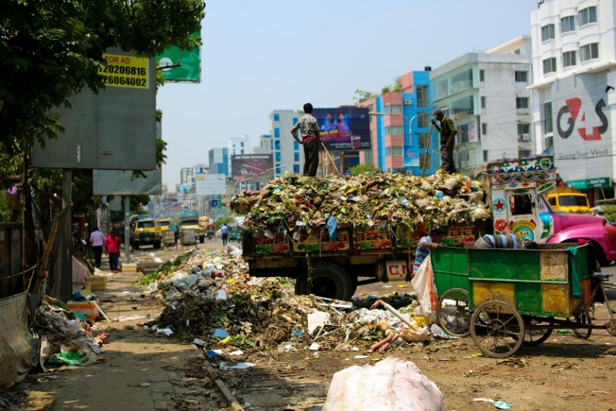

[Taken from: https://www.pexels.com/photo/photo-of-a-dump-truck-across-buildings-2382894/
Accessed: 10 March 2025]

Write paragraphs on environmental stressors and ways of keeping the environment clean for human habitation.
Use the following as a guideline:
- Define the term ‘environmental stressor’ and provide THREE negative emotional effects
caused by being subjected to environmental stressors over a long period of time. (1 + 3) (4)
(DSS – Lower Order)
Environmental stressors are …
- external factors in our world that can cause physical/psychological/emotional distress to individuals/the population. ()
- natural/human-made factors in the immediate vicinity/surrounding/neighbourhood that can negatively impact the well-being of living organisms. ()
- any physical/chemical/biological factors in the external surroundings that can disrupt the balance of an ecosystem/cause harm to living organisms. ()
Any ONE of the above for ONE mark
AND
It could cause…
- anxiety/fear of possible health consequences. ()
- feelings of hopelessness/sadness/depression/burnout if it is not possible to escape the source of stress. ()
- frustration/irritability, particularly when the stressors disrupt daily life. ()
- anger/resentment towards those alleged to have disturbed the environment resulting in stress. ()
- despair/a sense of being powerless to change the situation. ()
- people to feel guilty about the negative impact their lifestyle/actions may have on the environment/the people around them. ()
- a sense of insecurity/vulnerability due to depletion of physical safety/inability to access basic services due to disruption of supply. ()
Any THREE of the above for ONE mark each

- Analyse ways in which the media could be used to create positive environmental
change in communities with unhealthy environments. (2 x 4) (8)
(DHR – Middle Order)
The media could …
- be used to educate the public about the causes/consequences of environmental problems () since most people rely on the media for information () which could effectively make many aware of the consequences of their behaviour () and if that happens, many people could change their ways of treating the environment. ()
- create short public service announcements on radio/local newspapers/etc. on specific environmental hazards () since that could accord them the opportunity to include powerful/informative/attractive messages for many to read () which could raise awareness about the adverse effects of the hazard () and that could sensitise offenders/authorities/government/community members to demand positive change/seek accountability/apprehend perpetrators. ()
- make use of social media platforms () since it could enable them to share information in a cheap/fast manner () which could make it more likely to create large online communities of environmentally conscious individuals all over the world () and in doing so, lead to increased engagement/networking/collaboration among community members around how to create change. ()
- encourage collaborative journalism () in which journalists could work with community members/environmental organisations to investigate/report on environmental issues () which can lead to increased public scrutiny/accountability of polluting industries () and that could increase pressure on government/industry leaders/those in authority to take remedial action. ()
- create documentary films on specific environmental concerns () since that could offer them an opportunity to provide a deeper understanding of complex environmental issues/showcase innovative solutions to environmental problems () which can inspire/motivate community members to take action () and they may be more likely to change their behaviours in a way that supports environmental initiatives. ()
- host blogs written by experts/activists () since that could provide in-depth analysis/relatable commentary on environmental issues/share information about upcoming events and initiatives () which can help build a community of like-minded individuals who are committed to positive environmental change () and they may be more likely to come together in a way that amplifies their impact/accelerates progress towards positive environmental change. ()
Any TWO of the above for FOUR marks each
(i.e. To be awarded the full FOUR marks for the ANALYSIS, candidates must: give a statement, () elaborate on the statement, () qualify the statement () and give an outcome. ())

- Critically discuss how community members could encourage each other to use safe
environmental practices. (2 x 4) (8)
(SER – Higher Order)
They could …
- educate each other on how to use safe environmental practices () through the creation of peer education programmes/environmental support groups/townhall meetings () which can involve sharing information/knowledge about environmentally friendly behaviours/demonstrating how environmentally healthy practices can be implemented in daily life () and that may lead to increased awareness/knowledge/motivation among community members to prefer environmentally friendly ways of doing the same things. ()
- provide acknowledgement/incentives for those who demonstrate positive behaviour () in the form of tangible rewards/discounts/free products for those who adopt safe environmental practices () which can lead to increased motivation/engagement among community members to adopt safe environmental practices who want to gain such rewards () and in doing so, these environmentally friendly habits will become a way of life. ()
- organise community clean-up events () as that may encourage them to work together in cleaning the environment (parks/beaches/streets etc. () which could provide tangible evidence to the community about how bad the problem has become, () and that may contribute towards the elimination of littering. ()
- create/participate in community gardening projects () by working alongside each other to grow food/plants in shared spaces such as community gardens () which may create a safe/collaborative space for them to come together and learn how to make their area more green/eco-friendly () and in doing so, they can take that information home and spread it to the rest of their family. ()

Any TWO of the above for FOUR marks each
(i.e. To be awarded the full FOUR marks for the CRITICAL DISCUSSION, candidates must: give a statement, () elaborate on the statement, () qualify the statement () and give an outcome. ())
[20]

[Grand Total: 43]

Activity 4: Reflection
Complete the following activity individually.

Consider the FOUR campaigns that were shared in Activity 2. If you had to come up with a campaign on an environmental or social issue that you feel strongly about, what would that issue be?

- Learners will have personal responses to this activity.

