CASE STUDY 1: Clean Up & Recycle SA
Read through the campaign’s information OR visit the website to answer the questions as a group. Ensure that every group member takes notes on their worksheet as you will need these notes in the next activity.
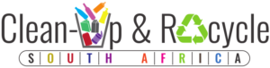 | 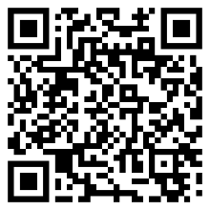
 | https://www.cleanupandrecycle.co.za

CLEAN-UP & RECYCLE WEEK 2024  If you’re wondering how you can get involved in this year’s Clean-up and Recycle Week, click on the image on the right to find out where clean-ups will be happening near you. | COMMITTED TO MAKING A DIFFERENCE  Together with our sponsors, partners and other volunteer organisations, we strive to bring as many people together throughout the year, via Clean-ups, wherever they are!
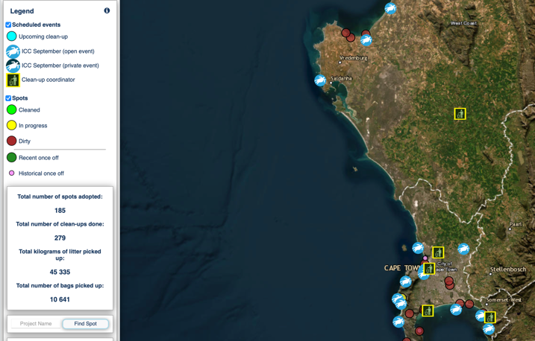 | 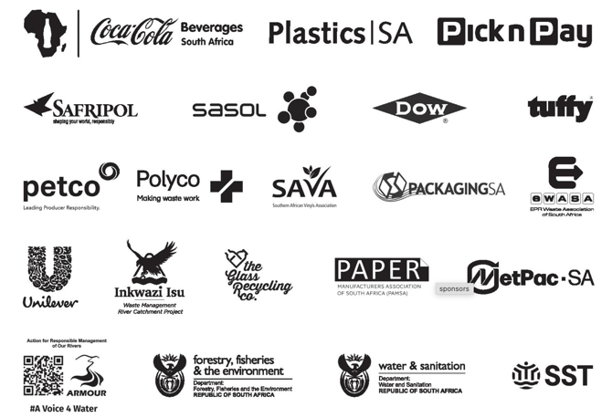
Clean-up and Recycle SA Campaign in Action 2023
In order to tackle environmental pollution, the plastics industry and its partners have been
collaborating with Government, Producer Responsibility Organisations (PROs), Community Based
Organisations and other Non-Governmental Organisations, through clean-up and recycling projects.

For the past 27 years, Plastics SA has been coordinating, with the support from our partners,
provincial coordinators and supporting organisations clean-ups along our roadsides, beaches and
river catchment projects along the coastline, as well as inland rivers.

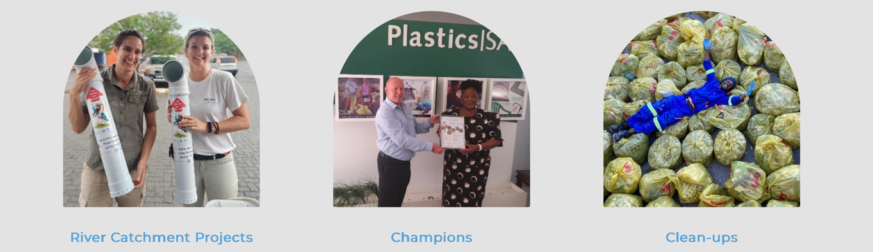
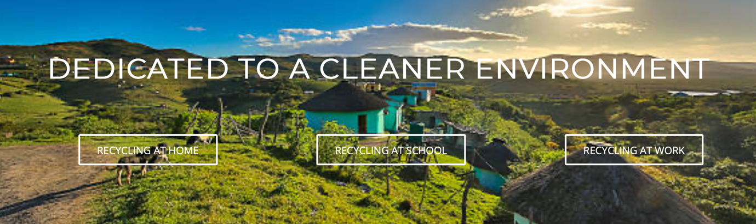
Although waste is removed, the main objective of clean-up campaigns through the Clean-up and The Recycle South Africa Campaign is raising awareness of the effects of littering and promoting the best waste practices to ensure the environment stays clean and people take responsibility for their own waste.

Clean-up campaigns encourage cohesion in communities and highlight the importance of a clean and healthy environment, building a sense of civic pride, and appreciating their common environment.

Plastics SA supports the national mascot, Billy Bin, which was unveiled as part of the National Good Green Deeds Programme, by President Ramaphosa in March 2019.

Billy Bin’s mission is to create awareness of the effects of littering and illegal dumping and remind everyone to keep their environment clean, promote good waste management practices and stop littering. A dirty environment can cause a general feeling of helplessness and hopelessness in the community.

Adverts and posts for Cleanup and Recycle Week 2023, reached more than 820 000 viewers during August and September 2023.
28 Aug – 03 Sep C&R Ocean 195,970 viewers
04 Sep – 10 Sep C&R Ocean 231,749 viewers
11 Sep – 17 Sep C&R Ocean 201,112 viewers
18 Sep – 24 Sep C&R Ocean You did again 202,718 viewers

CASE STUDY 2: SA Federation for Mental Health
Read through the campaign’s information OR visit the website to answer the questions as a group. Ensure that every group member takes notes on their worksheet as you will need these notes in the next activity.
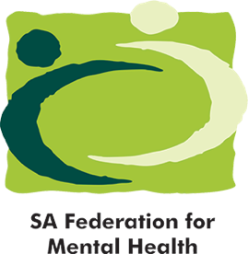 | 
 | https://www.safmh.org

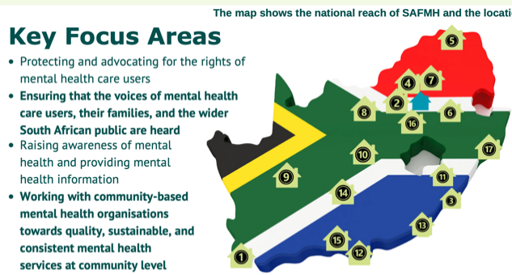
Who we are…
The South African Federation for Mental Health (SAFMH) is a national, human rights organisation with a 100-year-plus track record of creating a society where mental health is better prioritised. We work to ensure rights-based and evidence-based mental health services are included within South Africa’s policies, systems, and care. Our Mission is to work with the community and key stakeholders to achieve the highest possible level of mental health for all. Our Board is constituted of provincial representatives from Mental Health Societies. The 17 Mental Health Societies are independent organisations with their own governance and finance structures. These organisations provide community-based mental health services to communities that are often vulnerable and under-resourced.

Mental health awareness and public education

We use a number of avenues to create awareness (e.g. campaigns, press releases, social media etc.). These are informed by evidence and up-to-date data, such as The Lancet Commission for Ending Stigma and Discrimination (2022). Our awareness efforts are informed and amplified by our Mental Health Societies and persons with lived experience. In order to ensure that our awareness efforts reach everyone, everywhere, SAFMH works with its 17 Mental Health Societies (which are community-based mental health organisations located in all nine provinces across South Africa) to spread mental health awareness to the broader public.

Youth Advocacy Forum
In South Africa, young people have faced exclusion from important mental health policy and decision-making spaces, resulting in policies and practices being developed without their voices included. This past year SAFMH, through a generous grant from EMpower, piloted the first of its kind national youth advocacy and advisory forum for mental health in South Africa. The forum comprises 14 young people from diverse backgrounds and works closely to support SAFMH with national advocacy and awareness.

Our Awareness Campaigns  In addition to the daily promotion of mental health rights, SAFMH runs wider public campaigns on a yearly basis. Every year the organisation focuses on three main annual awareness month programmes in consultation with persons with lived experience of mental health conditions. In 2024, we also added Men’s Health Month to our list of month-long awareness campaigns, and we’ll be continuing with this in future. | 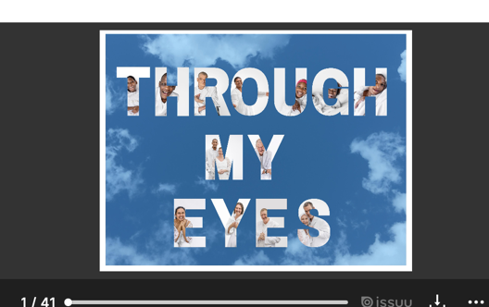
Some of our key partners include the Departments of Health and Social Development and Women, Youth and  Persons with Disability, the World Federation for Mental Health, United for Global Mental Health, the South African Disability Alliance, UNICEF, the National Coalition of Social Service Organisations (NACOSS) and our 17 Mental Health Societies. | 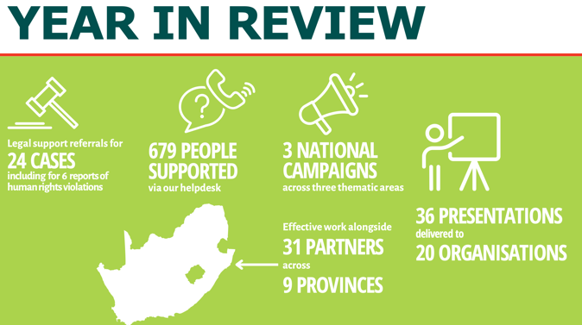
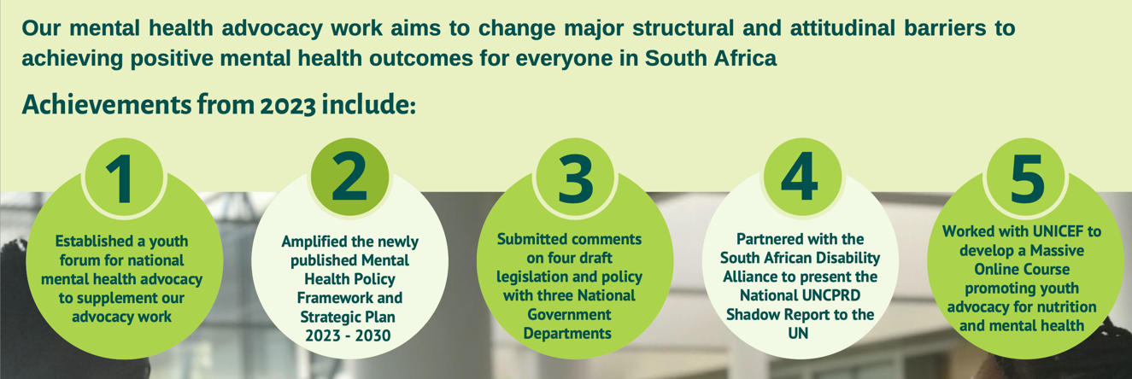

CASE STUDY 3: Sonke Gender Justice
Read through the campaign’s information OR visit the website to answer the questions as a group. Ensure that every group member takes notes on their worksheet as you will need these notes in the next activity.
 | 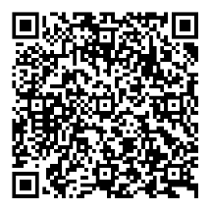
 | https://bit.ly/3FZIslm

Gender-based violence in South Africa
The high rates of gender-based violence (GBV) in South Africa, further highlighted by a number of high-profile cases over the last few years, have given rise to significant public support to end GBV. The government has made some efforts towards ending GBV, but these have been marred by inefficient coordination and almost no budget provisions made towards prevention and services.
One such effort towards effective coordination was the National Council on Gender-Based Violence (NCGBV), a council created for the purpose of drafting, costing, and implementing a national strategic plan (NSP) to combat GBV. Since its formation in 2012, it has been destabilised by political changes and a lack of funding to execute its mandate. There has been no official word on its status since 2014. The Ministry failed to reconstitute it and provide an update on its status.

Gender norms that permit violence also encourage men to have multiple sexual partners, forgo protection like condom use, and prevent many men from seeking healthcare. As a result men often become unaware transmitters of HIV and other STIs.

Sonke’s Community Education and Mobilisation (CEM) Unit works closely with men and women and boys and girls in many different communities across South Africa’s nine provinces to address gender inequalities, gender-based violence (GBV) and the spread and impact of HIV and AIDS.
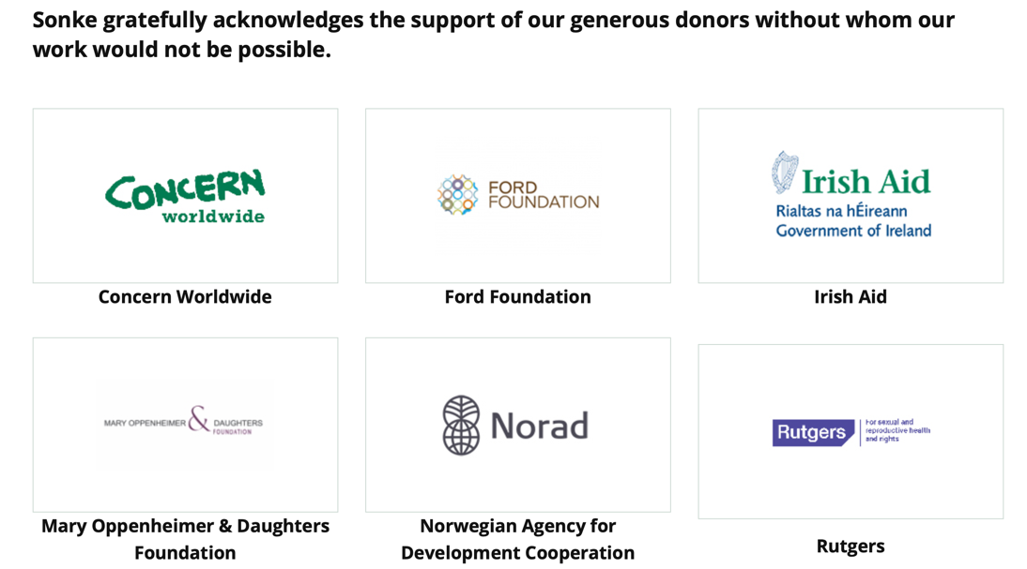
CASE STUDY 4: Peninsula School Feeding
Read through the campaign’s information OR visit the website to answer the questions as a group. Ensure that every group member takes notes on their worksheet as you will need these notes in the next activity.
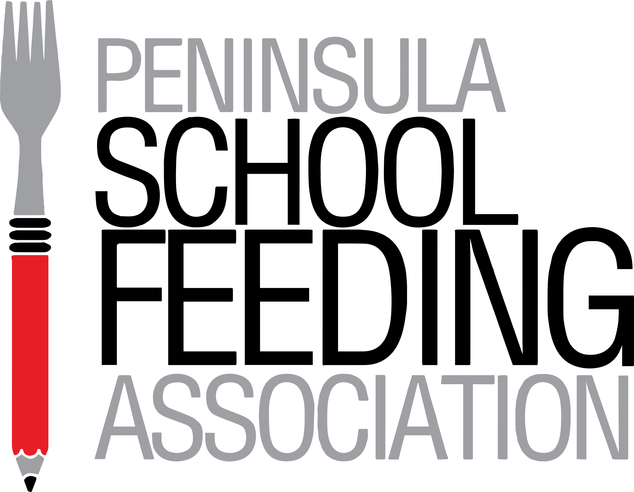 | 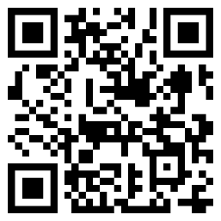
 | https://psfa.org.za/the-need/

The Fact  The latest University of Cape Town report reveals that 3 out of 4 children go hungry every day because 30% of our population live in poverty with food insecurity. | The Results  At school - these hungry children are unable to concentrate. Whilst hunger gnaws at them, they can't think about anything else. Or else they simply don't attend school at all. | 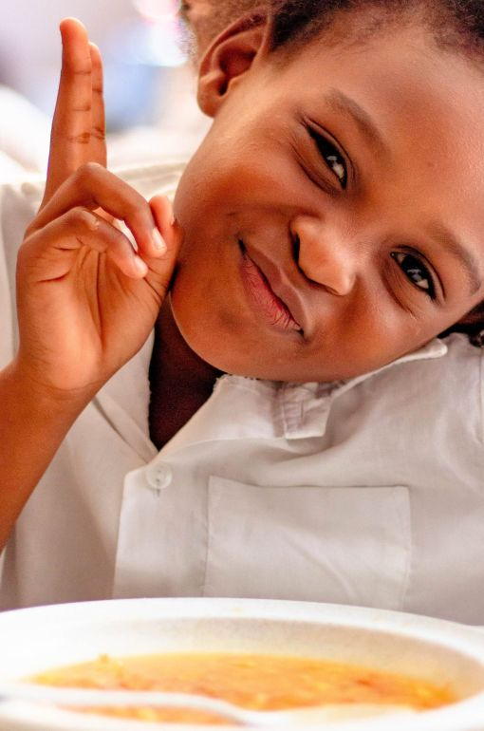
The Consequence
The deficits of undernutrition in children become irreversible if not addressed. In addition to the disastrous effect of hunger on education and a child’s future, another far-reaching outcome is a generation with poor immune systems, frequent illness, and a link to life-threatening diseases in adult life. Today’s unmet need will have serious consequences for tomorrow, without intervention.

The Answer
To develop into their full potential, every child needs regular, balanced nutrition, which includes food from all food groups and provides all essential nutrients – protein, carbohydrates, vitamins, and minerals. Our breakfasts and lunches are designed and prepared accordingly. Daily school meals provide an incentive to attend school and help children to focus on their studies. As an individual, a family, a group, a club, or a company, you can help to provide this essential nutrition, thereby growing an educated, healthy, and winning generation.

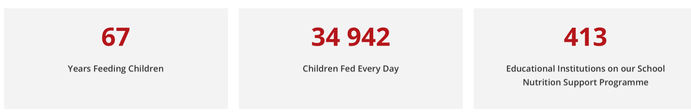

How can you help?
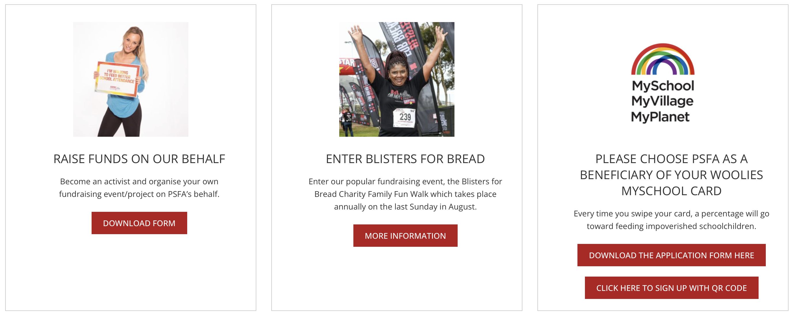

Partners  - Department of Social Development  - Primary, High and Special Needs Schools on our feeding programme  - TVET Colleges on our feeding programme  - Early Childhood Development Centre's on our feeding programme  - Hope Africa  - HelloFCB  - Ninjas for Hire  - Breadline Africa  - Diocese of False Bay Social Development Department  - Tiger Brands Foundation | 