CASE STUDY 1: Clean Up & Recycle SA
Read through the campaign’s information OR visit the website to answer the questions as a group. Ensure that every group member takes notes on their worksheet as you will need these notes in the next activity.
 | 
 | https://www.cleanupandrecycle.co.za

CLEAN-UP & RECYCLE WEEK 2024  If you’re wondering how you can get involved in this year’s Clean-up and Recycle Week, click on the image on the right to find out where clean-ups will be happening near you. | COMMITTED TO MAKING A DIFFERENCE  Together with our sponsors, partners and other volunteer organisations, we strive to bring as many people together throughout the year, via Clean-ups, wherever they are!
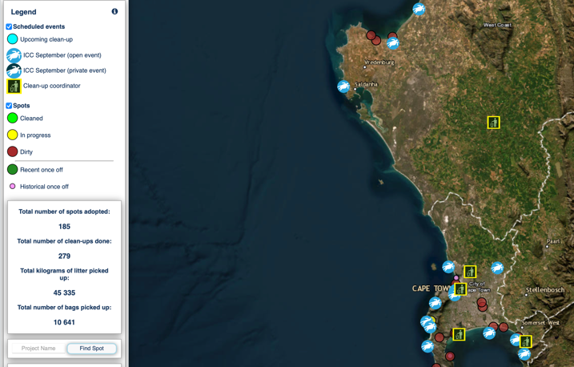 | 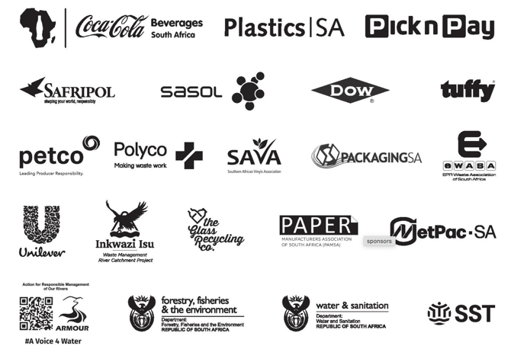
Clean-up and Recycle SA Campaign in Action 2023
In order to tackle environmental pollution, the plastics industry and its partners have been
collaborating with Government, Producer Responsibility Organisations (PROs), Community Based
Organisations and other Non-Governmental Organisations, through clean-up and recycling projects.

For the past 27 years, Plastics SA has been coordinating, with the support from our partners,
provincial coordinators and supporting organisations clean-ups along our roadsides, beaches and
river catchment projects along the coastline, as well as inland rivers.

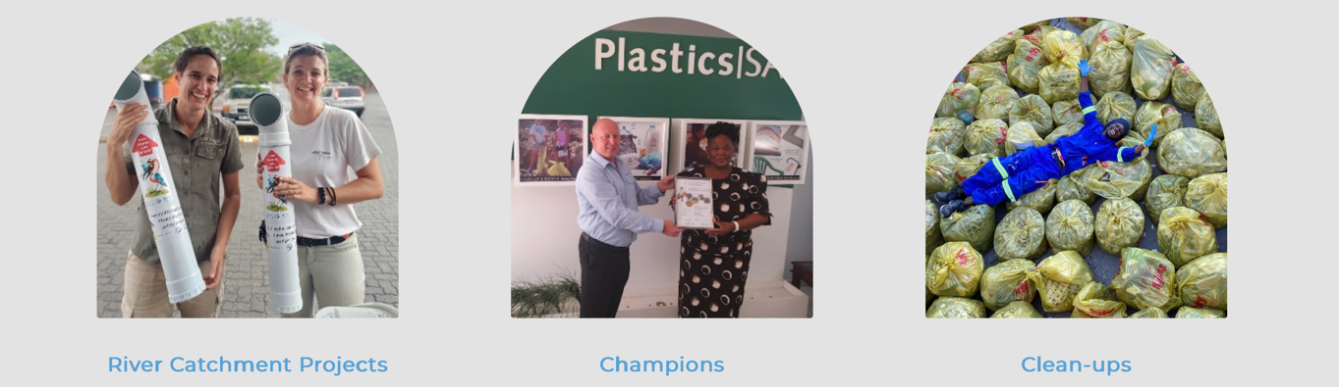
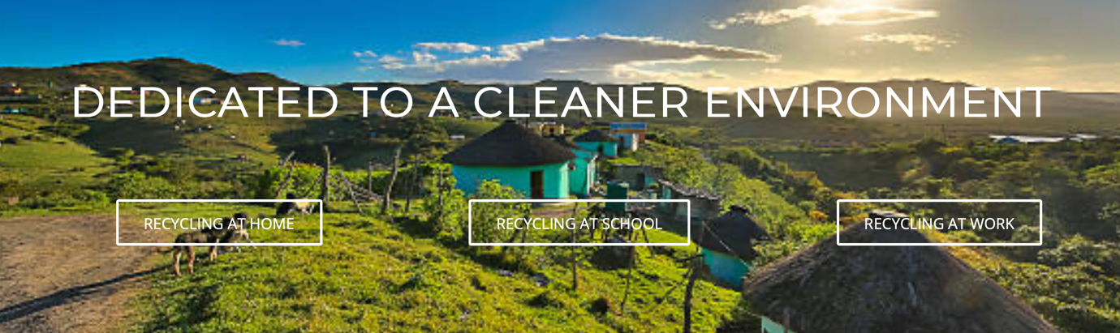
Although waste is removed, the main objective of clean-up campaigns through the Clean-up and The Recycle South Africa Campaign is raising awareness of the effects of littering and promoting the best waste practices to ensure the environment stays clean and people take responsibility for their own waste.

Clean-up campaigns encourage cohesion in communities and highlight the importance of a clean and healthy environment, building a sense of civic pride, and appreciating their common environment.

Plastics SA supports the national mascot, Billy Bin, which was unveiled as part of the National Good Green Deeds Programme, by President Ramaphosa in March 2019.

Billy Bin’s mission is to create awareness of the effects of littering and illegal dumping and remind everyone to keep their environment clean, promote good waste management practices and stop littering. A dirty environment can cause a general feeling of helplessness and hopelessness in the community.

Adverts and posts for Cleanup and Recycle Week 2023, reached more than 820 000 viewers during August and September 2023.
28 Aug – 03 Sep C&R Ocean 195,970 viewers
04 Sep – 10 Sep C&R Ocean 231,749 viewers
11 Sep – 17 Sep C&R Ocean 201,112 viewers
18 Sep – 24 Sep C&R Ocean You did again 202,718 viewers

2.1.1 Identify: Elaborate on some of the challenges which the campaign is trying to address.
This campaign addresses plastic pollution in the ocean and its harmful effects on marine life. It also aims to educate the public about caring for the environment by promoting recycling as a way of life.

2.1.2 Understand: Which key stakeholders are involved in this initiative? Why is it important that these stakeholders are involved?
Some businesses, such as Pick n Pay and Coca-Cola, operate nationally. The National Government is also involved. This means the campaign can be rolled out across South Africa, not just in selected communities. These companies also provide sponsorships, which give campaigns the resources to expand and the funding needed to support educational programmes.

2.1.3 Understand: In what way can this initiative be seen as an intervention and educational programme?
The campaign has tackled the issue of excessive litter in South African communities, which is often dismissed as “someone else’s problem.” Organising beach clean-up days brings communities together and educates them on how to take responsibility for their own environment. The campaign also targets younger children through the use of “Billy the Mascot,” helping to spark interest among the younger generation.
2.1.4 Evaluate: How does this initiative aim to promote safe and healthy living?
By educating the public about the effects of pollution and tracking the campaign’s effectiveness, people are more likely to change their habits around recycling. As a result, reduced pollution in an area could help prevent diseases like cholera, which can spread through stagnant, contaminated water. This shift in behaviour may also lead to greater community pride, with individuals taking more intentional care of their environment and one another.
CASE STUDY 2: SA Federation for Mental Health
Read through the campaign’s information OR visit the website to answer the questions as a group. Ensure that every group member takes notes on their worksheet as you will need these notes in the next activity.
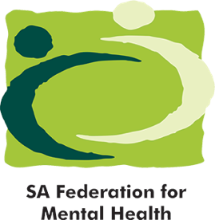 | 
 | https://www.safmh.org

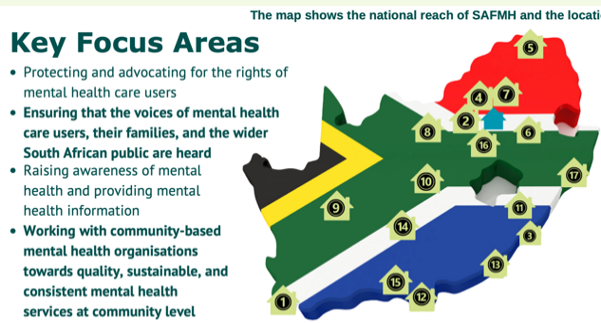
Who we are…
The South African Federation for Mental Health (SAFMH) is a national, human rights organisation with a 100-year-plus track record of creating a society where mental health is better prioritised. We work to ensure rights-based and evidence-based mental health services are included within South Africa’s policies, systems, and care. Our Mission is to work with the community and key stakeholders to achieve the highest possible level of mental health for all. Our Board is constituted of provincial representatives from Mental Health Societies. The 17 Mental Health Societies are independent organisations with their own governance and finance structures. These organisations provide community-based mental health services to communities that are often vulnerable and under-resourced.

Mental health awareness and public education

We use a number of avenues to create awareness (e.g. campaigns, press releases, social media etc.). These are informed by evidence and up-to-date data, such as The Lancet Commission for Ending Stigma and Discrimination (2022). Our awareness efforts are informed and amplified by our Mental Health Societies and persons with lived experience. In order to ensure that our awareness efforts reach everyone, everywhere, SAFMH works with its 17 Mental Health Societies (which are community-based mental health organisations located in all nine provinces across South Africa) to spread mental health awareness to the broader public.

Youth Advocacy Forum
In South Africa, young people have faced exclusion from important mental health policy and decision-making spaces, resulting in policies and practices being developed without their voices included. This past year SAFMH, through a generous grant from EMpower, piloted the first of its kind national youth advocacy and advisory forum for mental health in South Africa. The forum comprises 14 young people from diverse backgrounds and works closely to support SAFMH with national advocacy and awareness.

Our Awareness Campaigns  In addition to the daily promotion of mental health rights, SAFMH runs wider public campaigns on a yearly basis. Every year the organisation focuses on three main annual awareness month programmes in consultation with persons with lived experience of mental health conditions. In 2024, we also added Men’s Health Month to our list of month-long awareness campaigns, and we’ll be continuing with this in future. | 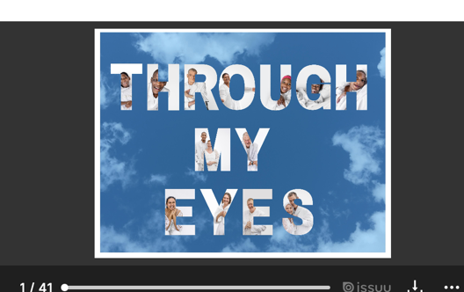
Some of our key partners include the Departments of Health and Social Development and Women, Youth and  Persons with Disability, the World Federation for Mental Health, United for Global Mental Health, the South African Disability Alliance, UNICEF, the National Coalition of Social Service Organisations (NACOSS) and our 17 Mental Health Societies. | 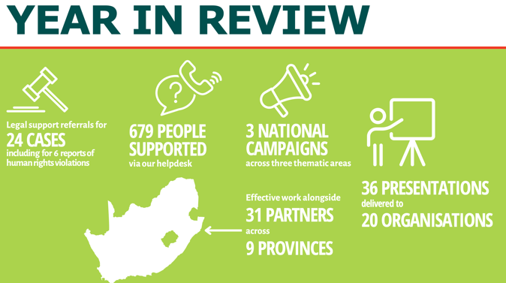
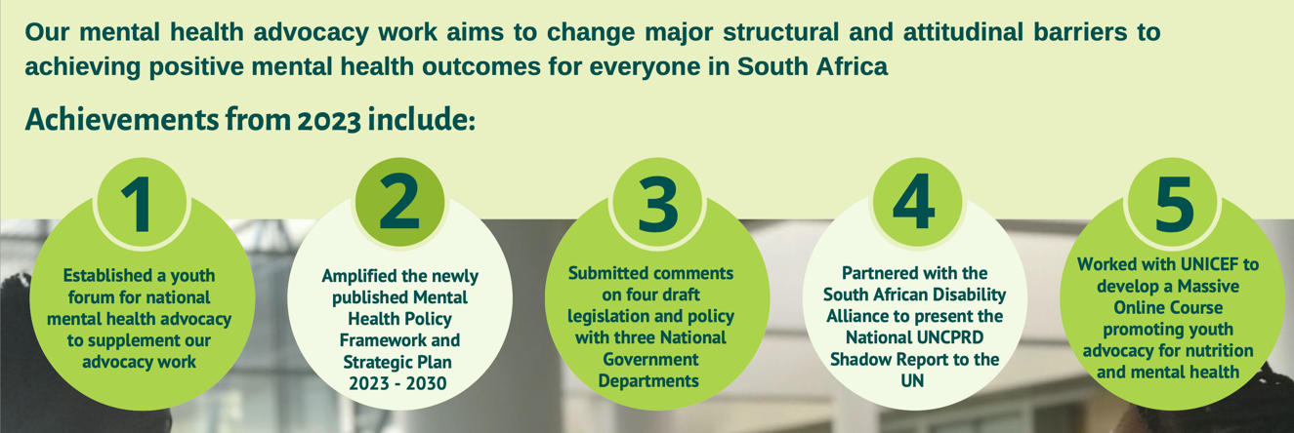

2.1.1 Identify: Elaborate on some of the challenges which the campaign is trying to address.
This campaign addresses the reality that many South Africans struggle with mental health issues but often don't know how to talk about them or where to seek help.
2.1.2 Understand: Which key stakeholders are involved in this initiative? Why is it important that these stakeholders are involved?
Key partners include the Departments of Health, Social Development, and Women, Youth and Persons with Disabilities, along with various Mental Health Societies. These partnerships ensure that the campaign can reach communities across the country, not just isolated areas. They also provide the necessary sponsorship and resources to expand the campaign and support educational programmes.

2.1.3 Understand: In what way can this initiative be seen as an intervention and educational programme?
The campaign tackles the problem of mental health stigma in South Africa, where these issues are often not spoken about. By featuring articles in popular men's magazines like Men’s Health, the campaign helps to challenge stereotypes and normalise conversations around mental well-being. In addition, the campaign focuses on educating young people by hosting presentations and creating safe platforms where youth can openly discuss mental health concerns.
2.1.4 Evaluate: How does this initiative aim to promote safe and healthy living?
Through public education and regular follow-ups to assess the campaign’s impact, the public becomes more informed and less judgmental towards those facing mental health challenges. Increased awareness can lead to more people seeking help or encouraging others to do so. Ultimately, the campaign promotes empathy and encourages communities to look out for one another with greater care and understanding.
CASE STUDY 3: Sonke Gender Justice
Read through the campaign’s information OR visit the website to answer the questions as a group. Ensure that every group member takes notes on their worksheet as you will need these notes in the next activity.
 | 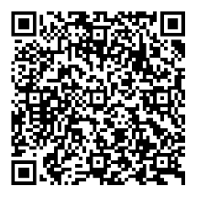
 | https://bit.ly/3FZIslm

Gender-based violence in South Africa
The high rates of gender-based violence (GBV) in South Africa, further highlighted by a number of high-profile cases over the last few years, have given rise to significant public support to end GBV. The government has made some efforts towards ending GBV, but these have been marred by inefficient coordination and almost no budget provisions made towards prevention and services.
One such effort towards effective coordination was the National Council on Gender-Based Violence (NCGBV), a council created for the purpose of drafting, costing, and implementing a national strategic plan (NSP) to combat GBV. Since its formation in 2012, it has been destabilised by political changes and a lack of funding to execute its mandate. There has been no official word on its status since 2014. The Ministry failed to reconstitute it and provide an update on its status.

Gender norms that permit violence also encourage men to have multiple sexual partners, forgo protection like condom use, and prevent many men from seeking healthcare. As a result men often become unaware transmitters of HIV and other STIs.

Sonke’s Community Education and Mobilisation (CEM) Unit works closely with men and women and boys and girls in many different communities across South Africa’s nine provinces to address gender inequalities, gender-based violence (GBV) and the spread and impact of HIV and AIDS.
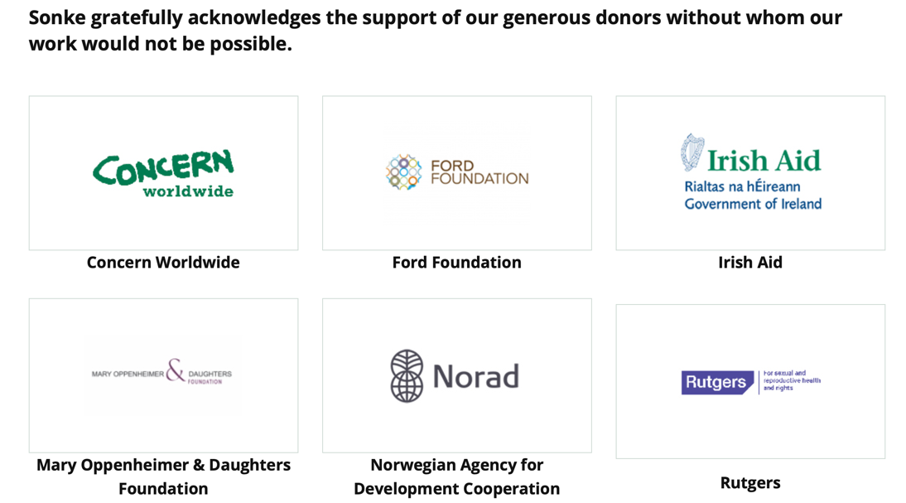

2.1.1 Identify: Elaborate on some of the challenges which the campaign is trying to address.
This campaign addresses the issue of gender-based violence (GBV) in South Africa by raising awareness and educating the public to help reduce incidents of violence.
2.1.2 Understand: Which key stakeholders are involved in this initiative? Why is it important that these stakeholders are involved?
Key partners include both local and international organisations, such as Irish Aid and Norad. Their involvement ensures that the campaign can be implemented across the country, not just in selected communities, and brings international support and funding to strengthen the message.
2.1.3 Understand: In what way can this initiative be seen as an intervention and educational programme?
The campaign tackles GBV by engaging directly with communities, educating both men and women and breaking down harmful stereotypes. It aims to change deeply rooted behaviours and beliefs that contribute to violence, particularly in areas where such behaviour has been normalised over time.
2.1.4 Evaluate: How does this initiative aim to promote safe and healthy living?
By informing the public about GBV, the campaign not only works to reduce violence but also aims to save lives. As more people become aware of the issue, they are better equipped to support victims and encourage others to seek help. Ultimately, the campaign fosters greater empathy, reduces judgement based on stereotypes, and encourages communities to look out for one another with care and responsibility.
CASE STUDY 4: Peninsula School Feeding
Read through the campaign’s information OR visit the website to answer the questions as a group. Ensure that every group member takes notes on their worksheet as you will need these notes in the next activity.
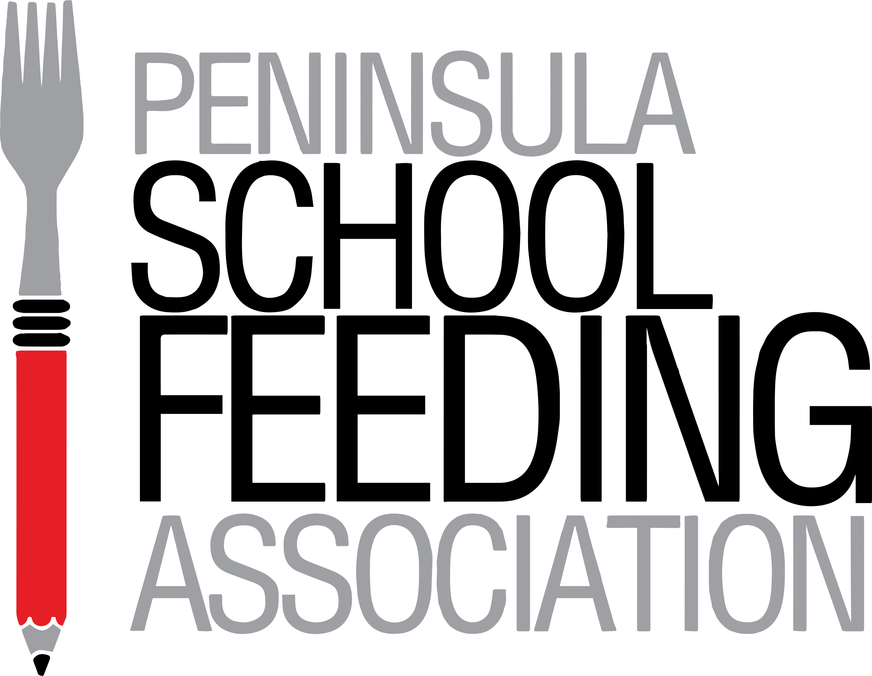 | 
 | https://psfa.org.za/the-need/

The Fact  The latest University of Cape Town report reveals that 3 out of 4 children go hungry every day because 30% of our population live in poverty with food insecurity. | The Results  At school - these hungry children are unable to concentrate. Whilst hunger gnaws at them, they can't think about anything else. Or else they simply don't attend school at all. | 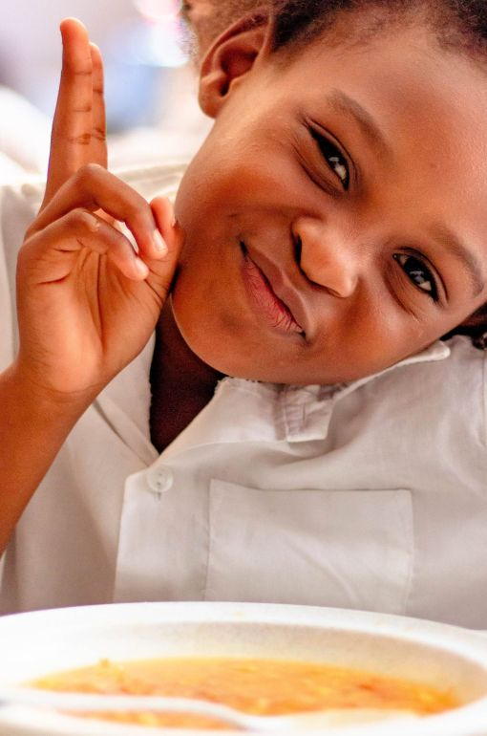
The Consequence
The deficits of undernutrition in children become irreversible if not addressed. In addition to the disastrous effect of hunger on education and a child’s future, another far-reaching outcome is a generation with poor immune systems, frequent illness, and a link to life-threatening diseases in adult life. Today’s unmet need will have serious consequences for tomorrow, without intervention.

The Answer
To develop into their full potential, every child needs regular, balanced nutrition, which includes food from all food groups and provides all essential nutrients – protein, carbohydrates, vitamins, and minerals. Our breakfasts and lunches are designed and prepared accordingly. Daily school meals provide an incentive to attend school and help children to focus on their studies. As an individual, a family, a group, a club, or a company, you can help to provide this essential nutrition, thereby growing an educated, healthy, and winning generation.

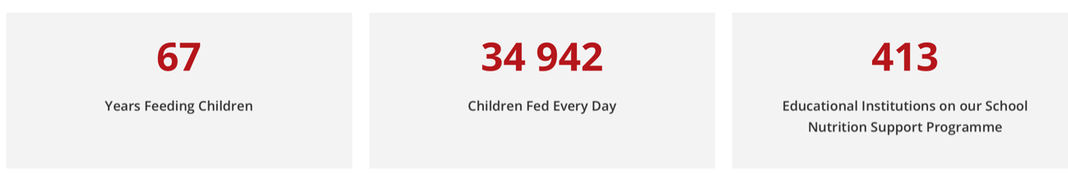

How can you help?
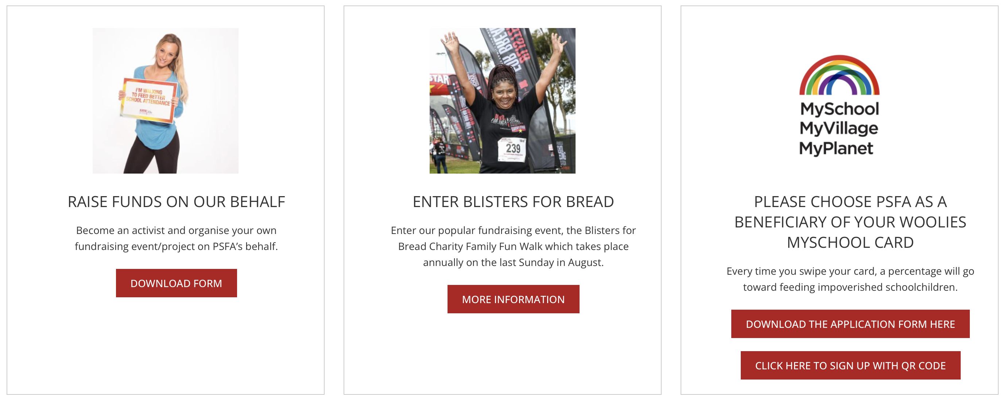

Partners  - Department of Social Development  - Primary, High and Special Needs Schools on our feeding programme  - TVET Colleges on our feeding programme  - Early Childhood Development Centre's on our feeding programme  - Hope Africa  - HelloFCB  - Ninjas for Hire  - Breadline Africa  - Diocese of False Bay Social Development Department  - Tiger Brands Foundation | 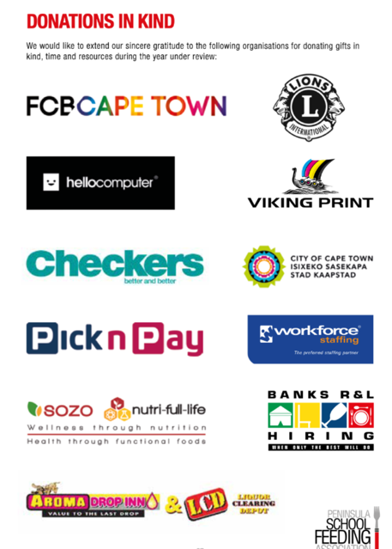

2.1.1 Identify: Elaborate on some of the challenges which the campaign is trying to address.
This campaign addresses the challenges faced by children who struggle to concentrate in class due to hunger, as well as the long-term effects of malnutrition.
2.1.2 Understand: Which key stakeholders are involved in this initiative? Why is it important that these stakeholders are involved?
Key partners include national companies like Tiger Brands and local institutions such as TVET Colleges. These partnerships make it possible for the campaign to expand to other areas across South Africa.
2.1.3 Understand: In what way can this initiative be seen as an intervention and educational programme?
By focusing on hungry and malnourished children, the campaign has helped raise awareness about the urgent need to feed learners. This awareness has led to greater community education on how these needs can be addressed and who to partner with for support. In addition, the public has been empowered to take action by organising their own fundraising initiatives to contribute to the cause.

2.1.4 Evaluate: How does this initiative aim to promote safe and healthy living?
By educating people about poverty and child hunger, the campaign has encouraged financial support from companies and hands-on involvement from communities, including preparing meals for learners. The immediate benefit is improved concentration in class, as learners are no longer distracted by hunger. In the long term, the campaign helps prevent health problems linked to malnutrition, supporting both academic success and overall well-being.

