
Lesson 1 – Worksheet
 | Activity 1: Think-Pair-Share  Complete the following activity in pairs.
  - Write down FIVE government services you used this morning.
___________________________________________________________________________________________________________________________________________________________________________________________________________________________________________________________________________________________________________________________________________________________________________________________________________

1.2 In the space provided on the cellphone graphic below, choose FOUR government services you’ve mentioned in Question 1.1. Imagine you are the social media representative for your local municipality, and you want to create a trend on social media. Come up with a few creative hashtags to get each government service trending (e.g. #PavedRoadsRock). For each service, also indicate which level of government is responsible: National, Provincial, or Local.
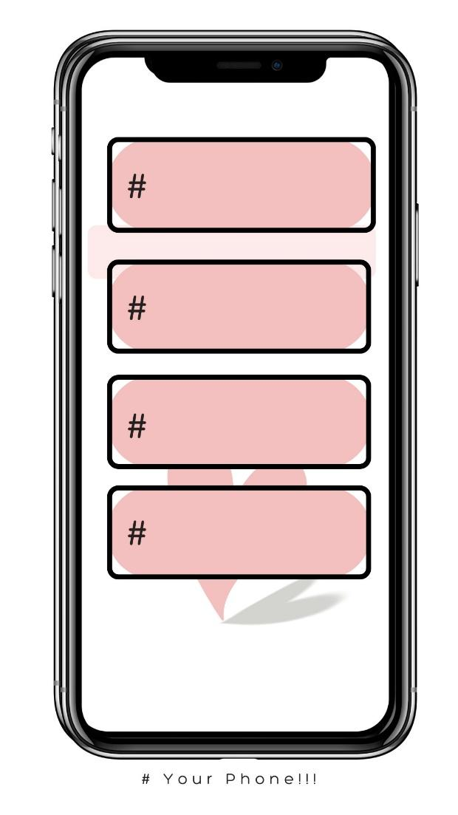
Level of Government
↓

Activity 2: Different Levels of Government
Complete the following activity in pairs.

2.1 | Name three national policies that directly impact your life.  - ____________________________________________________________________________________________________________________________________________________  - ____________________________________________________________________________________________________________________________________________________  - ____________________________________________________________________________________________________________________________________________________
2.2 | Why do you think provinces need their own laws?  __________________________________________________________________________________________________________________________________________________________________________________________________________________________________________
2.3 | What services could your local government improve?  ________________________________________________________________________________________________________________________________________________________________________________________________________________________________________________________________________________________________________________________

Activity 3: Case Study
Complete the following activity groups.

Read through the example case study on loadshedding and take note of the actions mentioned to address the issue. The task also focuses on the challenges that change may involve. Your teacher will assign you one of four topics, which you must analyse in the same way as the loadshedding example.

As a group, complete the following grid, based on the headline that was assigned to you.
3.1 Brainstorm: What is the problem expressed in the headline?
____________________________________________________________________________________________________________________________________________________________________________________________________________________________________________________________________________________________________________________________________________________________________________________
3.2 National Government’s Response:  _____________________________________________________________________________________________________________________________________________________________________________________________ | 3.3 Provincial Government’s Response:  _____________________________________________________________________________________________________________________________________________________________________________________________ | 3.4 Local Government’s Response:  _____________________________________________________________________________________________________________________________________________________________________________________________
3.5 What can the local community do to assist in dealing with this issue?
____________________________________________________________________________________________________________________________________________________________________________________________________________________________________________________________________________________________________________________________________________________________________________________
Activity 4: Reflection
Complete the following activity individually.
Based on what you have learnt in today’s lesson, answer the following questions.

4.1 Identify ONE service that needs improvement in your school community.
__________________________________________________________________________________________________________________________________________________________________

4.2 How can you be part of an action plan to make this change happen?
__________________________________________________________________________________________________________________________________________________________________

4.3 Who would you need help with to make this change a reality?
_________________________________________________________________________________

