
Lesson 1 – Worksheet MEMO
 | Activity 1: Think-Pair-Share  Complete the following activity in pairs.
  - Write down FIVE government services you used this morning.
___________________________________________________________________________________________________________________________________________________________________________________________________________________________________________________________________________________________________________________________________________________________________________________________________________

1.2 In the space provided on the cellphone graphic below, choose FOUR government services you’ve mentioned in Question 1.1. Imagine you are the social media representative for your local municipality, and you want to create a trend on social media. Come up with a few creative hashtags to get each government service trending (e.g. #PavedRoadsRock). For each service, also indicate which level of government is responsible: National, Provincial, or Local.
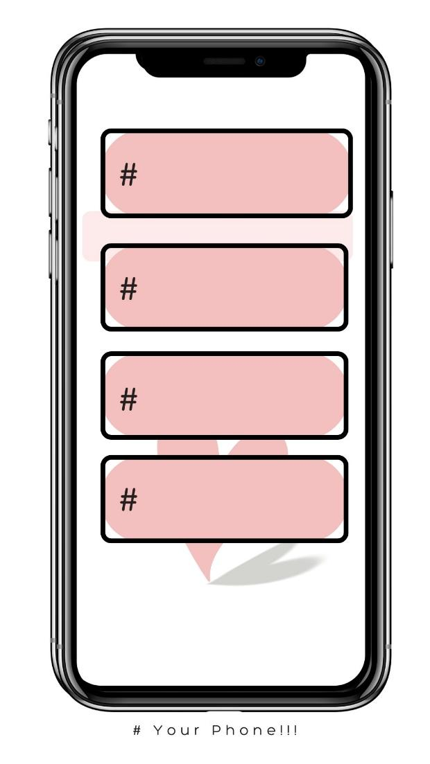
Level of Government
↓

Learners will have personal responses to this activity.
Activity 2: Different Levels of Government
Complete the following activity in pairs.

2.1 | Name three national policies that directly impact your life.  - National School Nutrition Programme (provides free meals at schools).  - National Health Insurance (NHI) (aims to give all citizens access to healthcare).  - National Minimum Wage (ensures workers earn a baseline income, e.g., R25.42 per hour in 2023).  - South African Schools Act (ensures what we learn and how we learn it).
2.2 | Why do you think provinces need their own laws?  - Provinces would ensure that issues specific to their regions are addressed in a meaningful and effective way.
2.3 | What services could your local government improve?  - Learners will have personal responses to this question.

Activity 3: Case Study
Complete the following activity groups.

Read through the example case study on loadshedding and take note of the actions mentioned to address the issue. The task also focuses on the challenges that change may involve. Your teacher will assign you one of four topics, which you must analyse in the same way as the loadshedding example.

As a group, complete the following grid, based on the headline that was assigned to you.
Case Study 1
3.1 Brainstorm: What is the problem expressed in the headline?
- South Africa is trying to reduce carbon emissions.
- The country is shifting from coal to cleaner energy sources like solar and EVs.
- The transition poses economic and infrastructure challenges.
- There's a risk of job losses in coal-related industries.
3.2 National Government’s Response:  - Introduced tax breaks for electric vehicles (EVs).  - Supports local solar energy projects.  - Promises to retrain workers from the coal industry.  - Aims to balance climate goals with economic growth. | 3.3 Provincial Government’s Response:  - Could implement retraining programmes tailored to local needs.  - May support regional solar/green tech projects.  - Help coordinate infrastructure upgrades (e.g. for EV charging). | 3.4 Local Government’s Response:  - Could promote awareness/education on renewable energy.  - May assist in approving/facilitating local solar installations.  - Could work with businesses/communities to support job transitions.
3.5 What can the local community do to assist in dealing with this issue?
- Support/use solar power/electric vehicles where possible.
- Participate in training/upskilling programmes.
- Get involved in local green initiatives/start community projects.
- Advocate for fair/inclusive energy policies.

Case Study 2
3.1 Brainstorm: What is the problem expressed in the headline?
- South Africa’s healthcare system faces overcrowding, outdated infrastructure, and unequal access.
- Rural and poor areas lack proper medical facilities.
- Corruption and poor maintenance have affected past projects.
3.2 National Government’s Response:  - Invested R10 billion to build new hospitals and upgrade clinics.  - Links this investment to the National Health Insurance (NHI) plan.  - Aims to create jobs and improve healthcare access across the country. | 3.3 Provincial Government’s Response:  - Likely involved in managing hospital construction/clinic upgrades within each province.  - Responsible for implementing the NHI plan on a regional level.  - May coordinate hiring/training of staff. | 3.4 Local Government’s Response:  - Could assist in identifying healthcare needs in specific communities.  - May oversee the maintenance and day-to-day running of local clinics.  - Might help monitor how healthcare services are delivered.
3.5 What can the local community do to assist in dealing with this issue?
- Report misuse of funds/corruption in local projects.
- Support/participate in public health campaigns.
- Encourage skilled healthcare workers to work in their communities.
- Help hold local/national leaders accountable for service delivery.

Case Study 3
3.1 Brainstorm: What is the problem expressed in the headline?
- Abandoned and illegally occupied buildings are creating urban decay.
- There is a shortage of safe, affordable housing.
- Vulnerable people are at risk of eviction and homelessness.
3.2 National Government’s Response:  - Reclaiming and renovating hijacked buildings.  - Aims to create affordable and inclusive housing.  - Links the plan to broader goals of urban renewal and social justice. | 3.3 Provincial Government’s Response:  - May manage housing projects within the province.  - Could coordinate with local municipalities to enforce property laws fairly.  - Might help monitor housing allocation/community impact. | 3.4 Local Government’s Response:  - Likely involved in identifying/securing hijacked buildings.  - Could help oversee building renovations/housing applications.  - Might work with communities to prevent forced displacement.
3.5 What can the local community do to assist in dealing with this issue?
- Engage in public consultations to raise concerns/suggest fair solutions.
- Support lawful housing initiatives that include the poor.
- Report criminal activity in hijacked buildings.
- Advocate for transparent/inclusive redevelopment plans.

Case Study 4
3.1 Brainstorm: What is the problem expressed in the headline?
- South Africa faces high poverty, unemployment (33%), and inequality.
- Many people rely on social grants for survival.
- Current grant payments are low and not a long-term solution on their own.
3.2 National Government’s Response:  - Shifting grants from short-term relief to long-term poverty support.  - Modernising grant systems to reduce corruption.  - Linking grants to job-creation programmes.  - Aiming to fund grants through economic growth, not debt. | 3.3 Provincial Government’s Response:  - Could assist in implementing job-linked programmes regionally.  - May help with grant distribution/fraud prevention.  - Might provide provincial data to support planning/monitoring. | 3.4 Local Government’s Response:  - May help register/support grant recipients.  - Could coordinate local job-creation/skills training projects.  - Might monitor community impact/needs.
3.5 What can the local community do to assist in dealing with this issue?
- Encourage participation in local job programmes.
- Report grant fraud/misuse of funds.
- Support community-led development projects.
- Advocate for fairer/more sustainable poverty solutions.

Learners may have varying responses to this activity.

Activity 4: Reflection
Complete the following activity individually.
Based on what you have learnt in today’s lesson, answer the following questions.

4.1 Identify ONE service that needs improvement in your school community.
__________________________________________________________________________________________________________________________________________________________________

4.2 How can you be part of an action plan to make this change happen?
__________________________________________________________________________________________________________________________________________________________________

4.3 Who would you need help with to make this change a reality?
_________________________________________________________________________________

Learners will have personal responses to this activity.

