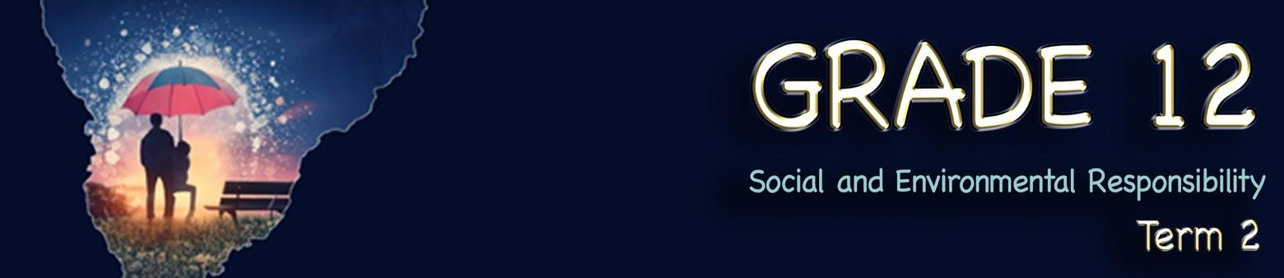
Lesson 2 – Worksheet
 | Activity 1: Icebreaker  Complete the following activity in pairs.


1.1.What issue did you want to fix and how would you do it?

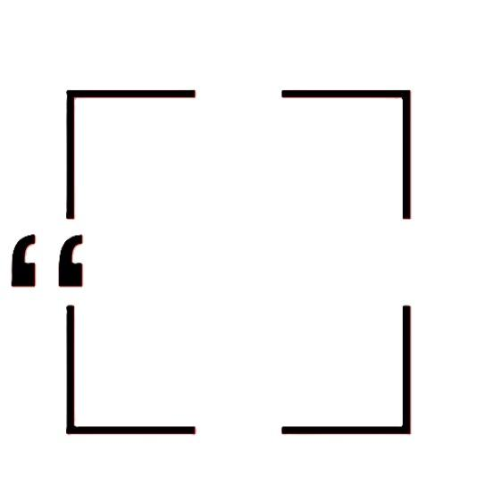

1.2. Who could you ask to help with this? issue?

Activity 2: Brainstorm
Complete the following activity in pairs.
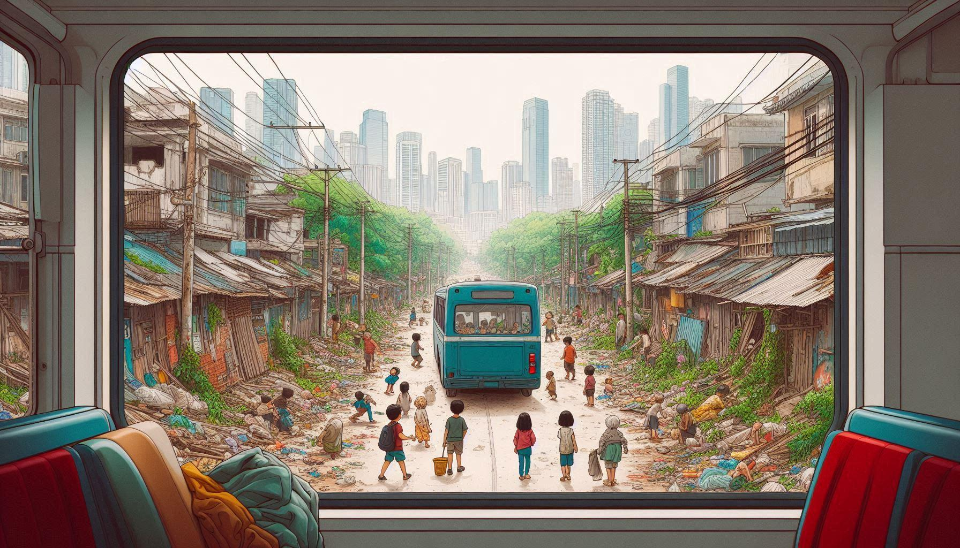

Activity 3: Social Issues
Complete the following activity in pairs.

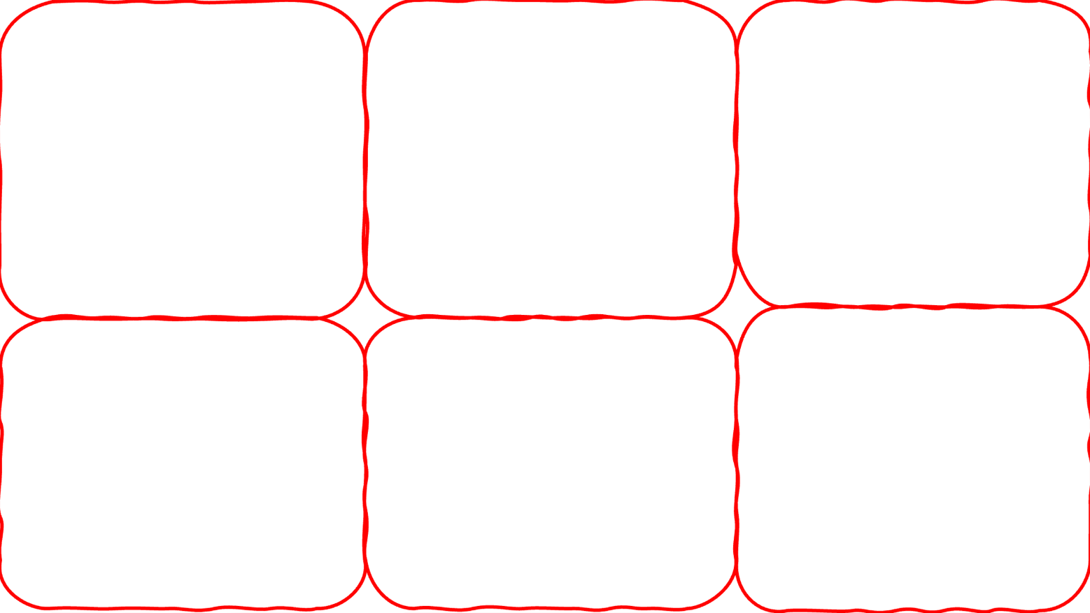
Look at the images on Slide 5 (Lesson 2 – PowerPoint). In the corresponding block below, identify the issue that is plaguing many of our communities.
Image 6
Image 5
Image 4
Image 3
Image 2
Image 1

Activity 4: Social Initiative
Complete the following activity individually.

Based on the video you watched (Youth advocacy trainings for nutrition and mental health in South Africa (https://www.youtube.com/watch?v=LNwb_Wb_hG0&t=3s)), answer the following questions.

4.1 What social challenge does this initiative address?

4.2 How does this initiative promote safe and healthy living?

4.3 In what way(s) can individual community members get involved with this initiative?

Activity 5: Group Discussion
Complete the following activity in groups.

Study the image below and answer the questions that follow.
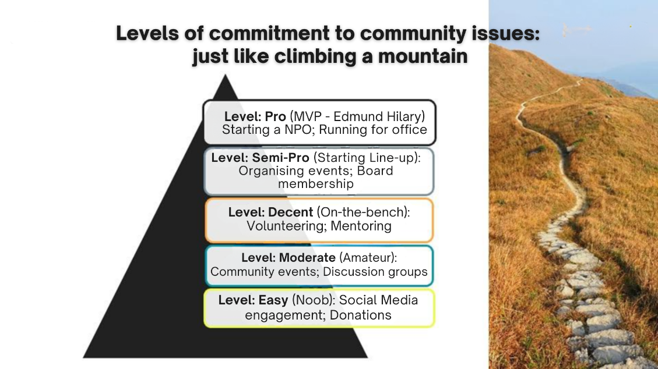

5.1 Discuss TWO ways in which community members (you and your friends) can make their community physically safer.
___________________________________________________________________________________________________________________________________________________________________________________________________________________________________________________________________________________________________________________________________________________________________________________________________________

5.2 Suggest TWO ways in which community members (you and your friends) can support victims of gender-based violence.
___________________________________________________________________________________________________________________________________________________________________________________________________________________________________________________________________________________________________________________________________________________________________________________________________________

5.3 How would you educate the broader community or society about the issues related to gender-based violence?
____________________________________________________________________________________________________________________________________________________________________________________________________________________________________________________________________________________________________________________________
_______________________________________________________________________________
Activity 6: Reflection: Taking Responsibility Today
Complete the following activity individually.

Read the statements below and answer the question that follows.
You have the power to create positive change.
Start with small actions in your community.

Work together for a safer, healthier South Africa.

Take a moment to think of your own local community group.

6.1 Identify ONE action that you can take in your community to improve the quality of life or help others.

_____________________________________________________________________________________________________________________________________________________________________________________________________________________________________________

