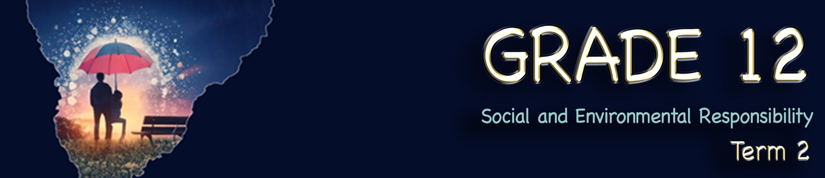
Lesson 4 – Worksheet
 | Activity 1: Personal Values & Personal Views  Complete the following activity individually.

1.1 Circle THREE values from the list below that are the most important to you right now in red and TWO values you wish to develop in years to come in green.
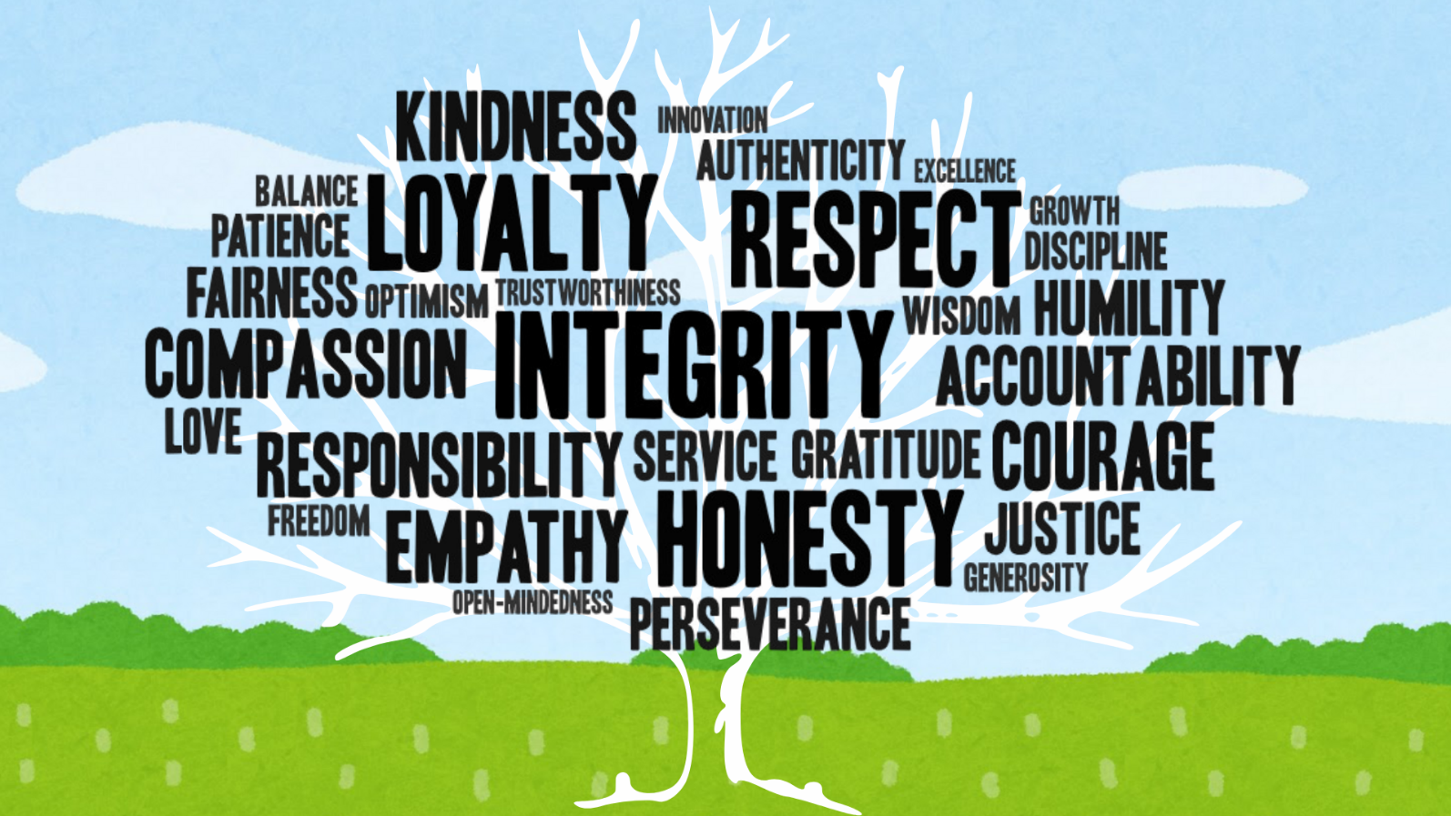

1.2 Explain how these values impact your responses to the people in your life.
___________________________________________________________________________________________________________________________________________________________________________________________________________________________________________________

1.3 Write one sentence expressing your personal view on each of the following points:
1.3.1 The importance of having a university degree to have a successful career.
___________________________________________________________________________________________________________________________________________________________________________________________________________________________________________________

    - The importance of family and how it defines the way you live.
___________________________________________________________________________________________________________________________________________________________________________________________________________________________________________________

    - The importance of exercising every day.
___________________________________________________________________________________________________________________________________________________________________________________________________________________________________________________

Activity 2: Beliefs & Ideologies
Complete the following activity individually.

2.1 Read the TWO extracts below and highlight any examples of belief and ideology in the text.
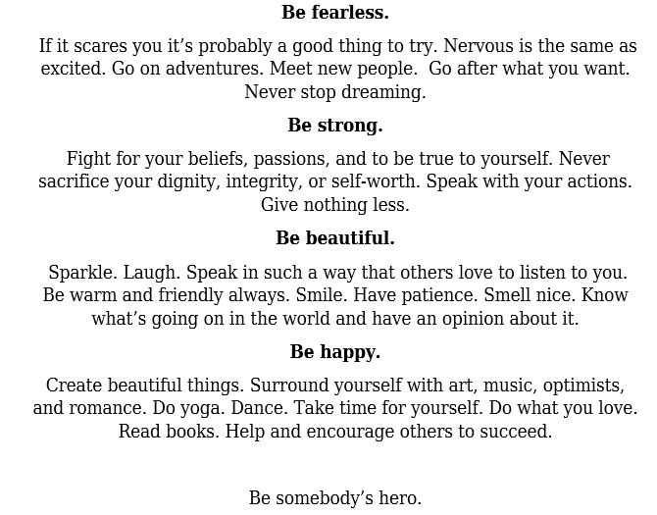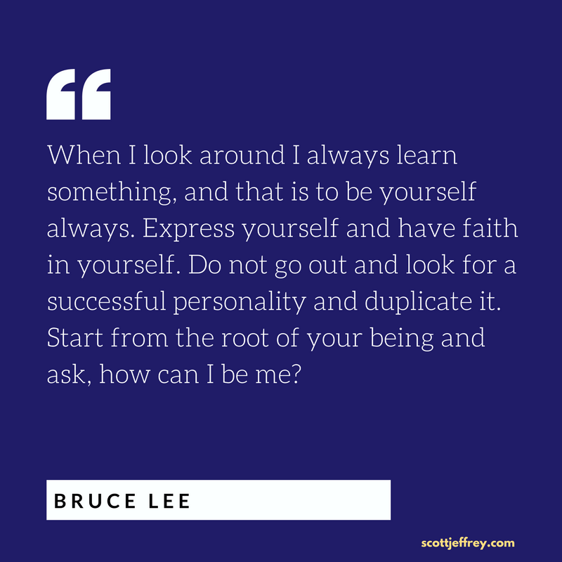
2.2 In one sentence, describe what you believe and explain how your belief or ideology shapes who you are.
______________________________________________________________________________________________________________________________________________________________________________________________________________________________________________________________________________
Activity 3: Lifestyle
Complete the following activity individually.

3.1 Your lifestyle is the way you live right now, for example, how much you exercise, eat healthily, sleep, and take care of yourself. Remember, your mission statement is about your goals, so it can include what you would like to achieve in the future. This could also include goals related to your emotional well-being or personal dreams, like starting a family or getting married one day.
In the space below, describe your LIFESTYLE PLAN.
____________________________________________________________________________________________________________________________________________________________________________________________________________________________________________________________________________________________________________________________________________________________________

3.2 Consider how you intend to live more sustainably by writing a sentence on your ENVIRONMENTAL PLAN.
______________________________________________________________________________________________________________________________________________________________________________________________________________________________________________________________________________

3.3 What are your goals for your career choices and studies in the years to come? List THREE goals for the future for CAREER and STUDIES.
____________________________________________________________________________________________________________________________________________________________________________________________________________________________________________________________________________________________________________________________________________________________________

Activity 4: Practise Assessment Questions
Complete the following activity individually.

Study the question and marking guidelines below. Circle the keywords in the question and underline the statement and qualifier in the answer. Write in any other responses you might have had.

Read the quote below and answer the questions that follow.
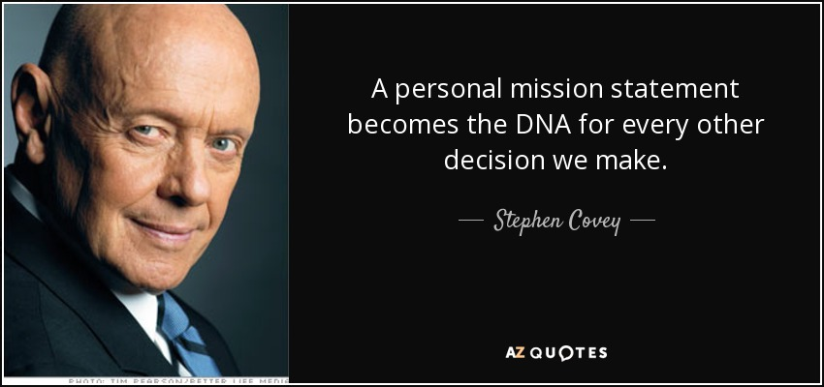

[Taken from: https://www.azquotes.com/quote/835629 Accessed on 19 March 2025]

Write paragraphs on a personal mission statement and vision for life.
Use the following as a guideline:
- Define the term ‘personal mission statement’ and state THREE core values that could
form part of a personal mission statement. (1 + 3) (4)
(Lower Order)
MARKING GUIDELINE ANSWERS:
Marks should be awarded as follows:
ONE () mark for the correct definition.

A personal mission statement is a…
- collection of your aims and values in life, which influence you to take a particular course of action in life. ()
- summary of your interests/objectives/values/aspirations/wishes/moral code which shape your idiosyncrasies (manners/peculiarities) in interaction with people/institutions/world etc. ()
- personal shortened declaration crafted based on your values/likes/interests/purpose which shape your approach to things/relationship with people and the world. ()
- description of who you are based on your values/dreams/attitudes/goals which embodies your intention of being in the world. ()

Any ONE of the above for ONE mark
AND

Marks should be awarded as follows:
ONE () mark for a well-explained response.

Core values may include the following:
- honesty ()
- responsibility ()
- loyalty ()
- truthfulness ()
- integrity ()
- punctuality ()
- accountability ()
- trustworthiness ()
- kindness ()
- respect ()
- faithfulness ()
- hardworking ()
- courageous ()
- empathy ()

Any THREE of the above for ONE mark each

- Analyse why values are an important part of your personal mission statement. (2 x 4) (8)
(Higher Order)
MARKING GUIDELINE ANSWERS:
Marks should be awarded as follows:
FOUR () marks for a well-explained response

It is important because…
- they constitute what people choose to live their lives in accordance with () since all people have certain preferences about things they identify with/all people relate to certain things that are important to them () which could determine their standing in life () and that could then enable them to monitor their behaviour while interacting with other people and the world. ()
- they inform what a person likes/has an interest in () as life presents people with different challenges/situations () which require a particular approach enriched with certain pointers/direction () and that is essential to confidently venture the world being guided by those set of principles. ()
- they may contribute towards the creation of a person’s identity () since they have the ability to determine the manner in which the public could view/approach you () which could enable you to craft an appropriate way to approach life/form relationships with certain people () and that may then assist you in surrounding yourself with like-minded people for the achievement of your personal goals in life. ()
- they may guide your actions in life () since actions are usually based on things you like/cherish () which could enable you to organise all your daily activities in a certain way () and that may act as a gauge/ monitor of the manner you do things. ()
- they may constitute a unique way of expressing cultural preferences () as a person’s outlook on life is largely dependent on cultural beliefs () which may inform the path a person could follow in life () and that could guide how they organise themselves towards the realisation of a self-fulfilling life. ()

Any TWO of the above for FOUR marks each
(i.e. To be awarded the full FOUR marks for the ANALYSIS, candidates must: give a statement, () elaborate on the statement, () qualify the statement () and give an outcome. ())

- Critically discuss how a personal mission statement could assist you in effectively
managing the stress of being in Grade 12. (2 x 4) (8)
(Higher Order)
MARKING GUIDELINE ANSWERS:
Marks should be awarded as follows:
FOUR () marks for a well-explained response.
It could enable learners to…
- continually critique the usefulness of their educational values in dealing with the challenges of having to study large volumes of work () since different subjects may present different challenges () which may require the development of relevant learning approaches () and if that happens, most learners may not struggle in tackling the different aspects of the different subjects. ()
- value the benefits of a balanced lifestyle () since aspects such as nutrition, sleep and recreational activities could promote physical/psychological health () which may lead to healthy bodies/minds () and if that is the case, they may be in a good position to endure the pressure of being in Grade 12 ()
- continuously monitor their psychological well-being () as that could enable them to focus on their goals () which may strengthen their resolve to confront their studies with confidence () and if that happens, they may use their sober minds to overcome hurdles that being at Grade 12 may bring. ()
- build solid/sound relationships with friends/family/schoolmates () since they may have a set of values to lean on when influenced to make negative choices () which may prevent adverse behaviour () and if that happens, they may be under less strain from peer pressure, making it easier for them to prioritise education. ()
- set goals and commit to them () since they have a vision for their future () which may inspire them/promote perseverance () and if this happens, their established purpose could enable them to overcome stress related to difficult subjects in Grade 12. ()
- continually evaluate their attitudes () since positive attitudes could promote positive efforts to do well () which may instil self-motivation to move forward () and if that happens, they may have the necessary urge to overcome the stress of imminent failure by exerting more effort. ()

Any TWO of the above for FOUR marks each
(i.e. To be awarded the full FOUR marks for the CRITICAL DISCUSSION, candidates must: give a statement, () elaborate on the statement, () qualify the statement () and give an outcome. ())

[20]
Activity 5: Reflection
Complete the following activity individually.

Reflect on your confidence in the content covered over the past four lessons. Think about how well you understand each section and how confidently you could apply that knowledge to a personal situation.
Rate each section from 1 to 5:
- 1 = Not confident at all
- 5 = Very confident

 |  | CONTENT | APPLICATION
Lesson 1 | I can elaborate on how the different levels of government create and amend laws, regulations, and rules for the improvement of safety and healthy living.
 | I can identify the responsibilities of the different levels of government and discuss examples.
 | I can explain how the different levels of government provide community services to promote safe and healthy living environments.
Lesson 2 | I can discuss the community’s responsibility to ensure environments and services that promote safe and healthy living.
 | I can critically discuss how the community can get involved in improving safe and healthy living.
Lesson 3 | I can discuss the responsibility of different levels of government to elaborate on educational and intervention programmes that address environments and services.
 | I can evaluate the effectiveness of a campaign by analysing the impact studies that relate to projects that address social and environmental issues.
Lesson 4 | I can write a personal mission and vision statement for life based on:  CORE VALUES: Personal views, values, belief systems, religion, ideologies
 | LIFE PURPOSE: Lifestyle (physical and emotional well-being), goals for studies and career choices.
 | FUTURE DIRECTION: Impact of vision on own actions/behaviour in life, environmental responsibility.

