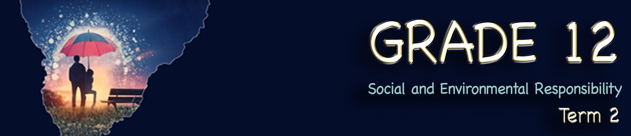
Content Summary

Lesson 1: In this lesson, you will need to understand and apply your knowledge to answer questions on:
- Responsibility of different levels of government:
  - Elaborate on the responsibilities of various levels of government to:
    - Create and amend laws, regulations, rules
    - Provide community services to promote safe and healthy living environments

1. Levels of Government in South Africa
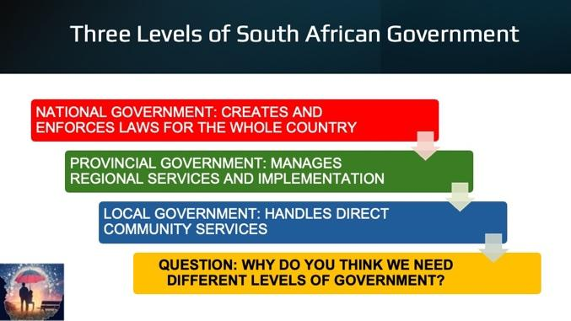
South Africa has a three-tier system of government, each with specific responsibilities to ensure the well-being of citizens. These are:
- National Government
- Provincial Government
- Local Government

Each level operates under the framework of the Constitution of South Africa and is responsible for governance, service delivery, and maintaining law and order.

2. Creation and amendment of laws, regulations, and rules
Each level of government plays a role in developing and implementing laws to protect citizens and promote a safe environment.

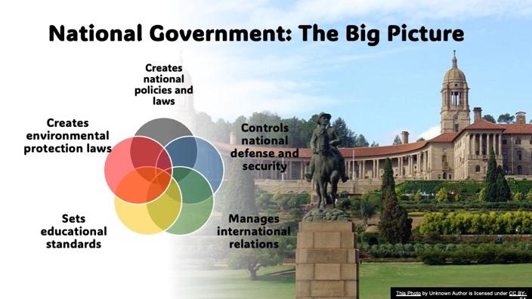
2.1 National Government in South Africa
The national government is the highest level of government in our country. The national government is responsible for creating and enforcing laws that apply to everyone across the country. These laws cover issues like defence, foreign policy, and national security. Think of it as the umbrella that covers all of us, ensuring we have a unified set of rules to follow. It operates within the framework of the Constitution of South Africa, which is the supreme law of the land.

2.1.1 Creation of national laws
The Parliament of South Africa, which consists of the National Assembly and the National Council of Provinces (NCOP), is responsible for drafting, debating, and passing laws that apply to the entire country. These laws address various aspects of governance, including human rights, trade, education, and security. The National Government also ensures that laws align with the Constitution and Bill of Rights.
Once laws are passed, they are implemented and enforced by different government departments and agencies.

2.1.2 Managing countrywide policies
The national government formulates policies to guide the country’s development and ensure social and economic stability. These policies address national concerns such as education, healthcare, economic growth, and environmental sustainability.

2.1.3 Examples of national laws and policies in South Africa

a) Environmental Laws
- National Environmental Management Act (NEMA), 1998 (Act No. 107 of 1998)
This law ensures sustainable development and environmental protection. It requires environmental impact assessments before major projects can proceed. It regulates waste management, air pollution, and conservation efforts.

- National Water Act, 1998 (Act No. 36 of 1998)
This act governs the use, conservation, and management of South Africa’s water resources. It ensures equitable access to water while protecting natural water sources.

b) Healthcare Laws
- National Health Act, 2003 (Act No. 61 of 2003)
This act provides a framework for a structured and equitable healthcare system. Ensures access to healthcare services for all citizens, particularly the poor. It regulates both public and private healthcare institutions.

- Medicines and Related Substances Act, 1965 (Act No. 101 of 1965, as amended)
This act governs the approval, registration, and distribution of medicines in South Africa. It ensures the safety and effectiveness of drugs available to the public.

c) Security and Defense Laws
- Defense Act, 2002 (Act No. 42 of 2002)
This act governs the South African National Defence Force (SANDF). It outlines the roles and responsibilities of the military in protecting the country.
- Protection of Personal Information Act (POPIA), 2013 (Act No. 4 of 2013)
This act regulates how personal data is collected, stored, and used. It protects citizens from privacy violations and cyber threats.

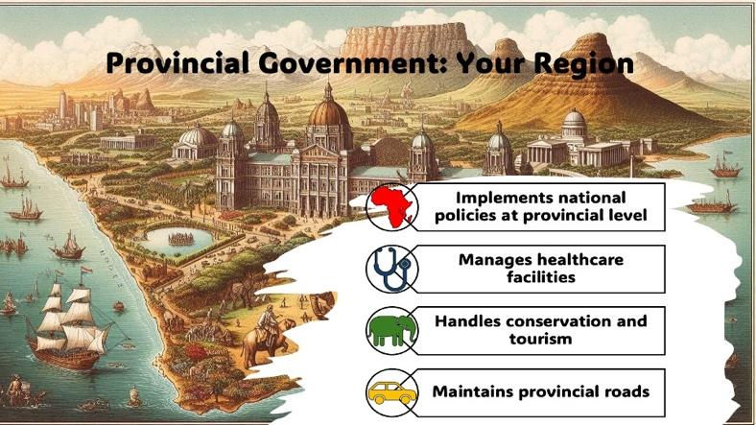
2.2 Provincial Government
This level of government manages regional services and ensures that national policies are implemented effectively in each province. They oversee areas like education, healthcare, and transportation within their region. Provincial governments help tailor national policies to meet the specific needs of their area.

    - Functions of Provincial Government

a) Developing Provincial Legislation
Each province has the power to pass laws on matters outlined in Schedule 4 and Schedule 5 of the Constitution, provided these laws do not conflict with national legislation. These matters include:
  - Education (excluding higher education)
  - Health services (like clinics and hospitals)
  - Environmental management (protecting rivers, parks, and wildlife)
  - Provincial roads and public transport (potholes being fixed)
  - Tourism and trade within the province (like promoting the province’s attractions)

b) Enforcing national laws
Provinces ensure national laws are implemented effectively. For example, the national government sets education policies, but provinces manage schools and hire teachers. Similarly, national health guidelines are adapted to local needs, like malaria prevention in high-risk areas.
c) Managing provincial resources
Provinces have control over their budgets and allocate resources to improve service delivery, such as building new schools, hospitals, and roads. They must ensure financial accountability and responsible governance.

Examples in a South African Context

a) Health Services
Each province oversees public healthcare facilities, staffing, and the provision of medical supplies.
Example: Gauteng, due to its high population, might focus on expanding hospitals and clinics, while Limpopo may prioritise mobile clinics to reach remote communities.

b) Environmental Management
Provinces develop specific strategies to protect their natural resources and manage environmental
challenges. Example: The Western Cape, which faces frequent droughts, might implement water conservation campaigns and desalination plants, while Mpumalanga, known for its coal industry, may focus on reducing air pollution and rehabilitating mining areas.

c) Waste Management
Provinces can implement different waste disposal and recycling policies. Example: KwaZulu-Natal
may invest in recycling initiatives and waste-to-energy plants, while the Free State might focus on cleanup campaigns and stricter landfill regulations.

In conclusion, Provincial Governments play a key role in adapting national policies to suit local needs. Their ability to develop legislation and enforce national laws allows them to address specific challenges within their provinces, ultimately improving service delivery and governance.

2.3 Local Government (Municipalities)
This is the level closest to our communities. Local governments handle direct community services such as waste management, public parks, and local law enforcement. They are responsible for making sure our neighbourhoods are safe and well-maintained. Local governments are very important because they address issues right where we live.

2.3.1 Role of local government in creating laws in South Africa
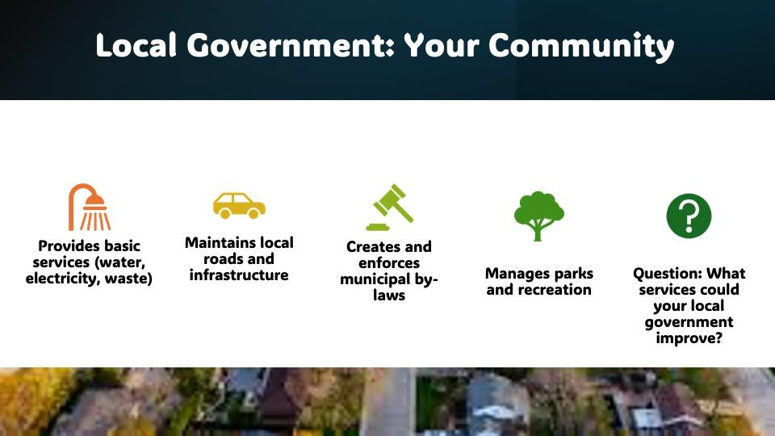
Services like trash collection, streetlights, or community parks. These are all managed locally. The Constitution of South Africa (Section 156) gives municipalities the power to create ’bylaws’ for their areas. These laws address local needs, ensuring communities function smoothly.

2.3.2 Types of Municipalities
- Metropolitan: (like Johannesburg or Cape Town) They control ’all services’ in their area.
- Local: (e.g., smaller towns) They share responsibilities with District Municipalities, which oversee services like water or roads across multiple towns.
- District: They support local municipalities, especially in rural areas.

2.3.3 Lawmaking powers
Local governments don’t make “acts” like Parliament, but they create bylaws. These are rules for local issues, such as:
  - Zoning (where shops or homes can be built),
  - Health regulations (e.g., food safety at markets), and
  - Traffic (speed limits in school zones).

Creating or changing bylaws involves:
- Public participation: Involving the community.
- Council approval: The municipal council must agree.
- Oversight: Sometimes provincial or national governments do checks to ensure compliance.
Local governments face challenges, like balancing autonomy (making local decisions) with accountability (answering to higher authorities). For example, if a municipality bans plastic bags but the national government doesn’t, conflicts can arise.

2.4 Provision of community services for safe and healthy living
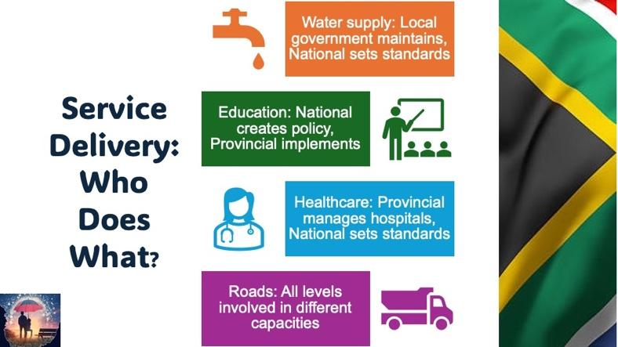
Governments provide essential services that impact the quality of life. These include infrastructure development, public health services, and environmental management.

2.4.1 National Government
Oversees large-scale policies and national programmes, such as:
  - National Health Insurance (NHI) for accessible healthcare.
  - Social grants to support vulnerable groups.
  - Water and electricity regulations to ensure fair access.

2.4.2 Provincial Government
- Manages healthcare, education, and environmental programs within the province.
- Works with municipalities to implement service delivery programmes.
Examples:
  - Building and maintaining provincial hospitals and clinics.
  - Supporting disaster management in cases of floods or fires.
  - Enforcing provincial conservation projects.

2.4.3 Local Government
- Provides direct service delivery to communities, such as:
  - Waste collection and disposal to prevent pollution.
  - Water and sanitation services to prevent diseases.
  - Housing and urban planning to ensure safe living conditions.
  - Maintaining roads, parks, and recreational facilities.
  - Street lighting and security services to promote safety.

Lesson 2: This lesson will build on your knowledge of the previous lesson. In this lesson you will need to understand and apply your knowledge to answer questions on:
- Responsibility of different levels of government
  - Critically discuss the community’s responsibility to ensure environments and services that promote safe and healthy living

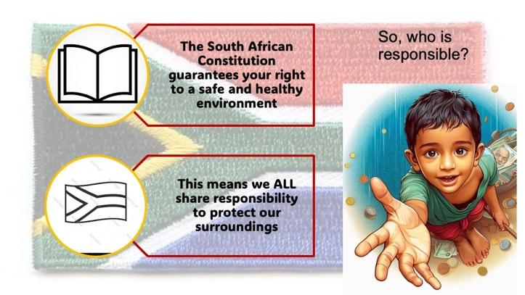
Constitutional Rights
The South African Constitution guarantees every individual the right to a safe and healthy environment. This establishes a collective responsibility among community members to protect their surroundings and advocate for sustainable practices.

Because we live in a democratic society, we are expected to protect that democracy and those who live in it. We all have a responsibility to help improve the quality of life for others. This includes speaking up and reporting crimes, volunteering our time to support community efforts, and even using social media to raise awareness through campaigns and positive messages.

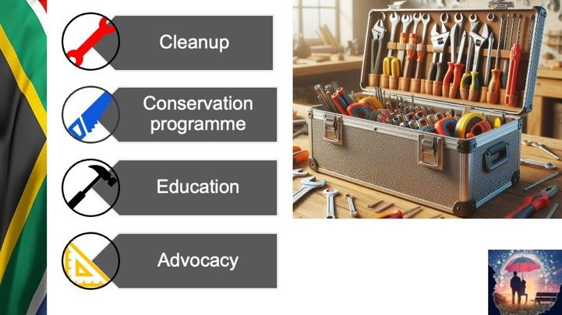
Generally, community responses to social and environmental challenges fall into four basic categories:
- Environmental cleanups are direct actions where community members gather to remove litter and pollutants from natural spaces. These hands-on activities not only improve local ecosystems but also build community bonds and environmental awareness.
- Conservation programmes focus on protecting and restoring natural habitats and endangered species. These initiatives, often partnerships between communities and conservation organisations, create sustainable solutions for preserving biodiversity.
- Education programmes empower communities through knowledge. By teaching sustainable practices in schools and community centres, these programmes help people understand environmental issues and equip them with skills to address challenges locally.
- Finally, advocacy involves communities raising their voices to influence environmental policy. Through petitions, awareness campaigns, and engaging with local government, community advocacy drives systemic change beyond what individuals can achieve alone.

Remember, these responses are interconnected. A community cleanup might spark educational initiatives, which lead to conservation efforts, supported by advocacy for policy change. Together, they represent how empowered communities can transform environmental challenges into opportunities for positive change.

Ways that members of a community (you and your friends) can make their community physically safer

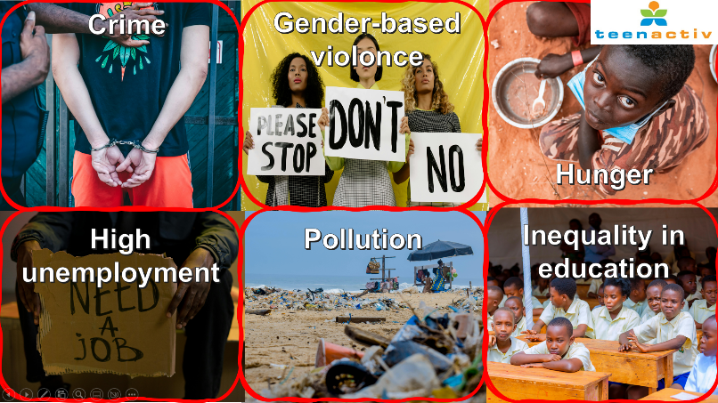
Create safer public spaces through community involvement
- Organise community safety audits where teens identify poorly lit areas, isolated paths and spaces where people feel unsafe
- Collaborate with local authorities to improve lighting in public areas, clear overgrown vegetation, and install emergency call boxes.
- Develop or maintain a volunteer escort system for walking home from school, events or public transportation.

Support victims of gender-based violence
- Create safe spaces for survivors to share their experiences by establishing learner-led support groups at school where survivors can speak freely without judgment. Ensure these spaces maintain strict confidentiality and are facilitated by trained peer mentors or counsellors who understand trauma-informed approaches.
- Organise awareness campaigns that combat harmful stereotypes by developing educational materials about gender-based violence, distributing resources about available support services, and hosting community workshops that teach healthy relationship skills. These initiatives help reduce stigma and create an environment where survivors feel comfortable seeking help.

Educate the broader community about issues related to gender-based violence
Start at school by organising awareness campaigns or discussion groups.
- Create posters with statistics and resources, host documentary screenings or invite local experts to speak at assemblies.
- Use social media strategically to share educational content, survivor stories (with permission) and resources. Short videos explaining consent, healthy relationships and warning signs of abuse can be particularly effective.
- Partner with local organisations already working on these issues. Many domestic violence shelters, rape crisis centres and youth organisations welcome teen volunteers and can provide mentorship.
- Engage with peers through peer-to-peer education. Programmes like "bystander intervention training" teach practical skills for safely intervening when witnessing potentially harmful situations.
- Create arts-based projects that explore these themes through visual art, creative writing, music and theatre. Art can communicate complex emotional topics in accessible ways. Work with trusted adults to organise community workshops for parents, teachers and other community members that focus on prevention and creating safer environments.

Lesson 3: In this lesson, you will need to understand and apply your knowledge to answer questions on:
- Responsibility of different levels of government:
  - Elaborate on educational and intervention programmes that address environments and services that promote safe and healthy living and evaluate impact studies that relate to projects that address social and environmental issues.

Educational and intervention programmes addressing social and environmental issues
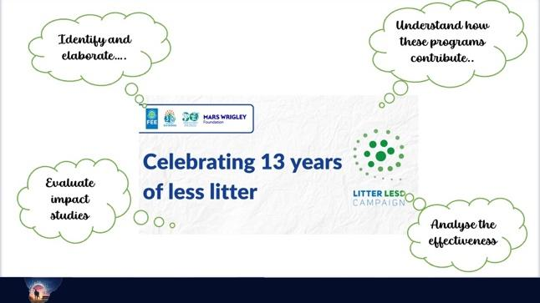
These programmes aim to create awareness, drive behavioural change, and implement practical solutions to social and environmental concerns.
Examples include:
- Environmental awareness campaigns: Programmes like Eco-Schools and Green Campus Initiatives teach learners and communities about sustainability, recycling, and climate change mitigation.
- Community clean-up initiatives: Organisations like Clean-Up & Recycle SA Week promote waste management and encourage public participation in maintaining clean environments.
- Water conservation and sanitation projects: Water Wise and Operation Hydrate focus on responsible water usage and providing clean water to communities in need.
- Social development initiatives:
  - Feeding schemes (e.g., the National School Nutrition Programme) address hunger and malnutrition.
  - Anti-substance abuse campaigns educate communities on the dangers of drug and alcohol abuse.
  - Gender-based violence awareness programmes work to prevent abuse and support survivors.

Promoting healthy living through education and intervention
- Mental and emotional well-being programmes (e.g., South African Depression and Anxiety Group (SADAG)) support mental health.
- HIV/AIDS awareness and prevention campaigns (e.g., LoveLife and Brothers for Life).
- Physical health and nutrition programmes encourage healthy lifestyles through exercise and balanced diets (e.g., Heart and Stroke Foundation SA).

Evaluating impact studies of social and environmental projects
Impact studies assess the effectiveness of intervention programmes. Evaluations typically consider:
- Effectiveness and outcomes: How well the programme met its objectives.
- Sustainability and long-term Impact: Whether the intervention has long-lasting benefits.
- Community involvement: The level of participation and engagement from stakeholders.

Questions that could be asked when evaluating a campaign
- Reach and awareness
  - How many people were exposed to the campaign?
  - Was the target audience aware of its message?
- Behavioural impact
  - Did the campaign encourage the desired behaviour change (e.g., recycling, donations)?
  - Were the changes lasting?
- Engagement and participation
  - How actively did the audience engage with the campaign (e.g., through social media, events, or direct actions)?
- Message clarity and appeal
  - Was the campaign's message clear, compelling, and relevant to the audience?
- Impact and sustainability
  - Did the campaign achieve its goals (social/environmental impact)?
  - What were the long-term effects or lasting changes?

Lesson 4: In this last lesson, you will need to understand and apply your knowledge to answer questions on:
- Formulate a personal mission and vision statement for life based on:
  - Personal views, values, belief systems, religion, ideologies, lifestyle (physical and emotional well-being), environmental responsibility, goals for studies and career choices
  - Impact of vision on own actions/ behaviour in life

Vision and Mission Statement
The VISION STATEMENT is the big picture you’re aiming for, whereas the PERSONAL MISSION STATEMENT is HOW you’re going to achieve that vision. It is a statement that helps you define your core values, life purpose, and the direction you want to take. It acts as a guide for making decisions and setting goals.

The statement is made up of THREE PARTS:
- PART 1: CORE VALUES: Personal views, values, belief systems, religion, and ideologies.
- PART 2: LIFE PURPOSE: Lifestyle (physical and emotional well-being) and goals for studies and career choices.
- PART 3: FUTURE DIRECTION: Impact of vision on own actions/behaviour in life and environmental responsibility.

Part 1: Core values
- Start by reflecting on what your values are important to you.
- Next, consider your personal views. This is your own personal responses and opinions on your future, religion, culture and values.
- To write your personal mission statement, you need to reflect deeply on your values, priorities, and beliefs. It’s about aligning your actions with what truly matters to you, rather than simply going through life without direction. A personal mission helps you take control and lead your life with purpose. This requires knowing what you believe in and identifying the ideology or belief system you think both you and society should strive to live by.
Part 2: Life purpose
Your lifestyle is the way you live right now, for example, how much you exercise, eat healthily, sleep, and take care of yourself. Remember, your mission statement is about your goals, so it can include what you would like to achieve in the future. This could also include goals related to your emotional well-being or personal dreams, like starting a family or getting married one day.

Part 3: Future Direction
Consider how your personal vision influences your actions, both now and in the future. Reflect on how it shapes your behaviour, your attitude towards others, and your sense of responsibility toward the environment.
__________________________________________________________________________________
APPLICATION SUMMARY
As mentioned in the lesson, content in Life Orientation refers to the information you need to understand and apply when answering different questions and scenarios. Below is a summary of the tips for studying Life Orientation that was covered in the last lesson.
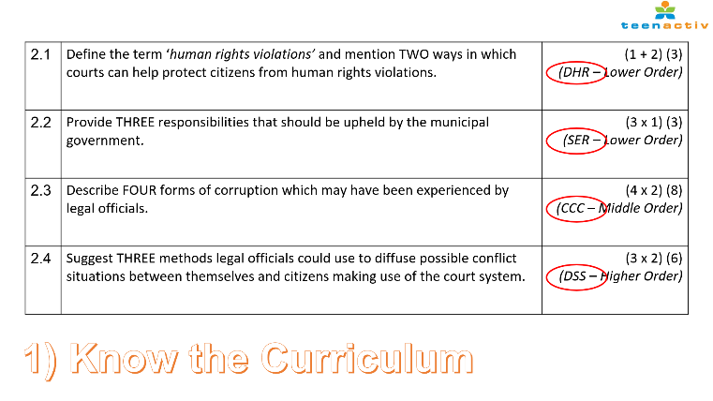
- Firstly, it’s important to know your curriculum.
The abbreviations refer to the main themes you’ve covered in Life Orientation each term:
- DSS – Development of the Self in Society
- SER – Social and Environmental Responsibility
- CCC – Careers and Career Choices
In your exam, a single question may integrate content from two or more of these sections, so it’s important to understand how they connect.

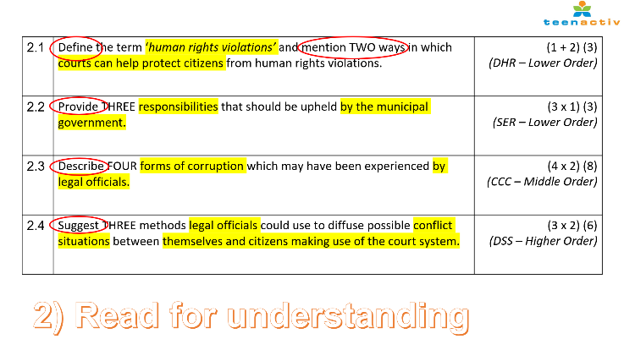
2) Secondly, read all questions carefully before assuming you know the answer.
Take your time to highlight the key content words. These show you exactly what the question is asking. For example, in Question 2.4, the focus is specifically on legal officials and a conflict situation involving citizens using the court system.

Once you’ve identified the key content, you also need to understand what action is required. For instance, Question 2.1 says “define”, which means you’re expected to give a clear, factual statement.

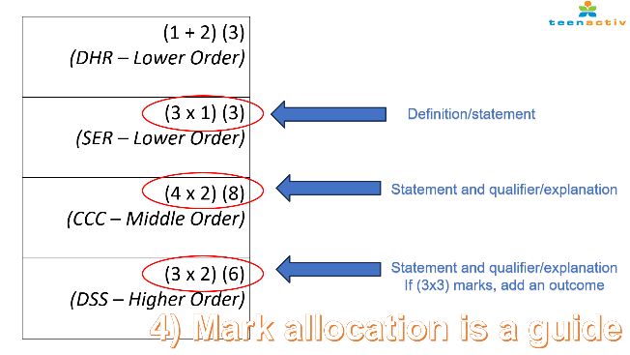
3) Lastly, pay close attention to the mark allocation for each question. It guides you on how to structure your response.
- When the mark allocation is (3 x 1), it requires three separate statements, each worth 1 mark.
- A middle-order question might be shown as (4 x 2). This means you need to give four statements, each supported by a brief explanation or qualifier.
- For higher-order questions, you may see allocations like (3 x 2), but more commonly (3 x 3) or (3 x 4). In these cases:
  - (3 x 3) typically requires a statement, a qualifier, and an outcome.
  - (3 x 4) may require a statement, elaboration on the statement, a qualifier, and an outcome.

Important: Even if your exact answer does not appear in the marking guideline, you can still be awarded marks, as long as the marker or moderator can clearly link your response to the marking guideline, and it meets the specific requirements of the question while including valid examples or explanations.

To become more familiar with the types of questions and how to respond accurately, it’s important to practise using past NSC exam papers along with the marking guidelines. This will help you understand the question format and what is expected in your answers.

