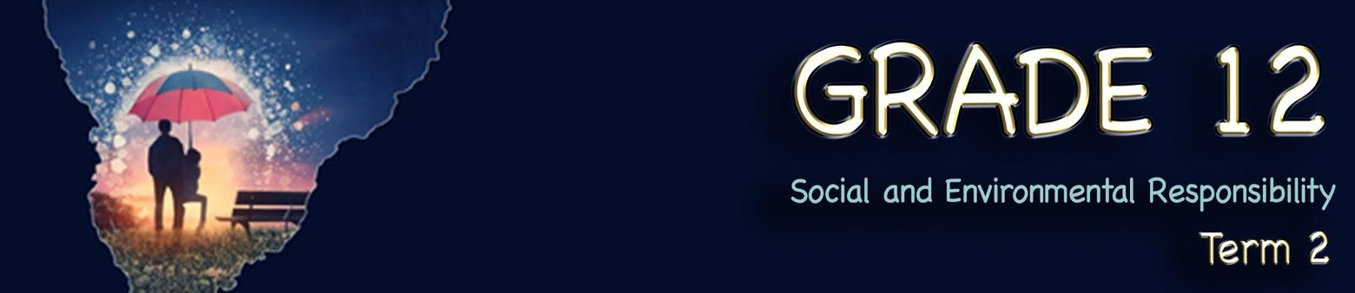
Lesson 2 – Worksheet MEMO
 | Activity 1: Icebreaker  Complete the following activity in pairs.


1.1.What issue did you want to fix and how would you do it?



1.2. Who could you ask to help with this? issue?

Learners will have personal responses to this activity.
Activity 2: Brainstorm
Complete the following activity in pairs.
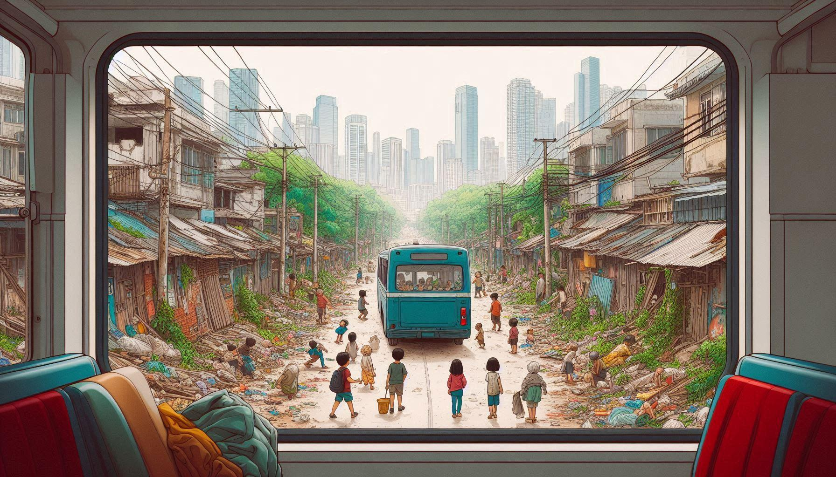

- Responses may include the following:
- Urban inequality – There is a dramatic contrast between modern skyscrapers in the background and an impoverished, informal settlement in the foreground.
- Poverty and inadequate housing – Simple structures with metal roofing and makeshift materials line a dirt road, indicating substandard living conditions.
- Lack of waste management – Debris and garbage are scattered along the roadway, suggesting insufficient sanitation services.
- Limited infrastructure – Exposed, tangled electrical wires overhead point to informal or inadequate utilities.
- Child vulnerability – Several children appear to be unsupervised in the street, potentially indicating limited access to education or childcare.
- Transportation inequity – A blue bus navigates through this informal settlement, highlighting limited transportation options and accessibility issues.
- Urban migration and unplanned development – The contrast between modern high-rises and informal settlements suggests rapid urbanisation without adequate planning or resources.
- Environmental concerns – Despite some greenery, the overall environmental quality appears compromised by pollution and waste.

Activity 3: Social Issues
Complete the following activity in pairs.


Look at the images on Slide 5 (Lesson 2 – PowerPoint). In the corresponding block below, identify the issue that is plaguing many of our communities.
Image 6
Inequality in education
Image 5
Pollution (plastic waste and contamination of the environment)

Image 4
High unemployment (most prevalent amongst the youth)
Image 3
Hunger/Starvation mostly impacting children
Image 2
Gender-based violence
Image 1
High crime rates/violent crimes

Activity 4: Social Initiative
Complete the following activity individually.

Based on the video you watched (Youth advocacy trainings for nutrition and mental health in South Africa (https://www.youtube.com/watch?v=LNwb_Wb_hG0&t=3s), answer the following questions.

4.1 What social challenge does this initiative address?

This Unicef Initiative addresses the issues of nutrition and mental health among the children of South Africa.

4.2 How does this initiative promote safe and healthy living?
Through education – the initiative aims to educate South Africans on the importance of correct nutrition and the importance of mental health.

4.3 In what way(s) can individual community members get involved with this initiative?
Individuals within a community can volunteer to be trained to educate members of the wider community about issues pertaining to proper nutrition and the importance of mental health and well-being. This will ensure that stereotypes are addressed and that people at risk will be willing to obtain help, should they need it.

Activity 5: Group Discussion
Complete the following activity in groups.

Study the image below and answer the questions that follow.
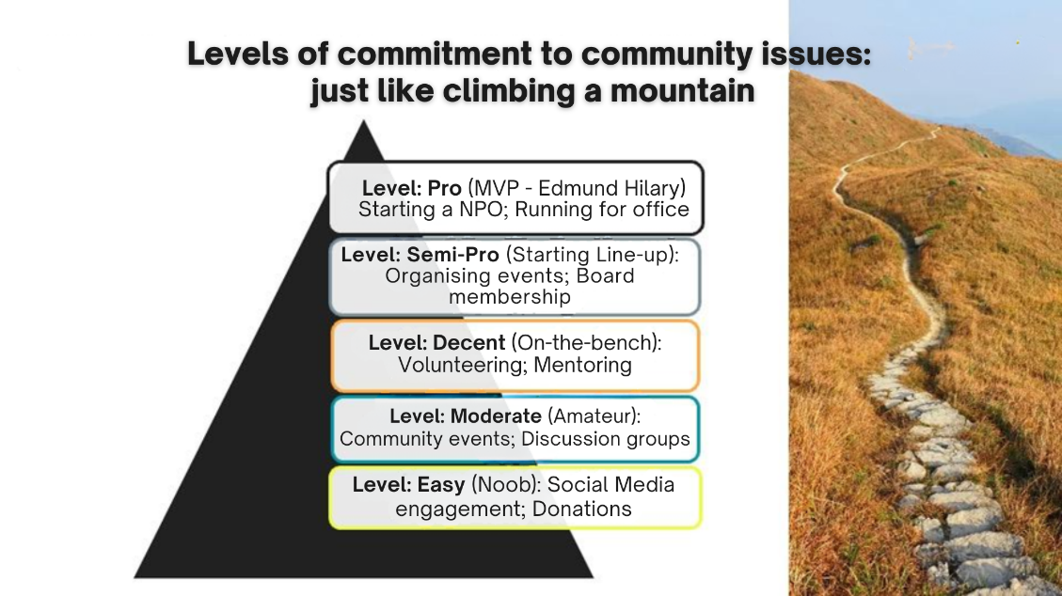

5.1 Discuss TWO ways in which community members (you and your friends) can make their community physically safer.
- Organise community safety audits where teens identify poorly lit areas/isolated paths/spaces where people feel unsafe
- Collaborate with local authorities to improve lighting in public areas/clear overgrown vegetation/install emergency call boxes.
- Develop/maintain a volunteer escort system for walking home from school/events/public transportation.

5.2 Suggest TWO ways in which community members (you and your friends) can support victims of gender-based violence.

- Create safe spaces for survivors to share their experiences by establishing learner-led support groups at school where survivors can speak freely without judgment. Ensure these spaces maintain strict confidentiality/are facilitated by trained peer mentors or counsellors who understand trauma-informed approaches.
- Organise awareness campaigns that combat harmful stereotypes by developing educational materials about gender-based violence/distributing resources about available support services/hosting community workshops that teach healthy relationship skills. These initiatives help reduce stigma/create an environment where survivors feel comfortable seeking help.

5.3 How would you educate the broader community or society about the issues related to gender-based violence?
Start at school by organising awareness campaigns or discussion groups:
- Create posters with statistics/resources/host documentary screenings/invite local experts to speak at assemblies.
- Use social media strategically to share educational content/survivor stories (with permission)/resources. Short videos explaining consent/healthy relationships/warning signs of abuse can be particularly effective.
- Partner with local organisations already working on these issues. Many domestic violence shelters/rape crisis centres/youth organisations welcome teen volunteers/can provide mentorship.
- Engage with peers through peer-to-peer education. Programmes like "bystander intervention training" teach practical skills for safely intervening when witnessing potentially harmful situations.
- Create arts-based projects that explore these themes through visual art/creative writing/music/theatre. Art can communicate complex emotional topics in accessible ways. Work with trusted adults to organise community workshops for parents/teachers/other community members that focus on prevention/creating safer environments.
Activity 6: Reflection: Taking Responsibility Today
Complete the following activity individually.

Read the statements below and answer the question that follows.
You have the power to create positive change.
Start with small actions in your community.

Work together for a safer, healthier South Africa.

Take a moment to think of your own local community group.

6.1 Identify ONE action that you can take in your community to improve the quality of life or help others.

_____________________________________________________________________________________________________________________________________________________________________________________________________________________________________________

Learners will have personal responses to this activity.

