

Les 2 – Werkkaart
 | Aktiwiteit 1: Positiewe en Negatiewe Rolmodelle  Voltooi die volgende breinkaart in pare.
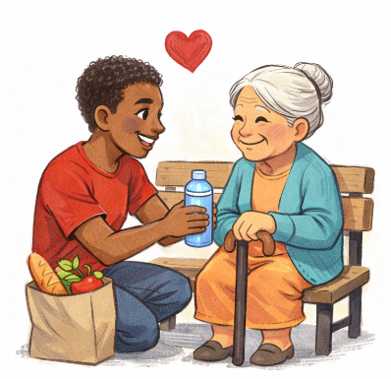
Rolmodelle |  | Voorbeelde
Definisie van 'n rolmodel: ______________  ____________________________________  ____________________________________  ____________________________________ |  | bv. Ouers/Voogde  ___________________  ___________________  ___________________

Eienskappe/gedrag van positiewe rolmodelle |  | Eienskappe/gedrag van negatiewe rolmodelle
_______________________________________  _______________________________________  _______________________________________  _______________________________________  _______________________________________  _______________________________________  _______________________________________  _______________________________________  _______________________________________  _______________________________________  _______________________________________ |  | _______________________________________  _______________________________________  _______________________________________  _______________________________________  _______________________________________  _______________________________________  _______________________________________  _______________________________________  _______________________________________  _______________________________________  _______________________________________

Invloed op jongmense |  | Invloed op jongmense
_______________________________________  _______________________________________  _______________________________________  _______________________________________  _______________________________________  _______________________________________  _______________________________________ |  | _______________________________________  _______________________________________  _______________________________________  _______________________________________  _______________________________________  _______________________________________  _______________________________________

Aktiwiteit 2: Informele Assessering
Voltooi die volgende aktiwiteit individueel.

Bestudeer die infografika hieronder en beantwoord die vrae wat volg.
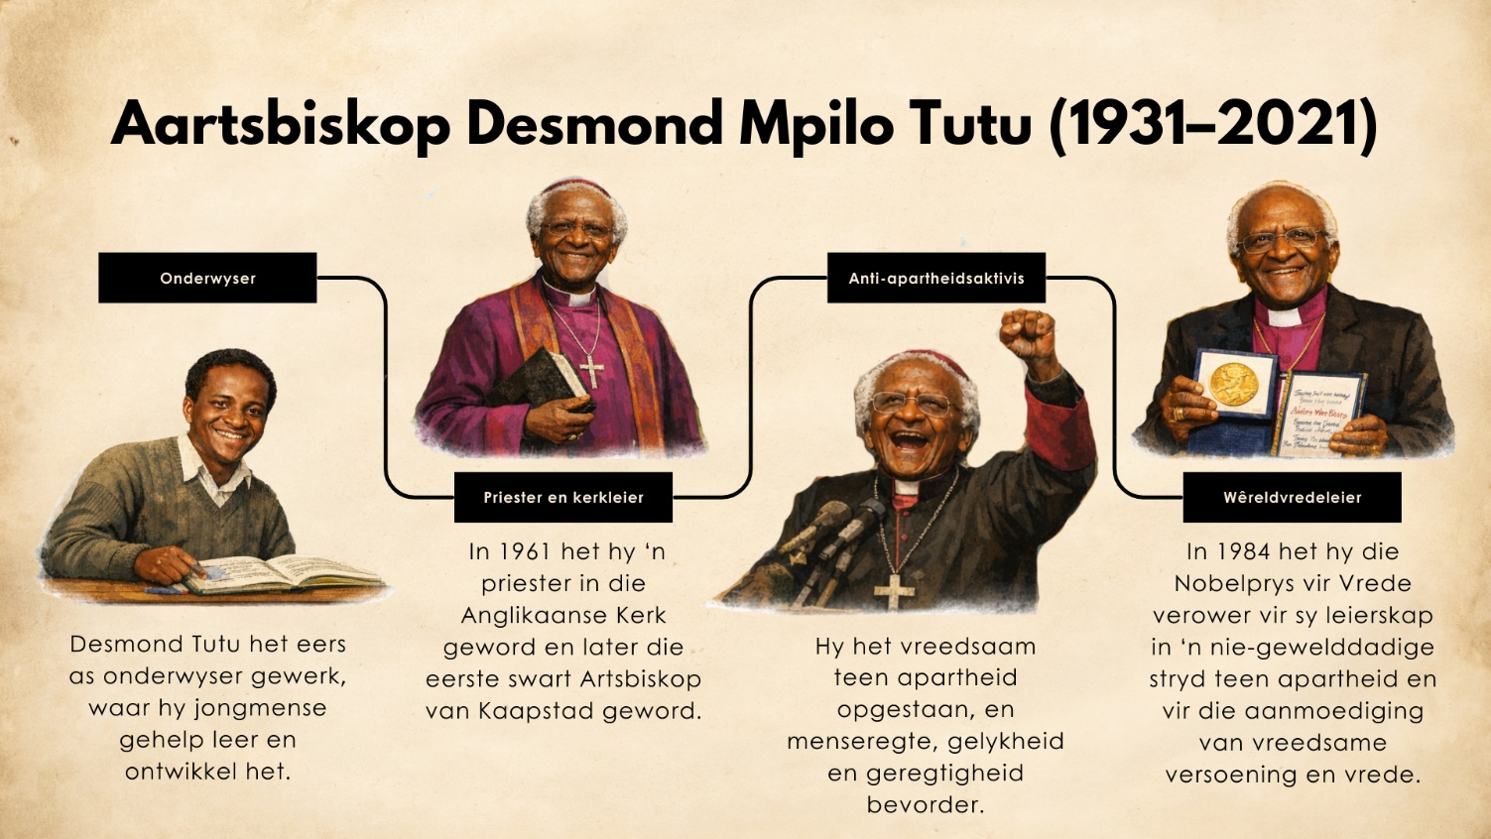
Desmond Tutu: 'n Rolmodel vir geregtigheid en vrede
[Aangepas vanaf: https://www.britannica.com/biography/Desmond-Tutu Toegangsdatum 10 Januarie 2026]

1. Definieer die term 'rolmodel'. (1 × 1) (1)
_________________________________________________________________________________
_________________________________________________________________________________

2. Onderskei tussen 'n positiewe rolmodel en 'n negatiewe rolmodel. Sluit ook in jou
antwoord 'n voorbeeld van die gedrag van elkeen in. (1 × 4) (4)
_________________________________________________________________________________
_________________________________________________________________________________
_________________________________________________________________________________
_________________________________________________________________________________

3. Bespreek TWEE maniere waarop 'n positiewe rolmodel die grondwetlike waardes van
Suid-Afrika kan bevorder. (2 × 2) (4)
_________________________________________________________________________________
_________________________________________________________________________________
_________________________________________________________________________________
_________________________________________________________________________________

4. Beveel TWEE dade van vriendelikheid aan wat jongmense kan beoefen om positiewe
rolmodelle binne hul gemeenskappe te word. Dui ook in jou antwoord aan hoe hierdie
dade gemeenskappe sal verbeter. (2 × 3) (6)
_________________________________________________________________________________
_________________________________________________________________________________
_________________________________________________________________________________
_________________________________________________________________________________
_________________________________________________________________________________
_________________________________________________________________________________
_________________________________________________________________________________
_________________________________________________________________________________

[Totaal: 15]

Aktiwiteit 3: Refleksie
Voltooi die volgende aktiwiteit individueel.

Dink na oor die rolmodelle in jou lewe en die soort persoon wat jy graag wil wees.

1. Lys TWEE van jou rolmodelle en verduidelik watter positiewe eienskappe of gedrag hulle toon.
________________________________________________________________________________________
________________________________________________________________________________________
________________________________________________________________________________________ ________________________________________________________________________________________

2. Dink oor jou eie gedrag. In watter mate dink jy is jy 'n positiewe rolmodel vir ander by die skool,
by die huis, of in jou gemeenskap?
________________________________________________________________________________________
________________________________________________________________________________________
________________________________________________________________________________________ ________________________________________________________________________________________

3. Stel EEN manier voor waarop jy jou gedrag kan verbeter sodat jy 'n meer positiewe rolmodel vir ander kan wees.
________________________________________________________________________________________
________________________________________________________________________________________
________________________________________________________________________________________ ________________________________________________________________________________________

