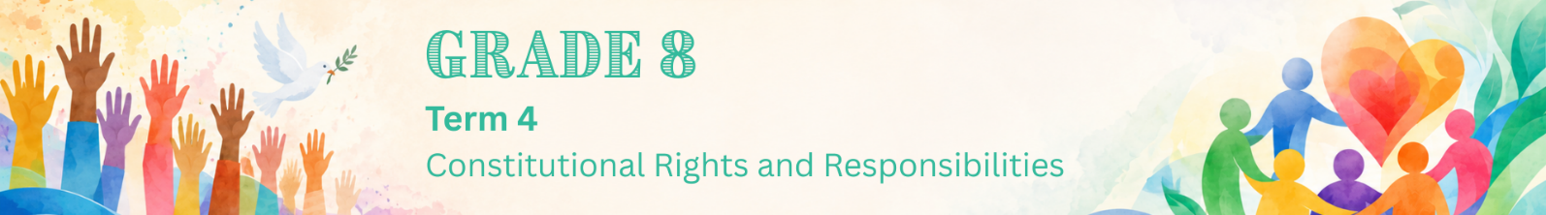

Lesson 1 – Worksheet
 | Activity 1: Recapping Human Rights  Complete the following activity in groups.

Write one human right you can remember in each puzzle piece. Try to fill in as many pieces as possible.

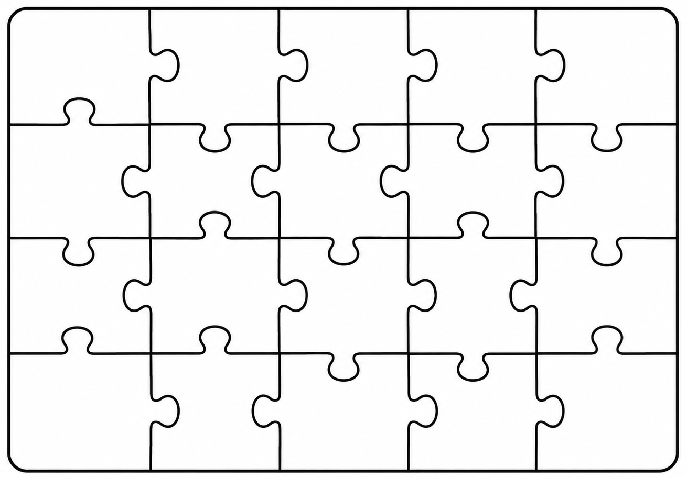
Human Rights Puzzle

Activity 2: Human Rights Violations & Counterstrategies
Complete the following activity individually.

1. Read the extract below and answer the following questions.

Private school investigated over learner’s beard

A private school is being investigated after it allegedly told a Muslim Grade 8 learner that he could not grow a beard for religious reasons. The learner’s family says the school treated him unfairly and did not respect his constitutional right to freedom of religion. They explain that, according to their religious beliefs, he is expected to grow a beard after reaching puberty.

The family claims the school told the learner to either shave his beard or leave the school. They have now asked the Department of Education to look into the matter.

This case has started a debate about how schools should balance their rules with learners’ constitutional rights. South African law protects people from being treated unfairly because of their religion, but schools may also have codes of conduct if these rules are fair and reasonable.

[Adapted from: https://www.news24.com/ Accessed on 01 July 2025]

a. Define the term 'human rights violation'. (1 × 1) (1)
___________________________________________________________________________
___________________________________________________________________________

b. Discuss ONE right that is being violated in the above text. (1 × 2) (2)
___________________________________________________________________________
___________________________________________________________________________
___________________________________________________________________________

c. Suggest ONE counterstrategy the parents of the learner could use against this
human right violation. (1 × 3) (3)
___________________________________________________________________________
___________________________________________________________________________
___________________________________________________________________________
___________________________________________________________________________
[Sub-total: 6]

2. Read the extract below and answer the following questions.

Environmental injustice in South Durban

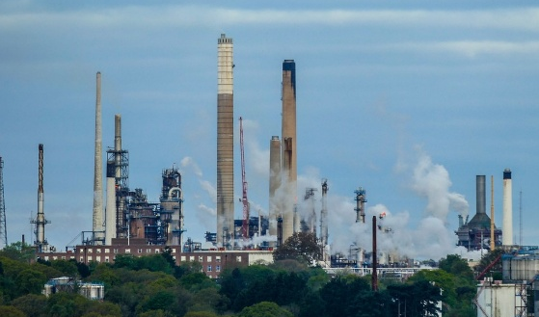
Communities in South Durban face serious health risks because they live close to large oil refineries. These refineries contribute to air pollution in the area.

A report by Greenpeace Africa found that air pollution caused about 42 000 deaths in South Africa in 2023.
This shows how environmental problems can affect people’s health and even lead to death. It also shows that vulnerable communities are often affected the most.

[Adapted from: https://www.dailymaverick.co.za/ Accessed on 01 July 2025]

a. State ONE human right being violated in the above text. (1 × 1) (1)
___________________________________________________________________________

b. Explain ONE impact that the situation described above could have on the wider
community. (1 × 2) (2)
___________________________________________________________________________
___________________________________________________________________________
___________________________________________________________________________

c. Suggest ONE counterstrategy community members can use against this violation. (1 × 3) (3)
___________________________________________________________________________
___________________________________________________________________________
___________________________________________________________________________
___________________________________________________________________________
[Sub-total: 6]
[Grand total: 12]

Activity 3: Homework Reflection
Complete the following activity individually.

1. Think about your school or community. State ONE human rights issue that you think young people should care more about.
_________________________________________________________________________________

2. Which counterstrategy do you think you would be most likely to use if you saw someone’s rights being violated? Motivate your answer.
__________________________________________________________________________________________________________________________________________________________________

