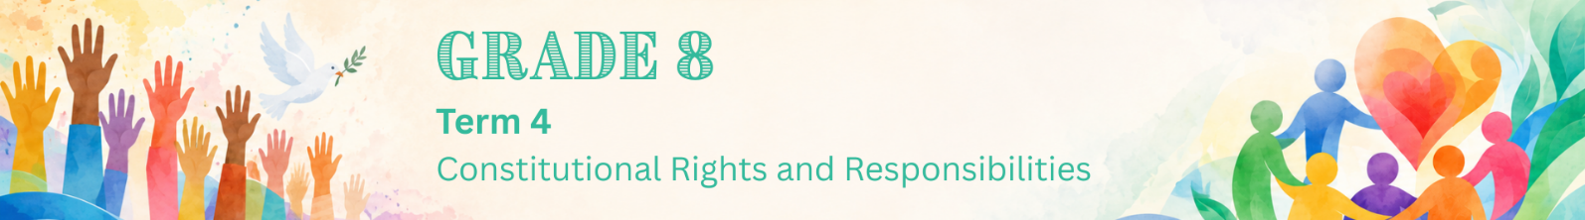

Lesson 2 – Worksheet
 | Activity 1: Gender Equity Issues in Sport  Complete the following activity individually.

Read the extract below and answer the questions that follow.

Women in sport: Why change is still needed

In many schools, clubs and professional sports, girls and women are taking part in sport and achieving excellent results. However, they do not always receive the same attention, support or opportunities as boys and men.

To achieve gender equity, it is very important that women’s sport is often shown on television, online platforms or social media. Improving sport for everyone means thinking carefully about fairness. It also means asking whether all athletes, even at school level, are receiving the support they need to participate, improve and succeed.
[Adapted from https://www.thedailyvox.co.za/race-transformation-agenda-gender-transformation-sports/
Accessed on: 27 May 2026]

1. Differentiate between 'equality' and 'equity'. (1 × 2) (2)
__________________________________________________________________________________________________________________________________________________________________

2. State TWO examples of stereotyping in sport that could discourage girls from participating
in sport. (2 × 1) (2)
__________________________________________________________________________________________________________________________________________________________________

3. Explain how the media can affect support for women's sport. (1 × 2) (2)
__________________________________________________________________________________________________________________________________________________________________

4. Recommend TWO practical ways your school could promote gender equity in sport. In
each answer, explain how the strategy would improve female participation. (2 × 3) (6)
__________________________________________________________________________________________________________________________________________________________________
__________________________________________________________________________________________________________________________________________________________________
__________________________________________________________________________________________________________________________________________________________________

[Total: 12]
Activity 2: Homework Reflection
Complete the following activity individually.

Women’s sport needs more visibility and support. Choose ONE of the challenges below and complete the following reflection sentence.

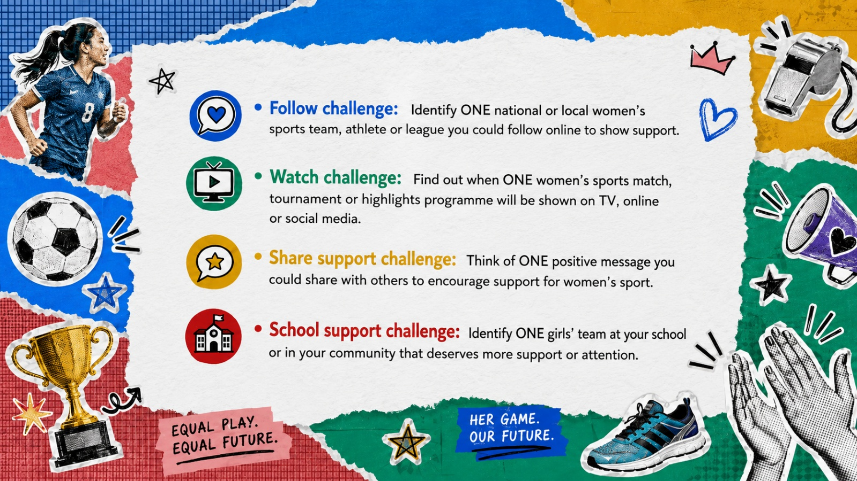

Reflection sentence:
I choose the ______________________ challenge. One way this can help promote gender equity in sport is ______________________________________________________________________________________________________________________________________________________________________________.

