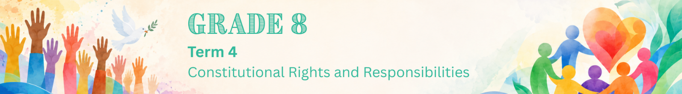

Lesson 3 – Worksheet
 | Activity 1: Impact of Gender-Based Violence  Complete the following activity in groups.

Study the infographic below and complete the following activity.
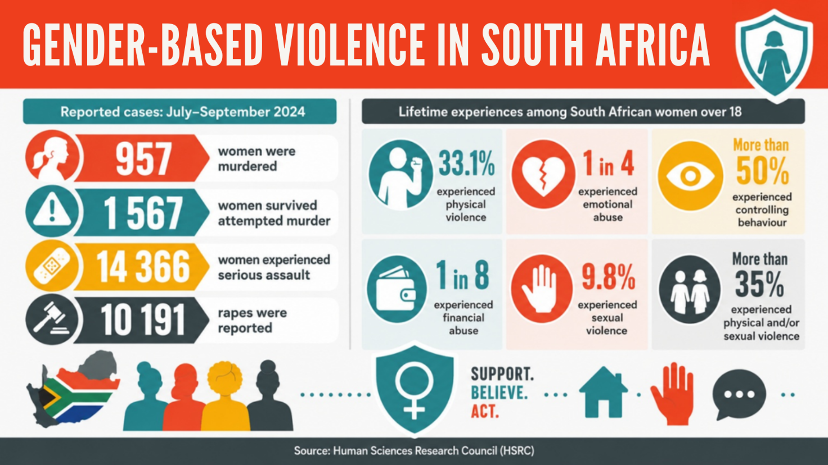
[Adapted from https://hsrc.ac.za/news/review/violence-against-women-in-south-africa-intersecting-vulnerabilities/
Accessed: 27 May 2026]

Brainstorm the impact that gender-based violence and rape may have on the following areas of a person's life. Mention examples.
Emotional Impact | Health Impact | Social Impact
Activity 2: Understanding and Responding to GBV
Complete the following activity individually.

Read the extract below and answer the following questions.

Gender-based violence as a human rights issue

“Violence against women is perhaps the most shameful human rights violation, and it is perhaps the most pervasive. It knows no boundaries of geography, culture or wealth. As long as it continues, we cannot claim to be making real progress towards equality, development and peace.”
- Kofi Annan

Former UN Secretary-General Kofi Annan was a strong supporter of women’s empowerment. He believed that women’s rights, equal opportunities and participation in decision-making are important for development, health, education and peace.

[Adapted from https://www.kofiannanfoundation.org/gender-equality-and-inclusion/ Accessed: 27 May 2026]

1. Define the term ‘gender-based violence’. (1 × 1) (1)
__________________________________________________________________________________________________________________________________________________________________

2. State TWO forms of gender-based violence. (2 × 1) (2)
__________________________________________________________________________________________________________________________________________________________________

3. Describe TWO factors that might contribute to gender-based violence. (2 × 2) (4)
__________________________________________________________________________________________________________________________________________________________________
__________________________________________________________________________________________________________________________________________________________________

4. Recommend ONE responsible action a Grade 8 learner could take to challenge harmful
attitudes toward girls at school. In your answer, indicate how the action could help prevent
gender-based violence. (1 × 3) (3)
__________________________________________________________________________________________________________________________________________________________________
__________________________________________________________________________________________________________________________________________________________________
[Total: 10]

