

Lesson 3 – Worksheet
 | Activity 1: Thoughts During Adolescence  Complete the following activity individually.

Read the statements in the image below. Have you ever had some of these thoughts?

Rate the thoughts you struggle with the most by writing one of the following numbers next to each speech bubble in the image:
1 = I do not struggle with this at all
2 = I sometimes think about this
3 = I think about this quite often

Remember, your answers are private. You do not have to share them with anyone.

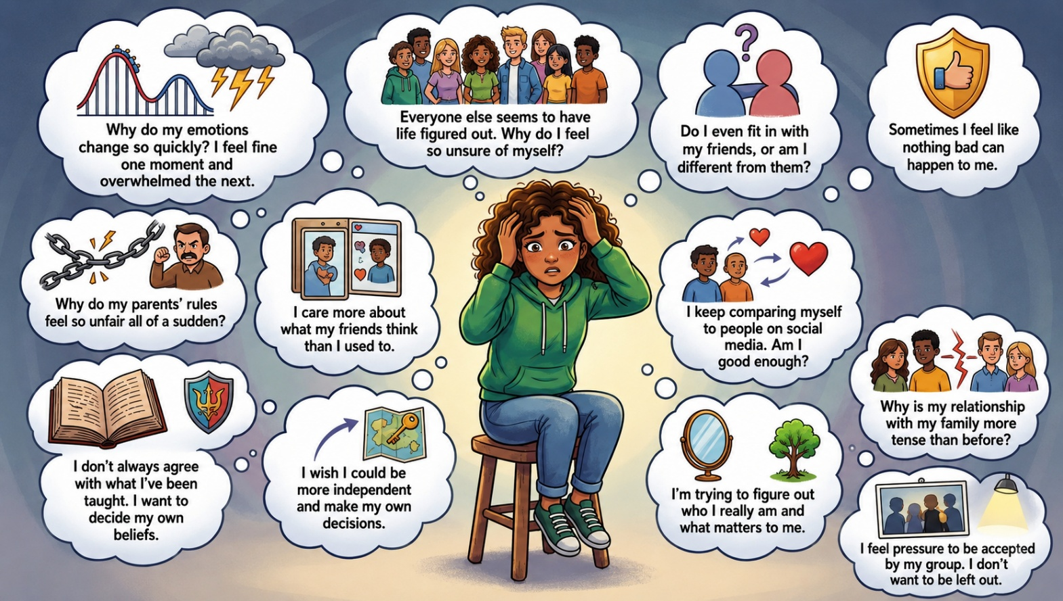

Activity 2: Emotional and Social Changes During Adolescence
Complete the following activity individually.

Watch the video Emotional Shifts in Teenagers up until 3 min 36 sec. Then complete Part 1 below.

Part 1: Emotional changes during adolescence

Choose an emotional change from COLUMN B that matches an image in COLUMN A. Write only the letter (A–E) next to the question numbers (1 to 5).
Column A |  | Column B
1. | 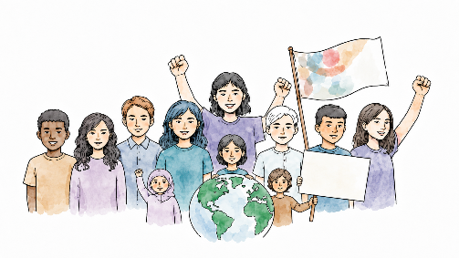 | A. | "Invincible" stage of thinking and acting
2. |  | B. | Feelings of insecurity
3. | 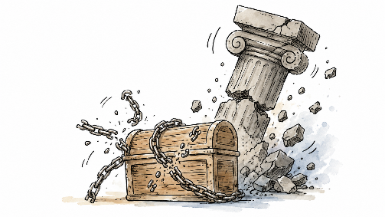 | C. | Changing needs in belief and values
4. | 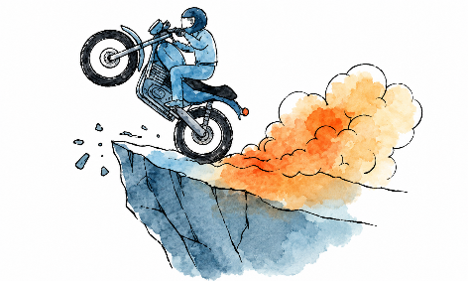 | D. | Emotions become more intense, and mood swings occur
5. | 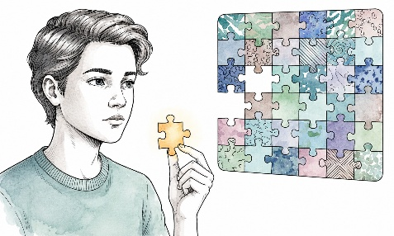 | E. | Challenging authority

Answers:
1. _____ ; 2. _____ ; 3. _____ ; 4. _____ ; 5. _____

Part 2: Social changes during adolescence

Study the images below and answer the following questions.

Image 1 | Image 2
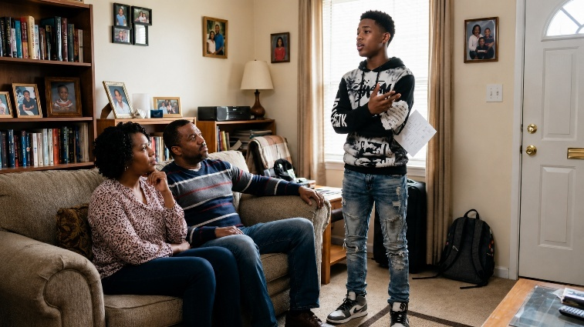 | 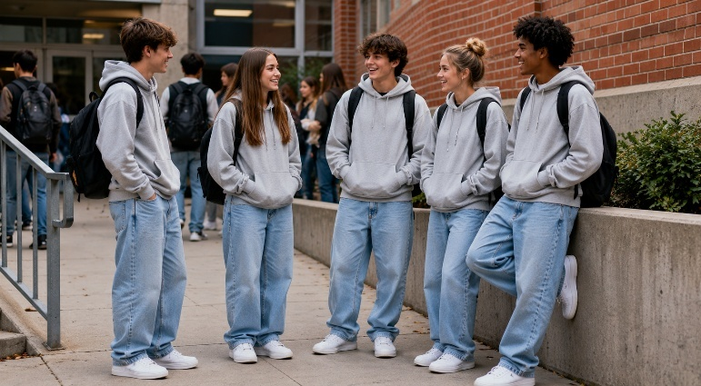
Image 3 | Image 4
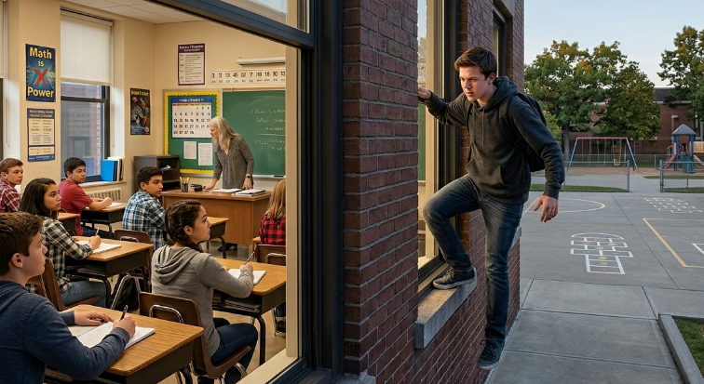 | 

1. Identify the social change shown in each image. (4 × 1) (4)
Image 1: _________________________________________________________________________
_________________________________________________________________________________
Image 2: _________________________________________________________________________
_________________________________________________________________________________
Image 3: _________________________________________________________________________
_________________________________________________________________________________
Image 4: _________________________________________________________________________
_________________________________________________________________________________

2. Discuss ONE possible negative effect of the social change in each image. (4 × 2) (8)
Image 1: _________________________________________________________________________
_________________________________________________________________________________
Image 2: _________________________________________________________________________
_________________________________________________________________________________
Image 3: _________________________________________________________________________
_________________________________________________________________________________
Image 4: _________________________________________________________________________
_________________________________________________________________________________

3. Discuss ONE possible positive effect of the social change in each image. (4 × 2) (8)
Image 1: _________________________________________________________________________
_________________________________________________________________________________
Image 2: _________________________________________________________________________
_________________________________________________________________________________
Image 3: _________________________________________________________________________
_________________________________________________________________________________
Image 4: _________________________________________________________________________
_________________________________________________________________________________

[Total: 20]
Activity 3: Coping with Changes During Adolescence
Complete the following activity in groups.

Read through the scenario that was assigned to your group. Then discuss and answer the questions below.

1. State ONE emotional or social change shown in the scenario. (1 × 1) (1)
__________________________________________________________________________________________________________________________________________________________________

2. Explain why this change is common during adolescence. (1 × 2) (2)
__________________________________________________________________________________________________________________________________________________________________
_________________________________________________________________________________

3. Recommend ONE positive strategy that could be used to handle this situation. (1 × 2) (2)
__________________________________________________________________________________________________________________________________________________________________
_________________________________________________________________________________
[Total: 5]
Activity 4: Reflection
Complete the following activity individually.

Complete the statements below.

1. One aspect I learned about myself today is ______________________________________________
_________________________________________________________________________________

2. One question I still have about the work is ______________________________________________
_________________________________________________________________________________

3. One suggestion I have for coping with emotions is ________________________________________
_________________________________________________________________________________

