

Lesson 4 – Worksheet
 | Activity 1: Substance Use and Unwanted Pregnancy  Complete the following activity in pairs.

Turn to your peer and briefly discuss the questions below.

- Why could using substances lead to an unwanted pregnancy?
- What advice would you give to a friend who is going to a wild party with lots of alcohol, to help make sure that they do not end up in a situation where an unwanted pregnancy could occur?
Activity 2: Reflection
Complete the following activity individually.

State ONE personal boundary you would like to set or strengthen to help you make responsible choices and feel more in control of your life. Explain why this boundary is important to you.
____________________________________________________________________________________________________________________________________________________________________________________________________________________________________________________________________________________________________________________________________________________________
Activity 3: Homework Activity
Complete the following activity individually.

Study the infographic below and answer the following questions.

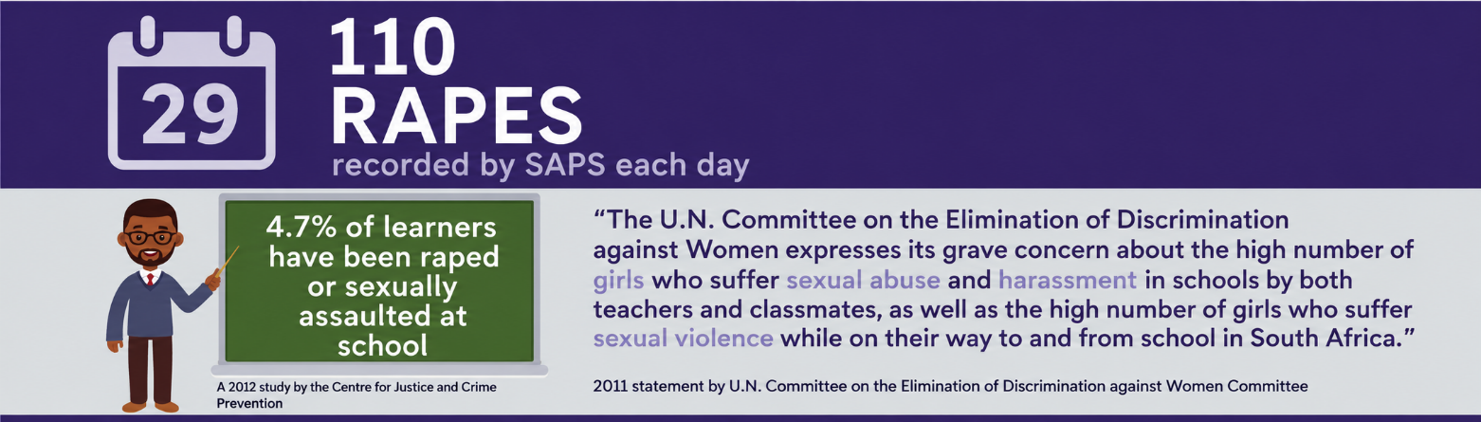
[Adapted from: https://www.soulcity.org.za/ Accessed: 18 May 2026]

1. Identify TWO situations where a teenager may need extra caution to reduce vulnerability
to sexual violence or rape. (2 × 1) (2)
___________________________________________________________________________________________________________________________________________________________________________________________________________________________________________________

2. Differentiate between 'rape' and 'sexual abuse'. (1 × 2) (2)
___________________________________________________________________________________________________________________________________________________________________________________________________________________________________________________
3. Analyse how having a strong value system could help teenagers make responsible
decisions about sexual behaviour. In your answer, also indicate how this could
contribute to a healthy lifestyle. (1 × 3) (3)
____________________________________________________________________________________________________________________________________________________________________________________________________________________________________________________________________________________________________________________________________
4. Recommend ONE strategy a teenager could use to respond to unwanted sexual attention
from a fellow classmate. In your answer, also indicate how this strategy may enable the
teenager to build a respectful environment for other learners. (1 × 3) (3)
____________________________________________________________________________________________________________________________________________________________________________________________________________________________________________________________________________________________________________________________________
[Total: 10]

