Scenario 1: Lara and Ms Mzambi
Read through the text messages. Then discuss and answer the questions in the space provided next to the text messages.
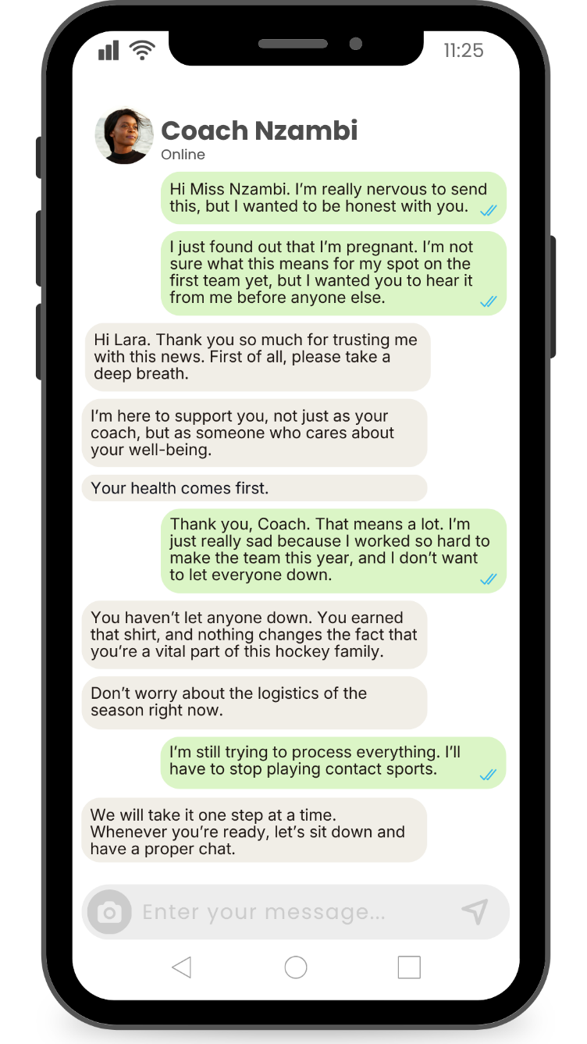
  1. What life role has changed in this scenario?
  2. How will this change impact Lara?
  3. How will this change impact Lara's relationship with her family?
  4. Suggest ONE strategy Lara can use to manage this change positively.
Scenario 2: Gina and Rose
Read through the text messages. Then discuss and answer the questions in the space provided next to the text messages.
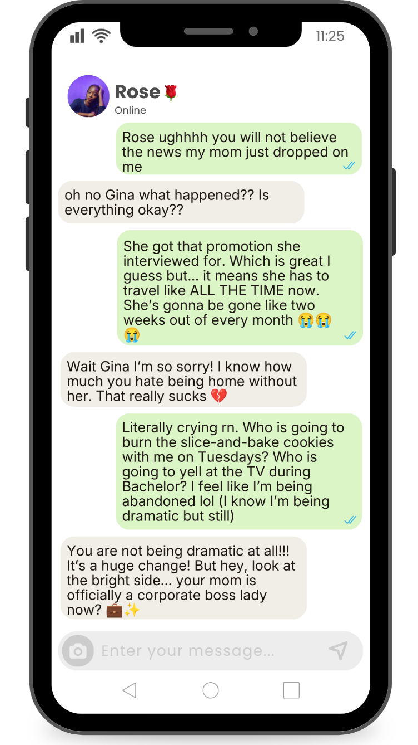
  1. What life role has changed in this scenario?
  2. How will this change impact Gina?
  3. How will this change impact the relationship between Gina and her mom?
  4. Suggest ONE strategy Gina and her mom can use to manage this change positively.
Scenario 3: Jakob and Renee
Read through the text messages. Then discuss and answer the questions in the space provided next to the text messages.
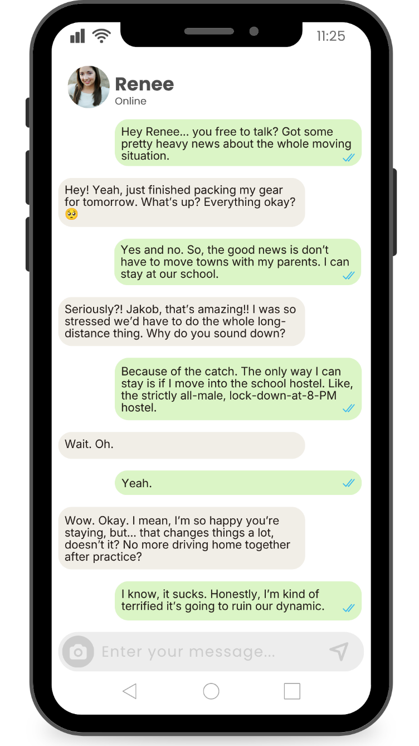
  1. What life role has changed in this scenario?
  2. How will this change impact Jakob?
  3. How will this change impact Jakob's relationship with his family?
  4. Suggest ONE strategy Jakob can use to manage this change positively.
Scenario 4: Nicky and Nathan
Read through the text messages. Then discuss and answer the questions in the space provided next to the text messages.
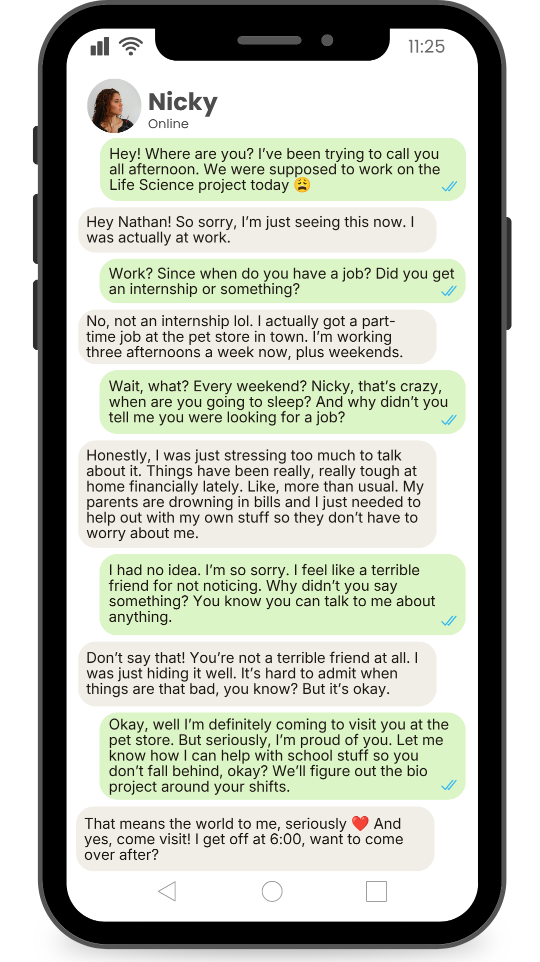
  1. What life role has changed in this scenario?
  2. How will this change impact Nicky?
  3. How will this change impact Nicky's relationship with her family?
  4. Suggest ONE strategy Nicky can use to manage this change positively.

