Scenario 1: Lara and Ms Mzambi
Read through the text messages. Then discuss and answer the questions in the space provided next to the text messages.
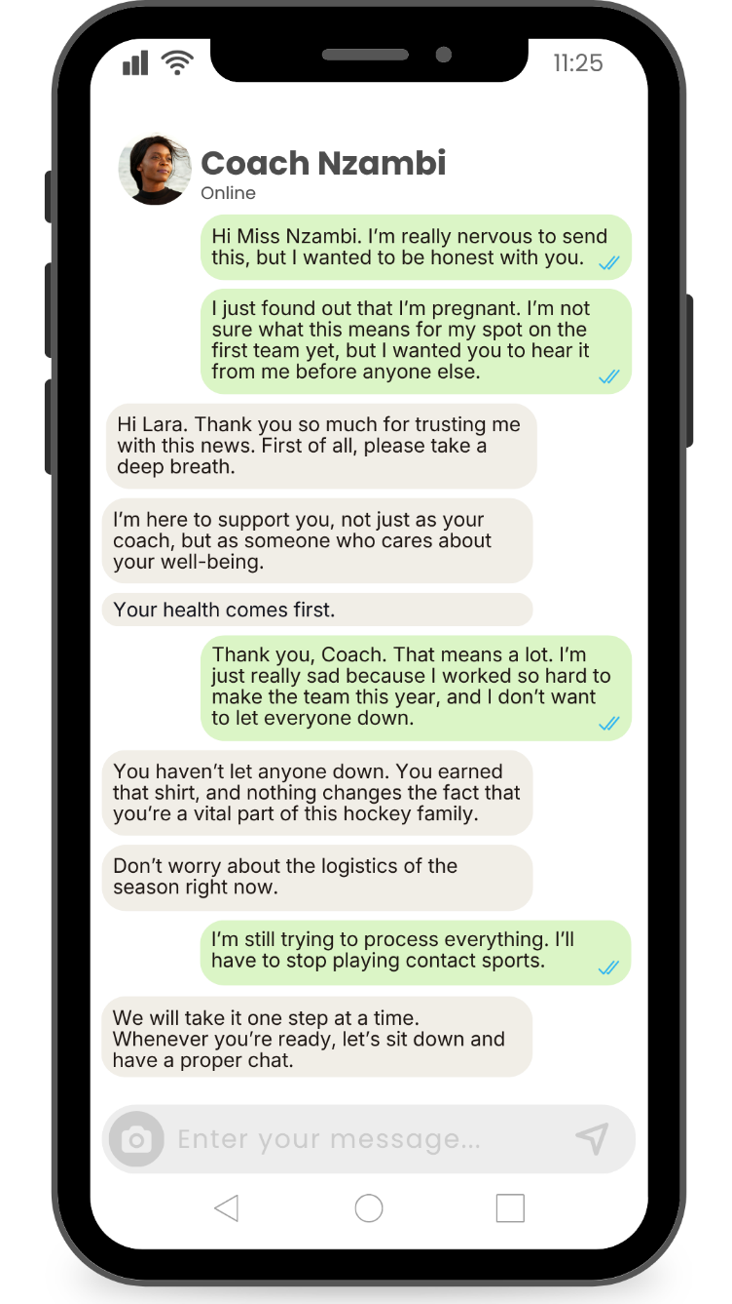
  1. What life role has changed in this scenario?
  Learner → Pregnant teenager/future parent
  Sportsperson → Unable to continue contact sport
  2. How will this change impact Lara?
  Emotional distress (sad, anxious, overwhelmed)
  Loss of opportunity (cannot play hockey/loss of team role)
  Physical health considerations (pregnancy limits activities)
  Uncertainty about the future (school, sport, goals)
  3. How will this change impact Lara's relationship with her family?
  Family may need to provide more support (emotional/financial)
  Possible disappointment or concern from parents
  Increased responsibility within the family
  Changes in family dynamics/expectations
  4. Suggest ONE strategy Lara can use to manage this change positively.
  - Seek support from trusted adults like parents or a sports coach by communicating concerns. The result will be not enduring a challenging experience on your own.
  - Discuss new life roles with a counsellor and seek advice on how to still achieve goals in the future.
Scenario 2: Gina and Rose
Read through the text messages. Then discuss and answer the questions in the space provided next to the text messages.
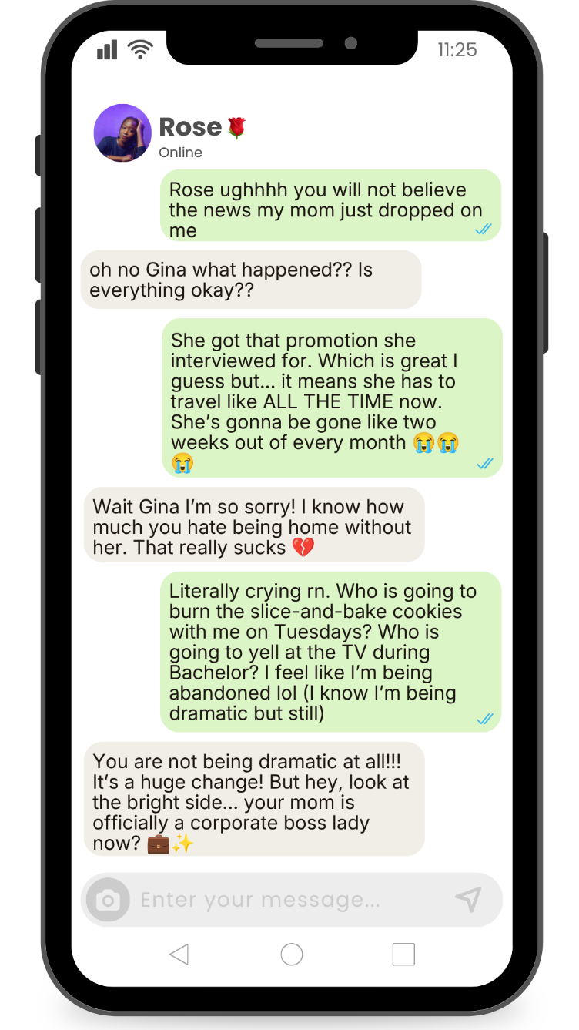
  1. What life role has changed in this scenario?
  Mother → Working parent with frequent travel
  Daughter → More independent child at home
  2. How will this change impact Gina?
  Feelings of loneliness or abandonment
  Emotional distress (missing bonding time)
  Increased independence
  Adjustment to a new routine at home
  3. How will this change impact the relationship between Gina and her mom?
  Reduced time spent together
  Change/strengthening/weakening in family routines and bonding
  Possible strain in the mother-daughter relationship
  Need for stronger communication
  4. Suggest ONE strategy Gina and her mom can use to manage this change positively.
  - Schedule quality time when mother is available and make the most of these times together.
  - Maintain regular communication (calls/messages) and build a support system (friends/other family members) while the mother is away.
Scenario 3: Jakob and Renee
Read through the text messages. Then discuss and answer the questions in the space provided next to the text messages.
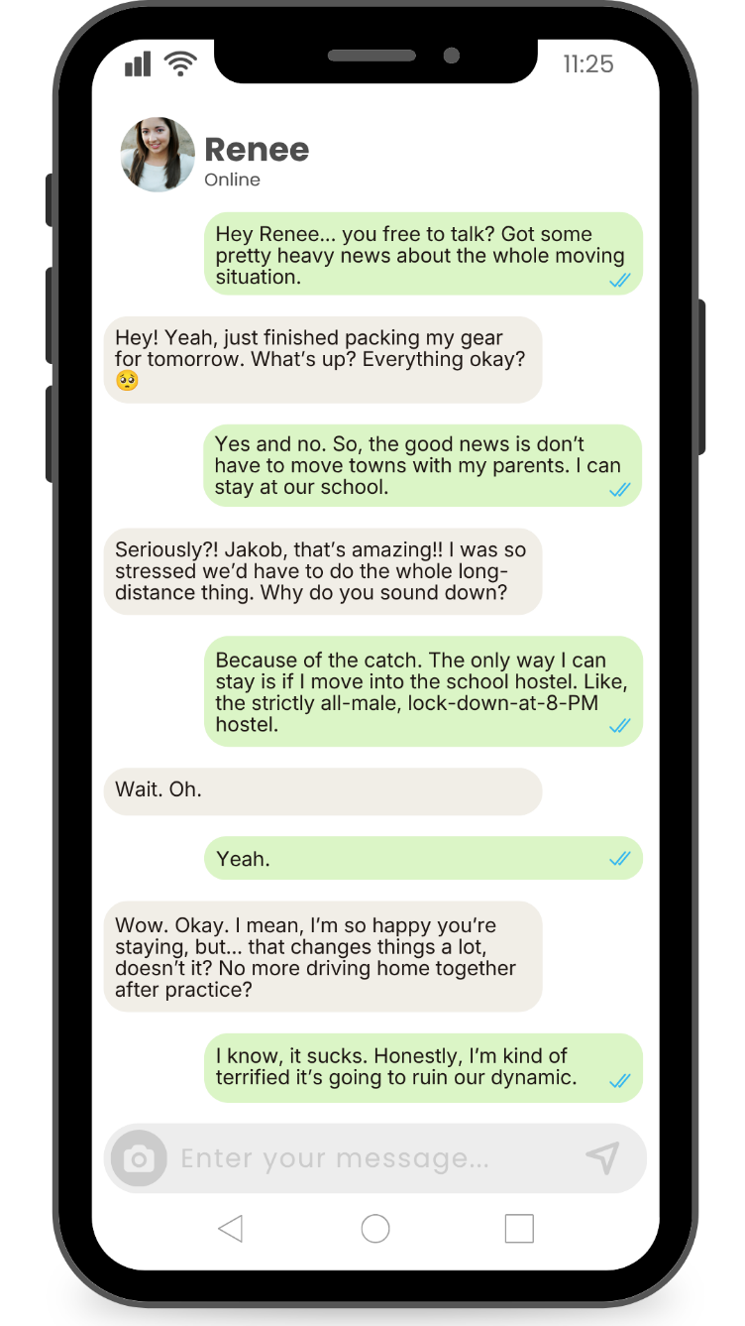
  1. What life role has changed in this scenario?
  Learner living at home → Boarder/hostel resident
  Boyfriend → Long-distance relationship partner
  2. How will this change impact Jakob?
  Emotional stress and anxiety (fear of change)
  Loss of freedom (strict hostel rules)
  Reduced time with partner
  Adjustment challenges (new environment)
  3. How will this change impact Jakob's relationship with his family?
  Less daily contact with family
  Increased independence
  Possible feelings of distance or disconnection
  Family may feel concerned or supportive
  4. Suggest ONE strategy Jakob can use to manage this change positively.
  - Maintain communication through phone calls and video chats and arrange to meet during holidays or over weekends.
  - Establish new routines in the hostel and make new friendships to help you settle into this new role.
Scenario 4: Nicky and Nathan
Read through the text messages. Then discuss and answer the questions in the space provided next to the text messages.
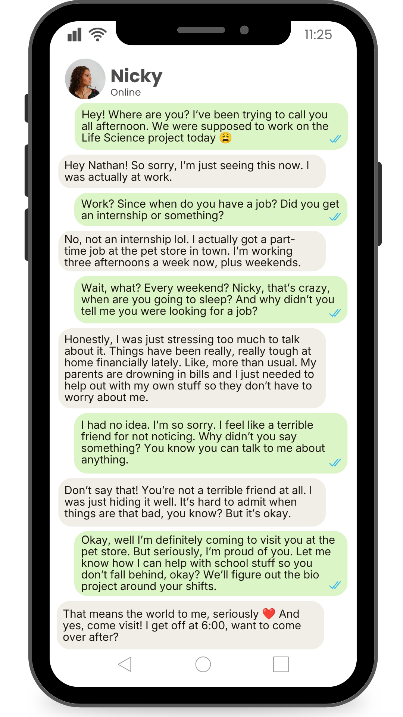
  1. What life role has changed in this scenario?
  Learner → Learner + worker (part-time employee)
  Child → Contributor to family finances
  2. How will this change impact Nicky?
  Increased stress and fatigue (balancing school and work)
  Less study time → risk of falling behind academically
  Positive impact: sense of responsibility and independence
  Emotional pressure due to family financial situation
  3. How will this change impact Nicky's relationship with her family?
  Stronger sense of responsibility toward family
  Reduced dependency on parents
  Family may feel relieved/supportive
  Less time for family interaction
  4. Suggest ONE strategy Nicky can use to manage this change positively.
  - Seek academic support from teachers to assist in managing time by developing a structured study schedule.
  - Communicate openly with family and friends to ensure time for self-care and spending time with family and friends.

